Supplementary materials

Pilot study of biofouling occurrence in a brackish water reverse osmosis system using intermittent operation
Hye-Won Kimª, Woodan Choi^{a, b}, Dongwoo Suh^{c}, Youngbin Baek^{d}*, Kyungjin Cho^{a, b}*, Seongpil Jeong^{a, b}*

ª Center for Water Cycle Research, Climate and Environmental Research Institute, Korea Institute of Science and Technology (KIST), Seoul 02792, Republic of Korea
^{b} Division of Energy & Environment Technology, KIST school, Korea University of Science and Technology (UST), Seoul 02792, Republic of Korea
^{c} School of Chemical and Biological Engineering, College of Engineering, Institute of Chemical Process (ICP), Seoul National University (SNU), 1 Gwanak-ro, Gwanak-gu, Seoul 08826, Republic of Korea
^{d} Department of Biological Engineering, Inha University, 100 Inha-ro, Michuhol-gu, Incheon 22212, Republic of Korea

*Co-corresponding author at: Tel.: +82 (0)2-958-6444; fax: +82 (0)2-958-5839
E-mail address: spjeong@kist.re.kr (Seongpil Jeong)
*Co-corresponding author at: Tel.: +82 (0)2-958-5838; fax: +82 (0)2-958-5839
E-mail address: faith@kist.re.kr (Kyungjin Cho)
*Co-corresponding author at: Tel.: +82 (0)32-860-7516
E-mail address: ybbaek@inha.ac.kr (Youngbin Baek)

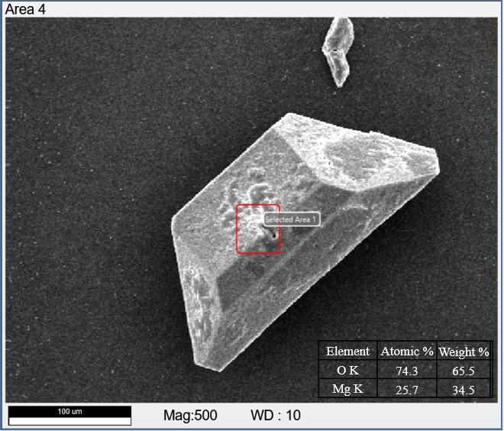
Fig. S1. EDS result of crystal formed on the membrane surface in continuous-oxic condition

Table S1 Diversity indices of the biomass samples.

No. | Sample code | Chao1 index | Shannon index
1 | Ano-CON | 72.3 | 2.8
2 | Ano-CON-Bio | 126.9 | 3.4
3 | Ano-INT | 60.0 | 3.1
4 | Ano-INT-Bio | 97.0 | 3.9
5 | Ox-CON | 48.0 | 2.6
6 | Ox-CON-Bio | 97.4 | 3.5
7 | Ox-INT | 35.2 | 2.7
8 | Ox-INT-Bio | 111.0 | 3.6

 | Ano-CON | Ano-CON-Bio | Ano-INT | Ano-INT-Bio | Ox-CON | Ox-CON-Bio | Ox-INT | Ox-INT-Bio
OTU 1 | 50.5 | 15.2 | 30.1 | 7.7 | 3.5 | 2.5 | 4.6 | 1.1
OTU 2 | 7.9 | 7.3 | 19.1 | 11.1 | 21.5 | 30.0 | 38.3 | 22.1
OTU 3 | 6.3 | 13.1 | 4.4 | 21.8 | 16.6 | 16.6 | 19.5 | 23.3
OTU 4 | 0.0 | 0.1 | 0.4 | 0.6 | 15.7 | 15.1 | 11.6 | 17.1
OTU 5 | 4.9 | 2.1 | 12.7 | 0.3 | 33.4 | 9.3 | 1.5 | 1.1
OTU 6 | 8.2 | 1.5 | 6.4 | 1.8 | 0.0 | 0.1 | 0.00 | 0.1
OTU 7 | 7.2 | 28.0 | 2.5 | 19.1 | 0.0 | 6.4 | 0.0 | 11.0
OTU 8 | 0.1 | 0.0 | 0.0 | 0.0 | 2.0 | 1.1 | 13.3 | 0.4
OTU 9 | 1.9 | 1.8 | 10.7 | 9.0 | 0.1 | 1.3 | 0.1 | 0.4
OTU 10 | 4.5 | 0.1 | 3.8 | 0.1 | 0.0 | 0.0 | 0.0 | 0.0
OTU 11 | 1.5 | 17.1 | 4.5 | 3.3 | 0.2 | 1.6 | 0.7 | 0.9
OTU 12 | 1.5 | 0.2 | 1.7 | 0.1 | 0.0 | 0.0 | 0.0 | 0.1
OTU 13 | 0.1 | 2.6 | 0.0 | 2.2 | 0.0 | 0.0 | 0.0 | 0.6
OTU 14 | 0.0 | 0.9 | 0.0 | 2.3 | 0.0 | 0.1 | 0.0 | 1.7
OTU 15 | 0.0 | 1.0 | 0.0 | 1.7 | 0.0 | 0.6 | 0.0 | 1.9
OTU 17 | 0.1 | 0.1 | 0.2 | 0.1 | 0.0 | 3.0 | 0.0 | 0.2
OTU 18 | 0.1 | 0.1 | 0.1 | 1.5 | 0.9 | 0.8 | 0.8 | 1.1
OTU 19 | 0.0 | 0.6 | 0.0 | 3.3 | 0.0 | 0.4 | 0.0 | 0.7
OTU 20 | 0.0 | 0.0 | 0.0 | 0.0 | 1.6 | 2.0 | 3.7 | 0.4
OTU 21 | 0.0 | 0.1 | 0.0 | 2.1 | 0.0 | 1.26 | 0.0 | 1.5
OTU 22 | 0.0 | 0.5 | 0.0 | 0.5 | 0.0 | 0.0 | 0.0 | 2.4
OTU 23 | 0.0 | 0.0 | 0.2 | 1.9 | 1.5 | 1.1 | 2.3 | 1.4
OTU 24 | 0.0 | 0.4 | 0.0 | 1.6 | 0.0 | 0.3 | 0.0 | 2.6
OTU 25 | 0.8 | 1.3 | 0.3 | 0.6 | 0.0 | 0.0 | 0.0 | 0.0
OTU 29 | 0.1 | 0.0 | 0.3 | 0.0 | 1.3 | 0.6 | 1.6 | 0.2
Table S2 Relative abundance (%) of the major bacterial OTUs, which were highlighted with yellow (Top five) and green (Top ten) colors.
Table S3 Flux recovery and quantitative analysis for attached bacterial concentration and EPS (e.g. protein and polysaccharide) concentration onto the membrane after cleaning processes in various conditions.
Cleaning conditions |  | Flux recovery (%) | Attached bacterial conc. (× 10⁷ CFU/cm²) | EPS conc. (μg/cm²)
 |  | Flux recovery (%) | Attached bacterial conc. (× 10⁷ CFU/cm²) | Protein | Polysaccharide
Control ª |  | 69.0 ^{b} | 4.6 ± 1.2 | 14.5 ± 4.0 | 40.5 ± 2.2
Time  (min) | 15 | 68.7 | 1.7 | 2.7 ± 0.5 | 24.3 ± 0.9
Time  (min) | 30 | 69.4 | 1.0 | 2.0 ± 0.2 | 25.4 ± 2.1
Time  (min) | 60 | 69.8 | 1.0 | 2.3 ± 0.4 | 25.2 ± 0.7
Flow velocity  (L/min) | 0.6 | 73.9 | 1.6 | 1.9 ± 0.4 | 30.1 ± 0.1
Flow velocity  (L/min) | 1.2 | 75.9 | 1.3 | 0.9 ± 0.3 | 29.2 ± 5.1
Flow velocity  (L/min) | 1.2  (reverse) | 75.6 | 1.4 | 1.4 ± 0.8 | 27.4 ± 2.5
ª Control data was obtained after 2nd filtration (29 h operation).
^{b} Flux recovery for control was calculated from flux after 2nd intermittent filtration divided by initial flux (× 100%).

