Supplemental Material. Early life exposure to Chlordecone and cognitive and behavioral outcomes in Guadeloupian Children

Table of content:
Figure S1. Flow chart of the Timoun study (Neurodevelopment at seven years)
Figure S2. Conceptual Directed Acyclic Graph representing the associations between chlordecone exposure, FSIQ, and potential confounders
Figure S3. Correlation plot of maternal and 7-years exposures
Table S1. Associations between cord- and 7-years blood chlordecone concentrations and cognitive and behavioral functions using SEM analyses, stratified by sex.
Figure S4. Dose response relationship between cord- and 7-years blood chlordecone concentrations and WISC-IV scores.
Figure S5. Dose response relationship between cord- and 7-years blood chlordecone concentrations and behavioral latent functions.
Figure S6. Associations between cord-blood and 7-years chlordecone concentrations and WISC-IV composite scores obtained from the SEM path analysis with additional adjustment for co-exposures, stratified by sex.
Figure S7. Associations between cord-blood and 7-years chlordecone concentrations and standardized behavioral functions obtained using SEM analyses with additional adjustment for co-exposures, stratified by sex.

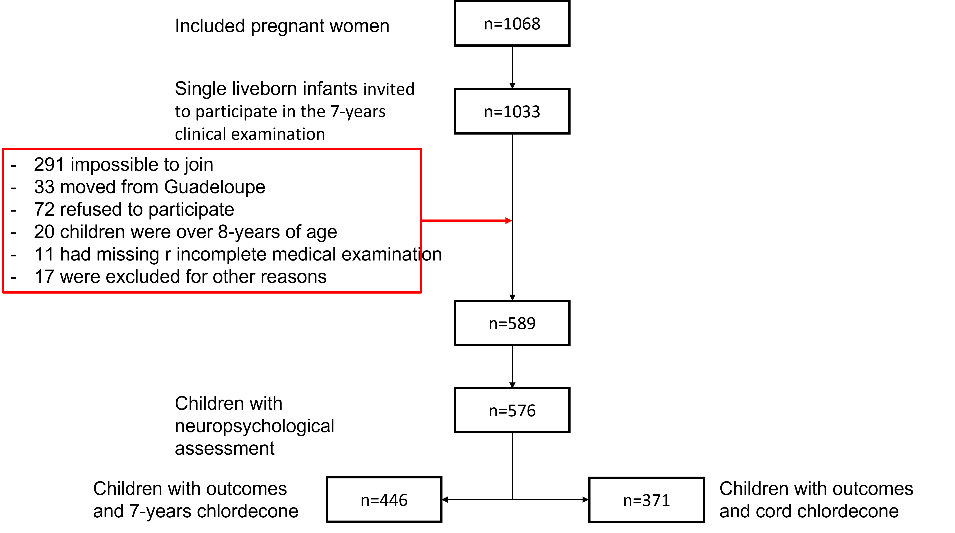

Figure S1. Flow chart of the Timoun study (Neurodevelopment at seven years)

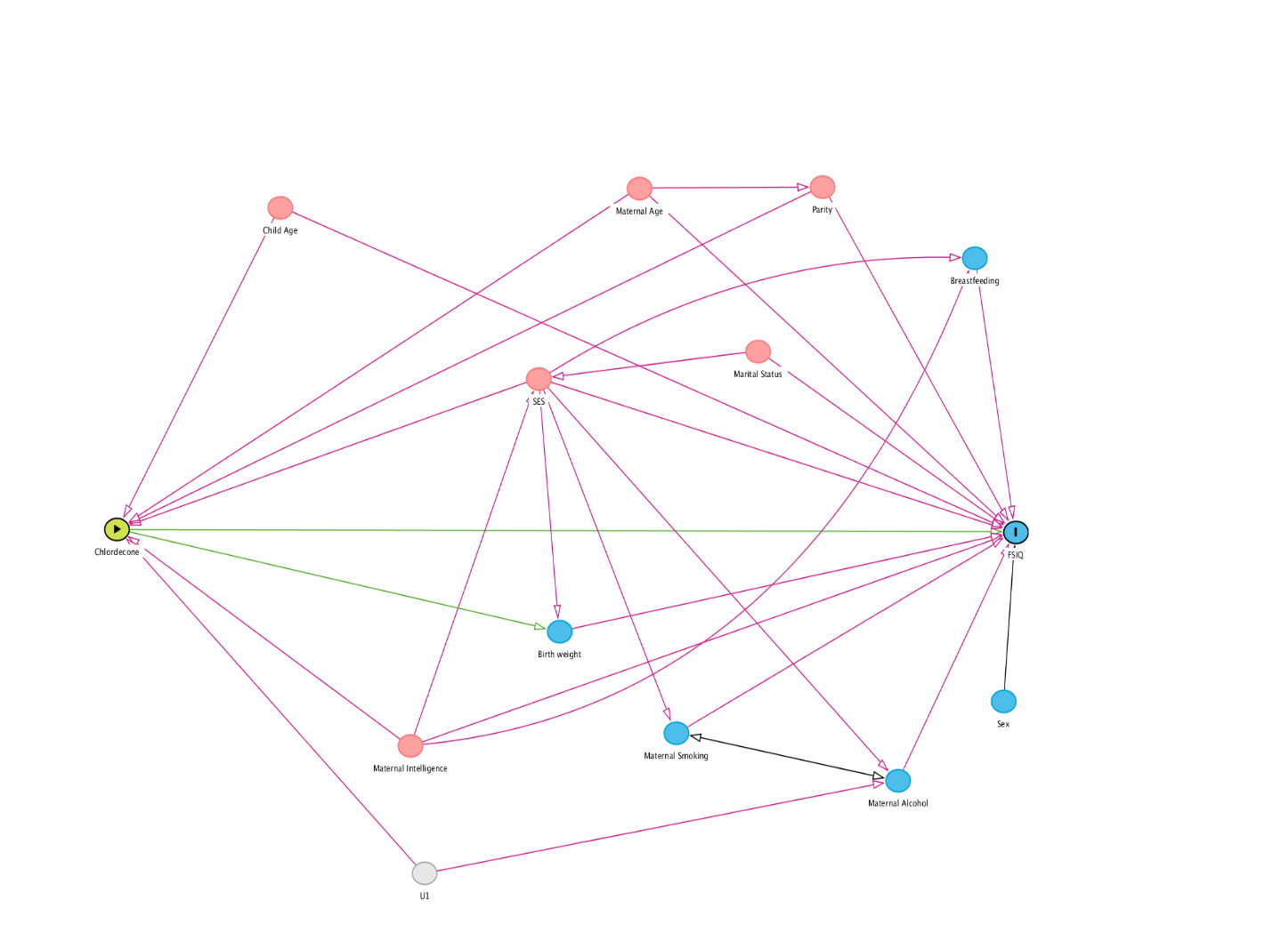
Figure S2. Conceptual Directed Acyclic Graph representing the associations between chlordecone exposure, FSIQ, and potential confounders

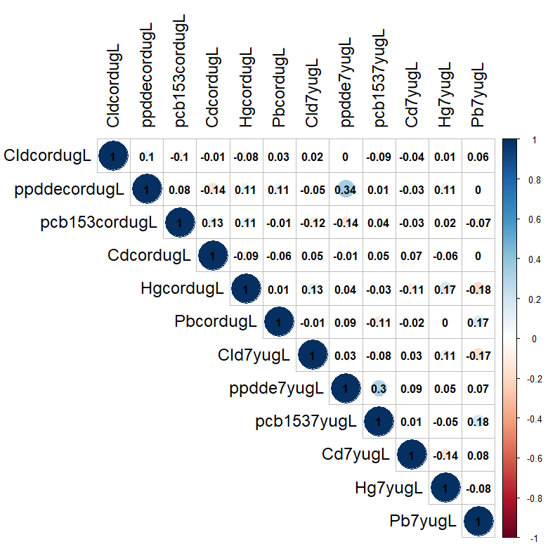
Figure S3. Correlation plot of cord and 7-years exposures. Cd: Cadmium; Cld: Chlordecone; Hg: Mercury; Pb: Lead; pp-DDE: pp- dichlorodiphenyl dichloroethane; PCB: dichlorodiphenyl dichloroethane.

Table S1. Associations between cord- and 7-years blood chlordecone concentrations and cognitive and behavioral functions using SEM analyses, stratified by sex. Models were adjusted for child’s age and sex, maternal age, parity, Raven score, education, marital status, monthly household income, and alcohol and smoking during pregnancy.

Test | Function | All |  | Sex-stratified Estimates (95% CI) |  | P-effect modification
Test | Function | Estimate  (95% CI) | p-value | Boys | Girls
Cord Blood
SDQ | Internalizing problems | 0.04 (-0.02, 0.10) | 0.23 | 0.00 (-0.07, 0.07) | 0.10 (0.01, 0.19) | 0.08
SDQ | Externalizing problems | 0.02 (-0.04, 0.08) | 0.46 | 0.04 (-0.06, 0.13) | 0.01 (-0.06, 0.09) | 0.72
WISC-IV | Working memory | 0.07 (-0.42, 0.56) | 0.78 | 0.24 (-0.39, 0.88) | 0.09 (-0.70, 0.88) | 0.76
WISC-IV | Perceptive reasoning | -0.12 (-0.93, 0.69) | 0.77 | 0.70 (-0.82, 2.22) | -0.75 (-1.66, 0.15) | 0.11
WISC-IV | Processing speed | 0.07 (-0.47, 0.61) | 0.79 | 0.84 (0.08, 1.60) | -0.48 (-1.26, 0.29) | 0.02
WISC-IV | Verbal comprehension | -0.40 (-0.93, 0.14) | 0.15 | -0.66 (-1.63, 0.18) | -0.48 (-1.17, 0.20) | 0.77
WISC-IV | Full scale IQ | -0.13 (-0.71, 0.45) | 0.66 | 0.31 (-0.76, 1.38) | -0.53 (-1.22, 0.16) | 0.20
7 Years Blood
SDQ | Internalizing problems | 0.01 (-0.05, 0.06) | 0.78 | -0.01 (-0.07, 0.04) | 0.02 (-0.03, 0.08) | 0.36
SDQ | Externalizing problems | 0.04 (0.00, 0.08) | 0.04 | 0.03 (-0.03, 0.08) | 0.05 (0.01, 0.10) | 0.43
WISC-IV | Working memory | -0.69 (-1.18, -0.19) | 0.01 | -1.36 (-2.04, -0.69) | 0.10 (-0.54, 0.75) | 0.002
WISC-IV | Perceptive reasoning | -0.69 (-1.27, -0.11) | 0.02 | -1.18 (-1.97, -0.38) | -0.28 (-1.04, 0.47) | 0.11
WISC-IV | Processing speed | -0.17 (-0.61, 0.28) | 0.46 | -0.39 (-1.02, 0.24) | 0.07 (-0.50, 0.64) | 0.29
WISC-IV | Verbal comprehension | -0.50 (-0.89, -0.10) | 0.01 | -0.37 (-0.93, 0.19) | -0.56 (-1.10, -0.02) | 0.62
WISC-IV | Full scale IQ | -0.67 (-1.13, -0.22) | 0.003 | -1.07 (-1.72, -0.42) | -0.25 (-0.81, 0.31) | 0.06

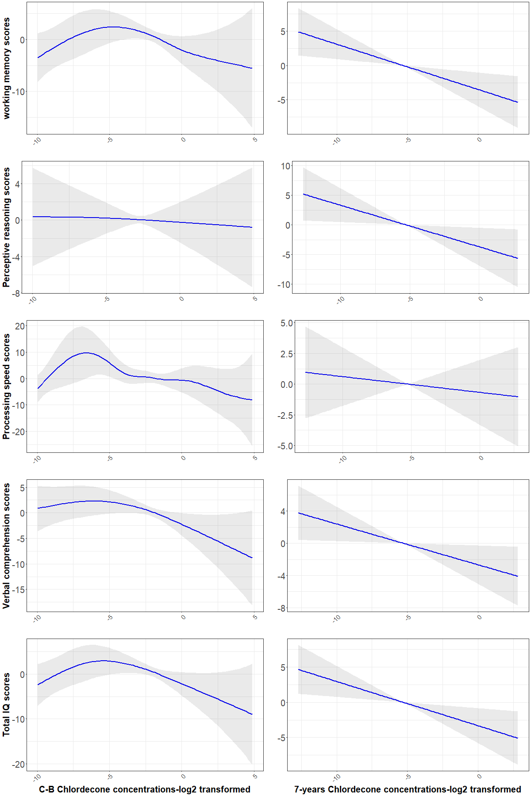
Figure S4. Dose response relationship between cord- and 7-years blood chlordecone concentrations and WISC-IV scores.

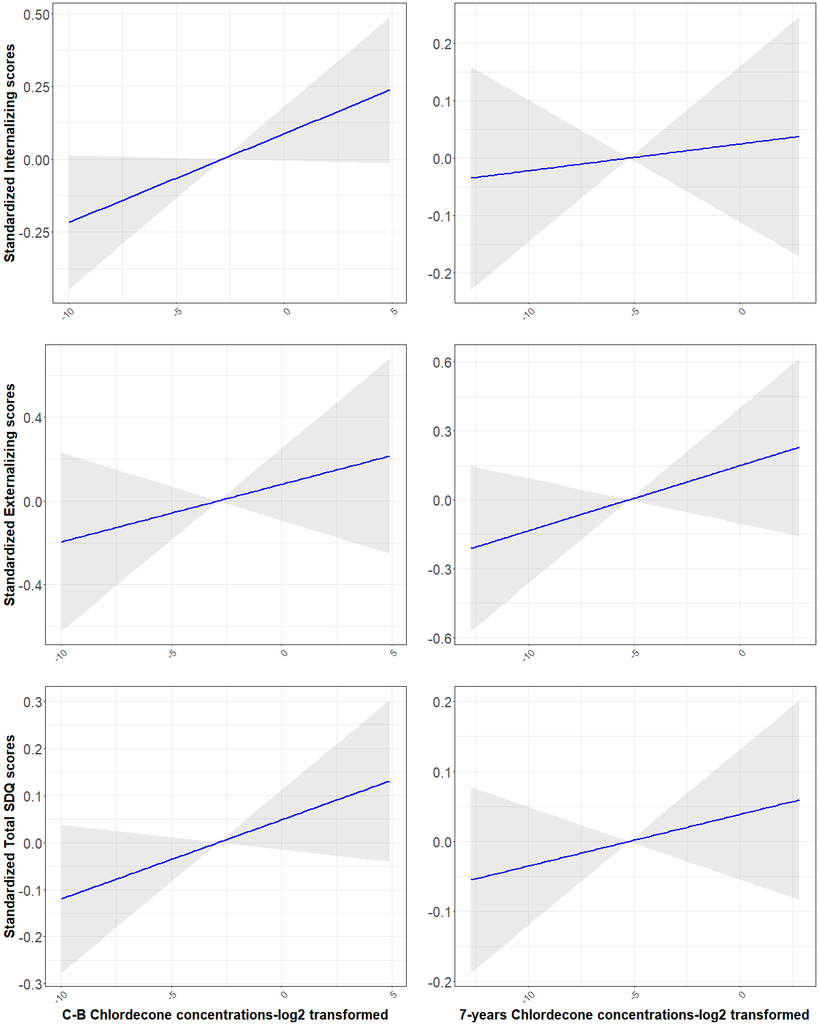

Figure S5. Dose response relationship between cord- and 7-years blood chlordecone concentrations and behavioral latent functions.

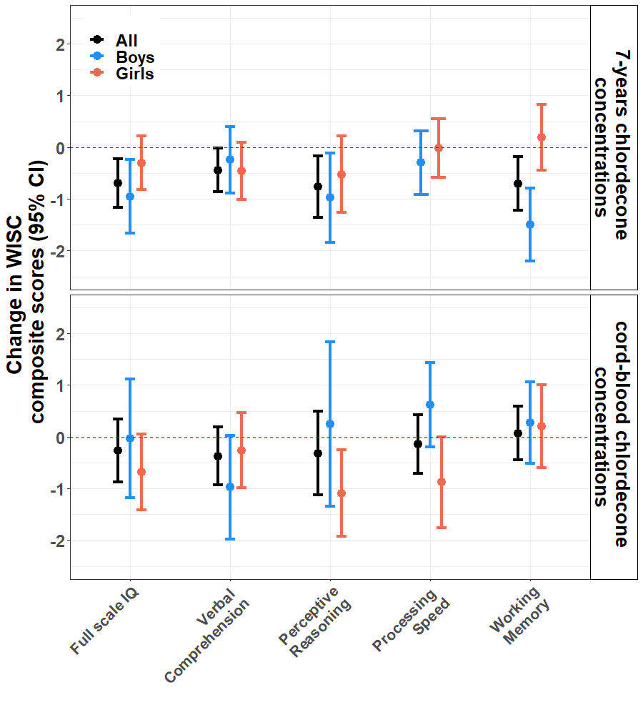
Figure S6. Associations between cord-blood and 7-years chlordecone concentrations and WISC-IV composite scores obtained from the SEM path analysis with additional adjustment for co-exposures (i.e. Pb, Cd, Hg, PCB-153, and pp-DDE), stratified by sex. Models were adjusted for child’s age and sex, maternal age, parity, Raven score, education, marital status, monthly household income, and alcohol and smoking during pregnancy, in addition to the co-environmental exposures.

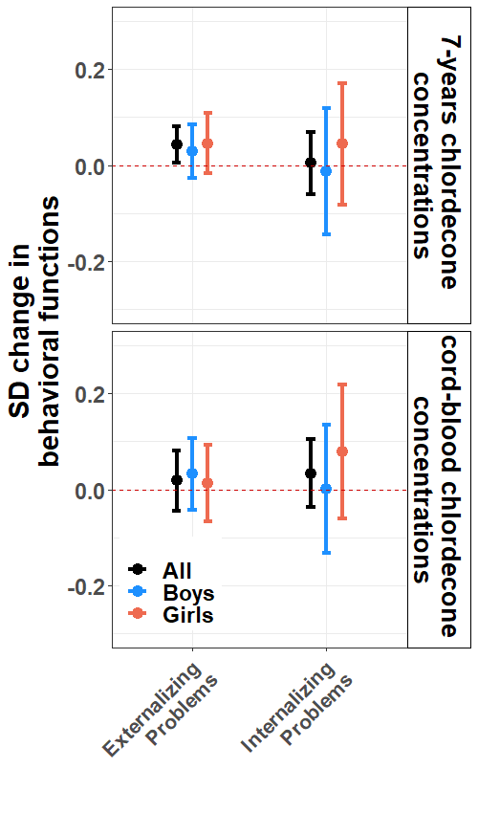
Figure S7. Associations between cord-blood and 7-years chlordecone concentrations and standardized behavioral functions obtained using SEM analyses with additional adjustment for co-exposures (i.e. Pb, Cd, Hg, PCB-153, and pp-DDE), stratified by sex. Models were adjusted for child’s age and sex, maternal age, parity, Raven score, education, marital status, monthly household income, and alcohol and smoking during pregnancy, in addition to the co-environmental exposures.

