Fig.S1
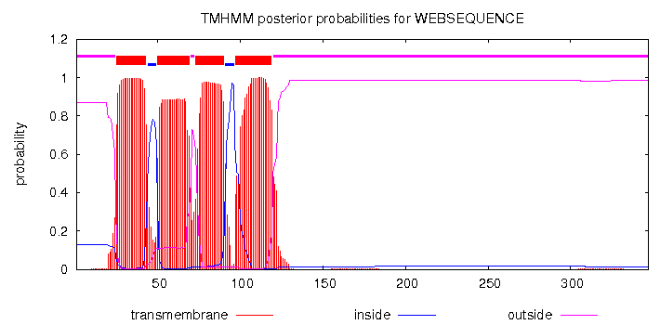
Fig.S1. Possibl transmembrane domains prediction for the amino acid sequence of ORF1 of ChRV1 by the TMHMM Server v. 2.0 program. The default settings were utilized for this analysis.

