Supplementary Information

Article title: Cytotoxic effects of novel 2-methylthio dihydropyrimidines on human acute myeloid leukemia cell lines

Journal name: Investigational New Drugs

Author names: Yuki Toguchi (ORCID: 0000-0003-4794-9435), Hidetomo Kikuchi* (ORCID: 0000-0002-7704-4859), Yoshio Nishimura, Bo Yuan (ORCID: 0000-0002-3406-258X), Rie Arai (ORCID: 0000-0002-9049-5005), Hidetsura Cho, Katsuyoshi Sunaga
*Corresponding

Affiliation and e-mail address of the corresponding author: Department of Pharmacotherapy, Clinical Dietetics and Human Nutrition, Master's program, Josai University Graduate School of Pharmaceutical Sciences, 1-1, Keyakidai, Sakado, Saitama 350-0295, Japan; hkikuchi@josai.ac.jp

Materials and methods
Materials for the synthesis of 2-methylthio DPs
All reaction reagents and solvents for synthesis were purchased from FUJIFILM Wako Pure Chemical Corporation (Osaka, Japan) or Tokyo Chemical Industry Co., Ltd. (Tokyo, Japan) or Kanto Chemical Co., Inc. (Tokyo, Japan). TLC was performed using pre-coated silica gel 60 F254 plates (Merck KGaA, Germany) using the indicated solvents. Column chromatography was performed on silica gel 60 [70–230 mesh, NACALAI TESQUE, Inc. (Kyoto, Japan)] or Silica gel 60N (spherical, neutral, 40–50 µm, Kanto Chemical Co., Inc.) using the indicated solvents.

Synthesis of 2-methylthio DPs
Melting points were determined with an AS ONE melting point apparatus ATM-02 (AS ONE Corporation, Japan) or Yanaco melting point apparatus MP-J3 without correction. ¹H NMR spectra were recorded on a Bruker AVANCETM III 600 (600 MHz, Bruker Japan K.K., Japan) with tetramethylsilane (d 0 ppm) in CDCl₃ or dimethylsulfoxide (d 2.49 ppm) in DMSO-d₆, or methanol (d 3.30 ppm) in CD₃OD as internal standards. ¹³C NMR spectra were recorded on a Bruker AVANCETM III 600 (150 MHz) with chloroform (d 77.0 ppm) in CDCl₃, or dimethylsulfoxide (d 39.7 ppm) in DMSO-d₆, or methanol (d 49.0 ppm) in CD₃OD as internal standards. Multiplicities for ¹H NMR were designated as s = singlet, d = doublet, t = triplet, q = quartet, dd = doublet of doublets, dq = doublet of quartets, tq = triplet of quartets, m = multiplet, and br = broad. Infrared spectra (IR) were measured on a JASCO FT/IR-6100 or JASCO FT/IR-4100 Fourier Transform Infrared Spectrophotometer (JASCO Corporation, Japan). Mass spectra were recorded on a JEOL JMS-700 mass analyzer (JEOL Ltd., Japan). High-resolution spectroscopy (HRMS) was performed using a JEOL JMS-700 mass analyzer.
Following the literature procedure[1], ethyl 4,4,6-trimethyl-2-methylthio-1,4-dihydropyrimidine-5-carboxylate (DP01)[1], methyl 4,4,6-trimethyl-2-methylthio-1,4-dihydropyrimidine-5-carboxylate (DP02)[1], benzyl 4,4,6-trimethyl-2-methylthio-1,4-dihydropyrimidine-5-carboxylate (DP03)[1], ethyl 4,6-dimethyl-2-methylthio-4-pentyl-1,4-dihydropyrimidine-5-carboxylate (DP04)[1], ethyl 4-methyl-2-methylthio-1,3-diazaspiro[5.5]undeca-2,5-diene-5-carboxylate (DP05)[1], ethyl 4-ethyl-6-methyl-2-methylthio-4-phenyl-1,4-dihydropyrimidine-5-carboxylate (DP06)[1], ethyl 6-methyl-2-methylthio-1H-spiro[fluorene-9’,4-pyrimidine]-5-carboxylate (DP07)[1], and ethyl 4,4-dimethyl-2-methylthio-6-phenyl-1,4-dihydropyrimidine-5-carboxylate (DP08)[1] were prepared. Ethyl 6-methyl-2-methylthio-1,4-dihydropyrimidine-5-carboxylate (DP09)[2] was prepared under the reported condition[2]. Ethyl 4-cyclohexyl-6-methyl-2-methylthio-1,4-dihydropyrimidine-5-carboxylate (DP10) was synthesized by cyclocondensation of ethyl 2-(cyclohexylmethylene)-3-oxobutanoate and S-methylisothiourea hemisulfate salt. Ethyl 6-methyl-2-methylthio-4-propyl-1,4-dihydropyrimidine-5-carboxylate (DP11) was prepared from the corresponding 2-thioxo compounds[3] by S-methylation under the reported condition[2]. The experimental procedure and their physiochemical and spectral data for DP10 and DP11 were shown in Supplementary data.
Following the literature procedure[1], ethyl 4,4-dimethyl-2-methylthio-6-oxo-1,4,5,6-tetrahydropyrimidine-5-carboxylate (DP12), methyl 4,4-dimethyl-2-methylthio-6-oxo-1,4,5,6-tetrahydropyrimidine-5-carboxylate (DP13), ethyl 4-methyl-2-methylthio-6-oxo-4-pentyl-1,4,5,6-tetrahydropyrimidine-5-carboxylate (DP14), ethyl 2-methylthio-6-oxo-4,4-dipropyl-1,4,5,6-tetrahydropyrimidine-5-carboxylate (DP15), ethyl 7-methylthio-9-oxo-6,8-diazaspiro[4.5]undec-6-ene-10-carboxylate (DP16), ethyl 2-methylthio-4-oxo-1,3-diazaspiro[5.5]undec-1-ene-5-carboxylate (DP17), ethyl 4-ethyl-2-methylthio-6-oxo-4-phenyl-1,4,5,6-tetrahydropyrimidine-5-carboxylate (DP18), and ethyl 2-methylthio-6-oxo-5,6-dihydro-1H-spiro[fluorene-9’,4-pyrimidine]-5-carboxylate (DP19) were synthesized by cyclocondensation reaction of the corresponding dialkyl 2-(gem-disubstituted)methylene malonates (DM20–DM27) and S-methylisothiourea hemisulfate salt. The malonates (DM20–DM27) were prepared under the conditions similar to those described for the synthesis of 2-(gem-disubstituted)methylene-3-oxoesters[1].
The experimental procedure and their physiochemical and spectral data for DM20–DM27 and DP12–DP19 as a mixture of tautomeric isomers were shown in Supplementary data.

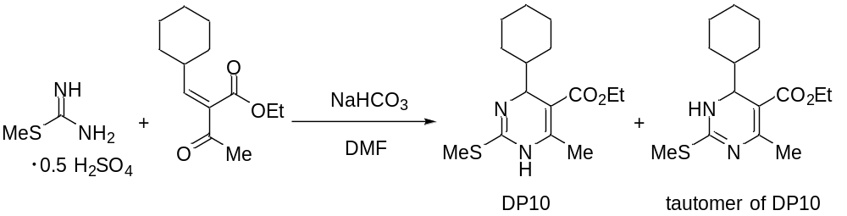
Scheme S1. Synthesis of DP10 and tautomer of DP10.

Ethyl 4-cyclohexyl-6-methyl-2-methylthio-1,4-dihydropyrimidine-5-carboxylate (DP10) and ethyl 6-cyclohexyl-4-methyl-2-methylthio-1,6-dihydropyrimidine-5-carboxylate (tautomer of DP10).
A mixture of S-methylisothiourea hemisulfate salt (434 mg, 3.12 mmol) and ethyl 2-(cyclohexylmethylene)-3-oxobutanoate (234 mg, 1.04 mmol), and NaHCO₃ (350 mg, 4.17 mmol) in dry DMF (2.0 mL) was heated at 65 ºC for 16 h under Ar. To the reaction mixture was added EtOAc (10 mL) followed by water (5 mL), and the organic layer was separated. The aqueous layer was extracted with EtOAc (10 mL), and the combined organic layer and extracts were washed with brine, dried over Na₂SO₄, and concentrated under reduced pressure. The residue was purified by flash column chromatography [n-hexane-EtOAc (6:1 to 4:1)] to give DP10 and tautomer of DP10 as an inseparable mixture (294 mg, 0.992 mmol, 95%) as a pale yellow oil. ¹H NMR of mixture of the tautomers (CD₃OD, 600 MHz): δ = 0.85–0.98 (m, 1H), 1.05–1.23 (m, 4H), 1.27 (t, J = 7.2 Hz, 3H), 1.32–1.81 (m, 6H), 2.23 (s, 3H), 2.41 (s, 3H), 4.12 (dq, J = 10.8, 7.2 Hz, 1H), 4.16 (dq, J = 10.8, 7.2 Hz, 1H), 4.24–4.39 (brs, 1H). ¹³C NMR of mixture of the tautomers (CD₃OD, 150 MHz): δ = 13.8, 14.7, 19.4, 27.3, 27.5, 27.7, 28.9, 29.8, 46.4, 59.9, 60.8, 101.2, 148.0–153.0 (br), 156.0–161.0 (br), 169.1. IR (neat): 3294, 2925, 2852, 1655, 1490, 1448, 1265, 1212, 1166, 1137, 1096, 755 cm⁻¹.
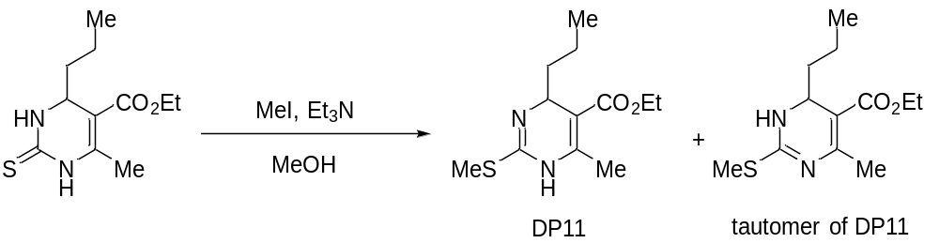
Scheme S2. Synthesis of DP11 and tautomer of DP11.

Ethyl 6-methyl-2-methylthio-4-propyl-1,4-dihydropyrimidine-5-carboxylate (DP11) and ethyl 4-methyl-2-methylthio-6-propyl-1,6-dihydropyrimidine-5-carboxylate (tautomer of DP11).
To a solution of ethyl 6-methyl-4-propyl-2-thioxo-1,2,3,4-tetrahydropyrimidine-5-carboxylate (485 mg, 2.00 mmol) and Et₃N (2.8 mL, 20.1 mmol) in anhydrous MeOH (8 mL) was added MeI (1.25 mL, 20.1 mmol) at 0 ºC, and the mixture was heated at 45 ºC for 2 h, and water (5 mL) was added. The organic materials were extracted with EtOAc (30 mL), and the combined organic extracts were washed with water and brine, dried over Na₂SO₄, and concentrated under reduced pressure. The residue was purified by silica gel column chromatography [n-hexane-EtOAc (6:1 to 3:1)] to give DP11 and tautomer of DP11 as an inseparable mixture (435 mg, 1.70 mmol, 85%) as a pale yellow oil. ¹H NMR of mixture of the tautomers (CD₃OD, 600 MHz): δ = 0.90 (t, J = 6.6 Hz, 3H), 1.27 (t, J = 7.2 Hz, 3H), 1.28–1.49 (m, 4H), 2.20 (s, 3H), 2.39 (s, 3H), 4.13 (dq, J = 10.8, 7.2 Hz, 1H), 4.16 (dq, J = 10.8, 7.2 Hz, 1H), 4.38–4.54 (brs, 1H). ¹³C NMR of mixture of the tautomers (CD₃OD, 150 MHz): δ = 13.7, 14.5, 14.7, 18.8, 19.2, 39.7, 54.8, 60.8, 102.4, 148.0–152.0 (br), 155.5–159.5 (br), 168.6. IR (neat): 3296, 2958, 2931, 1678, 1646, 1490, 1275, 1170, 1116, 1082 cm⁻¹.
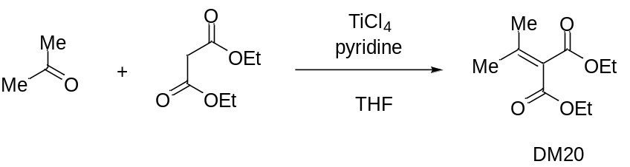
Scheme S3. Synthesis of DM20.

Diethyl 2-(propan-2-ylidene)malonate (DM20)
A solution of diethyl malonate (4.80 g, 30.0 mmol), acetone (4.4 mL, 59.8 mmol), and pyridine (9.50 g, 120 mmol) in dry THF (40 mL) was added to an ice-cooled solution of TiCl₄ (4.4 mL, 30.0 mmol) in dry THF (25 mL). The reaction mixture was stirred at room temperature for 17 h, and EtOAc (40 mL) and aqueous 2M HCl solution (40 mL) were added. The organic layer was separated, and the aqueous layer was extracted with EtOAc (40 mL). The combined organic layer and extracts were washed with water, brine, dried over MgSO₄, and concentrated under reduced pressure. The residue was purified by flash column chromatography [n-hexane-EtOAc (30:1)] to give DM20 (2.30 g, 11.5 mmol, 38%) as a colorless oil. ¹H NMR (CDCl₃, 600 MHz): δ = 1.29 (t, J = 7.2 Hz, 6H), 2.07 (s, 6H), 4.24 (q, J = 7.2 Hz, 4H). ¹³C NMR (CDCl₃, 150 MHz): δ = 14.0, 22.9, 60.7, 124.7, 154.8, 165.5. IR (neat): 2983, 1723, 1640, 1244, 1210, 1107, 1059 cm⁻¹. HRMS-EI: m/z [M]⁺ calcd for C₁₀H₁₆O₄: 200.1049; found: 200.1059.
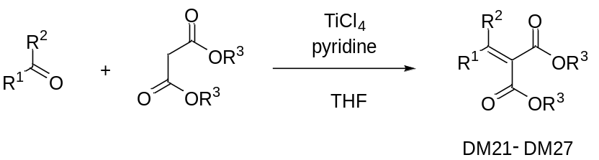
Scheme S4. Synthesis of dialkyl 2-(gem-disubstituted)methylene malonates DM21–DM27.

Dialkyl 2-(gem-disubstituted)methylene malonates (DM21–DM27)
The compounds DM21–DM27, were all assembled under the conditions similar to those described for the synthesis of DM20, and below recorded are their isolated yield and their physicochemical and spectral data.
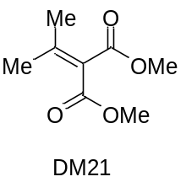
Dimethyl 2-(propan-2-ylidene)malonate (DM21)
Colorless oil. Yield: 38%. ¹H NMR (CDCl₃, 600 MHz): δ = 2.07 (s, 6H), 3.77 (s, 6H). ¹³C NMR (CDCl₃, 150 MHz): δ = 23.1, 52.0, 124.0, 155.8, 166.0. IR (neat): 2954, 1726, 1641, 1436, 1298, 1243, 1214, 1109, 1063 cm⁻¹. HRMS-EI: m/z [M]⁺ calcd for C₈H₁₂O₄: 172.0736; found: 172.0739.
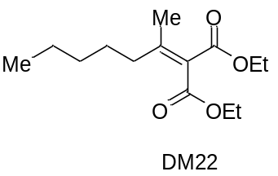
Diethyl 2-(heptan-2-ylidene)malonate (DM22)
Colorless oil. Yield: 42%. ¹H NMR (CDCl₃, 600 MHz): δ = 0.89 (t, J = 7.2 Hz, 3H), 1.287 (t, J = 7.2 Hz, 3H), 1.294 (t, J = 7.2 Hz, 3H), 1.27–1.36 (m, 4H), 1.46–1.55 (m, 2H), 2.07 (s, 3H), 2.33 (t, J = 7.8 Hz, 2H), 4.22 (q, J = 7.2 Hz, 2H), 4.24 (q, J = 7.2 Hz, 2H). ¹³C NMR (CDCl₃, 150 MHz): δ = 13.9, 14.0 (unresolved), 20.7, 22.4, 27.5, 31.8, 36.7, 60.7, 60.8, 124.4, 158.9, 165.5, 165.8. The unresolved signal, δ 14.0, was further analyzed by HSQC experiment, which revealed that the signal was due to two carbons of OCH₂CH₃ moieties because of its correlation to the signals at δ_{H} 1.287 and δ_{H} 1.294. IR (neat): 2958, 2931, 1723, 1635, 1241, 1213, 1123, 1058 cm⁻¹. HRMS-EI: m/z [M]⁺ calcd for C₁₄H₂₄O₄: 256.1675; found: 256.1686.
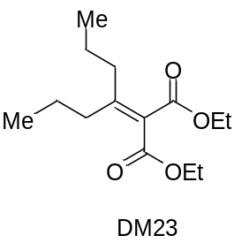
Diethyl 2-(heptan-4-ylidene)malonate (DM23)
Colorless oil. Yield: 41%. ¹H NMR (CDCl₃, 600 MHz): δ = 0.96 (t, J = 7.2 Hz, 6H), 1.29 (t, J = 7.2 Hz, 6H), 1.52 (tq, J = 7.2, 7.2 Hz, 4H), 2.33 (t, J = 7.2 Hz, 4H), 4.23 (q, J = 7.2 Hz, 4H). ¹³C NMR (CDCl₃, 150 MHz): δ = 14.0, 14.3, 21.7, 36.2, 60.7, 124.6, 162.5, 165.7. IR (neat): 2964, 2874, 1723, 1628, 1251, 1214, 1125, 1061 cm⁻¹. HRMS-EI: m/z [M]⁺ calcd for C₁₄H₂₄O₄: 256.1675; found: 256.1683.
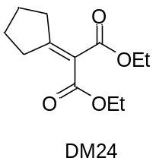
Diethyl 2-cyclopentylidenemalonate (DM24)
Colorless oil. Yield: 47%. ¹H NMR (CDCl₃, 600 MHz): δ = 1.30 (t, J = 7.2 Hz, 6H), 1.71–1.75 (m, 4H), 2.66–2.70 (m, 4H), 4.24 (q, J = 7.2 Hz, 4H). ¹³C NMR (CDCl₃, 150 MHz): δ = 14.1, 25.9, 34.3, 60.7, 120.5, 165.5, 169.2. IR (neat): 2964, 1720, 1641, 1296, 1236, 1059, 1038 cm⁻¹. HRMS-EI: m/z [M]⁺ calcd for C₁₂H₁₈O₄: 226.1205; found: 226.1210.
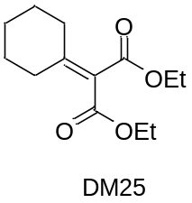
Diethyl 2-cyclohexylidenemalonate (DM25)
Colorless oil. Yield: 28%. ¹H NMR (CDCl₃, 600 MHz): δ = 1.29 (t, J = 7.2 Hz, 6H), 1.58–1.63 (m, 2H), 1.67–1.73 (m, 4H), 2.50–2.54 (m, 4H), 4.23 (q, J = 7.2 Hz, 4H). ¹³C NMR (CDCl₃, 150 MHz): δ = 14.0, 26.0, 28.1, 32.6, 60.8, 121.8, 161.6, 165.7. IR (neat): 2935, 2859, 1721, 1633, 1275, 1241, 1204, 1053 cm⁻¹. HRMS-EI: m/z [M]⁺ calcd for C₁₃H₂₀O₄: 240.1362; found: 240.1368.
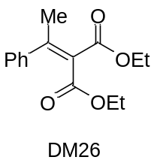
Ethyl 2-(1-phenylpropylidene)malonate (DM26)
Colorless crystals. Yield: 26%. Mp 37–38 ºC (n-hexane). ¹H NMR (CDCl₃, 600 MHz): δ = 0.93 (t, J = 7.2 Hz, 3H), 1.02 (t, J = 7.2 Hz, 3H), 1.32 (t, J = 7.2 Hz, 3H), 2.78 (q, J = 7.2 Hz, 2H), 3.94 (q, J = 7.2 Hz, 2H), 4.29 (q, J = 7.2 Hz, 2H), 7.20 (dd, J = 7.8, 1.8 Hz, 2H), 7.29–7.37 (m, 3H). ¹³C NMR (CDCl₃, 150 MHz): δ = 12.2, 13.5, 14.1, 29.3, 60.8, 61.1, 125.7, 127.1, 128.1, 128.2, 139.9, 160.9, 164.7, 166.0. IR (KBr): 2981, 1718, 1616, 1319, 1268, 1224, 1110, 1068, 706 cm⁻¹.
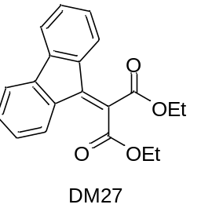
Ethyl 2-(9H-fluoren-9-ylidene)malonate (DM27)
Yellow crystals. Yield: 65%. Mp 49–50 ºC (n-hexane). ¹H NMR (CDCl₃, 600 MHz): δ = 1.39 (t, J = 7.2 Hz, 6H), 4.44 (q, J = 7.2 Hz, 4H), 7.21 (t, J = 7.8 Hz, 2H), 7.37 (t, J = 7.8 Hz, 2H), 7.60 (d, J = 7.8 Hz, 2H), 7.81 (d, J = 7.8 Hz, 2H). ¹³C NMR (CDCl₃, 150 MHz): δ = 13.9, 62.0, 119.6, 123.0, 126.0, 127.6, 130.9, 135.6, 141.7, 144.0, 165.4. IR (KBr): 2984, 1716, 1595, 1450, 1257, 1242, 1230, 1215, 1151, 1074, 726 cm⁻¹. HRMS-EI: m/z [M]⁺ calcd for C₂₀H₁₈O₄: 322.1205; found: 322.1198.
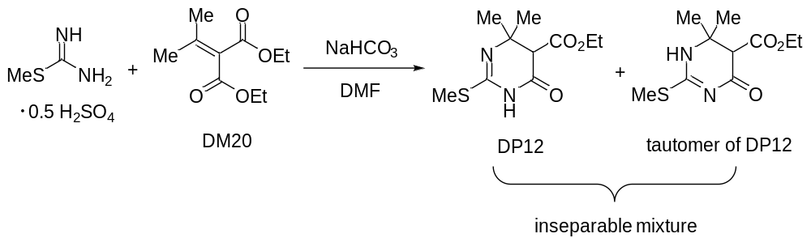
Scheme S5. Synthesis of DP12 and tautomer of DP12.

Ethyl 4,4-dimethyl-2-methylthio-6-oxo-1,4,5,6-tetrahydropyrimidine-5-carboxylate (DP12) and ethyl 6,6-dimethyl-2-methylthio-4-oxo-1,4,5,6-tetrahydropyrimidine-5-carboxylate (tautomer of DP12)
A mixture of 20a (100 mg, 0.499 mmol) and S-methylisothiourea hemisulfate salt (105 mg, 0.754 mmol), and NaHCO₃ (168 mg, 2.00 mmol) in dry DMF (1.0 mL) was heated at 65 ºC for 12 h under Ar. To the reaction mixture was added EtOAc (20 mL) followed by water (5 mL), and the organic layer was separated. The aqueous layer was extracted with EtOAc (10 mL), and the combined organic layer and extracts were washed with brine, dried over Na₂SO₄, and concentrated under reduced pressure. The residue was purified by flash column chromatography [n-hexane-EtOAc (6:1 to 1.5:1)] to give DP12 and tautomer of DP12 as an inseparable mixture (105 mg, 0.430 mmol, 86%) in a ratio of 2.5:1.0 in DMSO-d₆. Structural assignments of each tautomer were not made. Colorless oil. ¹H NMR of the major component (DMSO-d₆, 600 MHz): δ = 1.16 (s, 3H), 1.17 (t, J = 7.2 Hz, 3H), 1.18 (s, 3H), 3.36 (s, 1H), 4.10 (q, J = 7.2 Hz, 2H), 11.00 (s, 1H). ¹H NMR of the minor component (DMSO-d₆, 600 MHz): δ = 1.17 (t, J = 7.2 Hz, 3H), 1.19 (s, 3H), 1.22 (s, 3H), 3.37 (s, 1H), 4.08 (q, J = 7.2 Hz, 2H), 9.44 (s, 1H). ¹³C NMR of mixture of the tautomers (DMSO-d₆, 150 MHz): δ = 12.6, 12.8, 14.25, 14.26, 23.1, 25.5, 26.8, 28.3, 54.7, 56.7, 57.3, 57.5, 60.8, 61.0, 150.8, 166.1, 167.7, 167.8, 170.6, 170.9. IR (neat): 3216, 2979, 2932, 1737, 1712, 1632, 1498, 1341, 1309, 1183, 1129 cm⁻¹. HRMS-EI: m/z [M]⁺ calcd for C₁₀H₁₆N₂O₃S: 244.0882; found: 244.0873.
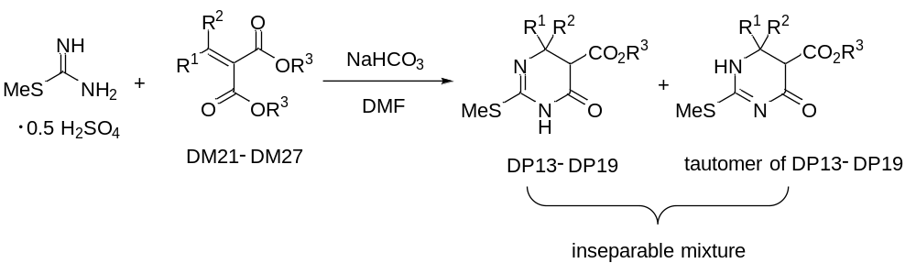
Scheme S6. Synthesis of DP13–DP19 and tautomer of DP13–DP19.

Alkyl 6-oxo-4,4-disubstituted-1,4,5,6-tetrahydropyrimidine-5-carboxylates (DP13–DP19) and alkyl 4-oxo-6,6-disubstituted-1,4,5,6-tetrahydropyrimidine-5-carboxylates (tautomer of DP13–DP19)
The inseparable mixture of DP13–DP19 and tautomer of DP13–DP19, was all assembled under the conditions similar to those described for the synthesis of DP12, and below recorded are their isolated yield and their physicochemical and spectral data. Structural assignments of each tautomer were not made.
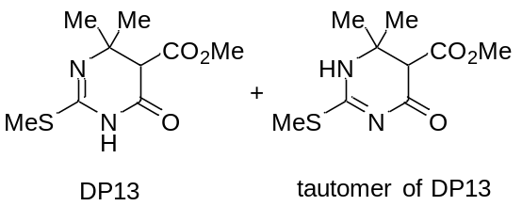
Methyl 4,4-dimethyl-2-methylthio-6-oxo-1,4,5,6-tetrahydropyrimidine-5-carboxylate (DP13) and methyl 6,6-dimethyl-2-methylthio-4-oxo-1,4,5,6-tetrahydropyrimidine-5-carboxylate (tautomer of DP13)
The inseparable mixture of the tautomers was obtained as colorless crystals in 87% yield in a ratio of 6.0:1.0 in CDCl₃. Mp 129–130 ºC (n-hexane-EtOAc). ¹H NMR of the major component (CDCl₃, 600 MHz): δ = 1.29 (s, 3H), 1.33 (s, 3H), 2.42 (s, 3H), 3.75 (s, 1H), 7.94 (s, 1H). ¹H NMR of the minor component (CDCl₃, 600 MHz): δ = 1.36 (s, 3H), 1.42 (s, 3H), 2.54 (s, 3H), 3.75 (s, 1H), 6.05 (s, 1H). ¹³C NMR of mixture of the tautomers (CDCl₃, 150 MHz): δ = 13.0, 13.3, 23.4, 25.3, 27.1, 28.3, 52.2, 52.3, 54.9, 56.9, 57.1, 57.9, 149.7, 166.7, 167.7, 171.2, 172.0. Two signals were unresolved in the region of 149.7–172.0 ppm. IR (KBr): 3198, 3110, 2978, 2934, 1751, 1692, 1636, 1467, 1374, 1269, 1172, 1133 cm⁻¹. HRMS-EI: m/z [M]⁺ calcd for C₉H₁₄N₂O₃S: 230.0725; found: 230.0727.
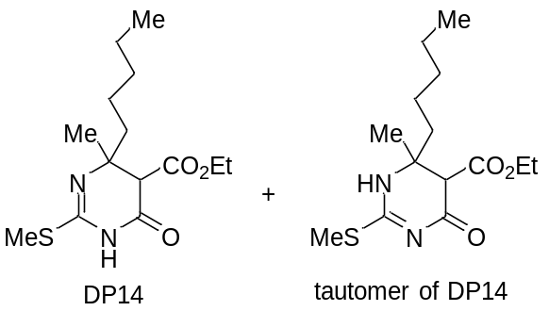
Ethyl 4-methyl-2-methylthio-6-oxo-4-pentyl-1,4,5,6-tetrahydropyrimidine-5-carboxylate (DP14) and ethyl 6-methyl-2-methylthio-4-oxo-6-pentyl-1,4,5,6-tetrahydropyrimidine-5-carboxylate (tautomer of DP14)
The inseparable mixture of the tautomers was obtained as colorless crystals in 71% yield in a ratio of 2.4:1.0 in DMSO-d₆. Mp 65–66 ºC (n-hexane). ¹H NMR of the major component (DMSO-d₆, 600 MHz): δ = 0.861 (t, J = 7.2 Hz, 3H), 1.12–1.52 (m, 14H), 2.29 (s, 3H), 3.42 (s, 1H), 4.06–4.18 (m, 2H), 10.96 (s, 1H). ¹H NMR of the minor component (DMSO-d₆, 600 MHz): δ = 0.855 (t, J = 7.2 Hz, 3H), 1.12–1.52 (m, 14H), 2.38 (s, 3H), 3.36 (s, 1H), 4.06–4.18 (m, 2H), 9.38 (s, 1H). ¹³C NMR of mixture of the tautomers (DMSO-d₆, 150 MHz): δ = 12.6, 12.8, 13.96, 13.99, 14.2, 21.4, 22.07, 22.12, 22.58, 22.64, 22.9, 31.5, 31.7, 38.8, 40.9, 55.1, 55.6, 57.1, 59.8, 60.7, 60.8, 150.5, 166.2, 167.5, 167.8, 170.6, 171.1. Two signals were unresolved in the region of 12.6–14.2 ppm. IR (KBr): 3194, 3093, 2933, 1749, 1690, 1636, 1473, 1376, 1173, 1129 cm⁻¹. HRMS-EI: m/z [M]⁺ calcd for C₁₄H₂₄N₂O₃S: 300.1508; found: 300.1515.
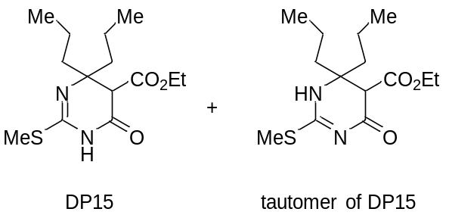
Ethyl 2-methylthio-6-oxo-4,4-dipropyl-1,4,5,6-tetrahydropyrimidine-5-carboxylate (DP15) and ethyl 2-methylthio-4-oxo-6,6-dipropyl-1,4,5,6-tetrahydropyrimidine-5-carboxylate (tautomer of DP15)
The inseparable mixture of the tautomers was obtained as a colorless oil in 32% yield in a ratio of 2.5:1.0 in DMSO-d₆. ¹H NMR of the major component (DMSO-d₆, 600 MHz): δ = 0.826 (t, J = 7.2 Hz, 6H), 1.16 (t, J = 7.2 Hz, 3H), 1.18–1.65 (m, 8H), 2.27 (s, 3H), 3.38 (s, 1H), 4.01–4.16 (m, 2H), 10.94 (s, 1H). ¹H NMR of the minor component (DMSO-d₆, 600 MHz): δ = 0.828 (t, J = 7.2 Hz, 6H), 1.16 (t, J = 7.2 Hz, 3H), 1.18–1.65 (m, 8H), 2.35 (s, 3H), 3.35 (s, 1H), 4.01–4.16 (m, 2H), 9.31 (s, 1H). ¹³C NMR of mixture of the tautomers (DMSO-d₆, 150 MHz): δ = 12.5, 12.8, 14.15, 14.18, 14.3, 14.5, 14.6, 14.7, 16.26, 16.31, 16.5, 16.6, 36.4, 37.9, 39.2, 40.0, 54.5, 54.9, 59.7, 60.7, 60.9, 62.5, 150.0, 166.2, 167.4, 167.6, 170.6, 171.0. IR (neat): 3207, 2960, 2933, 2873, 1737, 1704, 1634, 1496, 1466, 1305, 1177 cm⁻¹. HRMS-EI: m/z [M]⁺ calcd for C₁₄H₂₄N₂O₃S: 300.1508; found: 300.1509.
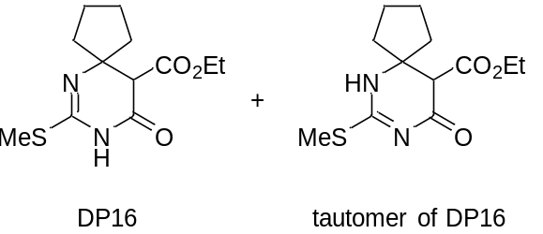
Ethyl 7-methylthio-9-oxo-6,8-diazaspiro[4.5]undec-6-ene-10-carboxylate (DP16) and ethyl 7-methylthio-9-oxo-6,8-diazaspiro[4.5]undec-7-ene-10-carboxylate (tautomer of DP16)
The inseparable mixture of the tautomers was obtained as a colorless oil in 82% yield in a ratio of 3.9:1.0 in DMSO-d₆. ¹H NMR of the major component (DMSO-d₆, 600 MHz): δ = 1.16 (t, J = 7.2 Hz, 3H), 1.48–1.90 (m, 8H), 2.27 (s, 3H), 3.32 (s, 1H), 4.03–4.13 (m, 2H), 10.94 (s, 1H). ¹H NMR of the minor component (DMSO-d₆, 600 MHz): δ = 1.16 (t, J = 7.2 Hz, 3H), 1.48–1.90 (m, 8H), 2.37 (s, 3H), 3.33 (s, 1H), 4.03–4.13 (m, 2H), 9.47 (s, 1H). ¹³C NMR of mixture of the tautomers (DMSO-d₆, 150 MHz): δ = 12.5, 12.8, 14.10, 14.14, 23.18, 23.21, 23.4, 33.8, 36.6, 38.6, 39.3, 54.8, 55.2, 60.7, 61.0, 64.5, 67.7, 150.8, 166.0, 167.4, 167.6, 170.2, 171.2. Two signals were unresolved in the region of 23.18–23.4 ppm. IR (neat): 3196, 3101, 2954, 1731, 1698, 1630, 1467, 1354, 1302, 1178, 1133 cm⁻¹. HRMS-EI: m/z [M]⁺ calcd for C₁₂H₁₈N₂O₃S: 270.1038; found: 270.1042.
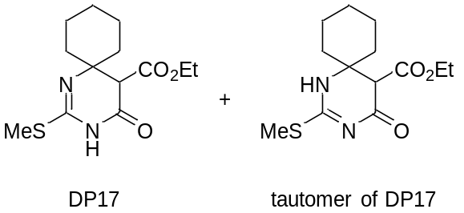
Ethyl 2-methylthio-4-oxo-1,3-diazaspiro[5.5]undec-1-ene-5-carboxylate (DP17) and ethyl 2-methylthio-4-oxo-1,3-diazaspiro[5.5]undec-2-ene-5-carboxylate (tautomer of DP17)
The inseparable mixture of the tautomers was obtained as colorless crystals in 85% yield in a ratio of 5.5:1.0 in DMSO-d₆. Mp 92–93 ºC (n-hexane-EtOAc). ¹H NMR of the major component (DMSO-d₆, 600 MHz): δ = 1.15 (t, J = 7.2 Hz, 3H), 1.17–1.82 (m, 10H), 2.31 (s, 3H), 3.27 (s, 1H), 4.072 (q, J = 7.2 Hz, 2H), 11.00 (s, 1H). ¹H NMR of the minor component (DMSO-d₆, 600 MHz): δ = 1.15 (t, J = 7.2 Hz, 3H), 1.17–1.82 (m, 10H), 2.36 (s, 3H), 3.33 (s, 1H), 4.067 (q, J = 7.2 Hz, 2H), 9.25 (s, 1H). ¹³C NMR of mixture of the tautomers (DMSO-d₆, 150 MHz): δ = 12.5, 12.9, 14.2, 20.8, 21.0, 21.3, 21.6, 24.7, 25.3, 31.8, 34.3, 34.6, 36.0, 55.4, 56.6, 56.7, 59.2, 60.8, 61.0, 149.8, 165.8, 167.2, 167.4, 170.0, 171.6. Two signals were unresolved in the region of 12.5–14.2 ppm. IR (KBr): 2933, 1748, 1687, 1641, 1460, 1374, 1131 cm⁻¹. HRMS-EI: m/z [M]⁺ calcd for C₁₃H₂₀N₂O₃S: 284.1194; found: 284.1191.
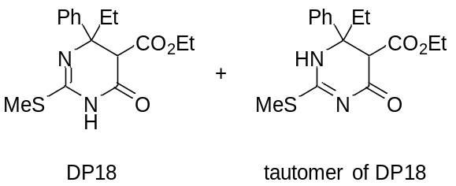
Ethyl 4-ethyl-2-methylthio-6-oxo-4-phenyl-1,4,5,6-tetrahydropyrimidine-5-carboxylate (DP18) and ethyl 6-ethyl-2-methylthio-4-oxo-6-phenyl-1,4,5,6-tetrahydropyrimidine-5-carboxylate (tautomer of DP18)
The inseparable mixture of the tautomers was obtained as colorless crystals in 22% yield in a ratio of 1.5:1.0 in CDCl₃. Mp 137–140 ºC (n-hexane-EtOAc). ¹H NMR of the major component (CDCl₃, 600 MHz): δ = 0.70 (t, J = 7.2 Hz, 3H), 0.77 (t, J = 7.2 Hz, 3H), 1.85–2.01 (m, 2H), 2.60 (s, 3H), 3.65 (dq, J = 10.8, 7.2 Hz, 1H), 3.70 (dq, J = 10.8, 7.2 Hz, 1H), 3.72 (s, 1H), 7.21–7.90 (m, 6H). ¹H NMR of the minor component (CDCl₃, 600 MHz): δ = 0.75 (t, J = 7.2 Hz, 3H), 1.26 (t, J = 7.2 Hz, 3H), 2.11 (dq, J = 13.8, 7.2 Hz, 1H), 1.85–2.01 (m, 1H), 2.58 (s, 3H), 3.87 (s, 1H), 4.18 (dq, J = 10.8, 7.2 Hz, 1H), 4.22 (dq, J = 10.8, 7.2 Hz, 1H), 7.21–7.90 (m, 6H). ¹³C NMR of mixture of the tautomers (CDCl₃, 150 MHz): δ = 8.0, 8.3, 13.2, 13.3, 13.4, 14.0, 32.5, 33.9, 57.4, 58.4, 61.2, 61.6, 66.39, 66.41, 125.9, 126.8, 127.0, 127.2, 127.9, 128.4, 141.4, 141.5, 149.0, 151.2, 165.97, 166.03, 166.2, 166.8. IR (KBr): 3195, 3099, 2980, 2925, 1734, 1698, 1645, 1472, 1446, 1350, 1308, 1233, 1151, 1115, 757, 701 cm⁻¹. HRMS-EI: m/z [M]⁺ calcd for C₁₆H₂₀N₂O₃S: 320.1195; found: 320.1196.
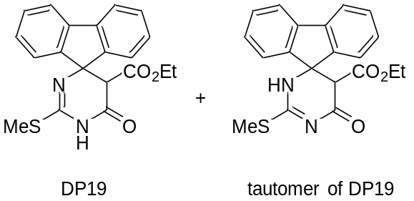
Ethyl 2-methylthio-6-oxo-5,6-dihydro-1H-spiro[fluorene-9’,4-pyrimidine]-5-carboxylate (DP19) and ethyl 2-methylthio-6-oxo-5,6-dihydro-3H-spiro[fluorene-9’,4-pyrimidine]-5-carboxylate (tautomer of DP19)
The inseparable mixture of the tautomers was obtained as colorless crystals in 11% yield in a ratio of 5.0:1.0 in CDCl₃. Mp 210–212 ºC (n-hexane-EtOAc). ¹H NMR of the major component (CDCl₃, 600 MHz): δ = 0.85 (t, J = 7.2 Hz, 3H), 2.37 (s, 3H), 3.82–3.90 (m, 2H), 7.22–7.48 (m, 6H), 7.66 (dd, J = 7.8, 3.0 Hz, 2H), 7.80 (s, 1H). ¹H NMR of the minor component (CDCl₃, 600 MHz): δ = 0.95 (t, J = 7.2 Hz, 3H), 2.65 (s, 3H), 3.91–3.99 (m, 2H), 6.15 (s, 1H), 7.22–7.48 (m, 6H), 7.52 (dd, J = 7.8, 4.2 Hz, 2H). ¹³C NMR of mixture of the major component (DMSO-d₆, 150 MHz): δ = 12.8, 13.4, 54.2, 60.2, 70.4, 120.2, 120.3, 124.0, 124.3, 128.0, 128.1, 128.95, 129.03, 139.5, 139.8, 145.9, 147.7, 155.5, 165.8. Two signals were unresolved in the region of 120.2–165.8 ppm. IR (KBr): 3177, 3082, 2908, 1754, 1700, 1617, 1352, 1159, 1128, 770, 743 cm⁻¹. HRMS-EI: m/z [M]⁺ calcd for C₂₀H₁₈O₃S: 366.1038; found: 366.1043.

References
1. Nishimura Y, Okamoto Y, Ikunaka M, Ohyama Y (2011) Synthetic studies on novel 1,4-dihydro-2-methylthio-4,4,6-trisubstituted pyrimidine-5-carboxylic acid esters and their tautomers. Chemical & pharmaceutical bulletin 59:1458–66. https://doi.org/10.1248/cpb.59.1458
2. Cho H, Nishimura Y, Ikeda H, et al (2018) Experimental and theoretical studies on thermodynamics and properties of tautomers of 2-substituted 6(4)-methyl-1,4(1,6)-dihydropyrimidine-5-carboxylates. Tetrahedron 74:2405–2413. https://doi.org/10.1016/J.TET.2018.03.032
3. Nishimura Y, Kikuchi H, Kubo T, et al (2020) Synthesis of 6-unsubstituted 2-oxo, 2-thioxo, and 2-amino-3,4-dihydropyrimidines and their antiproliferative effect on HL-60 cells. Tetrahedron Letters 61:151967. https://doi.org/10.1016/j.tetlet.2020.151967

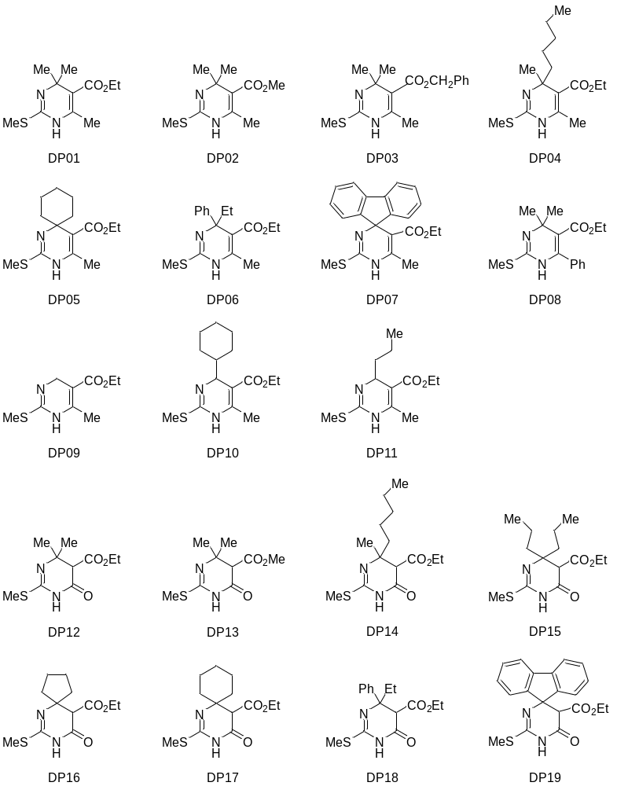
Supplementary Fig. 1 Structures of 19 types of novel 2-methylthio DPs.

Supplementary Fig. 2 Cell viability of 2-methylthio DPs in NB4 or HL-60 cells. Following 96 h treatment with various concentrations of 2-methylthio DPs against NB4 (A,C,E, and G) or HL-60 cells (B, D, F, and H), cell viability was determined by WST-8 (A-F) or XTT assay (G and H) as described in “Materials and Methods”. Cell viability was calculated as the ratio of the absorbance at 450 nm of each treatment group to that of the corresponding untreated control group. Data are shown as the mean ± SD from at least three independent experiments. Statistical analysis used one-way ANOVA followed by Dunnett's post hoc test. † p < 0.05, § p < 0.01 vs control.
Control
DP03
24 h
48 h
72 h
96 h
DNA content
Cell numbers

Supplementary Fig. 3 Alteration of cell cycle in DP03-treated NB4 cells at 24, 48, 72, and 96 h. Following treatment with 10 μM DP03 against NB4 cells, cell cycle profiling was performed by a FCM, CytoFLEX S as described in “Materials and Methods”. A representative FCM histogram from three separate experiments is shown.

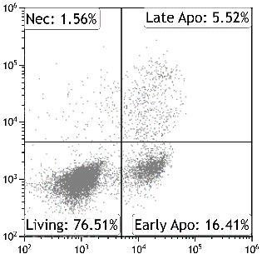
Control
DP03
Control
DP03
PI
10 μM SB 203580
1 μM LY 294002
5 μM Tyr AG 490
Vehcle
1 μM SP 600125
1 μM PD 98059

Annexin V-FITC

Supplementary Fig. 4 Inhibited apoptosis induction in NB4 cells treated with DP03 combined with the inhibitors, SP 600125, PD 98059, SB 203580, or LY 294002, respectively. Following treatment with 10 μM DP03 against NB4 cells in the presence or absence of 1 μM SP 600125, 1 μM PD 98059, 10 μM SB 203580, 1 μM LY 294002, or 5 μM Tyr AG 490, respectively, cells were stained with Annexin V-FITC and PI and analyzed by a FCM, CytoFLEX S as described in “Materials and Methods”. A representative FCM dot plot from three and more separate experiments is shown.

