Supplementary Figure 1. Flattened corrected interferograms of ascending orbit P131-F640. Master image was acquired on April 26, 2016.
Supplementary Figure S2. Flattened corrected interferograms of ascending orbit P130-F650. Master image was acquired on June 16, 2016.

Supplementary Figure S3. Flattened corrected interferograms of descending orbit P23-F2950-2960. Master is image acquired on April 18, 2016.

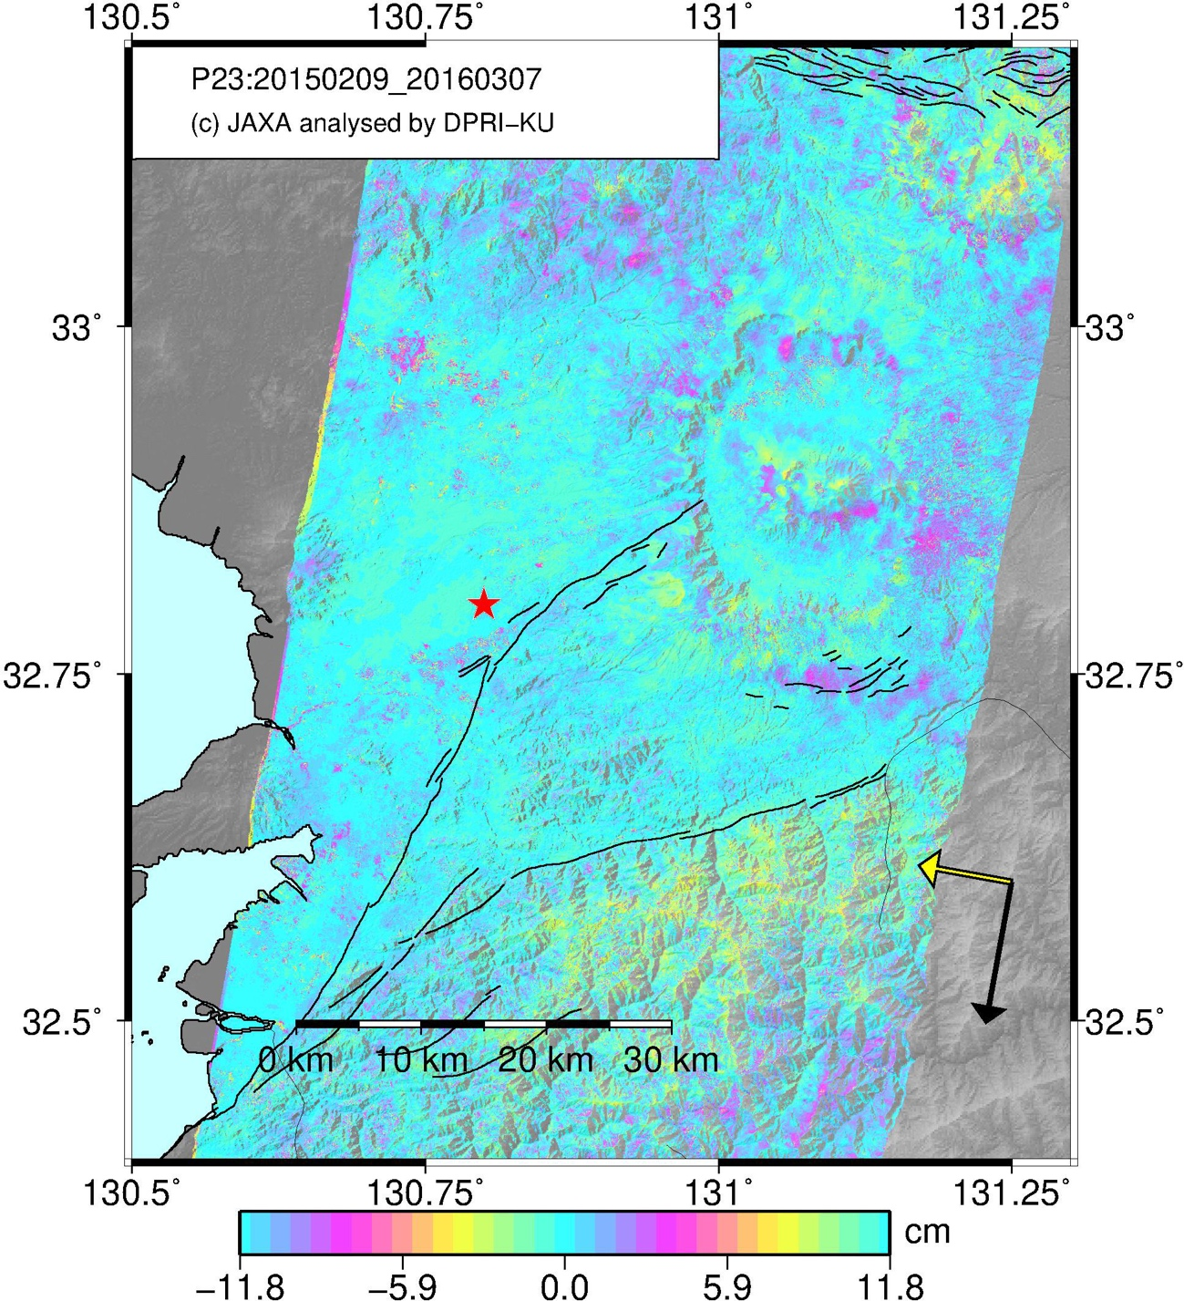
Figure S4. Interferogram of P23-F2950-2960 before the 2016 Kumamoto earthquake. Master: Feb. 9, 2015. Slave: Mar. 7, 2016.
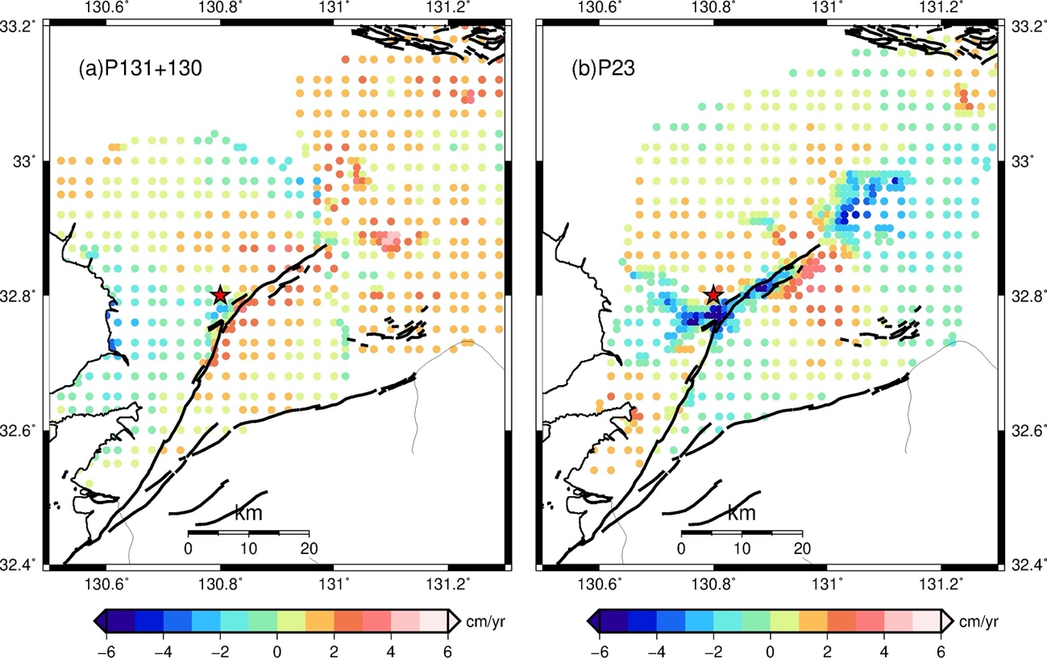
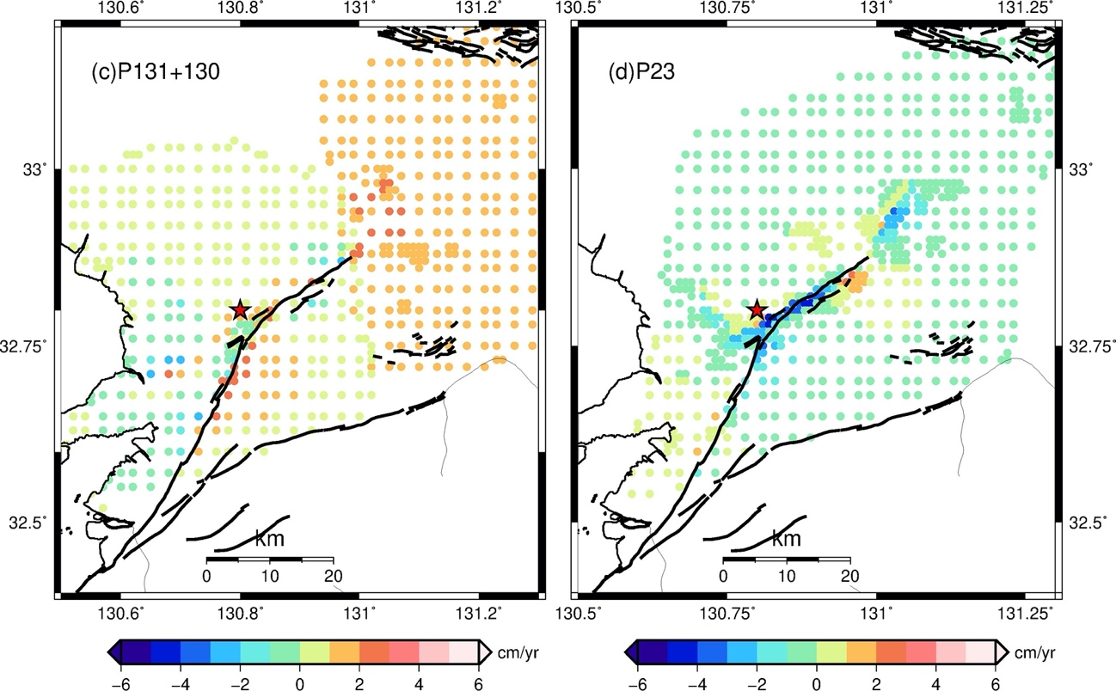
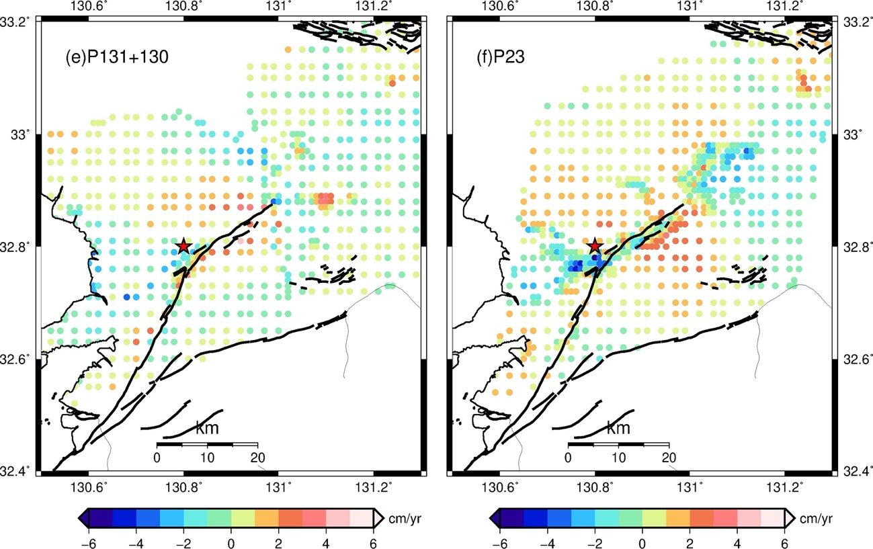
Supplementary Figure S5. Fitting of afterslip model. (a) Down-sampled interferograms of ascending orbit P131-F640 and P130-F650. (b) Down-sampled interferogram of descending orbit P23-F2950-2960. (c) Simulated rate of LOS changes of ascending orbit P131-F640 and P130-F650. (d) Simulated rate of LOS changes of descending orbit P23-F2950-2960. (e) Residuals for ascending orbits. (f) Residuals for descending orbit.

