Supplementary Figures and Legends
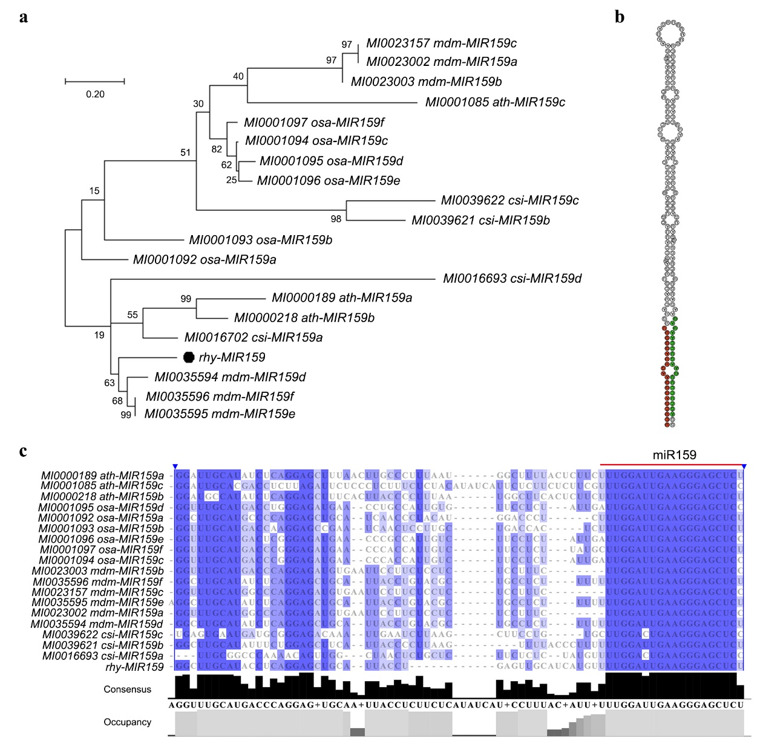
Supplementary Figure S1 Characterization of MIR159 in rose.
a, Phylogenetic analysis of rhy-MIR159 with other precursors of MIR159. The phylogenetic tree was constructed using MEGA software version X with the maximum likelihood algorithm. Bootstrap values indicate the confidence of each branch, and the scale indicates the branch length. b, The predicted secondary structure of rhy-MIR159.
c, Alignment analysis of miR159 precursor sequence. Red line indicates the sequence of mature miR159.

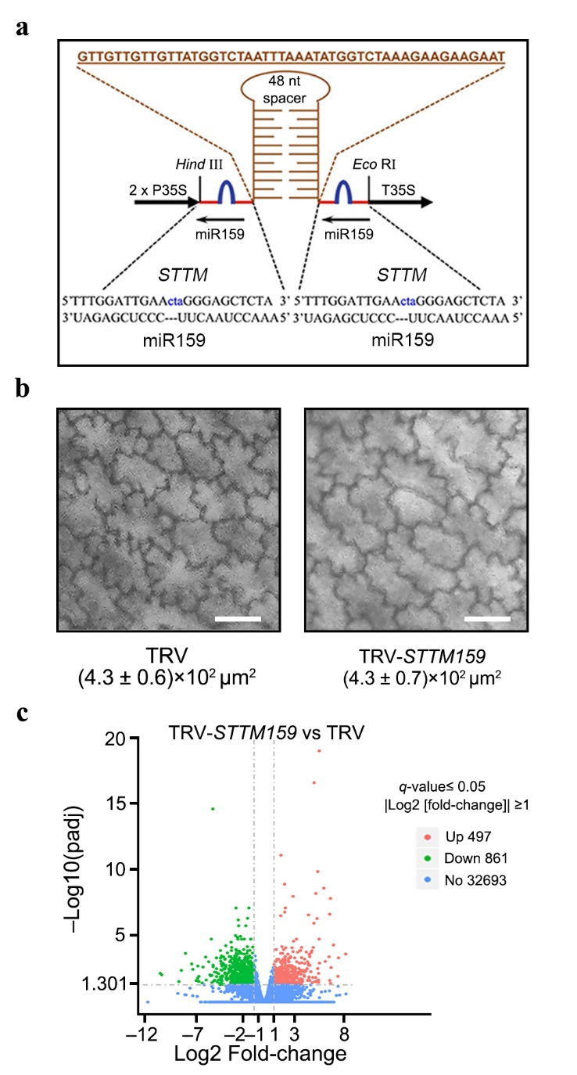
Supplementary Figure S2 Silencing of MIR159 in rose petals.
a, Schematic representation of STTM (Short tandem target mimic) structure of miR159 inserted into the TRV vector.
b, Cell size in miR159-silenced and TRV control petals at fully opened stage. The mean values ± SD from three biological replicates (n = 3) are shown. The numbers below (C) indicate the cell size (mean values ± SD). Scale bar, 20 μm.
c, Up- and down- regulated DEG number in comparison analysis between TRV-STTM159 and TRV petals, whose samples with three biological replicates (n = 3) were collected at 3 d after stage 0 for RNA sequencing.

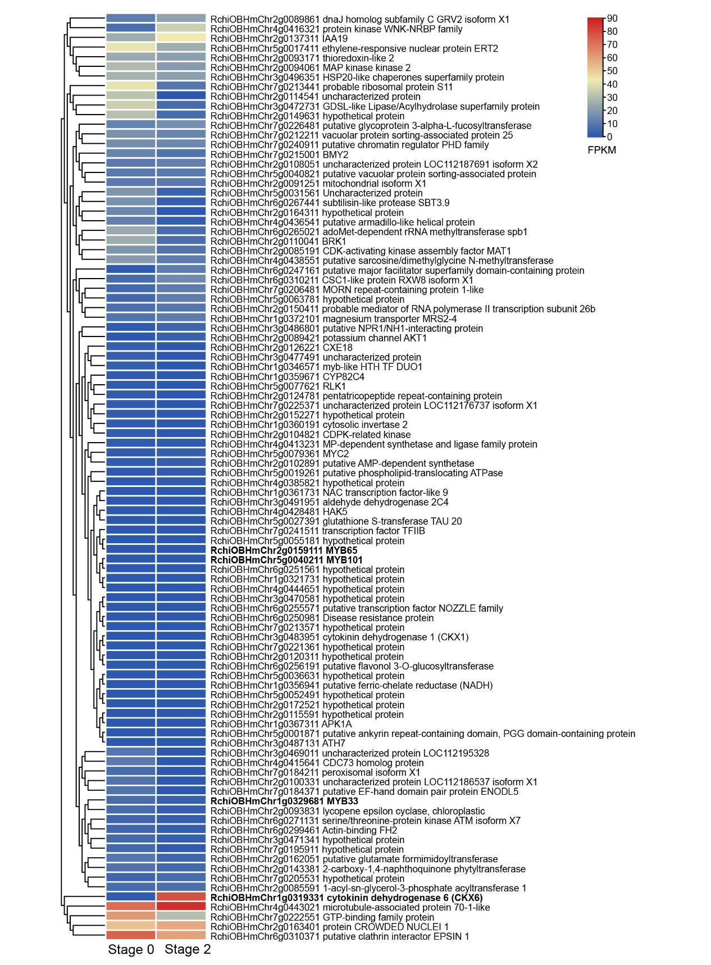
Supplementary Figure S3
The expression profiles of predicted miR159 targets in petals at Stage 0 and Stage 2.

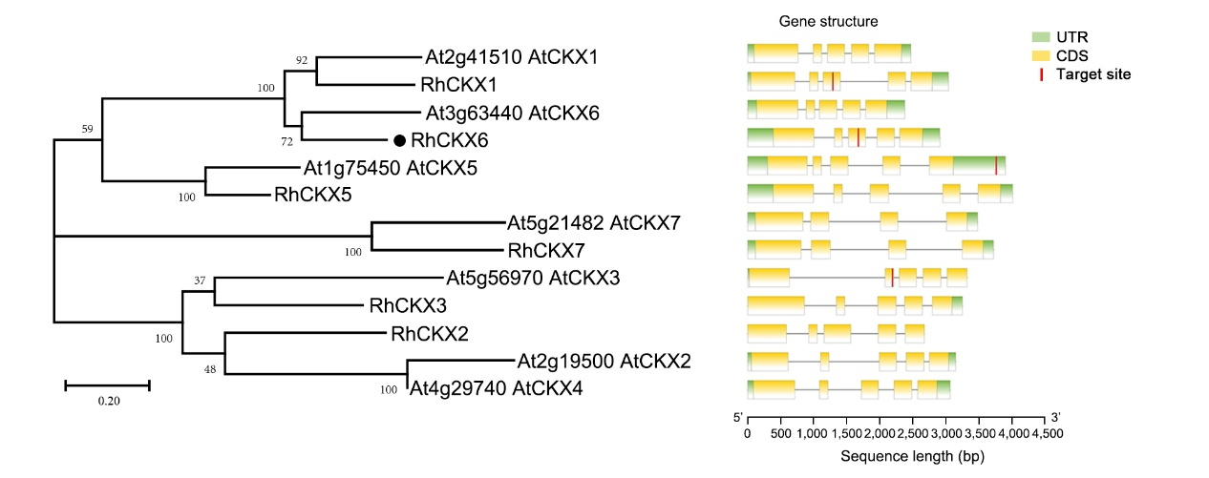Supplementary Figure S4 Prediction of miR159 target site in CKX transcripts.
Phylogenetic analysis of CKX proteins in rose and Arabidopsis (Left) using MEGA software version X with the maximum likelihood algorithm. Bootstrap values indicate the confidence of each branch, and the scale indicates branch length. Gene structure (Right) shows the predicted miR159 target site in CKX transcripts by using psRNATarget online tool (https://www.zhaolab.org/ psRNATarget/) and visualization analysis (TBtools software version 1.098). Scale bar below the gene structures represents the gene length.

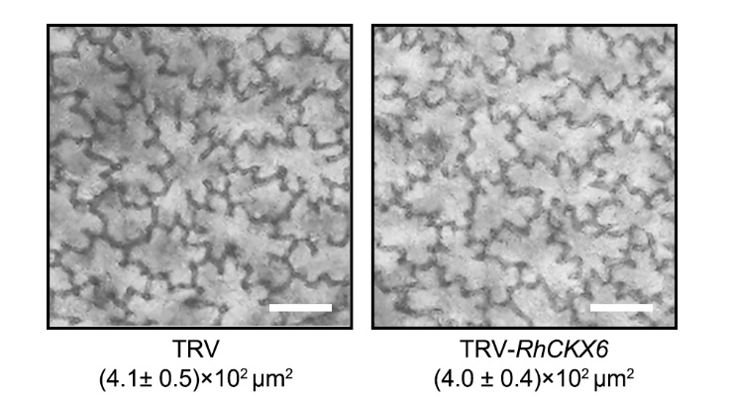
Supplementary Figure S5 Cell size of TRV and RhCKX6-silenced petals on fully expanded stage.
Cell size of RhCKX6-silenced and TRV control petals at fully opened stage. The mean values ± SD from three biological replicates (n = 3) are shown. The numbers below image indicate the cell size (mean values ± SD). Scale bar, 20 μm.

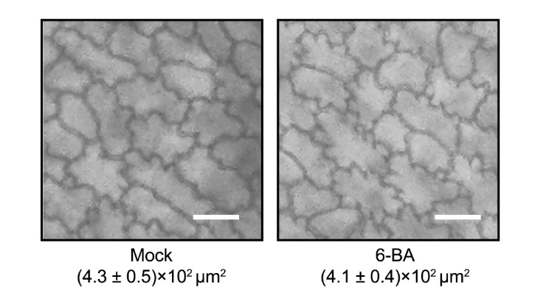
Supplementary Figure S6 Effect of 6-BA on cell size of rose petals on fully expanded stage.
Cell size of 6-BA treated and Mock petals at fully opened stage. The mean values ± SD from three biological replicates (n = 3) are shown. The numbers below image indicate the cell size (mean values ± SD). Scale bar, 20 μm.

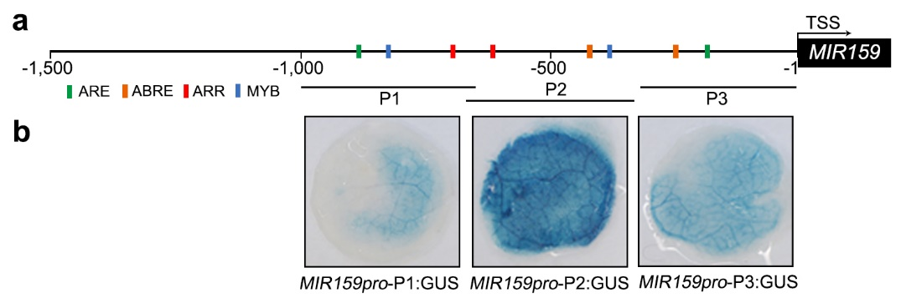
Supplementary Figure S7 Transactivation analysis of the promoter of MIR159.
a, Predicted cis-elements in the promoter of MIR159.
b, Transactivation analysis of truncated promoter fragments of MIR159.
MIR159 promoter (–1 to –1000 bp) was truncated into three short segments (P1, P2, P3), and were constructed into 35Smini:GUS vector and were infiltrated into rose petals. GUS staining was taken 3 days after infiltration of rose petals.

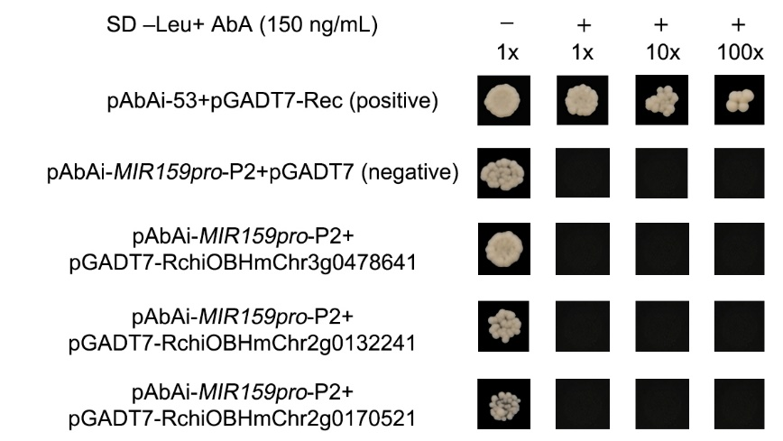
Supplementary Figure S8 Verification of the possible up-stream regulators. Y1H analysis between candidate proteins (RchiOBHmChr3g0478641, RchiOBHmChr2g0132241 and RchiOBHmChr2g0170521) with the MIR159 promoter.
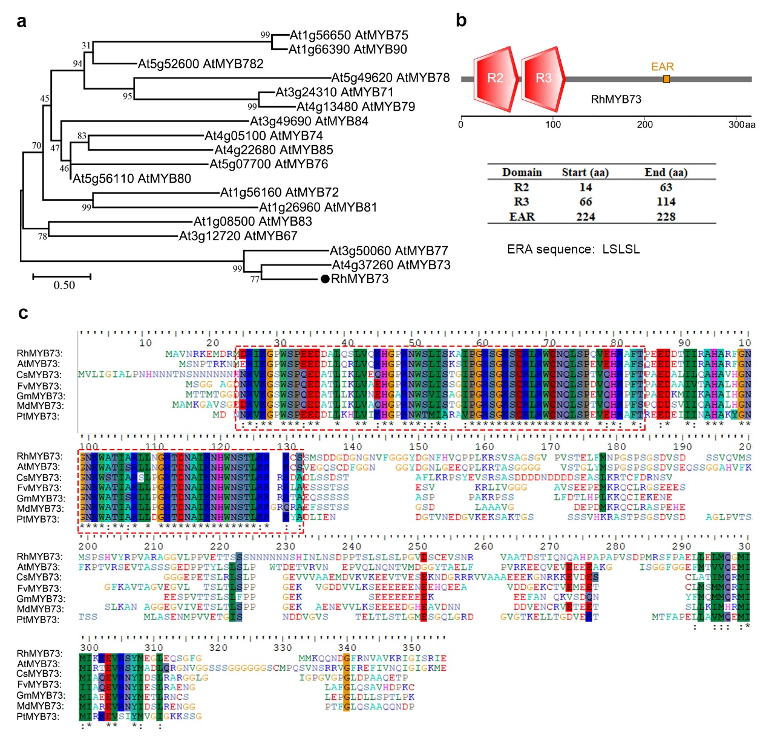
Supplementary Figure S9 Characterization of RhMYB73.
a, Phylogenetic analysis of RhMYB73. Bootstrap values indicate the confidence of each branch, and the scale indicates branch length. Black dot represents the RhMYB73.
b, Conserved domain analysis of RhMYB73 protein, including location of different domains (upper and middle) by using website prediction (http://smart.embl-heidelberg.de/). Scale bar represents the protein length. The bottom shows the EAR sequence: LSLSL.
c, Alignment of putative amino acid sequences of RhMYB73 protein with other 6 species: AtMYB73 (AT4G37260.1), A. thaliana; CsMYB73 (XP_004148201.1), Cucumis sativus; FvMYB73 (XM_011472328.1), Fragaria vesca; GmMYB73 (XP_006595859.1), Glycine max; MdMYB73 (XP_008374172.2), Malus domestica; PtMYB73 (XP_002313145.1), Populus trichocarpa. The conserved MYB domain was showed using dashed box, and the conserved degree of amino acid sites was aligned using BioEdit sequence alignment editor software. Amino acids that are similar in 100% of aligned sequences with same color background.

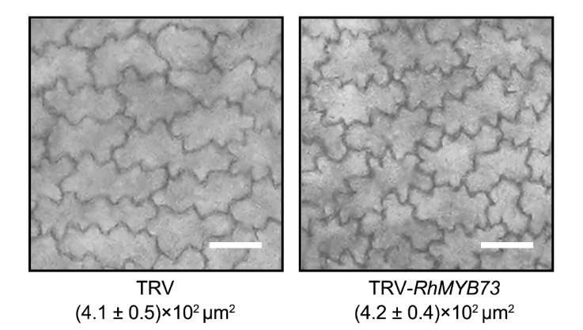
Supplementary Figure S10. Cell size in RhMYB73-silenced petals on fully expanded stage.
Cell size of RhMYB73-silenced and TRV control petals at fully opened stage. The mean values ± SD from three biological replicates (n = 3) are shown. The numbers below image indicate the cell size (mean values ± SD). Scale bar, 20μm.

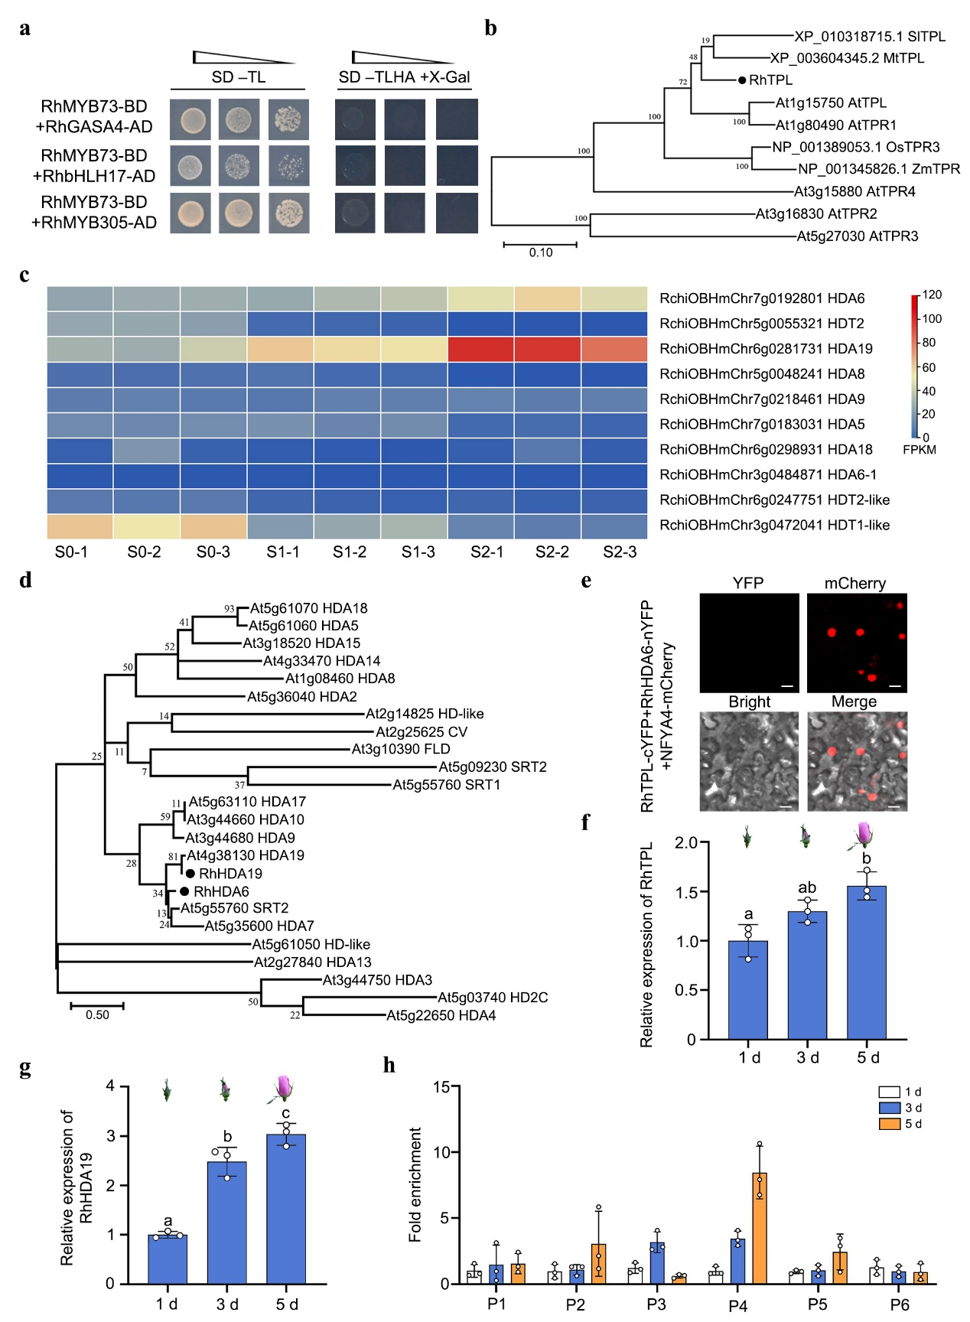
Supplementary Figure S11 Characterization of RhHDA19 and RhTPL.
a, Y2H assay for the possible interaction between RhMYB73 and candidate proteins from IP-MS. b, Phylogenetic tree analysis of RhTPL. Bootstrap values indicate the confidence of each branch, and the scale indicates branch length.
c, Expression profiles of predicted HDAC genes in petals during early development phase.
d, Phylogenetic tree analysis of RhHDA19 (d). Bootstrap values indicate the confidence of each branch, and the scale indicates branch length.
e, Bimolecular fluorescence complementation assay of interaction between RhTPL and RhHDA6. N. benthamiana leaves were co-infiltrated with RhTPL-cYFP and RhHDA6-nYFP constructs. The visual imaging was observed by confocal microscopy 3 d after infiltration. Scale, 20 μm. The experiment was performed independently three times, and representative results are shown.
f & g, Quantitative RT-PCR analysis of RhTPL (f) and RhHDA19 (g) in rose petals during early development phase (1 d, 3 d, 5 d after Stage 0). RhUBI2 was used as an internal control. The mean values ± SD are shown from three biological replicates (n = 3). Different letters above each bar in (f & g) indicate significant differences according to one-way ANOVA with Tukey’s multiple comparisons test (P < 0.05).
h, ChIP-quantitative PCR assay of the relative H3K14ac level in the MIR159 promoter in rose petals during early development phase (1 d, 3 d, 5 d after Stage 0). The experiment was performed independently twice with similar results, and one representative result is shown. The mean values ± SD are shown from three biological replicates (n = 3).

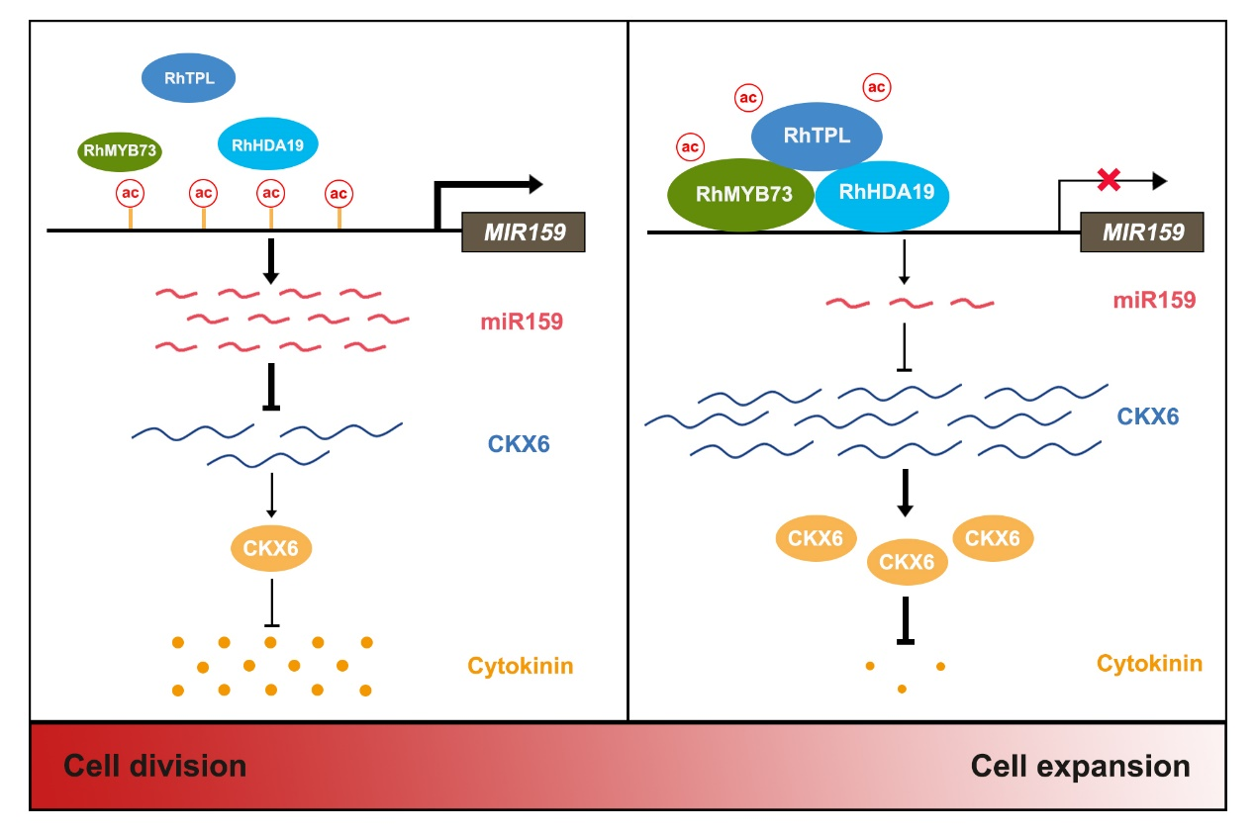
Supplementary Figure S12 Proposed model of MIR159-CKX6 module in governing onset of cell expansion via triggering rapid clearance of cytokinin in rose petals.
Stage 0, low level of MYB73 cannot recruit TPL-HDA19 complex to the promoter of MIR159, high level of miR159 leads to cleavage of CKX6 transcripts, and thus maintains high concentration of cytokinins, which promotes cell division. As petal development, increasing MYB73 recruits TPL-HDA19 complex to the promoter of MIR159, and thus suppresses expression of MIR159. Low level of miR159 releases accumulation of CKX6 transcripts and thus initiates the clearance of cytokinins, which results in cease of cell division and startup of cell expansion.

