Supplementary materials

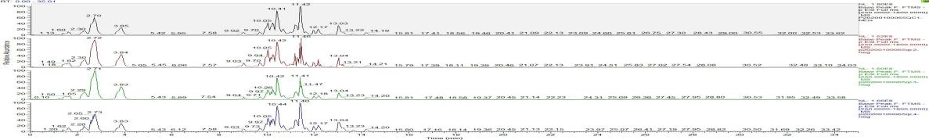
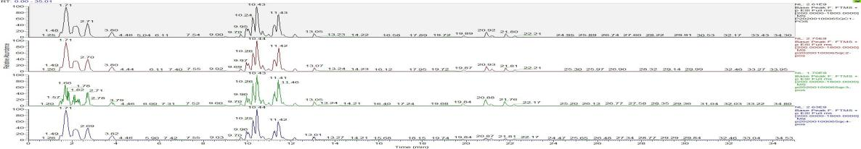
A
B

Fig.1. The base peak chromatogram of each QC sample in positive model (A) and negative model (B).

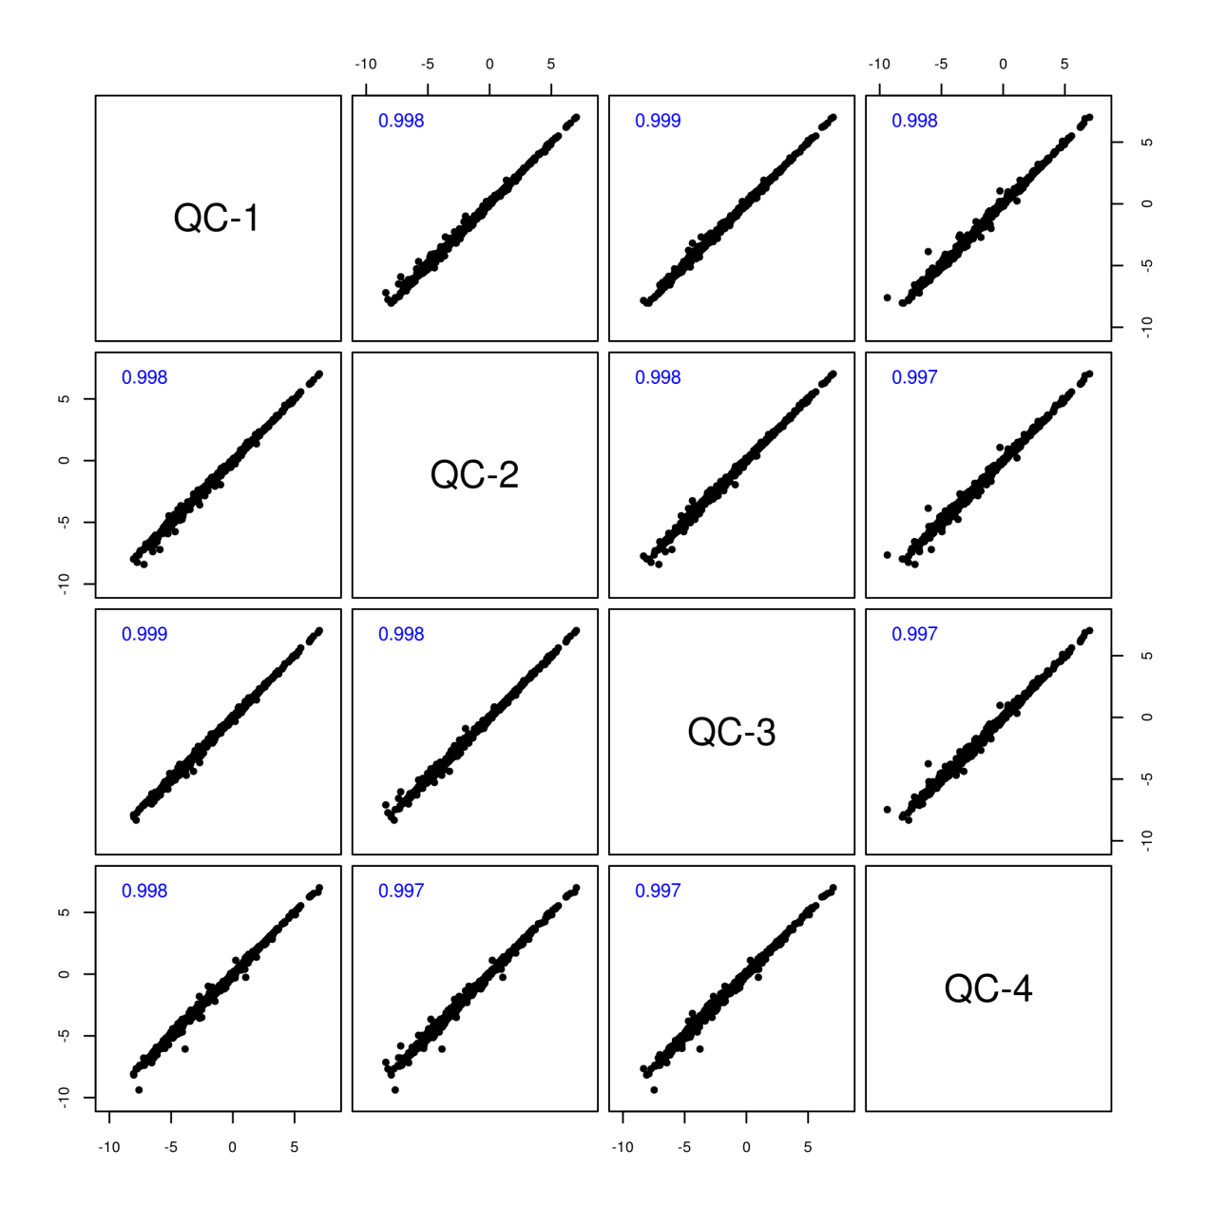

Fig. 2. The Pearson correlation analysis of the four QC samples based on the response intensity of the extracted peaks

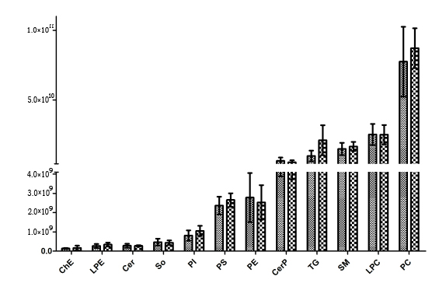
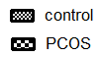
P=0.007

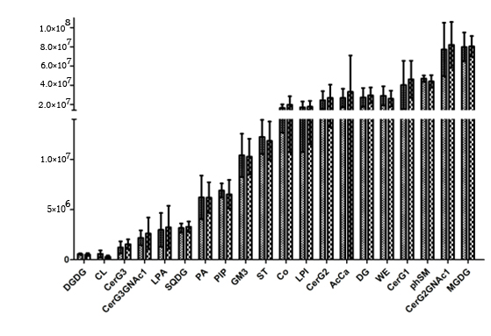

Fig. 3. Comparison of the lipid class of the PCOS group and the control group in follicular fluid

Table 1 The significantly differential lipids with VIP more than 1 and P < 0.05.
LipidIon | Class |  | IonFormula | CalMz | RT-(min) | Fold Change | P-value | VIP
PE(16:0/22:6)+H |  | PE | C43 H75 O8 N1 P1 | 764.522484 | 10.2352508 | 2.1364297 | 0.01170255 | 1.2827738
TG(16:0/14:0/18:1)+NH4 |  | TG | C51 H100 O6 N1 | 822.754516 | 20.7435549 | 2.82786013 | 0.00768395 | 1.04024184
TG(16:1/16:1/18:1)+NH4 |  | TG | C53 H100 O6 N1 | 846.754516 | 19.714067 | 2.85935032 | 0.00103754 | 2.07802736
TG(16:0/16:0/18:2)+NH4 |  | TG | C53 H102 O6 N1 | 848.770166 | 20.8812114 | 2.84645308 | 0.00753119 | 3.11342089
TG(16:0/16:0/18:1)+NH4 |  | TG | C53 H104 O6 N1 | 850.785816 | 21.7834094 | 2.9164798 | 0.00508461 | 3.14637718
TG(16:1/18:1/18:2)+NH4 |  | TG | C55 H102 O6 N1 | 872.770166 | 19.859873 | 2.51669633 | 0.00941933 | 4.83457578
TG(16:0/18:1/18:2)+NH4 |  | TG | C55 H104 O6 N1 | 874.785816 | 20.8954062 | 2.26683859 | 0.00796182 | 7.04217237
TG(16:0/18:1/18:2)+NH4 |  | TG | C55 H104 O6 N1 | 874.785816 | 19.8521076 | 2.42105627 | 0.00117044 | 1.21618584
TG(16:0/18:1/18:1)+NH4 |  | TG | C55 H106 O6 N1 | 876.801466 | 21.7866945 | 2.51369634 | 0.00910841 | 6.11421082
TG(18:0/16:0/18:1)+NH4 |  | TG | C55 H108 O6 N1 | 878.817116 | 22.584629 | 2.22068302 | 0.0275356 | 1.3333522
TG(18:1/18:2/18:3)+NH4 |  | TG | C57 H102 O6 N1 | 896.770166 | 19.4825832 | 2.55170831 | 0.00642044 | 1.03093598
TG(18:2/18:2/18:2)+NH4 |  | TG | C57 H102 O6 N1 | 896.770166 | 18.8771548 | 2.24487784 | 0.00535694 | 1.51541463
TG(16:0/18:1/20:4)+NH4 |  | TG | C57 H104 O6 N1 | 898.785816 | 20.5420673 | 2.42182935 | 0.00972723 | 1.68243907
TG(18:1/18:2/18:2)+NH4 |  | TG | C57 H104 O6 N1 | 898.785816 | 19.884727 | 2.00402129 | 0.00849049 | 2.6606902
TG(18:1/18:1/18:2)+NH4 |  | TG | C57 H106 O6 N1 | 900.801466 | 20.9160682 | 1.83056246 | 0.01101498 | 3.33870883
TG(18:0/18:1/18:2)+NH4 |  | TG | C57 H108 O6 N1 | 902.817116 | 20.8947311 | 1.52937154 | 0.03751919 | 1.62092888
TG(18:0/18:1/18:2)+NH4 |  | TG | C57 H108 O6 N1 | 902.817116 | 21.8017114 | 2.30938518 | 0.01129426 | 3.83179623
TG(16:0/18:1/20:1)+NH4 |  | TG | C57 H110 O6 N1 | 904.832766 | 22.5836836 | 2.22447076 | 0.02719304 | 1.57736708
LPE(18:1)-H |  | LPE | C23 H45 O7 N1 P1 | 478.293916 | 2.96803702 | 1.35627658 | 0.04383678 | 1.31595936
Cer(d18:1/16:0)+HCOO |  | Cer | C35 H68 O5 N1 | 582.510298 | 11.3804774 | 1.65187002 | 0.02982499 | 1.19827027
PE(16:0/18:2)-H |  | PE | C39 H73 O8 N1 P1 | 714.507931 | 10.7122963 | 2.02509893 | 0.00623164 | 2.06847352
PE(16:0/18:1)-H |  | PE | C39 H75 O8 N1 P1 | 716.523581 | 11.4653225 | 1.87622225 | 0.00103417 | 1.36389091
PE(16:0/20:4)-H |  | PE | C41 H73 O8 N1 P1 | 738.507931 | 10.5345784 | 1.94530888 | 0.01049121 | 2.08653155
PE(18:0/18:2)-H |  | PE | C41 H77 O8 N1 P1 | 742.539231 | 11.6753321 | 1.59339478 | 0.03091878 | 2.34017355
PE(18:0/18:1)-H |  | PE | C41 H79 O8 N1 P1 | 744.554881 | 12.413823 | 1.66288434 | 0.00777766 | 1.2000378
PE(16:0/22:6)-H |  | PE | C43 H73 O8 N1 P1 | 762.507931 | 10.2584914 | 2.08517498 | 0.01442886 | 3.08345178
PE(18:1/20:4)-H |  | PE | C43 H75 O8 N1 P1 | 764.523581 | 10.6214751 | 1.71023624 | 0.0148648 | 1.68604552
PE(16:0/22:5)-H |  | PE | C43 H75 O8 N1 P1 | 764.523581 | 10.9153492 | 2.03051326 | 0.01237958 | 1.17476918
PE(18:0/20:4)-H |  | PE | C43 H77 O8 N1 P1 | 766.539231 | 11.5051781 | 1.55899537 | 0.02358573 | 2.91621258
PE(18:1/22:6)-H |  | PE | C45 H75 O8 N1 P1 | 788.523581 | 10.323258 | 1.98966059 | 0.02424517 | 1.17590614
PE(18:0/22:6)-H |  | PE | C45 H77 O8 N1 P1 | 790.539231 | 11.2313382 | 2.08883459 | 0.01561633 | 2.20426914
PI(16:0/18:2)-H |  | PI | C43 H78 O13 N0 P1 | 833.518557 | 9.29326139 | 1.56851322 | 0.01842781 | 1.53643448
PI(16:0/18:1)-H |  | PI | C43 H80 O13 N0 P1 | 835.534207 | 10.0911401 | 1.56876413 | 0.0223933 | 1.66545385
PC(18:0/20:3)+HCOO |  | PC | C47 H87 O10 N1 P1 | 856.607311 | 11.6660913 | 1.20517005 | 0.03179569 | 1.9076139
PI(16:0/20:4)-H |  | PI | C45 H78 O13 N0 P1 | 857.518557 | 9.13174946 | 1.32385449 | 0.04040975 | 1.36442594
PI(18:0/20:3)-H |  | PI | C47 H84 O13 N0 P1 | 887.565507 | 10.5837271 | 1.4974899 | 0.03793427 | 1.34628739

