Table. S1 Statistics of T2m/surface/soil memories (unit: days) over the Tibetan Plateau in the ±5℃ experiment with different land models, in which “Range” refers to the interquartile range. The soil memories are at the original and interpolated layers.
LSM | Var | +5℃ |  |  | -5℃
LSM | Var | Mean | Median | Range | Mean | Median | Range
SSiB | T2m | 19.9 | 19.2 | 14.3-24.8 | 22.6 | 21.8 | 15.8-29.0
 | Surface | 19.8 | 19.2 | 14.2-24.7 | 22.5 | 21.7 | 15.7-28.8
 | 0m | 18.9 | 18.7 | 13.2-24.5 | 21.6 | 21.3 | 14.8-28.2
 | 0.05m | 21.1 | 20.2 | 15.5-25.8 | 24.0 | 22.8 | 16.8-30.5
 | 0.5m | 39.1 | 38.4 | 34.2-43.0 | 45.2 | 44.4 | 39.3-50.9
 | 1.0m | 59.0 | 58.2 | 53.5-63.7 | 68.8 | 68.6 | 61.8-75.4
 | 1.05m | 61.0 | 60.2 | 55.3-66.0 | 71.2 | 70.8 | 64.0-78.0
CLM | T2m | 13.0 | 10.8 | 7.2-15.8 | 15.7 | 12.0 | 7.8-18.8
 | Surface | 6.6 | 5.2 | 3.5-8.2 | 10.8 | 8.2 | 4.0-14.3
 | 0.01m | 46.0 | 10.8 | 5.0-123.0 | 48.0 | 18.8 | 5.3-123.0
 | 0.03m | 48.4 | 14.7 | 6.5-123.0 | 51.6 | 25.5 | 11.3-123.0
 | 0.05m | 51.6 | 19.9 | 9.2-123.0 | 54.0 | 27.8 | 17.8-123.0
 | 0.06m | 53.3 | 22.6 | 10.5-123.0 | 55.3 | 29.5 | 20.2-123.0
 | 0.12m | 61.6 | 39.7 | 18.0-123.0 | 60.2 | 35.0 | 26.8-123.0
 | 0.21m | 73.2 | 72.3 | 31.0-123.0 | 66.9 | 43.8 | 35.5-123.0
 | 0.37m | 96.1 | 111.7 | 71.4-123.0 | 79.7 | 77.4 | 41.3-123.0
 | 0.5m | 101.6 | 114.9 | 83.3-123.0 | 83.3 | 90.3 | 44.7-123.0
 | 0.62m | 106.6 | 120.8 | 95.7-123.0 | 86.6 | 101.5 | 48.3-123.0
 | 1.0m | 111.0 | 122.5 | 110.2-123.0 | 97.8 | 117.2 | 70.6-123.0
 | 1.04m | 111.4 | 123.0 | 119.5-123.0 | 99.0 | 120.0 | 72.8-123.0
 | 1.73m | 108.0 | 123.0 | 119.5-123.0 | 116.3 | 123.0 | 116.3-123.0
 | 2.86m | 106.5 | 123.0 | 123.0-123.0 | 119.0 | 123.0 | 121.5-123.0
Noah-MP | T2 | 6.1 | 4.8 | 3.2-8.0 | 7.3 | 5.7 | 3.5-10.3
 | Surface | 6.4 | 4.8 | 2.8-8.7 | 7.0 | 5.2 | 3.0-9.8
 | 0.05m | 15.8 | 12.0 | 8.2-20.3 | 15.8 | 12.0 | 7.7-19.0
 | 0.25m | 61.8 | 57.1 | 39.5-82.7 | 43.5 | 30.8 | 24.3-51.7
 | 0.5m | 85.2 | 89.7 | 71.5-103.2 | 48.9 | 31.9 | 25.7-73.5
 | 0.7m | 103.9 | 117.2 | 93.1-123.0 | 53.3 | 33.2 | 25.8-88.2
 | 1.0m | 104.5 | 118.8 | 92.2-123.0 | 62.3 | 46.5 | 38.8-88.0
 | 1.5m | 105.3 | 123.0 | 86.8-123.0 | 77.3 | 67.8 | 57.8-99.5

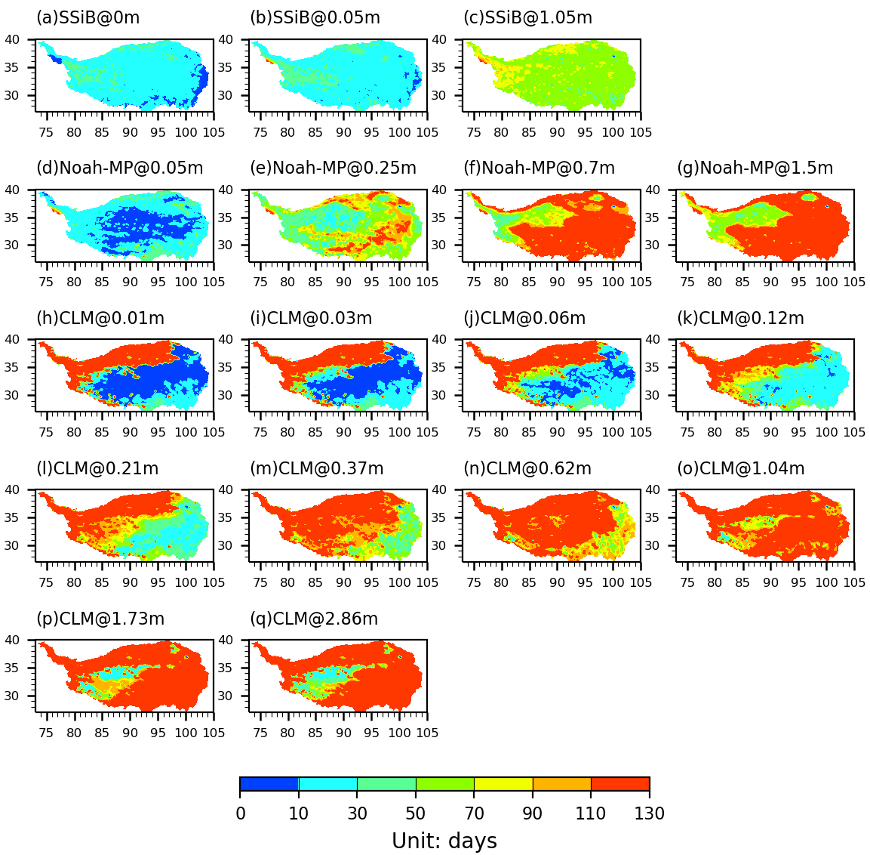
Fig. S1 Spatial distribution of T2m/surface/soil memories (unit: days) in the Tibetan Plateau in the +5℃ experiments with different land models. The soil memories are at the full and original layers in each land model.

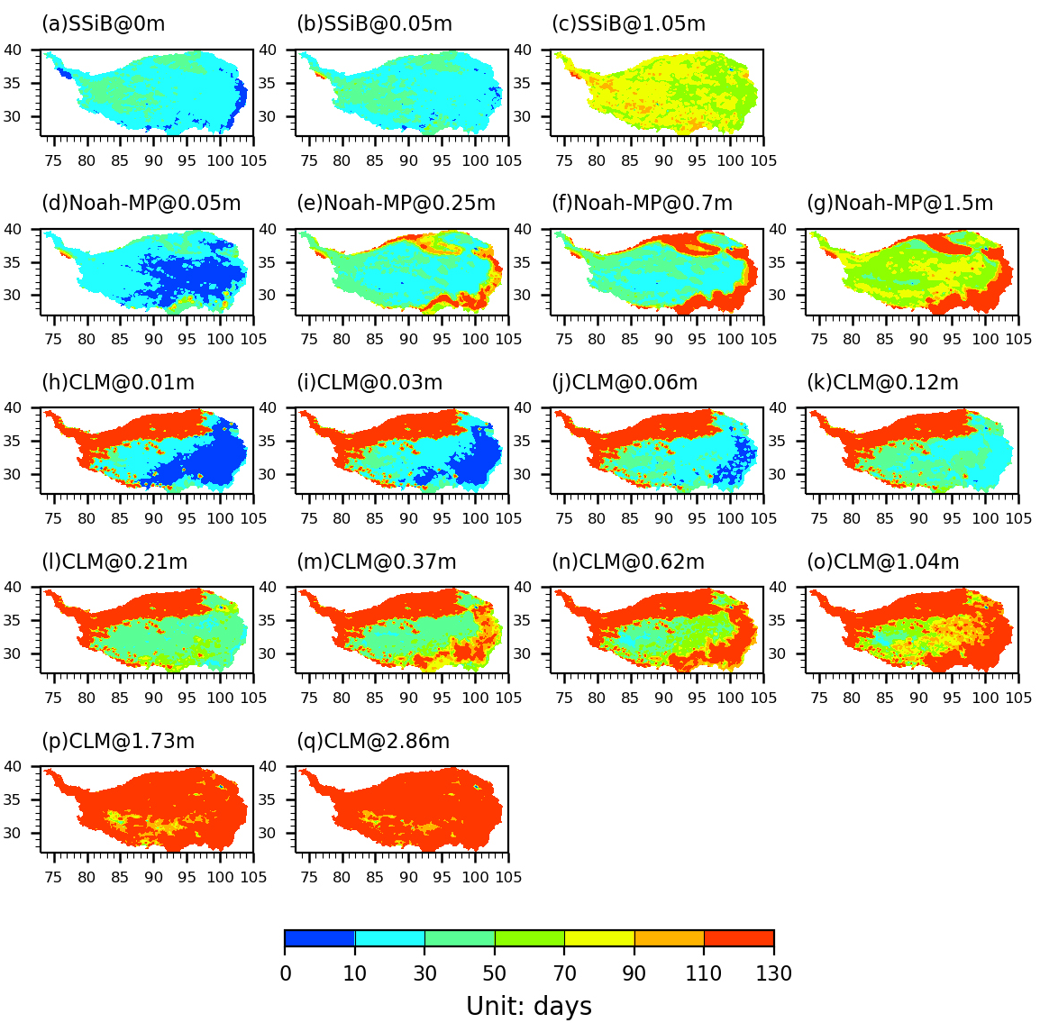
Fig. S2 Similar to Fig. S1, but in the -5℃ experiments.

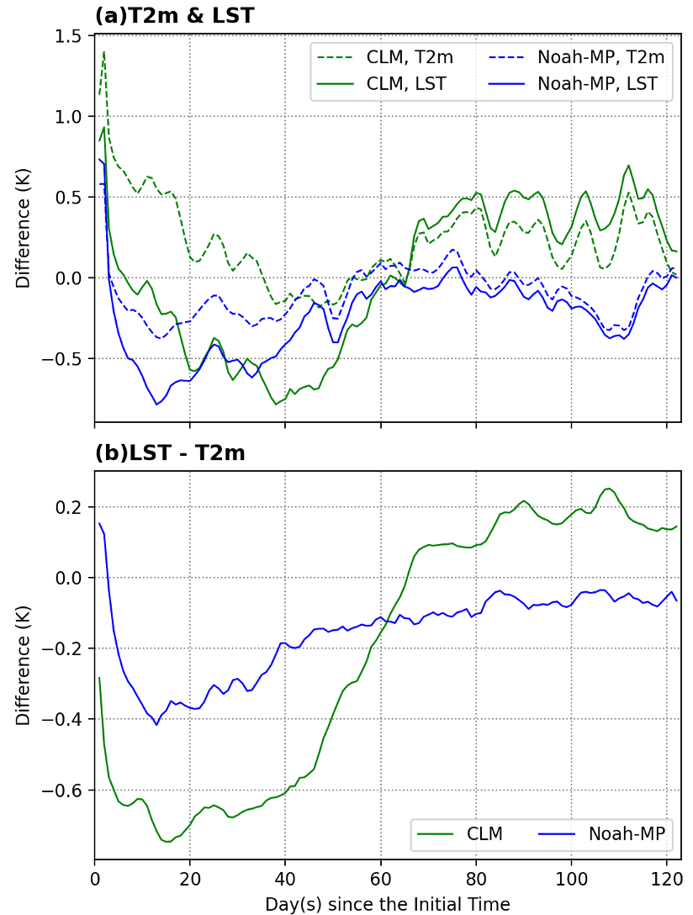
Fig. S3 Time series of the differences in daily T2m, LST (a), and temperature gradience between LST and T2m (LST-T2m, b) averaged over the Tibetan Plateau between the control and +5℃ experiment with CLM and Noah-MP.

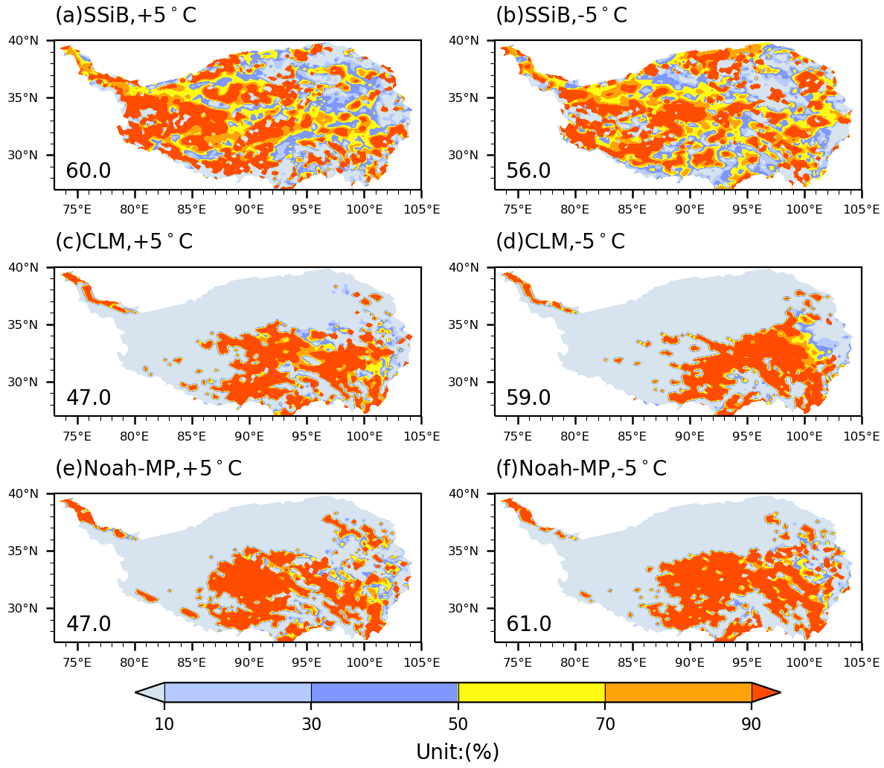
Fig. S4 Percentage of differences in May convective precipitation between the control and ±5℃ experiment in differences in May total precipitation. The percentage averaged over the Tibetan Plateau is listed.

Method to calculate convective available potential energy (CAPE)
We used the function “wrf_cape_3d” in NCL to calculate CAPE with 6-hourly WRF outputs and then calculate the monthly value (http://www.ncl.ucar.edu/Document/Functions/Built-in/wrf_cape_3d.shtml). The formula of CAPE is as below:
$CAPE=\int_{z_{f}}^{Z_{n}}{g\left(\frac{T_{v,parcel}-T_{v,env}}{T_{v,env}}\right)dz}$ (S1)
where $z_{f}$ and $Z_{n}$ are, respectively, the heights of the levels of free convection and equilibrium (neutral buoyancy), $T_{v,parcel}$ is the virtual temperature of the specific parcel, $T_{v,env}$ is the virtual temperature of the environment, and $g$ is the acceleration due to gravity.

