Supplementary material for
Bagging-based Adaptive Synthetic Oversampling Algorithm for Robust Policy Search in Reservoir Management

Sukwang Ji¹ and Kuk-Hyun Ahn²

September 2022

¹Graduate Research Assistant, Department of Civil and Environmental Engineering, Kongju National University, Cheon-an, South Korea; e-mail: wltnrhkd123@gm.kongju.ac.kr
²Associate Professor, Department of Civil and Environmental Engineering, Kongju National University, Cheon-an, South Korea; Corresponding author; e-mail: ahnkukhyun@ kongju.ac.kr

Introduction

This file contains 1 figure, presented to support the results and conclusions of “Bagging-based Adaptive Synthetic Oversampling Algorithm for Robust Policy Search in Reservoir Control”. To be specific, the figures are used for the following section:

Figures S1
- 4.3 Evaluation of four policy search algorithms

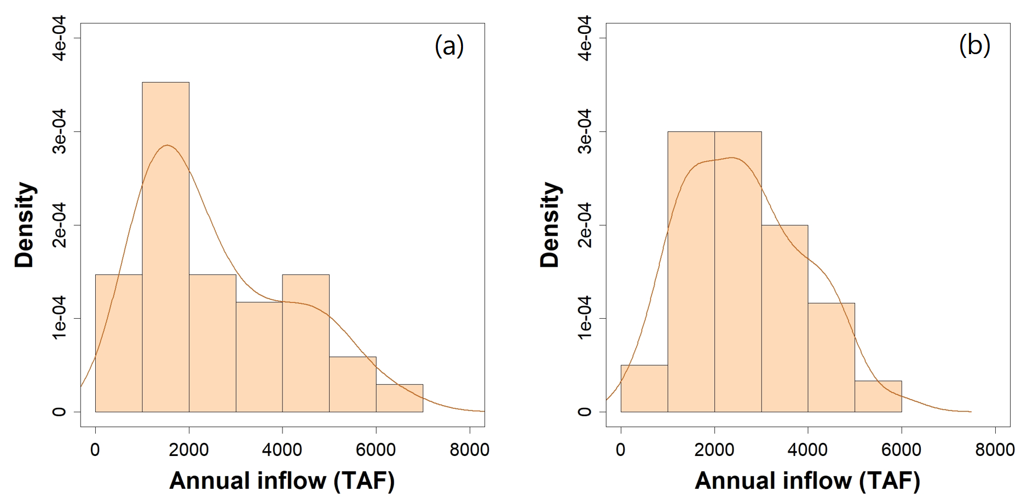
Figure S1 Histogram and kernel density curves of the observed annual inflow in (a) the training (1983-2016) and (b) test (1923-1982) periods.

