Dietary Proposal

Introduction

Children’s early years provide an important foundation for their future health and strongly influence many aspects of overall well-being. After having conducted an in-depth systematic review on the nutritional habits of children under the age of six with early childhood caries (ECC), we as the authors decided to create a new dietary proposal that can either be standalone or in conjunction with already established guides. With this nutritional guide in the armamentarium of healthcare professionals (HCP) and carers of children under the age of six, we aim to put emphasis on the prevention of early childhood caries through focus on dietary items as well as habits. Through this common risk factor approach, we can lead the battle on other non-communicable diseases that children face, such as childhood obesity and type II diabetes mellitus.

Defining terms
Free sugars - all sugars added to food and drinks in addition to those naturally present in honey, syrups, smoothies and fruit juice. It does not include sugars naturally present in milk and milk products.
Bound sugars - all sugars naturally present in whole fresh fruit and vegetables

The Eatwell Guide

The Eatwell Guide is one that is easily recognised by both carers and young children as it is implemented within the school curriculum. Although it is not applicable for children under the age of two due to different nutritional needs, children should soon move into a diet that follows similar proportions to the ones indicated on the diagram in Figure 1.

Following the Eatwell Guide, general good dietary practices to follow are:
- Consuming at least 5 portions of a variety of fruit and vegetables every day
- Base meals on carbohydrates (choosing wholegrain versions where possible and leaving skin on starchy root vegetables such as potatoes)
- Diary or dairy alternatives (such as soya drinks) should be included in the diet
- Protein from items such as beans, pulses, eggs, fish and non-processed lean meat should be consumed
- Opt for unsaturated oils and spreads rather than saturated
- Drink 6-8 glasses of fluid a day

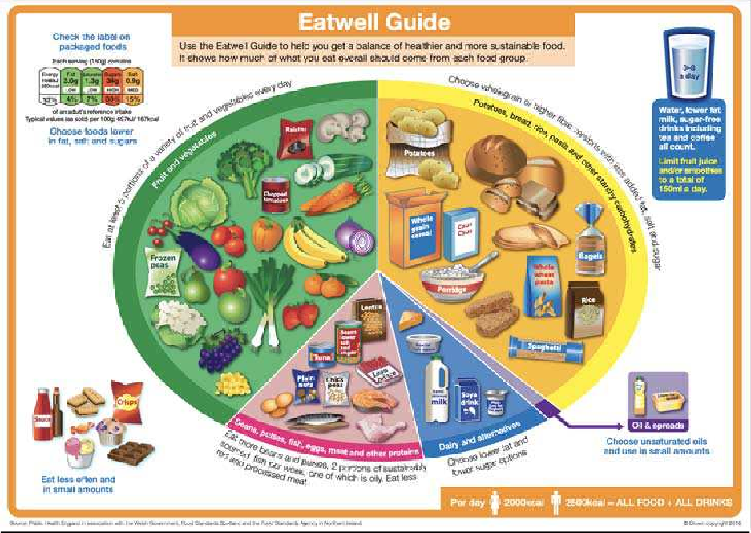

Figure 1: The Eatwell Guide¹

Many of the food present in our diet are meals that combine the groups partitioned in The Eatwell Guide. Towards the end of this guide, you will find exemplary meal ideas that combine these sections of the Eatwell plate and include the necessary macro and micronutrients that children under 6 require in their diets.

Dietary advice for under the age of 2

Important points to note (following on from recommendations from The Scientific Advisory Committee on Nutrition (SACN), Delivering Better Oral Health, The Eatwell Guide and our own suggestions):
- Exclusive breastfeeding is recommended for around the first six months of a baby’s life with continued breastfeeding throughout the first year, and after that
- for as long as the mother wishes to continue
- Solid foods should not be started until 6 months of age
- Breast milk, infant formula and water should be the only drinks offered to children between 6 and 12 months of age
- Wide range of solid foods should be introduced in an age-appropriate form from around 6 months of age Dietary, flavour and texture diversification should proceed incrementally
- After 6 months of age, drinking from a free-flow cup should be encouraged
- After the age of 1 year, feeding from a bottle should be discouraged
- Avoid adding sugar to baby foods or drinks
- Reduce the amount of food and drinks containing free sugars
- Reduce the frequency of sugary food and drinks and best option is to limit sugary food/drinks to mealtimes only if still within diet
- After the age of 1 year, 2 healthy snacks in between meals may be needed (for example fruit, vegetable sticks, toast, bread or plain yoghurt).
- Dried fruit should not be given as a snack

- Opt for sugar-free medicines if available (HCP to recommend/prescribe sugar free alternatives if available)
- Only milk or water should be drunk between meals
- Children should be supported in making healthy choices and encouraged through interactive approaches to be conscious of their choices and supported in them

Exemplar dietary guide by mealtimes for children over the age of 2 (breakfast, lunch, dinner, snacks)

NB: Please use this as a guide and feel free to edit the guide according to allergies, preferences and how accustomed the child is to solid foods. Aim for a variety of sources of fresh fruit and vegetables, proteins and carbohydrates. Follow recommended guidelines and child’s activity levels to direct the portion sizes.

Monday |  | Tuesday | Wednesday | Thursday | Friday
Breakfast  Drinks: Water only | Wholemeal toast with banana/avoc ado/low sugar labelled ‘green’ jam or homemade jam with reduced sugar | Whole-grain cereal with  ‘green’ or ‘amber’ colour coding for the sugar content, with berries  and plain cow’s milk or unsweetened plant-based milk | Porridge made with oats and plain cow’s  milk or  unsweetened plant-based milk with banana | Chia seed overnight oats and coconut milk pudding with fresh fruit of choice | Eggs and  spinach on wholemeal toast
Mid-morning snack | Plain rice cakes, plain yoghurt and seasonal fruit | Breadsticks and mixed vegetable sticks | Apple slices and nut butter of choice | Plain popcorn | Plain frozen  yoghurt and fresh fruit e.g., pineapple/mang o
Lunch  Drinks: Water only | Jacket potato with tuna/chickpe as and  sweetcorn | Wholemeal pasta with homemade tomato sauce and a protein source e.g.,  lean chicken breast, tofu | Wholemeal bread sandwich; avocado and sundried tomato salad/smashe d eggs | Homemade beans in tomato sauce on wholemeal toast | Wholegrain rice with steamed vegetable e.g., runner beans,  broccoli and protein of choice  e.g. salmon, tempeh

Mid-afternoon snack | Tomato slices and  cheese cut into sticks | Fresh fruit | Carrot, pepper sticks and hummus | Toasted pitta bread and smashed avocado | Avocado on plain crackers
Dinner  Drinks: Water or plain milk | Roasted sweet potatoes (white or orange flesh) and different vegetables eaten at  lunch e.g., carrots, beetroot alongside protein source e.g., oily fish like mackerel, lean beef, unrefined soy chunks | Homemade paella with  peas and vegetables and beans/seafoo d | Couscous and tabbouleh salad with hummus and falafel | Potato salad with chicken skewers/mea t alternative skewers and grilled Mediterranea n vegetables | Mexican bean  and pepper fajita wraps with salad and guacamole

Good practice
-After eating or drinking a sugary or acidic substance, sip water to aid in the clearance of the substance from the oral cavity
-Group snacks with meals
-If opting for plant-based milks, choose the unsweetened version to reduce free sugar consumption and opt for those fortified with minerals such as calcium
-Aim to vary food choices to obtain different nutrients from different food sources and grow a symbiotic gut microbiota
-Have a colourful plate where possible
-Use fresh over frozen or dried fruit and vegetables
-Steaming or roasting is preferable to frying or use of excessive saturated fats and oils
-Ideally children should just have water or plain milk/unsweetened plant-based milk with their meals, but if they request juice, opt for fresh juice with no additives and group 150ml juice/smoothies with mealtimes
-Children 1-6 years should be given a 10µg supplement of vitamin D per day
-Children under 1 should be given a daily vitamin D supplement containing 8.5 to 10µg of vitamin D only if they are
not being given infant formula (which is already fortified)
-No more than 19g a day sugar and avoid/reduce consumption of any free sugars
-Avoid snacking on dried fruit, and treats such as sweets and chocolate bars should not be eaten on more than one occasion a week

References:
- England PH. The Eatwell Guide. 2016.
- Scientific Advisory Committee on Nutrition. Feeding in the First Year of Life 2018
- Government H. Example menus for early years settings in England Part 1: Guidance 2017

