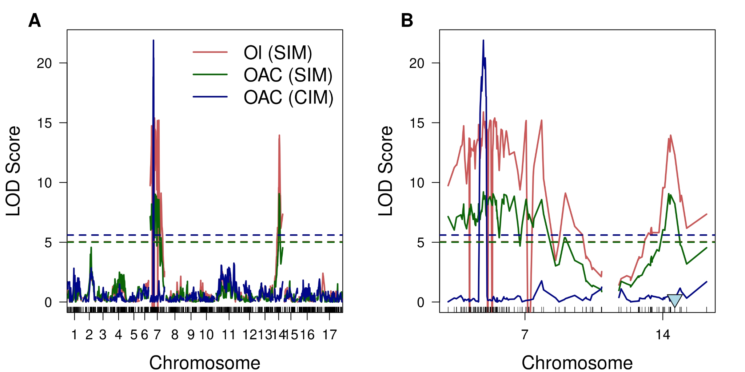
Fig. S1 – Likelihood curves of the LOD score Ol gene (high oleic trait) and oleic acid content (OAC) for VK876xVK101 (panels A and B) crosses. The mapping was performed using original genetic map for VK876xVK101 cross (Gubaev et al. 2022). The red curve reflects the results of SIM for the binary trait associated with the presence and/or absence of the Ol gene with the interval mapping approach. The green curve reflects the results of SIM adapted for non-normally distributed traits of OAC. The blue curve reflects the results of CIM of OAC. Colored horizontal dashed lines correspond to the permutation threshold for respective mapping approaches. Light blue triangle indicate marker that is most closely located to the Ol gene encoding FAD2-1 based on the physical map data.

