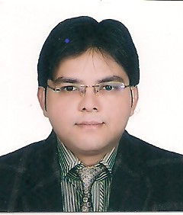
Author 1
Mr. Lalit Mohan Gupta, Computer Science and Engineering, Aligarh College of Engineering & Technology, Aligarh (lalitmguptaamu@gmail.com)
Mr. Lalit Mohan Gupta is pursuing PhD. in Computer Science from Dr. A.P.J Abdul Kalam Technical University, LUCKNOW. He did his MTech. in Software Engineering from Aligarh Muslim University, Aligarh. and having more than 12 years of teaching experience in the field of Computer Science Engineering. He is presently serving as an Assistant Professor in the Department of Computer Science & Engineering at Aligarh College of Technology and Management (ACET) . The main research area of Mr. Gupta is cloud computing and data security. He has published several research papers in the national/international journals/conferences of repute.
Author 2
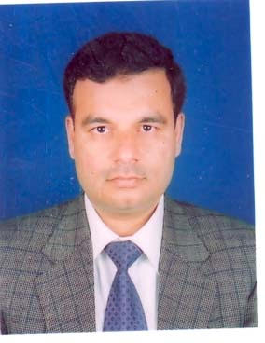
Dr. Abdus Samad, Computer Science & Engineering, Aligarh Muslim University, Aligarh (abdussamadamu@gmail.com)
Dr. Abdus Samad is working as an Associate Professor in the Department of Computer Engg., Zakir Husain College of Engg & Tech, AMU, Aligarh, and having teaching experience of more than 20 years. He is currently serving as Head of the Section. He completed his PhD at the Dept. of Computer Engineering, AMU, Aligarh in the year 2010. His research areas include parallel and distributed systems, algorithm design, microprocessor, and parallel system design. He has supervised PhD as well as M.Tech. dissertations. He has contributed and attended various national and international conferences in India and abroad, and published papers in reputed journals. He has also delivered keynote addresses and invited talks in conferences and workshops. Dr Samad is a Member of IE (India), IETE and also serving as Honorary Secretary of IETE Aligarh Centre. He is also a member of the Curriculum Design Committee of the University Polytechnic, JMI, New Delhi. He sharing various responsibilities in the department and also actively participated in various positions in the university administration, such as Assistant Proctor, and Warden of various Halls of residence.
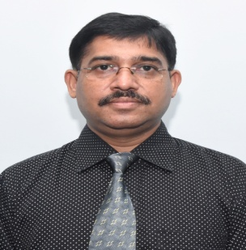
Author 3:
Dr. Hitendra Garg, Computer Science & Engineering, GLA University, Mathura (hitendra.garg@gmail.com)
Hitendra Garg did his Ph.D. (CSE) at the Motilal Nehru National Institute of Technology, Allahabad, and a Masters (Software Systems) from BITS-Pilani. He is presently working as an Associate Professor in the Department of Computer Engineering & Applications, GLA University, Mathura, India. He has a total experience of more than19 years in the field of academics/research. He has more than 27 research papers in the international journals/conference of repute. His research areas are image processing, cryptography, 3D data processing, etc.
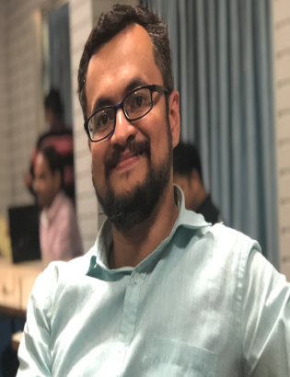
Author 4:
Dr. Kausha Shah, Computer Science & Engineering, Pandit Deendayal Energy University, Gujrat (shah.kaushal.a@gmail.com)
Dr. Kaushal Shah is currently serving as an Assistant Professor in the department of Computer Science and Engineering at Pandit Deendayal Energy University (PDEU). He has vast teaching experience of around 10 years. Prior to joining PDEU, he was serving at Vellore Institute of Technology in Computer Engineering Dept. as an Assistant Professor, Sr. Grade I. He did his PhD from Sardar Vallabhbhai National Institute of Technology in the area of Information Security. He was a gold medal list for being a branch topper in Master of Engineering in Computer Science and Engineering from Gujarat Technological University. He has received the financial grant from AICTE for conducting the ATAL Faculty Development Program. He has also received financial grant from Government of Gujarat for Student Start-up and Innovation Policy. He is an active researcher in the field of Information Security, Blockchain Technology, Cryptography, and Smart Grid. He has also published several research articles at reputed places and delivered keynote talks.

