Efficacy of Bacopa monnieri on memory and vascular functions: A randomised controlled trial

Natakorn Kamkaew1,2, Kornkanok Ingkaninan3, Neti Waranuch4, Watchara Kaewmahanin5, Chanchira Wasuntarawat1, Onrawee Khongsombat1, Peeraphong Thiarawat6, Duangnapa Roongpiboonsopit7, Jintanaporn Wattanathorn8, C. Norman Scholfield9, Ngamrayu Ngamdokmai10, Sutthinee Wisutthathum4, Usana Chatturong1, Anjaree Inchan1, and Krongkarn Chootip1,*
1Department of Physiology, Faculty of Medical Science and Center of Excellence for Innovation in Chemistry, Naresuan University, Phitsanulok, 65000, Thailand
2Division of Physiology, School of Medical Sciences, University of Phayao, Phayao, 56000, Thailand
3Department of Pharmaceutical Chemistry and Pharmacognosy, Faculty of Pharmaceutical Sciences and Center of Excellence for Innovation in Chemistry, Naresuan University, Phitsanulok, 65000, Thailand
4Cosmetics and Natural Products Research Center, Department of Pharmaceutical Technology, Faculty of Pharmaceutical Sciences and Center of Excellence for Innovation in Chemistry, Naresuan University, Phitsanulok, 65000, Thailand
5Department of Cardio-Thoracic Technology, Faculty of Allied Health Sciences, Naresuan University, Phitsanulok, 65000, Thailand
6Department of Surgery, Faculty of Medicine, Naresuan University, Phitsanulok, 65000, Thailand
7Division of Neurology, Department of Medicine, Faculty of Medicine, Naresuan University, Phitsanulok, 65000, Thailand
8Department of Physiology, Faculty of Medicine, Khon Kaen University, Khon Kaen, 40002, Thailand
9Akkhraratchakumari Veterinary College, Walailak University, Nakhon Si Thammarat, 80160, Thailand
10School of Medicine, Walailak University, Nakhon Si Thammarat, 80160, Thailand

Supplementary Information

Supplemental Fig. S1. MMSE scores.

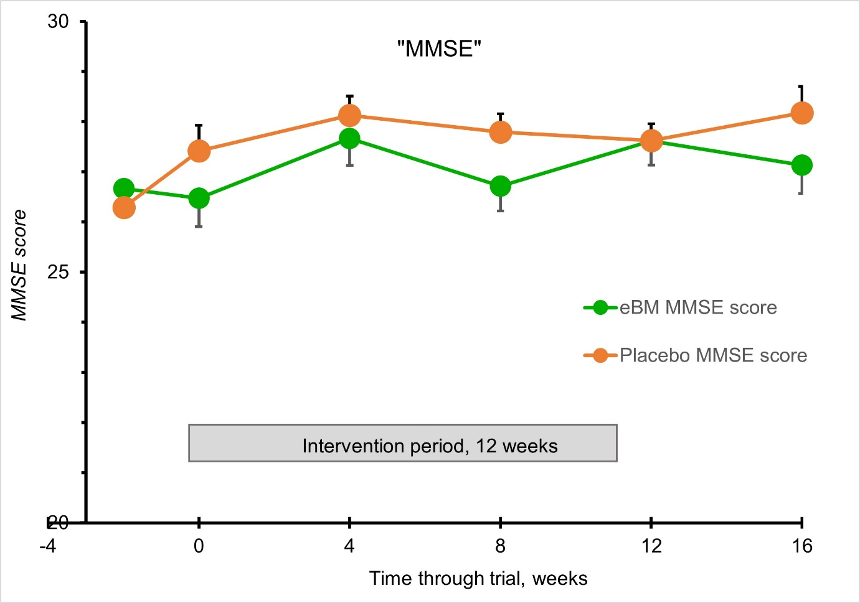

Supplemental Fig. S1 contain the mini-mental state examination (MMSE) score concerning 12 week intervention of the extract of B. monnieri (eBM) in green or the Placebo in red. The value for each data point is values at each time point and shown as means±SEM.

Supplemental Fig. S2. Blood pressure and heart rate.

Supplemental Fig. S2 shows blood pressure and the heart rate (HR) for the B. monnieri intervention (eBM) in green and placebo in orange. Data points are means±SEM.

Supplemental Table S1. Blood biochemistry data of the participants

Blood biochemistry | Normal range | Placebo (n=24) |  |  | eBM (n=21)
Blood biochemistry | Normal range | Baseline | Treatment | Treatment | Baseline | Treatment | Treatment
Blood biochemistry | Normal range | Baseline | week 0 | week 12 | Baseline | week 0 | week 12
HbA_{1C} (%) | 4.6-6.5 | 5.8 ± 0.5 | 5.7 ± 0.4 | 5.7 ± 0.4 | 5.8 ± 0.4 | 5.6 ± 0.4 | 5.7 ± 0.4
FBG (mg/dl) | <126 | 91.0 ± 7.1 | 92.0 ± 5.7 | 90.0 ± 6.8 | 90.1 ± 6.1 | 91.3 ± 7.0 | 90.0 ± 7.1
Total cholesterol mg/dl) | 150-200 | 216.5 ± 35.8 | 208.5 ± 37.5 | 220.7 ± 40.6 | 221.5 ± 37.4 | 206.6 ± 45.3 | 210.6 ± 48.7
Triglyceride (mg/dl) | 30-150 | 112.3 ± 44.5 | 116.4 ± 53.5 | 112.0 ± 51.4 | 128.4 ± 49.7 | 122.4 ± 58.5 | 122.6 ± 58.3
LDL (mg/dl) | <130 | 131.7 ± 36.4 | 126.2 ± 39.3 | 139.2 ± 39.9 | 125.8 ± 38.7 | 123.7 ± 55.1 | 126.0 ± 48.9
HDL (mg/dl) | 45-65 | 62.5 ± 13.8 | 59.2 ± 13.4 | 59.3 ± 14.3 | 63.5 ± 12.3 | 57.8 ± 14.1 | 56.6 ± 13.4
BUN (mg/dl) | 8-23 | 11.5 ± 2.7 | 11.9 ± 2.4 | 12.1 ± 2.5 | 11.8 ± 3.5 | 12.0 ± 3.7 | 13.1 ± 4.8
Creatinine (mg/dl) | 0.4-1.4 | 0.9 ± 0.1 | 0.9 ± 0.1 | 0.8 ± 0.1 | 0.9 ± 0.1 | 0.9 ± 0.1 | 0.8 ± 0.1
eGFR (ml/min/1.73m²) | >60 | 77.9 ± 12.4 | 78.3 ± 8.6 | 80.7 ± 11.9 | 76.0 ± 11.5 | 76.5 ± 12.5 | 78.02 ± 11.8
AST (unit) | 0-33 | 22.7 ± 5.2 | 23.1 ± 5.4 | 22.9 ± 5.4 | 21.9 ± 4.6 | 21.4 ± 3.9 | 22.5 ± 5.4
ALT (unit) | 3-35 | 16.4 ± 6.9 | 17.2 ± 7.0 | 14.6 ± 6.1 | 16.8 ± 6.4 | 15.0 ± 5.6 | 14.7 ± 4.8
ALP (I.U.) | 25-90 | 68.5 ± 13.6 | 69.0 ± 12.2 | 77.6 ± 13.5 | 66.2 ± 11.4 | 66.05 ± 14.5 | 75.0 ± 14.7
Calcium (mg/dl) | 8.8-10.6 | 9.8 ± 0.3 | 9.9 ± 0.3 | 9.8 ± 0.3 | 9.9 ± 0.4 | 10.0 ± 0.4 | 10.1 ± 0.4
Total protein (g/dl) | 6.0-8.0 | 7.55 ± 0.46 | 7.60 ± 0.53 | 7.93 ± 0.38 | 7.80 ± 0.46 | 7.66 ± 0.44 | 8.00 ± 0.38
Albumin (g/dl) | 3.8-5.5 | 4.63 ± 0.36 | 4.49 ± 0.20 | 4.36 ± 0.18 | 4.70 ± 0.42 | 4.57 ± 0.27 | 4.41 ± 0.16
Globulin (g/dl) | 2.3-3.5 | 2.91 ± 0.60 | 3.10 ± 0.54 | 3.57 ± 0.39 | 3.10 ± 0.57 | 3.09 ± 0.43 | 3.59 ± 0.32
Total bilirubin (mg/dl) | 0.2-1.2 | 0.62 ± 0.15 | 0.62 ± 0.18 | 0.56 ± 0.19 | 0.60 ± 0.16 | 0.59 ± 0.15 | 0.52 ± 0.20
Direct bilirubin (mg/dl) | <0.3 | 0.12 ± 0.07 | 0.13 ± 0.08 | 0.20 ± 0.06 | 0.11 ± 0.05 | 0.12 ± 0.06 | 0.19 ± 0.08

Supplemental Table S1 showing the blood biochemistry data of the participants and normal values. Values for biochemical parameters are presented as means ± SD. The baseline (before the placebo run-in period), the intervention treatment at week 0 and week 12 variances are shown separately for the placebo and eBM intervention groups. All values except ICAM-1, VCAM-1 or ADMA were determined at baseline, treatment week 0 and treatment week 12. Abbreviations: HbA1C, glycated haemoglobin; FBG, fasting blood sugar; LDL, low-density lipoprotein; HDL, high- density lipoprotein; BUN, blood urea nitrogen; eGFR, estimated glomerular filtration rate; AST, aspartate aminotransferase; ALT, alanine transaminase; ALP, alkaline phosphatase.

