Contribution Information Sheet

- What is the main claim of the paper? Why is this an important contribution to the machine learning literature?

I hereby claim that this research paper is a work to build machine learning models using Auto-regressive Integrated Moving Average (ARIMA) and Seasonal Auto-regressive Integrated Moving Average (SARIMA) to forecast smart-lockdowns using COVID-19 data. This study precisely forecast the start and end time for implementing a lockdown during pandemic. This study will be very useful in times when we encounter another virus with widespread capabilities like COVID in the future. This result is important as it has been observed that in the event of a sudden COVID-19 pandemic, people and government agencies were rendered helpless; thus, this paper proposes a study on time-series analysis over novel corona virus data to build machine learning models capable of making accurate predictions about spread and death cases in order to alert responsible agencies to act before the situation becomes out of control, which can be accomplished if the government can prepare hospital beds, oxygen cylinders, and other medical equipment necessary for the treatment of potential covid positive patients. I believe that this will assist many people and government agencies in maintaining a calm environment and citizens' composure. Furthermore, lessen the risk of novel corona virus or future diseases that have widespread capabilities.

- What is the evidence you provide to support your claim? Be precise.
The current model is a generalized model and methodology wherein this model can be trained for any disease or any other dataset, all it requires is a dataset that contains attributes as mentioned in table 2 of appendix a of manuscript, which shows the meta-data for the currently used dataset. As a author for this study, I claim this study is a unique application of the time series forecasting for COVID-19 data. Besides, this model only focuses on forecasting lockdown periods, thus less data required for training. Consider a future incident where pandemic occurs due to a new disease with has widespread tendencies, here this model will prove to be very reliable as it can be trained with less data.

The results are provided in the form of graphs that is obtained after forecasting values for COVID-19 spread and death cases respectively in the below figures for ARIMA and SARIMA models. These are step-line graphs, and the need for a lockdown is determined by the size of each step. The larger the step size, the more likely our machine learning model predicted a severe spread of cases and consecutive deaths, hence entailing a lockdown in the upcoming time period.

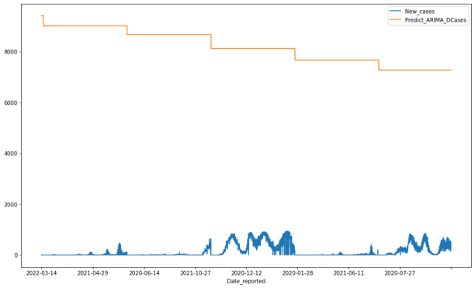
Figure 1: ARIMA Model’s prediction based on COVID Cases
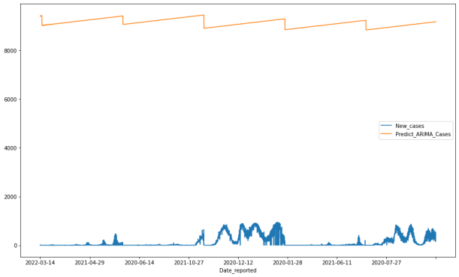
Figure 3: SARIMA Model’s prediction based on COVID Cases
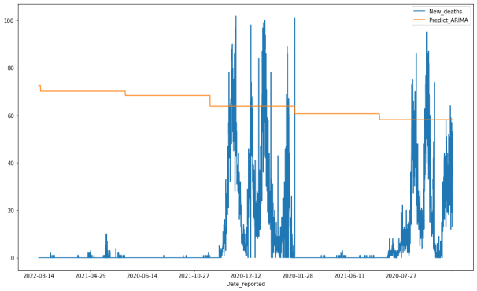
Figure 2: ARIMA Model’s prediction based on Death
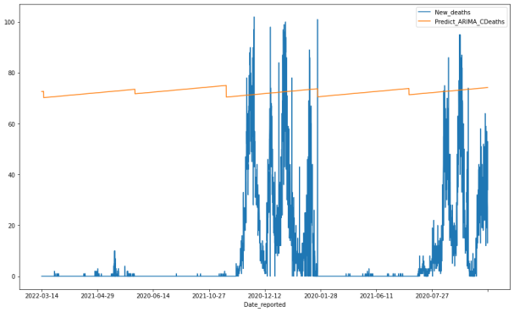
Figure 4: SARIMA Model’s prediction based on Death

- What papers by other authors make the most closely related contributions, and how is your paper related to them?

There has been prior studies made that closely relates to study of time-series analysis over COVID-19 but none were similar to the results that are provided in this study. Some of the studies are mentioned below:
- ArunKumar, K. E., Kalaga, D. V., Kumar, C. M. S., Chilkoor, G., Kawaji, M., & Brenza, T. M. (2021). Forecasting the dynamics of cumulative COVID-19 cases (confirmed, recovered and deaths) for top-16 countries using statistical machine learning models: Auto-Regressive Integrated Moving Average (ARIMA) and Seasonal Auto-Regressive Integrated Moving Average (SARIMA). Applied soft computing, 103, 107161.
- ArunKumar, K. E., Kalaga, D. V., Kumar, C. M. S., Kawaji, M., & Brenza, T. M. (2022). Comparative analysis of Gated Recurrent Units (GRU), long Short-Term memory (LSTM) cells, autoregressive Integrated moving average (ARIMA), seasonal autoregressive Integrated moving average (SARIMA) for forecasting COVID-19 trends. Alexandria Engineering Journal, 61(10), 7585-7603.
- Sahai, A. K., Rath, N., Sood, V., & Singh, M. P. (2020). ARIMA modelling & forecasting of COVID-19 in top five affected countries. Diabetes & Metabolic Syndrome: Clinical Research & Reviews, 14(5), 1419-1427.

These are some of the papers which have similar work but my research work and results are different and focuses on different scenarios. My work is to forecast lockdown periods i.e. to get start and end time for lockdown implementation during pandemic using COVID-19 disease whereas their research work concerns forecasting of actual spread cases of COVID-19 in mentioned regions/countries. The similarity lies on the usage of ARIMA and SARIMA models.

- Have you published parts of your paper before, for instance in a conference?

No prior publications have been made in any conferences/journals.

