Appendix A. Supplementary data
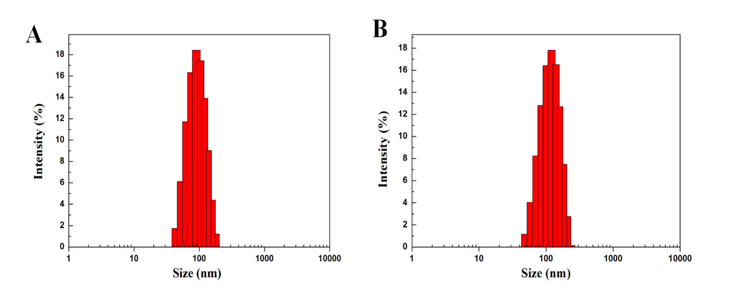
Fig. S1. Size distribution of Se NPs and Se@PDA samples in water. A) DLS data graph of Se NPs in aqueous solution. B) DLS data graph of Se@PDA in aqueous solution.
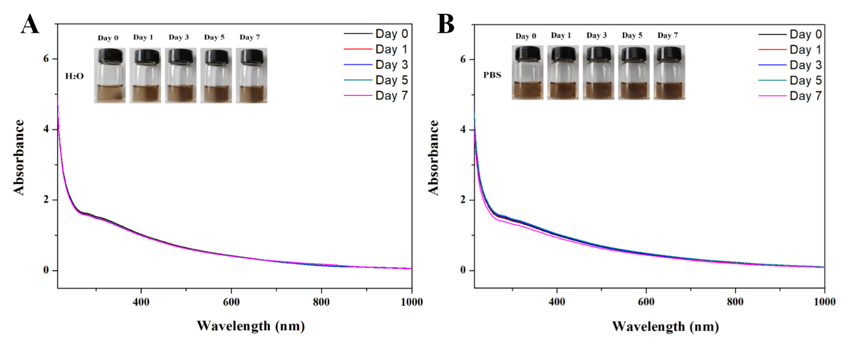
Fig. S2. The stability of Se@PDA. A) absorbance curve of the given number of days Se@PDA dispersed in water. B) The absorbance curve of Se@PDA dispersed in PBS on specified days.
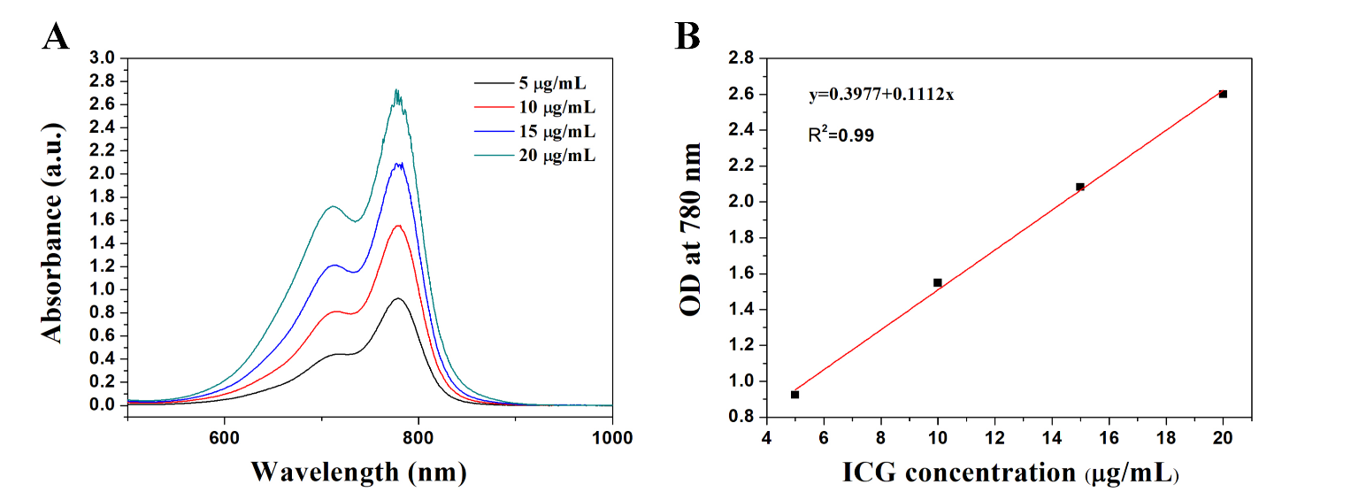
Fig. S3. Standard curve data for ICG A) UV absorption spectra of different concentrations of ICG. (B) Standard curve of ICG solution.

