Supplementary Information

Anti-cancer effect of orally absorbable heparin on orthotopically induced exocrine and endocrine pancreatic cancers

Hae Hyun Hwang, Hee Jeong Jeong, Sangwoo Yoon, Youngro Byun, Teruo Okano, Sung Wan Kim and Dong Yun Lee

*Supporting figure number: 5 figures.

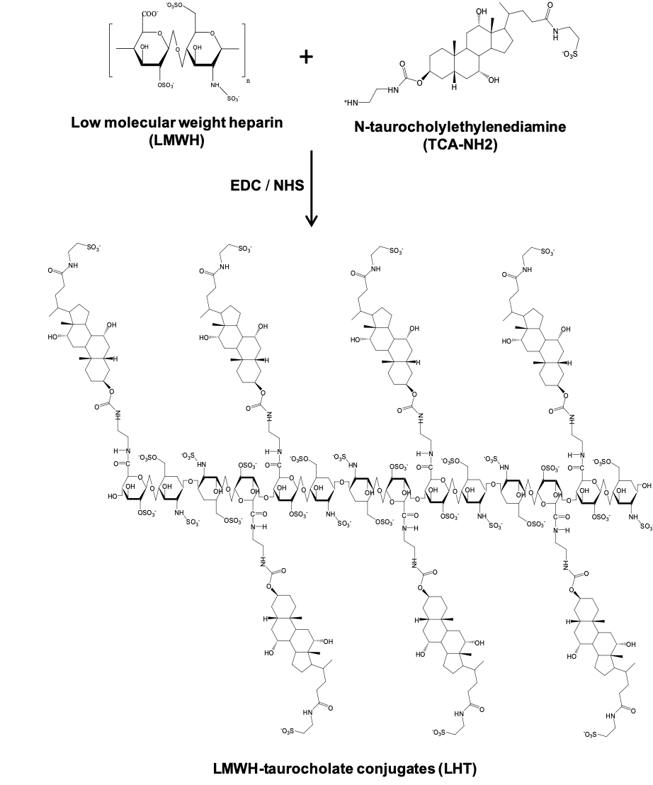
Figure S1. Chemical scheme for preparation of low-molecular weight heparin-taurocholate (LHT). Low molecular weight heparin (LMWH) was chemically conjugated with taurocholate modified with ethylenediamine.

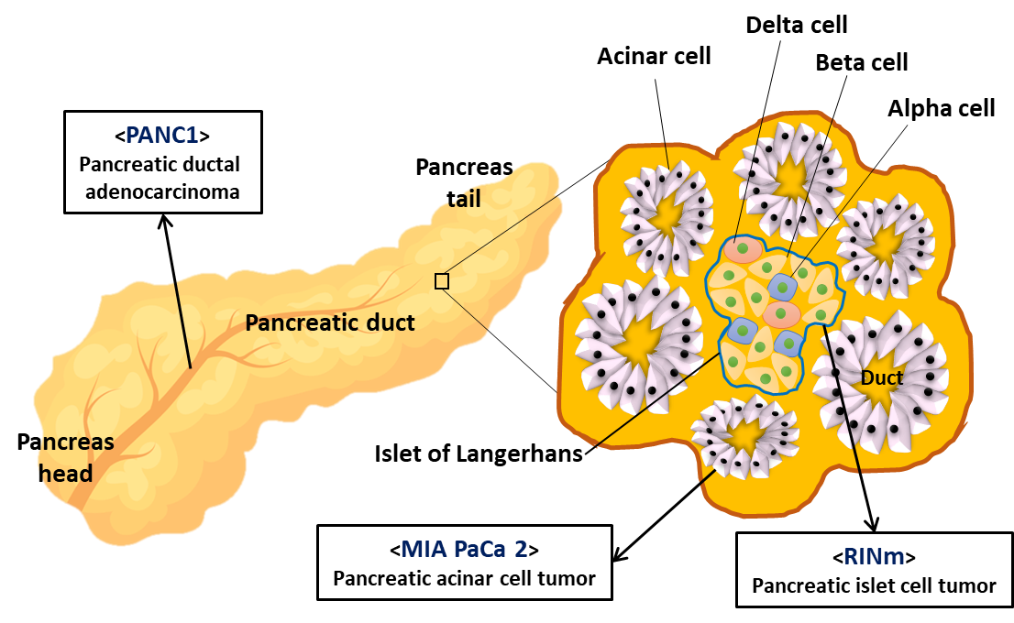

Figure S2. Origin of pancreatic tumor cell lines. PANC1 is a pancreatic ductal adenocarcinoma cell line from the duct of a pancreatic tumor. MIA PaCa-2 is a pancreatic adenocarcinoma cell line from the exocrine part of a pancreatic tumor. RINm is a rat insulinoma cell line from beta cells of a pancreatic islet cell tumor.

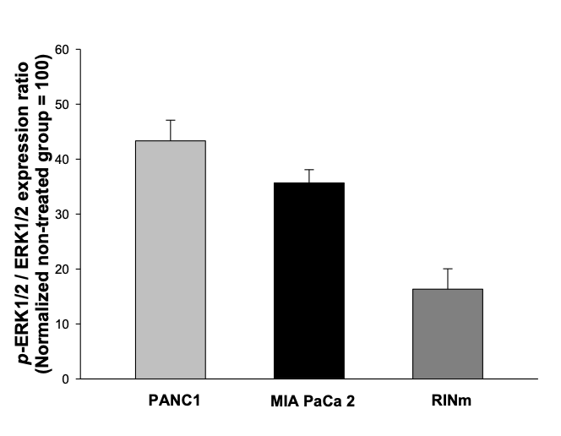
Figure S3. Normalization of phosphor-ERK1/2 as the ratio of phosphoprotein/total protein levels in the cell lysate of pancreatic cancer cells without or with LHT (100 µg/mL). Data were expressed with mean ± s.e.m. (n=5).

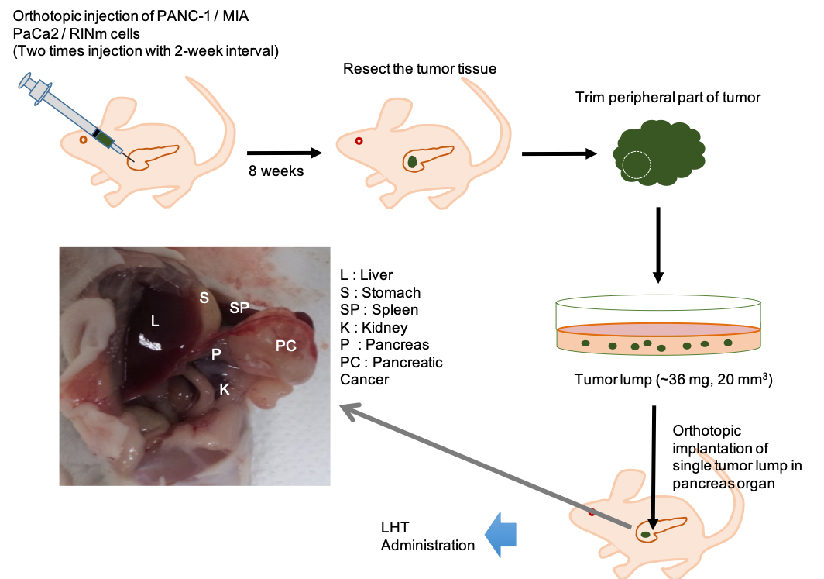
Figure S4. Surgical protocol to prepare three different kinds of orthotopic pancreatic cancer models using PANC-1, MIA PaCa-2 and RINm cells.

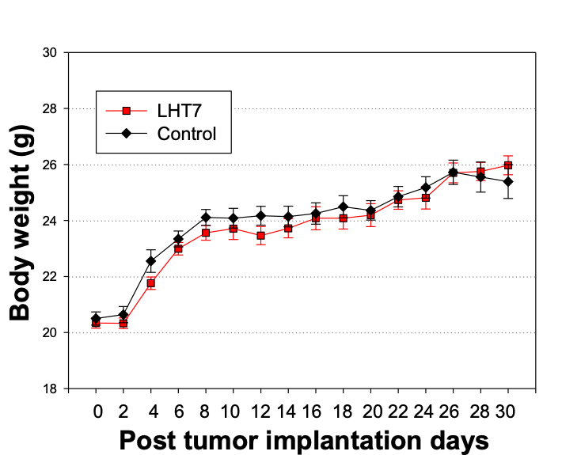

Figure S5. Body weight of orthotopic pancreatic mouse after intravenous administration of LHT (5 mg/kg/once every 2 days) or PBS vehicle for 30 days. Data were expressed with mean ± s.e.m. (n=5).

