Supplementary Material
SECTION A
Associations between individual pro-environmental behaviors and outward and self-centred orientation
To test for the association between outward and self-centred orientation and individual pro-environmental behaviors (PEBs) measured in our study, we conducted a series of chi-square tests. In every test, outward and self-centred orientation were treated as two grouping variables created by a median split of the continuous component variables used in the regressions in the main manuscript. Both of these grouping variables were then compared against every one of the individual pro-environmental behaviors measured in our study via a chi-squared test, with individual column proportions further compared by a z-test. The results for eleven surveyed behaviors are shown in Figs. S1–S11.
In general, outward orientation showed association with almost every surveyed PEB, with the exception of buying clothes and shoes, eating animal products, and efficient heating. Self-centred orientation, on the other hand, was only significantly associated with considering the origin of clothes and saving energy as forms of PEB. Also, notably, some PEBs were relatively frequent, meaning that even participants with high self-centred and low outward orientation mostly reported engaging in them to moderate or high levels. For example, only 3.6% of the sample reported not sorting any waste, 4.4% reported not doing anything to save energy, and 7.6% reported buying clothes and shoes once a month regardless of whether they need them, and there were no differences in these response options with regard to the either outward or self-centred orientation. On the other hand, some behaviors were relatively infrequent with very few people reporting engaging in those behaviors to the highest level. Among these were being vegetarian or vegan (2.6%), using mostly upcycled clothes (4.2%), zero waste living (10.8%), and buying clothes or shoes when the old ones cannot be used anymore (12.4%). Although there were some differences in these response options between people with low and high outward orientation, these differences were relatively small and generally, these behaviors were quite infrequently employed by our participants regardless of their orientation.

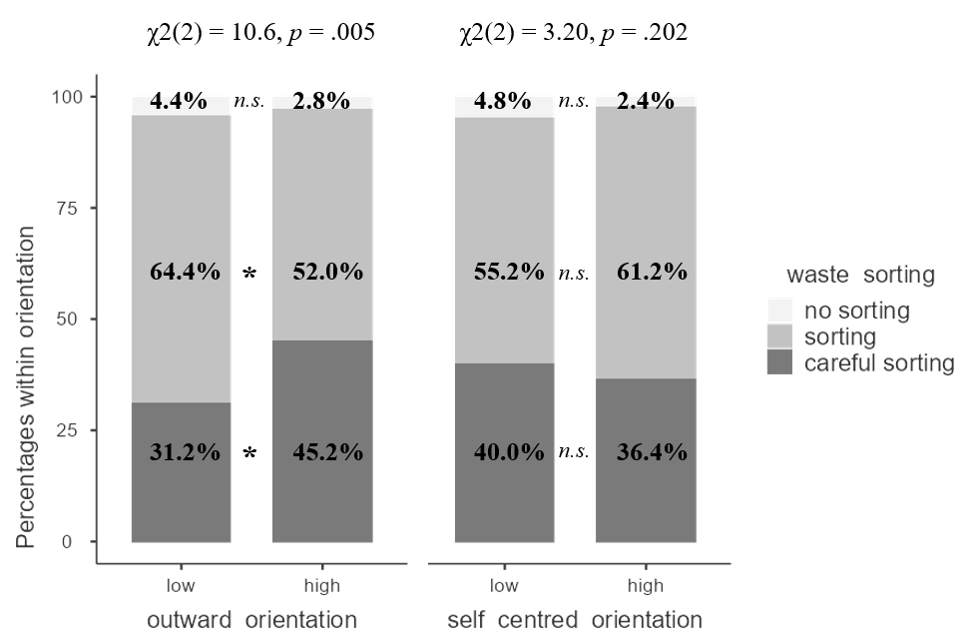
Figure S1. Stacked bar plot showing the results of chi-squared test of association between waste sorting and outward (left panel) and self-centred orientation (right panel). The bars show percentages of waste sorting response options within the columns. Column proportions are compared via z-test, significant differences (p < .05) are marked with asterisk (*).

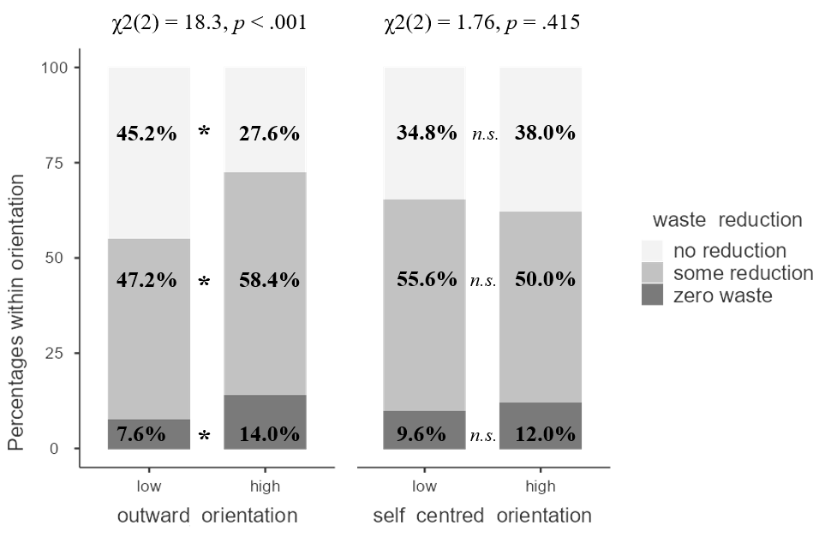
Figure S2. Stacked bar plot showing the results of chi-squared test of association between waste reduction and outward (left panel) and self-centred orientation (right panel). The bars show percentages of waste reduction response options within the columns. Column proportions are compared via z-test, significant differences (p < .05) are marked with asterisk (*).
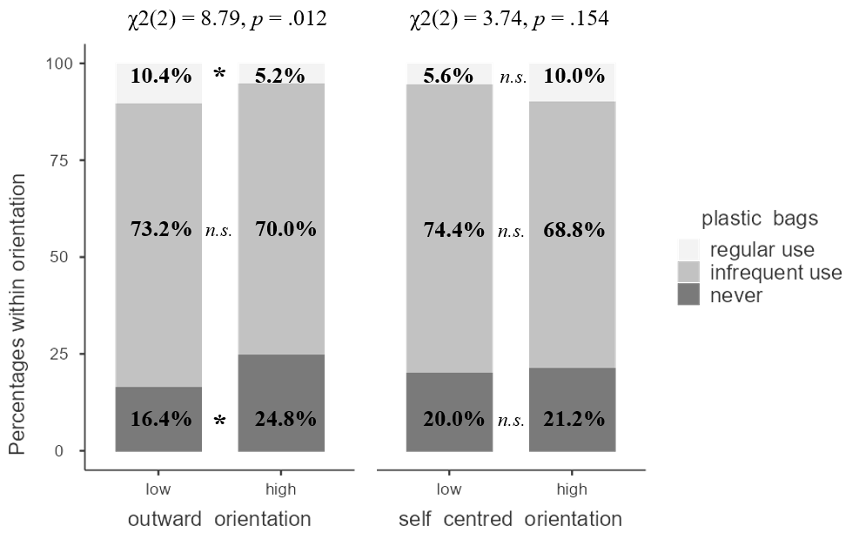
Figure S3. Stacked bar plot showing the results of chi-squared test of association between the use of plastic bags and outward (left panel) and self-centred orientation (right panel). The bars show percentages of plastic bag use response options within the columns. Column proportions are compared via z-test, significant differences (p < .05) are marked with asterisk (*).

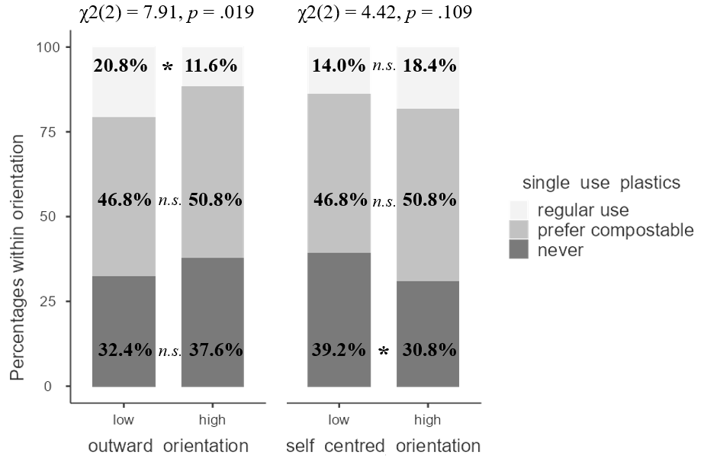
Figure S4. Stacked bar plot showing the results of chi-squared test of association between the single-use plastics use and outward (left panel) and self-centred orientation (right panel). The bars show percentages of single-use plastics use response options within the columns. Column proportions are compared via z-test, significant differences (p < .05) are marked with asterisk (*).
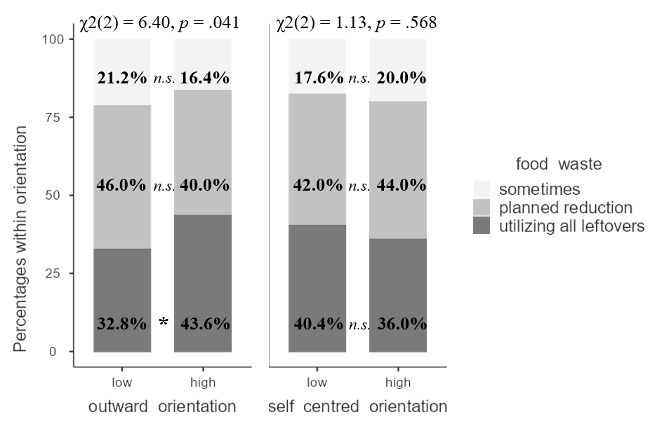
Figure S5. Stacked bar plot showing the results of chi-squared test of association between the food waste and outward (left panel) and self-centred orientation (right panel). The bars show percentages of food waste response options within the columns. Column proportions are compared via z-test, significant differences (p < .05) are marked with asterisk (*).

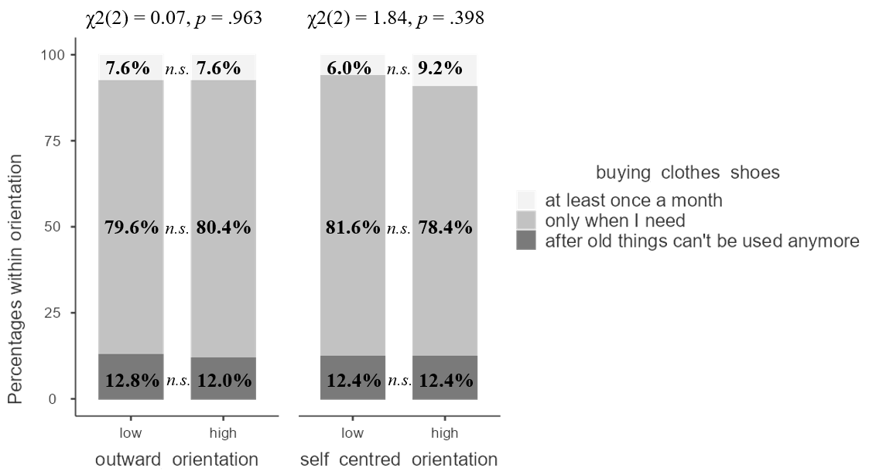
Figure S6. Stacked bar plot showing the results of chi-squared test of association between buying clothes and shoes and outward (left panel) and self-centred orientation (right panel). The bars show percentages of buying clothes and shoes response options within the columns. Column proportions are compared via z-test, significant differences (p < .05) are marked with asterisk (*).
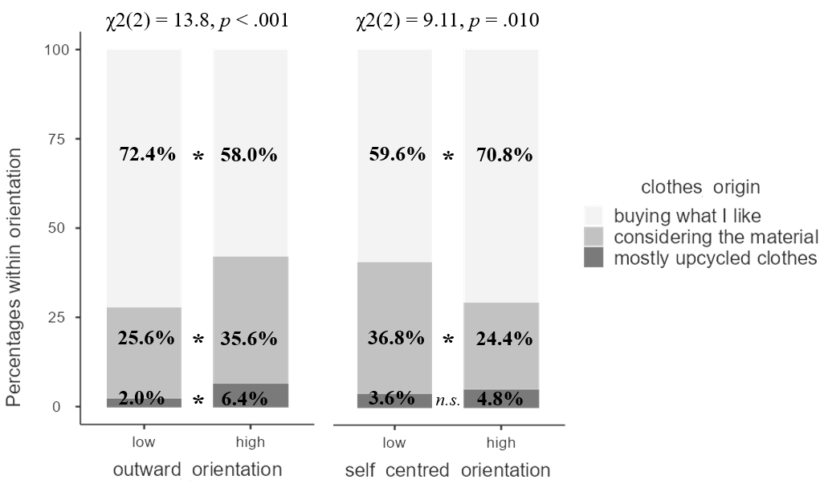
Figure S7. Stacked bar plot showing the results of chi-squared test of association between considering clothes origin and outward (left panel) and self-centred orientation (right panel). The bars show percentages of considering clothes origin response options within the columns. Column proportions are compared via z-test, significant differences (p < .05) are marked with asterisk (*).

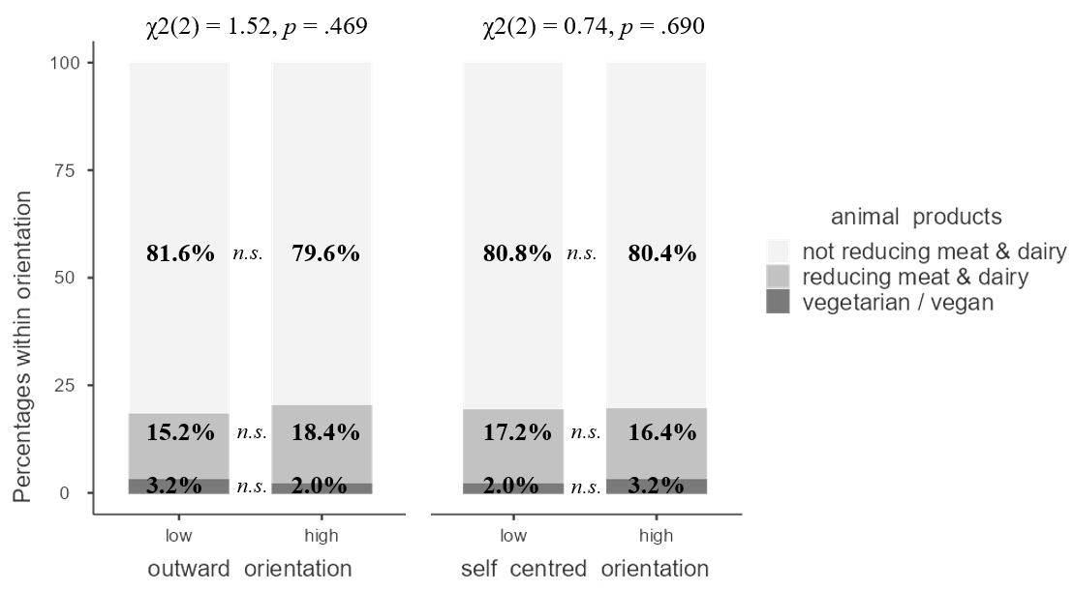
Figure S8. Stacked bar plot showing the results of chi-squared test of association between eating animal products and outward (left panel) and self-centred orientation (right panel). The bars show percentages of eating animal products response options within the columns. Column proportions are compared via z-test, significant differences (p < .05) are marked with asterisk (*).
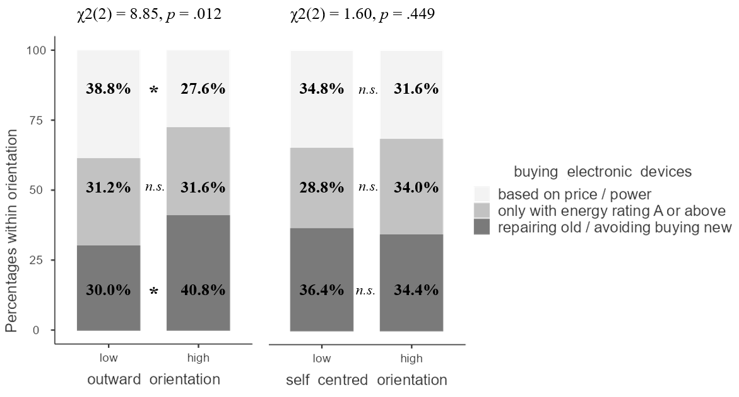
Figure S9. Stacked bar plot showing the results of chi-squared test of association between buying electronic devices and outward (left panel) and self-centred orientation (right panel). The bars show percentages of buying electronic devices response options within the columns. Column proportions are compared via z-test, significant differences (p < .05) are marked with asterisk (*).

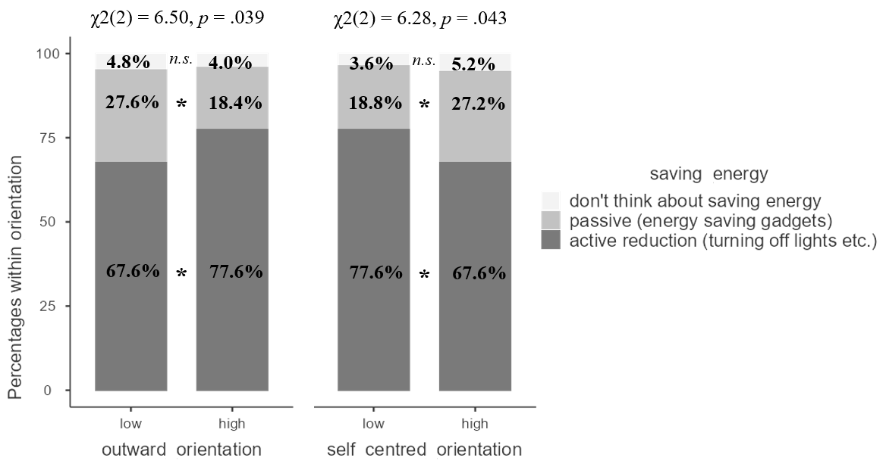
Figure S10. Stacked bar plot showing the results of chi-squared test of association between saving energy and outward (left panel) and self-centred orientation (right panel). The bars show percentages of saving energy response options within the columns. Column proportions are compared via z-test, significant differences (p < .05) are marked with asterisk (*).

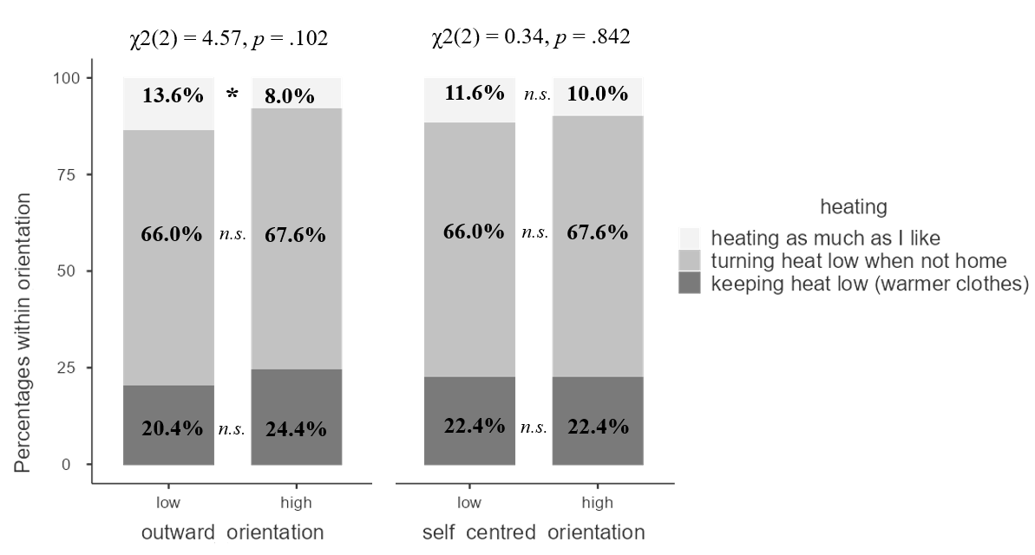
Figure S11. Stacked bar plot showing the results of chi-squared test of association between heating and outward orientation (left panel) and self-centred orientation (right panel). The bars show percentages of heating response options within the columns. Column proportions are compared via z-test, significant differences (p < .05) are marked with asterisk (*).

SECTION B
Regression models examining potential moderating effects of outward / self-centred orientation and helplessness on the association between environmental concern and pro-environmental behavior
In the main manuscript, we only present the results of a three-way interaction between outward / self-centred orientation, helplessness and concern as a predictor of pro-environmental behavior and decompose this interaction. Below, in Table S1 and S2, we include the full summaries of two regressions with added interaction terms.
Table S1. Summary of the hierarchical linear regression predicting self-reported pro-environmental behaviour with interacting effects of outward orientation, helplessness and environmental concern
 |  | β | p
Step 1 |  | ΔR² = .018, F(3,493) = 2.99, p = .031
Gender |  | –.04 | .349
Age |  | .10 | .017
Education |  | .03 | .536
Step 2 |  | ΔR² = .113, F(4,489) = 15.9, p < .001
Environmental concern |  | .23 | <.001
Helplessness |  | –.05 | .355
Outward orientation |  | .14 | .006
Self-centred orientation |  | –.04 | .386
Step 3 |  | ΔR² = .030, F(4,485) = 4.37, p = .002
Environmental concern * helplessness |  | .07 | .053
Outward orientation * helplessness |  | –.02 | .685
Outward orientation * environmental concern |  | .02 | .737
Outward orientation * environmental concern * helplessness |  | .11 | <.001
Full model |  | adj. R² = .142, F(11,485) = 8.48, p < .001
Note. The table shows standardized regression coefficients (β) and their significance at the final step of the model, as well as the change in model fit at three steps (ΔR²). Significant regression coefficients (p < .05) are presented in bold.

Table S2. Summary of the hierarchical linear regression predicting self-reported pro-environmental behaviour with interacting effects of self-centred orientation, helplessness and environmental concern
 |  | β | p
Step 1 |  | ΔR² = .018, F(3,493) = 2.99, p = .031
Gender |  | –.03 | .446
Age |  | .09 | .028
Education |  | .04 | .354
Step 2 |  | ΔR² = .113, F(4,489) = 15.9, p < .001
Environmental concern |  | .21 | <.001
Helplessness |  | –.01 | .835
Outward orientation |  | .20 | <.001
Self-centred orientation |  | –.10 | .057
Step 3 |  | ΔR² = .023, F(4,485) = 3.25, p = .012
Environmental concern * helplessness |  | .06 | .112
Self-centred orientation * helplessness |  | –.05 | .394
Self-centred orientation * environmental concern |  | .12 | .026
Self-centred orientation * environmental concern * helplessness |  | .07 | .024
Full model |  | adj. R² = .135, F(11,485) = 8.01, p < .001
Note. The table shows standardized regression coefficients (β) and their significance at the final step of the model, as well as the change in model fit at three steps (ΔR²). Significant regression coefficients (p < .05) are presented in bold.

