Electronic Supplementary Material

Hippocampal organotypic cultures as ex vivo model for tissue response to upconverting nanoparticles
Karolina Zajdel^{1,2} (), Justyna Janowska¹, Małgorzata Frontczak-Baniewicz¹, Joanna Sypecka¹, Bozena Sikora² ()

¹ Mossakowski Medical Research Institute, Polish Academy of Sciences, 5 Pawinskiego Str. 02-106 Warsaw, Poland
² Institute of Physics, Polish Academy of Sciences, Al. Lotnikow 32/46, PL-02-668 Warsaw, Poland

Supporting information to DOI 10.1007/s12274-****-****-* (automatically inserted by the publisher)
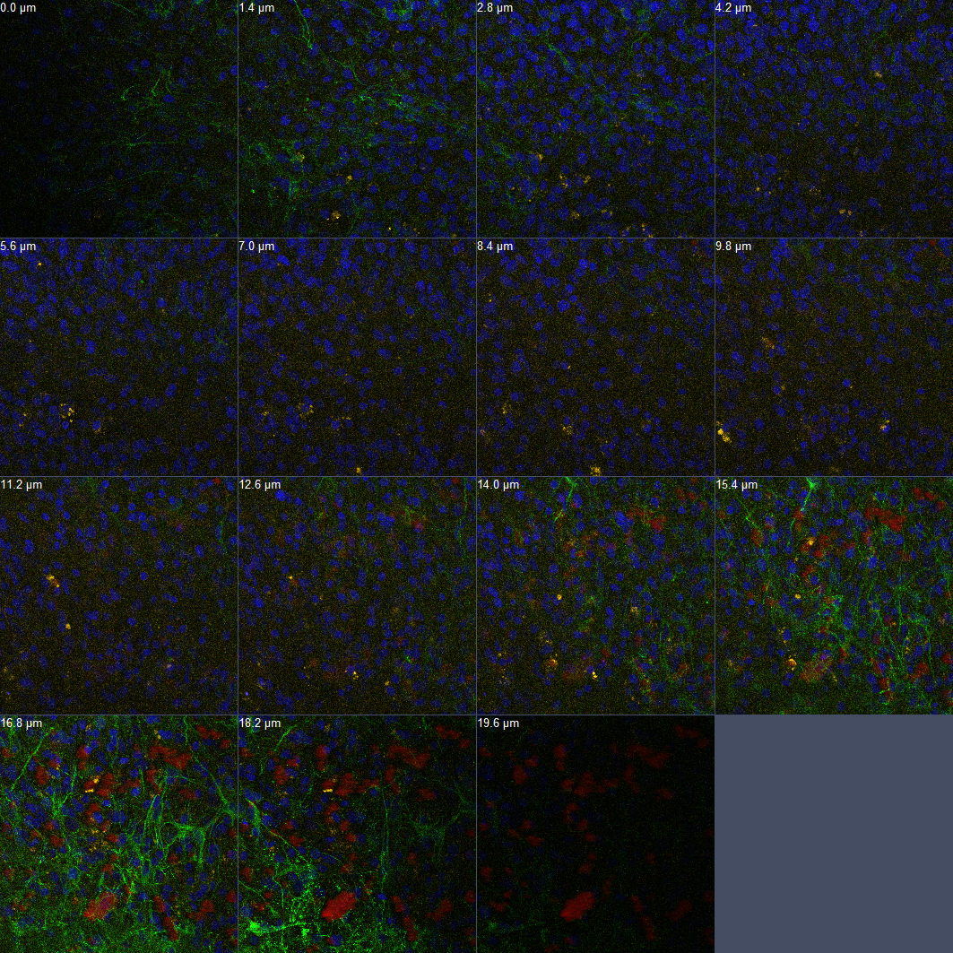
Figure S-1 The z-stack analysis of rat hippocampal slices incubated with 1 µg of UCNPs (1 µg in 4 µl) for 24 hours. Neurons are green, cell nuclei are blue, and the luminescence of UCNPs is marked red.

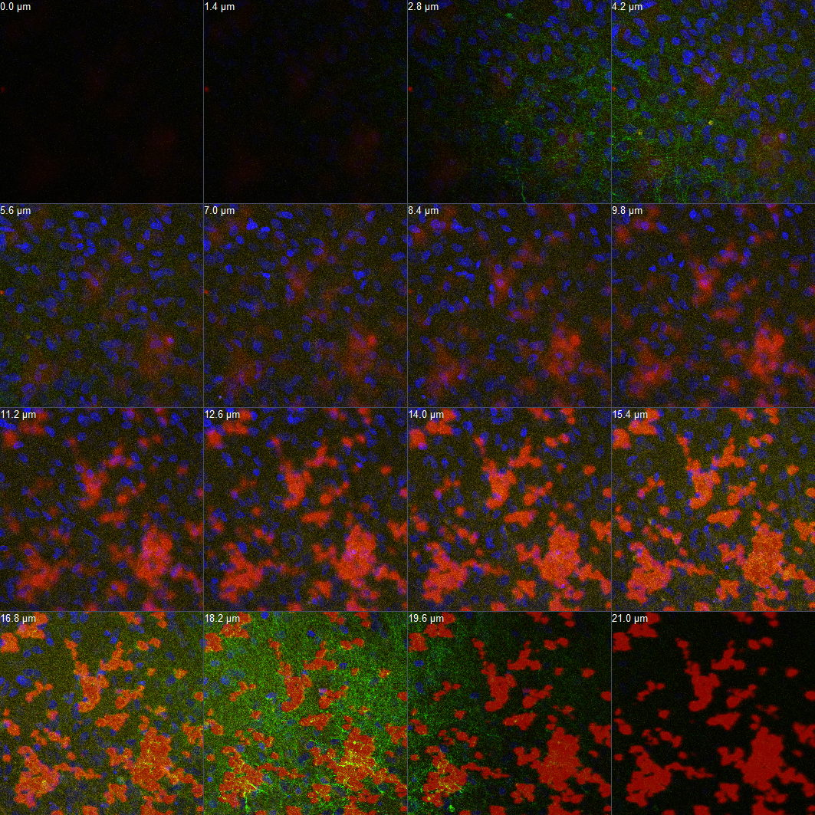
Figure S-2 The z-stack analysis of rat hippocampal slices incubated with 10 µg of UCNPs (1 µg in 4 µl) for 24 hours. Neurons are green, cell nuclei are blue, and the UCNPs luminescence is marked by red.
Address correspondence to First A. Firstauthor, email1; Third C. Thirdauthor, email2

