Supplementary Files

Supplementary Imaging Procesess
The imaging process was included: First, to eliminate the intrinsic dependency on voxel size for the radiomic features, a resampling method with a linear interpolation algorithm was used to normalize the voxel resolution. Higher-order texture analysis features were derived from different directions and different scales, so the anisotropic voxels scanned at other size were resampled to form voxels, i.e, 0.750 mm* 0.750 mm* 0.750 mm. Second, a Gaussian filter was used to remove “unwanted signals”. Because different scanners had the same gray level, gray level normalization was not performed here.

Image Segmentation and Radiomics feature extraction
T1WI, T2WI, ADC and SWI images for each patient were reviewed independently by two pediatric radiologists (observer 1, Z.X.M, a 5-year-experienced pediatric radiologist and observer 2, Y.Y, a 10-year-experienced pediatric radiologist) with anonymized clinical data. Any discrepancies between the two radiologists were settled by a third pediatric radiologist (L.X.M, a 25-year-experienced pediatric radiologist). In this study, DMVs were assessed and quantified with created region of interests (ROIs), closed to the lateral ventricles [14]. ROIs were drawn at the right and left WM involving the DMV. We selected two axial slices to draw the ROI on the level where the DMV showed its typical fan pattern of drainage into the subependymal vein. When drawing the ROIs, we excluded subependymal veins and large cortical veins. Then, we used AK software (Artificial Intelligence Kit v.3.3.0, GE Healthcare) to extract radiomics features. The features included first order, shape (Shape), gray-level run-length matrix (GLRLM), gray-level co-occurrence matrix (GLCM), gray-level dependence matrix (GLDM), gray-level size-zone matrix (GLSZM), and neighborhood gray difference matrix (NGTDM). The selected image transformations were: wavelet transformation (Wavelet), Level 1; logarithmic transformation (LoG), parameter Sigma selection 2.0, 3.0; local binary mode (LBP), Level 2, Radius 1.0, Subdivision select 1. A total of 1,316 features were extracted.

Supplementary Figure 1 The least absolute shrinkage and selection operator (LASSO) including the selection of the regular parameter \(\lambda\) and determination of the number of features.

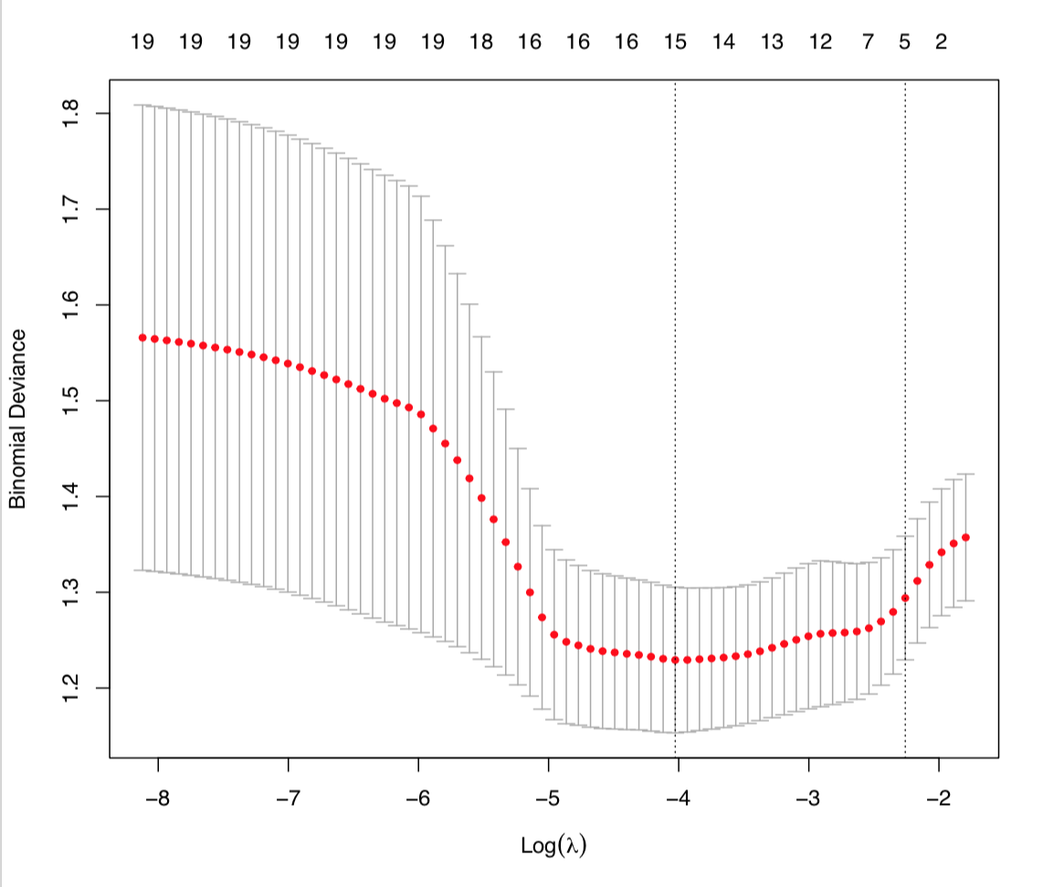
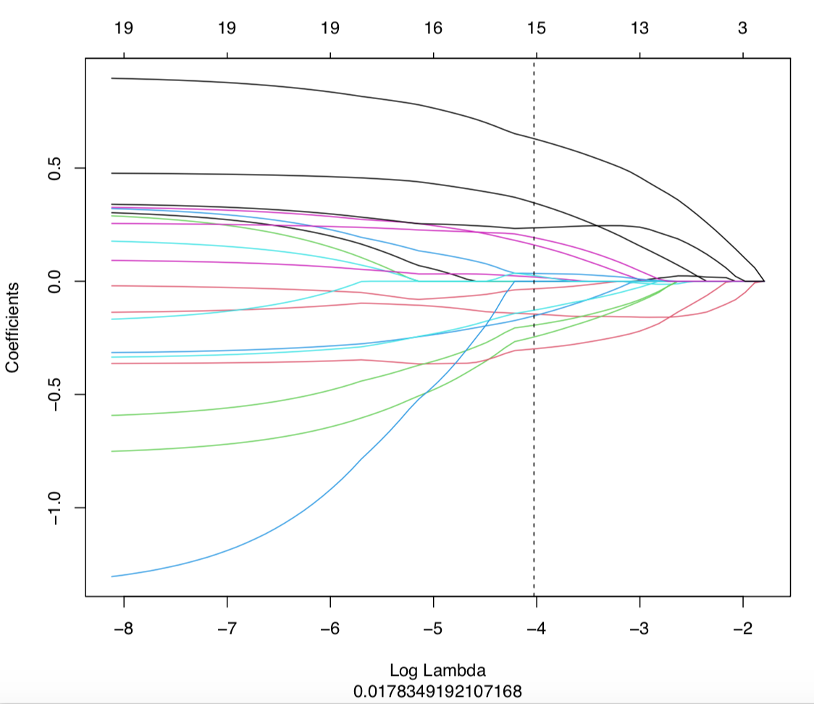
Equations
Equation 1

Rad-score formula
"radscore=0.629825973428418*log_sigma_2_0_mm_3D_firstorder_90Percentile+0.346484769778514*wavelet_HLH_firstorder_Median+0.235842106794395*wavelet_LHL_firstorder_Skewness+0.192932857181591*original_glszm_SmallAreaEmphasis+0.160504078436445*wavelet_LHH_firstorder_Kurtosis+0.0343670169425521*lbp_3D_k_glszm_ZoneEntropy+0.0251172765169056*wavelet_HHH_glrlm_RunVariance+0.0187560922061842*wavelet_HHL_firstorder_Median+-0.0335023890741496*log_sigma_2_0_mm_3D_glrlm_LowGrayLevelRunEmphasis+-0.127906576817766*wavelet_LHH_glszm_SmallAreaLowGrayLevelEmphasis+-0.144746396058406*wavelet_HHL_glcm_Imc1+-0.152855654858139*log_sigma_2_0_mm_3D_glszm_SizeZoneNonUniformityNormalized+-0.194134035522207*wavelet_LLL_ngtdm_Coarseness+-0.246031895063348*wavelet_LHH_glrlm_RunVariance+-0.298628672960307*wavelet_LHH_gldm_SmallDependenceLowGrayLevelEmphasis+-0.683688750272229*(Intercept)"

Equation 2

Nomoscore formula
"nomoscore=0.5966411737973*(Intercept)+0.283652825854209*Urea_nitrogen+0.103365987824817*Radscore"

