Table 1. Patient characteristics before and after propensity score matching
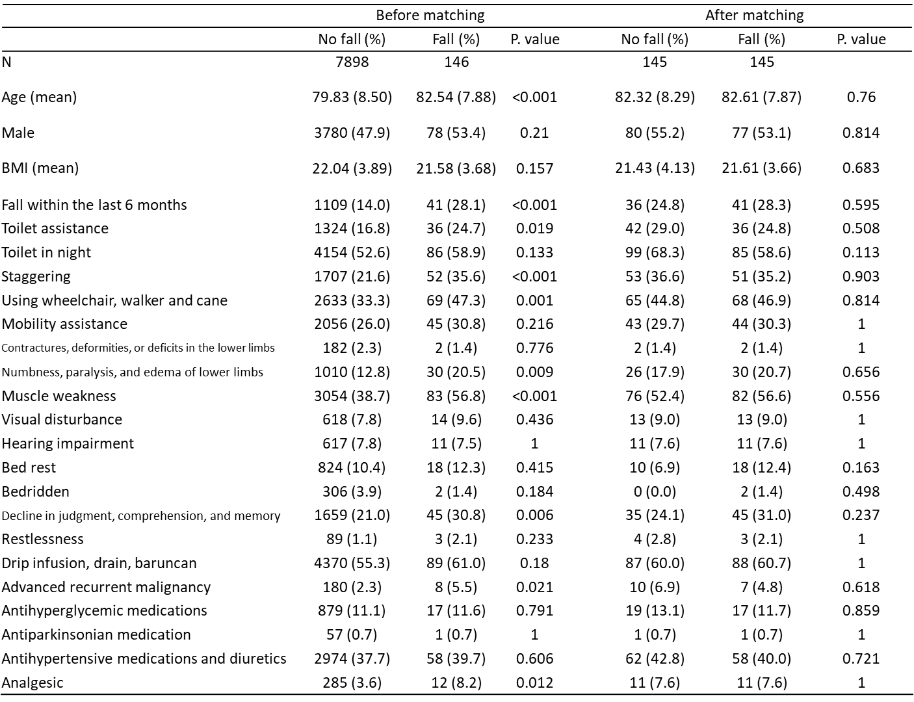

Table 2. Fall risk analysis of each hypnotic drug
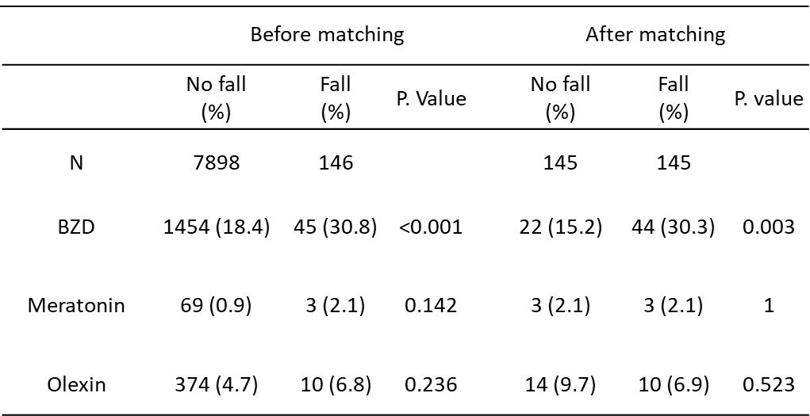

Table 3. Risk factors for nocturnal falls determined via multivariate logistic regression
