Supplementary Materials
Supplementary Materials S1. Topographic metrics for sampling plots
We derived the following topographic variables for each sampling plot using ArcGIS (ESRI 2017): Potential Direct Incident Radiation (PDIR), Heatload, Topographic Position Index (TPI), and Topographic Wetness Index (TWI). We used field-collected measurements of elevation, slope, and aspect to calculate PDIR and Heatload, following equations from McCune and Keon (2002). To calculate TPI and TWI, we used the 1/3 arc-second (~10 m) Digital Elevation Model (DEM) from the USGS National Elevation Dataset (US Geological Survey 2009). TPI describes the position along a slope gradient from a valley bottom position to a ridge top. We calculated TPI as the difference between the elevation of the DEM pixel corresponding to each sampling plot and the mean elevation of a 200-m focal neighborhood centered on the plot pixel. TWI represents topographic controls of hydrological processes (Beven and Kirkby 1979) and is closely related to soil moisture and productivity in many forest ecosystems (e.g. Swetnam et al. 2017, Raduła et al. 2018). We calculated TWI as the natural log of the upslope catchment area divided by the tangent of the slope (Beven and Kirkby 1979). Upslope catchment area was delineated using the Flow Direction and Flow Accumulation tools in ArcGIS.
Boxplots and one-way ANOVAs of each topographic variable as a function of fire year revealed differences in the range and distributions of most topographic variables among fire years, with the exception of TWI, for which a broad range was represented within all fire years (Fig. S1). For this reason, we chose to only include TWI as an indicator of fine-scale topographic variability in our analyses.

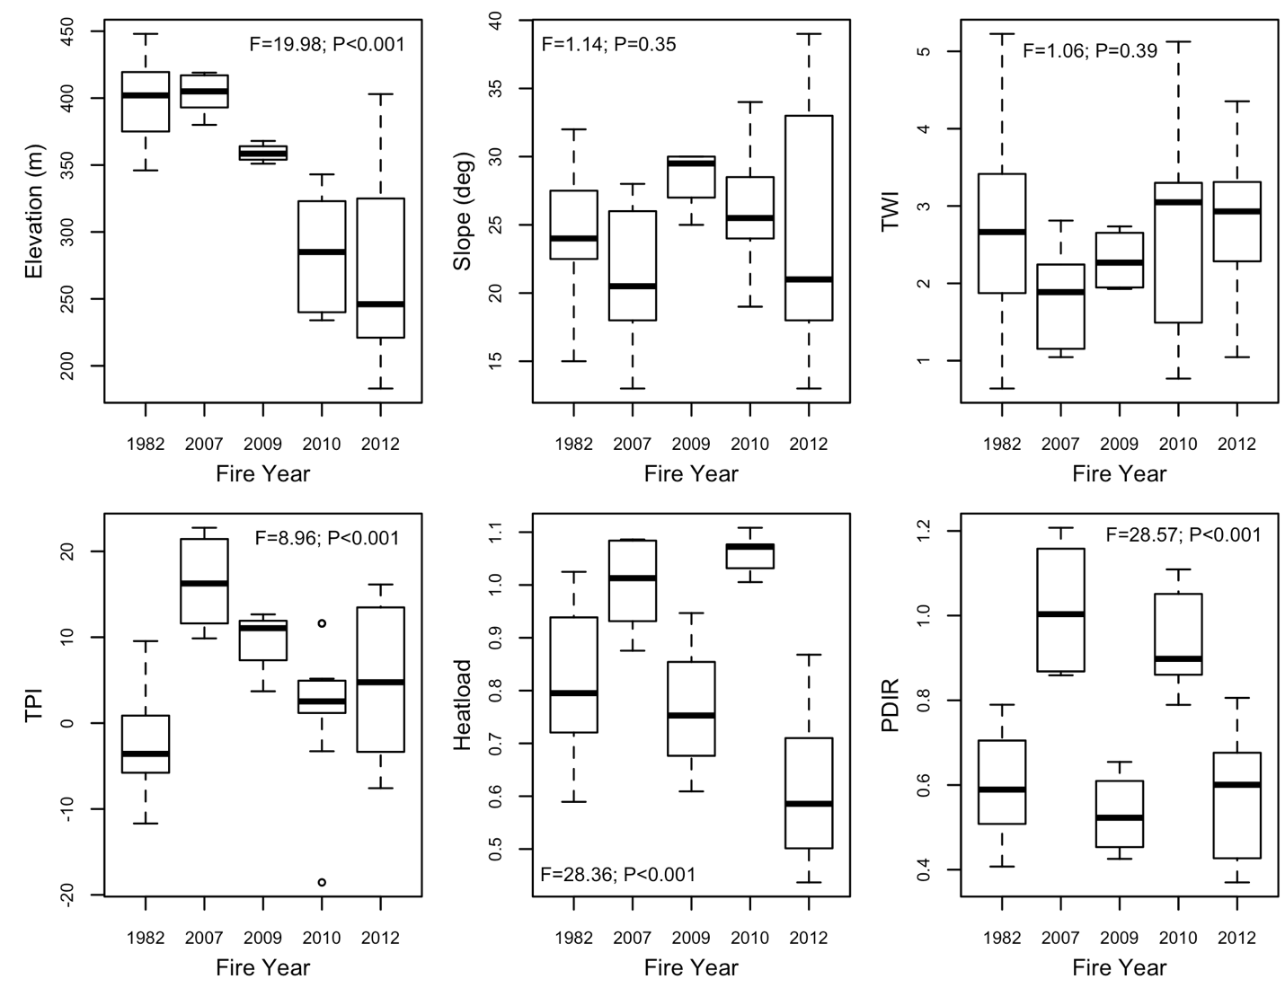Figure S1. Distribution of plots across topographic gradients for each fire year. TWI = Topographic Wetness Index; TPI = Topographic Position Index; PDIR = Potential Direct Incident Radiation. F and P statistics were calculated from analysis of variance testing differences among fire years. Bold line is the median, box margins show the interquartile range, whiskers are the farthest points within 1.5*IQR (interquartile range), and points are outliers.

Supplementary Materials S2. Tree density and size class distribution
Pre-fire tree cover
We used high-resolution aerial imagery to calculate pre-fire tree cover, a proxy for pre-fire seed availability. We derived pre-fire tree cover using land cover classification of USDA NAIP aerial photographic imagery (US Department of Agriculture 2013). All analyses were performed in ArcGIS using the RMRS Raster Utility toolbar (US Forest Service 2012). NAIP color-infrared imagery consists of four 8-bit spectral bands (red, green, blue and near-infrared [NIR]) at 1-m spatial resolution. High-resolution imagery was unavailable for the earliest fire year (1982). We photo-interpreted NAIP imagery collected in 2005 and 2009 to classify pixels as forest, bare earth, understory vegetation, rock, or water. We visually classified pixels within ten of our 0.1-ha plots, totaling approximately 9,000 pixels in each collection year. We withheld data from five of these classified plots for testing model accuracy. A series of softmax neural network (SNN) models was produced linking the components of NAIP spectral values with our sample of visually interpreted pixels to produce 1-m probabilistic surfaces for the five visually distinct land cover classes (St. Peter et al. 2018). Model accuracy was 93% when applied to the withheld visually-classified plots. Using these classification surfaces for each collection of NAIP imagery, we calculated percent tree cover within each plot from the most recent pre-fire collection year.
Data analysis
To characterize shifts in the distribution among tree size classes as a function of time since fire (TSF), we used a linear regression model predicting tree density for each size class in each plot (log₁₀-transformed; n = 50 plots x 4 size classes = 200) as a function of the interaction between tree size class (fixed factor with four levels) and TSF (fixed factor with five levels). To quantify total P. muricata density as a function of TSF and landscape variability, we used linear models predicting total live tree density (log₁₀-transformed; n = 50) as a function of the following candidate predictor variables: TSF (factor), TWI, and TSF*TWI. We ran a second analysis of tree density that added pre-fire tree cover to the predictor variables from the highest-ranking model from the previous model selection; this analysis excluded data from the 1982 burn for which pre-fire imagery was unavailable.
Results
As expected for a serotinous species, seedling density was extremely high following fires, followed by an exponential decline with time since fire (Fig. S2). The distribution of trees among size classes also shifted with time since fire (TSF*size class; F = 39.07, P < 0.001) in expected ways (transitioning from many small trees to fewer large trees), but the fast rate at which this occurred was exceptional (Fig. S2). The highest-ranking model of total P. muricata live tree density included the following predictors: TSF, TWI, and TSF*TWI (Table S1). There was an interaction between time since fire and topographic wetness index (P = 0.001; Table S2; Fig. S3a). In the younger post-fire plots (six to nine years after fire), tree density was positively related to TWI and the highest tree density was observed in wet sites. In contrast, in the oldest burned plots, wetter sites (higher TWI) had lower tree density than drier sites. The effect of pre-fire tree cover (excluding the 1982 fire for which data were unavailable) had a positive effect on post-fire tree density (P = 0.005; β = 0.926; Table S2; Fig. S3b).

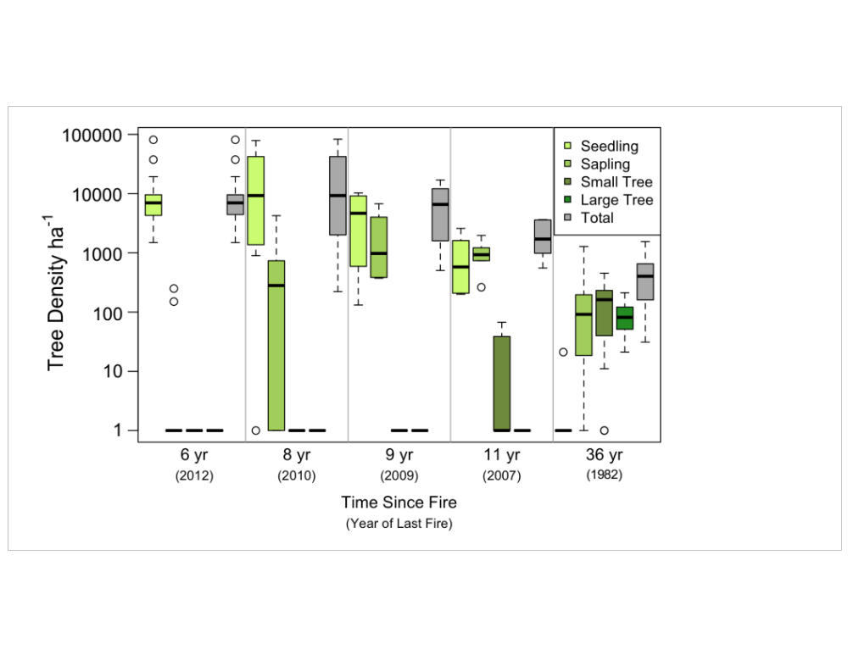
Figure S2. Tree density by size classes for each fire year. Bold line is the median, box margins show the interquartile range, whiskers are the farthest points within 1.5*IQR (interquartile range), and points are outliers.

Table S1. Candidate models for tree density analysis. Models are ranked by AIC_{c}, and models with delta AIC_{c} ≤ 4 are shown. Highest-ranking models are in bold.
Model Structure [Gaussian distribution; N=50] | AIC_{c} | Delta AIC_{c} | Weight
Full candidate model: tree density (log₁₀) ~ TSF + TWI + TSF*TWI
tree density (log₁₀) ~ TSF + TWI + TSF*TWI | 78.9 | 0.00 | 0.978

Table S2. Model results from the analysis of plot-level total live P. muricata density. F-value and P-value calculated from a type 2 ANOVA. Subset model (right column) excluded data from the 1982 fire for which pre-fire aerial imagery was not available. TSF = time since fire (factor with five levels); TWI = topographic wetness index. P-values bolded where <0.05.
 | Tree density,  all fire years  (log₁₀; ha⁻¹) |  | Tree density,  without 1982 fire  (log₁₀; ha⁻¹)
Predictor | F | P | F | P
TSF (yr) | 26.56 | <0.001 | 3.07 | 0.045
TWI | 2.02 | 0.163 | 12.93 | 0.001
TSF*TWI | 5.48 | 0.001 | 3.96 | 0.019
Pre-fire tree cover | n/a | n/a | 12.57 | 0.002
Adjusted R² | 0.71 |  | 0.60

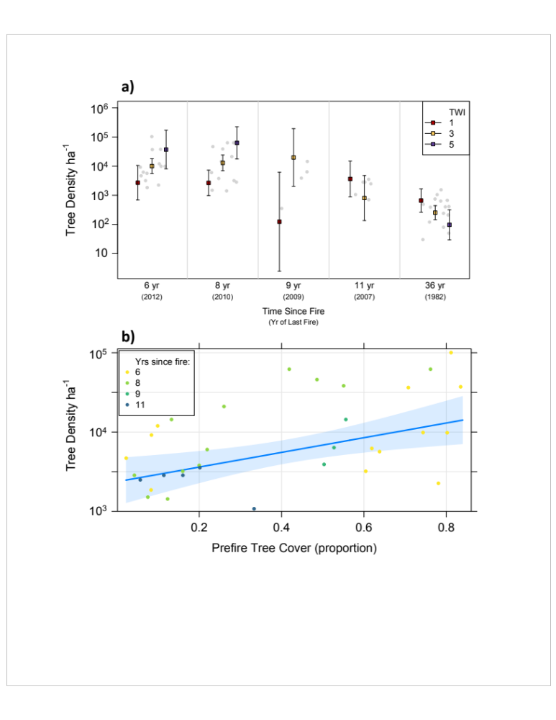
Figure S3. Partial effects plots for models predicting post-fire P. muricata density. (a) Modeled effect of the interaction between time since fire (TSF) and topographic wetness index (TWI) on post-fire P. muricata density (n = 50). (b) Modeled effect of pre-fire tree cover on post-fire P. muricata density (subset model excluding data from the 1982 fire; n = 35), after accounting for the effect of TWI and TSF. Both panels: Lines represent the coefficient estimate ± 95% confidence interval, and points show tree density assessed at the plot level.
Supplementary Materials S3. Canopy seed bank development in post-fire stands

Table S3. Candidate models for analyses of seedbank characteristics. Models are ranked by AIC_{c}, and models with delta AIC_{c} ≤ 4 are shown. Highest-ranking models in bold.
Model Structure | AIC_{c} | Delta AIC_{c} | Weight
Seed density model [Gaussian distribution; N=50]
Full model: seed density (log₁₀) ~ TSF + TWI + TSF*TWI
seed density (log₁₀) ~ TSF | 205.6 | 0.00 | 0.329
seed density (log₁₀) ~ TSF + TWI | 206.8 | 1.18 | 0.182
seed density (log₁₀) ~ TSF + TWI + TSF*TWI | 207.7 | 2.07 | 0.117
Seed viability model [Gaussian distribution; N=32]
Full model: seed viability ~ TSF
seed viability ~ 1 | -70.5 | 0.00 | 0.986
Seeds per cone model [Gaussian distribution; N=443]
Full model: seeds per cone ~ size class + (1|tree/plot/fire)
seeds per cone ~ size class + (1|tree/plot/fire) | 3777.4 | 0.00 | 1.000
Cones per tree model [Poisson distribution; N=3225]
Full candidate model: cones per tree ~ size class + TWI + tree density + (1|plot/fire)
cones per tree ~ tree density + size class + (1|plot/fire) | 17892.1 | 0.00 | 0.512
cones per tree ~ tree density + TWI + size class + (1|plot/fire) | 17894.0 | 1.90 | 0.198

Supplementary Materials S4. Pine pitch canker infection

Table S4. Candidate models for plot-level pitch canker analysis. Models are ranked by AIC_{c}, and models with delta AIC_{c} ≤ 4 are shown. Highest-ranking model is in bold.
Model Structure | AIC_{c} | Delta AIC_{c} | Weight
Proportion of plot infected model [Binomial distribution; N=50]
Full model: proportion infected ~ TSF + TWI + TSF*TWI
proportion infected ~ TSF | 54.3 | 0.00 | 0.434
proportion infected ~ 1 | 56.2 | 1.87 | 0.170
proportion infected ~ TSF + TWI | 57.0 | 2.72 | 0.111

References

Beven, K. J., and M. J. Kirkby. 1979. A physically based, variable contributing area model of basin hydrology. Hydrological Sciences Bulletin 24:43–69.
ESRI. 2017. ArcGIS Desktop. Environmental Systems Research Institute, Redlands, CA, USA.
McCune, B., and D. Keon. 2002. Equations for potential annual direct incident radiation and heat load. Journal of Vegetation Science 13:603–606.
Raduła, M. W., T. H. Szymura, and M. Szymura. 2018. Topographic wetness index explains soil moisture better than bioindication with Ellenberg’s indicator values. Ecological Indicators 85:172–179.
Swetnam, T. L., P. D. Brooks, H. R. Barnard, A. A. Harpold, and E. L. Gallo. 2017. Topographically driven differences in energy and water constrain climatic control on forest carbon sequestration. Ecosphere 8.
US Department of Agriculture. 2013. National Agriculture Imagery Program (NAIP) Information Sheet. https://www.fsa.usda.gov/Internet/FSA_File/naip_info_sheet_2013.pdf.
US Forest Service. 2012. RMRS Raster Utility. http://www.fs.fed.us/rm/raster-utility.
US Geological Survey. 2009. National Elevation Dataset. http://ned.usgs.gov/.

