SUPPLEMENTARY MATERIALS

Table S1. List of studies found using search terms for N.variegata plant in the Web of Science and ScienceDirect databases

N | Article Tile | Research area | Journal | Language | Year | DOI
1 | Effect of thinning and slashing on forage phytomass from a caatinga-of-Petrolina, Pernambuco, Brazil | Agriculture | Pesquisa Agropecuária Brasileira | English | 1995 | NA
2 | Mechanical, Morphological, and Structural Characteristics of Caroa (Neoglaziovia variegata) Fibres | Polymer Science | Polymers & Polymer Composites | English | 2008 | 10.1177/096739110801600902
3 | Soils and vegetation relations in areas under desertification in Jataúba County, Pernambuco State, Brazil | Agriculture | Revista Brasileira de Ciência do Solo | Portuguese | 2008 | 10.1590/S0100-06832008000300036
4 | Micropropagation and in vitro conservation of Neoglaziovia variegata (Arr. Cam.) mez, a fiber producing bromeliad from Brazil | Applied Sciences | Brazilian Archives of Biology and Technology | English | 2009 | 10.1590/S1516-89132009000400016
5 | Genetic variability estimated among caroá populations through RAPD markers | Agriculture | Pesquisa Agropecuária Brasileira | Portuguese | 2009 | 10.1590/S0100-204X2009000300010
6 | Evaluation of the effects of acetylation surface treatments on ‘caroá’ fiber | Agriculture | Revista Brasileira de Engenharia Agrícola e Ambiental | Portuguese | 2011 | 10.1590/S1415-43662011000100012
7 | Germinative response of Neoglaziovia variegata (Arruda) Mez seeds | Agriculture | Ciência e Agrotecnologia | Portuguese | 2011 | 10.1590/S1413-70542011000500012
8 | Gastroprotective Effect of an Ethanolic Extract from Neoglaziovia variegata (Arruda) Mez (Bromeliaceae) in Rats and Mice | Pharmacology & Pharmacy | Zeitschrift fur naturforschung section c-a journal of biosciences | English | 2013 | 10.5560/ZNC.2013.68c0097
9 | Somatic embryogenesis of Neoglaziovia variegata (Arruda) Mez, an important source of fiber from native Brazilian bromeliads | Life Sciences & Biomedicine | Brazilian Archives of Biology and Technology | English | 2013 | 10.1590/S1516-89132013000400004
10 | Morpho-physiological aspects of in vitro pre-acclimatization and acclimatization of the caroá plant | Agriculture | Revista Ciência Agronômica | Portuguese | 2013 | 10.1590/S1806-66902013000300017
11 | Antimicrobial potential of ethanolic plant extracts against gram negative bacilli isolated from the cervical-vaginal mucosa of sheep raised in the region of Petrolina-PE | Agriculture | Semina-Ciencias Agrarias | Portuguese | 2014 | 10.5433/1679-0359.2014v35n2p883
12 | Acaricidal activity of extracts from the leaves and aerial parts of Neoglaziovia variegata (Bromeliaceae) on the cattle tick Rhipicephalus (Boophilus) microplus | Veterinary Sciences | Research in Veterinary Science | English | 2015 | 10.1016/j.rvsc.2015.04.012
13 | Antibacterial potential of native plants from the caatinga biome against staphylococcus spp. isolates from small ruminants with mastitis | Veterinary Sciences | Revista Caatinga | English | 2016 | 10.1590/1983-21252016v29n328rc
14 | Non-Polar Natural Products from Bromelia laciniosa, Neoglaziovia variegata and Encholirium spectabile (Bromeliaceae) | Chemistry | Molecules | English | 2017 | 10.3390/molecules22091478
15 | Innovation in floriculture with ornamental plants from Caatinga biome | Agriculture | Ornamental Horticulture-Revista Brasileira de Horticultura Ornamental | English | 2017 | 10.14295/oh.v23i3.1081
16 | A novel poly-oxygenated flavone glucoside from aerial parts of the Brazilian plant Neoglaziovia variegata (Bromeliaceae) | Science & Technology | Heliyon | English | 2019 | 10.1016/j.heliyon.2019.e01369
17 | Gastroprotective Activity of Neoglaziovia variegata (Arruda) Mez. (Bromeliaceae) in Rats and Mice | Nutrition & Dietetics | Journal of Medicinal Food | English | 2021 | 10.1089/jmf.2020.0182
18 | Acaricidal efficacy and chemical study of hexane extracts of the leaves of Neoglaziovia variegata (Bromeliaceae) against the tick Rhipicephalus microplus | Entomology | Experimental and Applied Acarology | English | 2021 | 10.1007/s10493-021-00611-9
19 | Influence of Seasonality on Phytochemical Composition,  Phenolic Content and Antioxidant Activity of Neoglaziovia  variegata (Bromeliaceae) | Chemistry | Biointerface Research in Applied Chemistry | English | 2022 | 10.33263/BRIAC123.28892904
20 | Morphometric characterization and functional traits of fruits and seeds of Neoglaziovia variegata (Arruda) Mez. | Agriculture | Journal of Seed Science | English | 2022 | 10.1590/2317-1545v44250044
NA: not available, Source: Web of Science and ScienceDirect

Table S2. List of studies found using search terms for T. spicata plant in the Web of Science and ScienceDirect databases

N | Article Tile | Research area | Journal | Language | Year | DOI
1 | Assessment and quantification of phytoliths present in Chloris elata Desv., Chloris gayana Kunth, Tripogon spicatus (Ness) Ekman (Chloridoideae) | Plant Sciences | Iheringia Serie Botanica | Portuguese | 2012 | NA
2 | The resurrection plant Tripogon spicatus (poaceae) harbors a diversity of plant growth promoting bacteria in northeastern brazilian caatinga | Agriculture | Revista Brasileira de Ciência do Solo | English | 2015 | 10.1590/01000683rbcs20140646
3 | A molecular phylogeny and classification of the Cynodonteae (Poaceae: Chloridoideae) with four new genera: Orthacanthus, Triplasiella, Tripogonella, and Zaqiqah; three new subtribes: Dactylocteniinae, Orininae, and Zaqiqahinae; and a subgeneric classification of Distichlis | Evolutionary Biology | Taxon | English | 2016 | 10.12705/656.4
4 | Vegetative desiccation tolerance of Tripogon spicatus (Poaceae) from the tropical semiarid region of northeastern Brazil | Plant Sciences | Functional Plant Biology | English | 2017 | 10.1071/FP17066
5 | Tilletia tripogonellae (Tilletiaceae), a new smut fungus on Tripogonella spicata (Poaceae) from Argentina | Plant Sciences | Annales Botanici Fennici | English | 2018 | 10.5735/085.055.0407
6 | Inoculation of plant growth-promoting bacteria attenuates the negative effects of drought on sorghum | Microbiology | Archives of Microbiology | English | 2020 | 10.1007/s00203-020-01810-5
7 | Beneficial Plant-Associated Microorganisms From Semiarid Regions and Seasonally Dry Environments: A Review | Microbiology | Frontiers in Microbiology | English | 2021 | 10.3389/fmicb.2020.553223
NA: not available, Source: Web of Science and ScienceDirect

Table S3. Reads per sample obtained by sequencing of mycorrhizal (targeted to ITS and 18S rRNA) considering two sampled plants, Tripogonella Spicata (Nees) (n = 18) and Neoglaziovia variegata (Arruda) Mez. (n = 19)
Sample ID | NS31/AML2 and  AMV4.5NF/ AMDGR primers  (reads) | Plant | NCBI  BioSample accessions
109 | 13,108 | Tripogonella Spicata (Nees) | SAMN29923066
110 | 13,157 | Tripogonella Spicata (Nees) | SAMN29923067
111 | 13,740 | Tripogonella Spicata (Nees) | SAMN29923068
112 | 14,896 | Tripogonella Spicata (Nees) | SAMN29923069
113 | 14,144 | Tripogonella Spicata (Nees) | SAMN29923070
115 | 16,033 | Tripogonella Spicata (Nees) | SAMN29923071
116 | 14,195 | Tripogonella Spicata (Nees) | SAMN29923072
117 | 14,601 | Tripogonella Spicata (Nees) | SAMN29923073
118 | 14,528 | Tripogonella Spicata (Nees) | SAMN29923074
119 | 15,255 | Tripogonella Spicata (Nees) | SAMN29923075
120 | 17,121 | Tripogonella Spicata (Nees) | SAMN29923076
121 | 12,608 | Tripogonella Spicata (Nees) | SAMN29923077
122 | 12,843 | Tripogonella Spicata (Nees) | SAMN29923078
123 | 13,184 | Tripogonella Spicata (Nees) | SAMN29923079
124 | 15,850 | Tripogonella Spicata (Nees) | SAMN29923080
125 | 12,606 | Tripogonella Spicata (Nees) | SAMN29923081
126 | 10,930 | Tripogonella Spicata (Nees) | SAMN29923082
127 | 12,415 | Tripogonella Spicata (Nees) | SAMN29923083
128 | 13,202 | Neoglaziovia variegata (Arruda) Mez. | SAMN29923084
129 | 12,804 | Neoglaziovia variegata (Arruda) Mez. | SAMN29923085
130 | 15,204 | Neoglaziovia variegata (Arruda) Mez. | SAMN29923086
131 | 15,588 | Neoglaziovia variegata (Arruda) Mez. | SAMN29923087
132 | 14,513 | Neoglaziovia variegata (Arruda) Mez. | SAMN29923088
133 | 20,967 | Neoglaziovia variegata (Arruda) Mez. | SAMN29923089
134 | 13,792 | Neoglaziovia variegata (Arruda) Mez. | SAMN29923090
135 | 9,803 | Neoglaziovia variegata (Arruda) Mez. | SAMN29923091
136 | 14,855 | Neoglaziovia variegata (Arruda) Mez. | SAMN29923092
137 | 10,002 | Neoglaziovia variegata (Arruda) Mez. | SAMN29923093
138 | 14,077 | Neoglaziovia variegata (Arruda) Mez. | SAMN29923094
139 | 11,242 | Neoglaziovia variegata (Arruda) Mez. | SAMN29923095
140 | 14,198 | Neoglaziovia variegata (Arruda) Mez. | SAMN29923096
141 | 12,826 | Neoglaziovia variegata (Arruda) Mez. | SAMN29923097
143 | 16,263 | Neoglaziovia variegata (Arruda) Mez. | SAMN29923098
144 | 15,920 | Neoglaziovia variegata (Arruda) Mez. | SAMN29923099
146 | 16,450 | Neoglaziovia variegata (Arruda) Mez. | SAMN29923100
147 | 15,878 | Neoglaziovia variegata (Arruda) Mez. | SAMN29923101
149 | 18,448 | Neoglaziovia variegata (Arruda) Mez. | SAMN29923102

Table S4. Permutational Multivariate Analysis of Variance of the mycorrhizal community structure using Adonis test based on Bray Curtis distance (Permutation = 999)
 | DF | SS | MS | F Model | R² | p-value
Plant | 1 | 1.343 | 1.3430 | 2.9884 | 0.079 | 0.001 ***
Residuals | 35 | 15.729 | 0.4494 |  | 0.921
Total | 36 | 17.072 |  |  | 1.00
DF: degrees of freedom, SS: sum of squares, MS: Mean of squares, ***: p ≤ 0.001

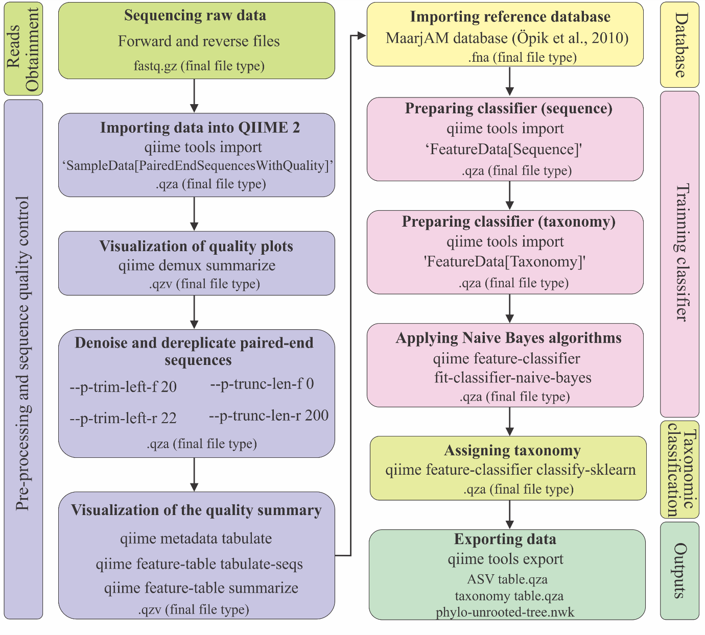
Fig. S1 Workflow of the pipeline used to analyse the AMF amplicon sequencing using nested PCR with NS31and AML2 as the first reaction and AMV4.5NF and AMDGR primers as the second round of PCR reactions.

