Antarctic snow algae: unraveling the processes underlying microbial community assembly during blooms formation
Daniela F. Soto,^{1,2*} Iván Gómez,^{1,2} and Pirjo Huovinen^{1,2}
¹Instituto de Ciencias Marinas y Limnológicas, Universidad Austral de Chile,Valdivia, Chile.
² Research Centre on Dynamics of High Latitude Marine Ecosystems (IDEAL), Valdivia, Chile.
* Corresponding author:
Daniela F. Soto
Instituto de Ciencias Marinas y Limnológicas, Facultad de Ciencias, Edificio Emilio Pugin 1er Piso, Campus Isla Teja, Universidad Austral de Chile, Valdivia, Chile.

e-mail address: daniela.soto@uach.cl
phone/fax number: (56) 63 2221210 - 221455

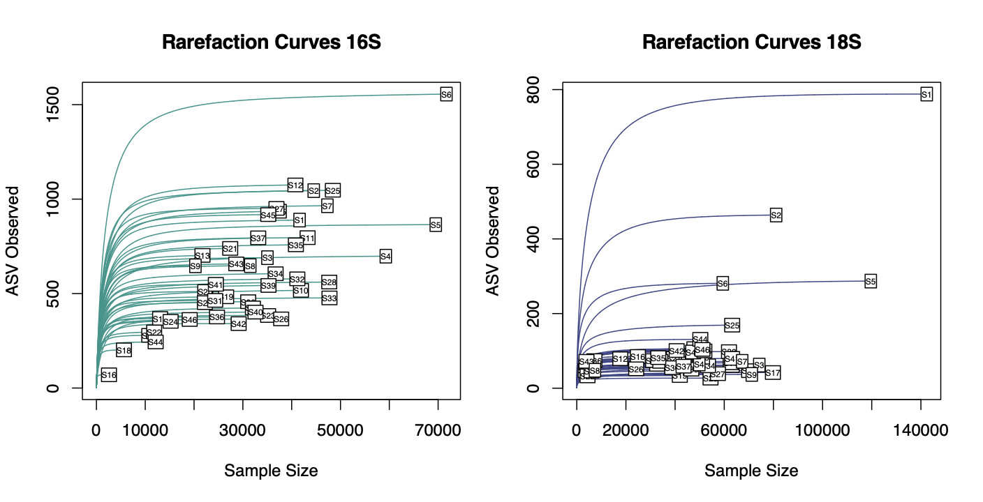
Supplementary Fig. 1. Rarefaction curves of bacterial and eukaryotic (16S rRNA and 18S rRNA genes) ASVs.

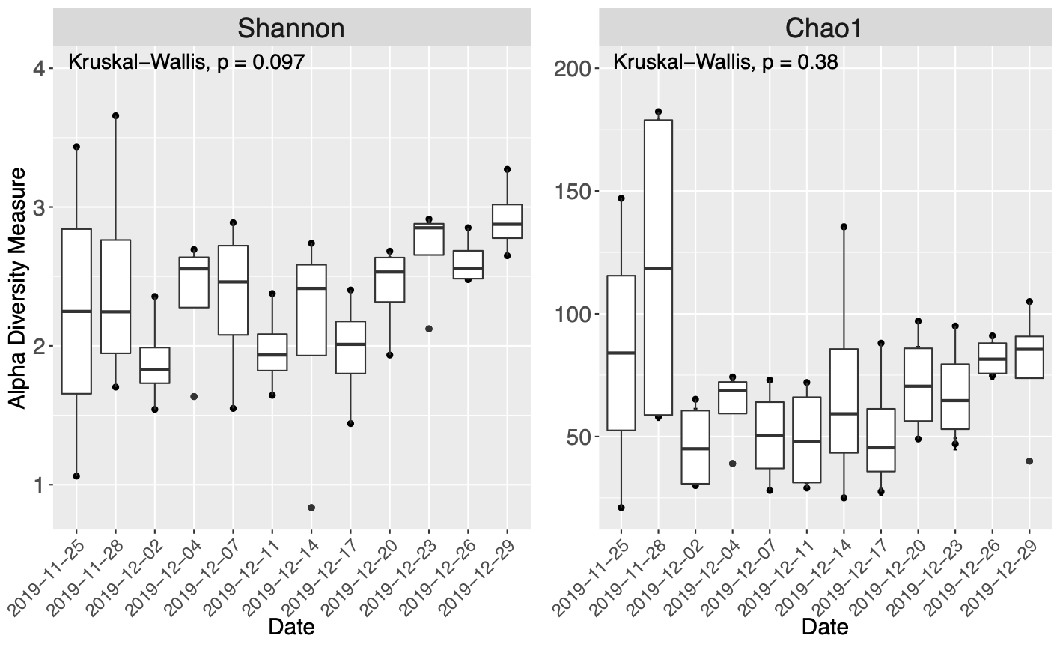
Supplementary Fig. 2. Boxplots of Shannon-Wiener diversity index and Richness (Chao 1) of bacterial communities in snow samples collected at O’Higgins. Statistical comparations were performed on the community structure based in metabarcoding using sampling day as categorical variable.

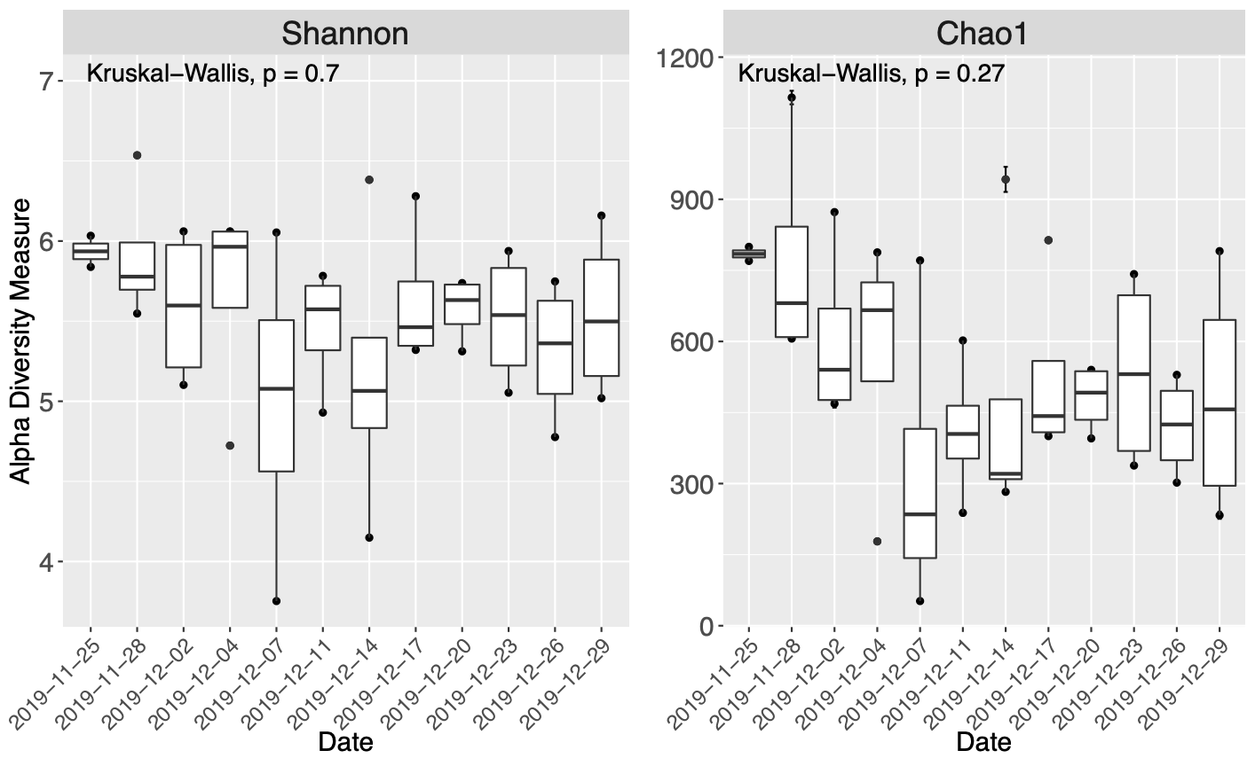
Supplementary Fig. 3. Lineplots of Shannon-Wiener diversity index and Richness (number of species) of eukaryotic communities in snow samples collected at O’Higgins. Statistical comparations were performed on the community structure based in metabarcoding using sampling day as categorical variable.

