SUPPLEMENTAL MATERIALS

Supplementary figure 1. Monthly spatial correlograms with test positivity for combined malaria cases/tests.
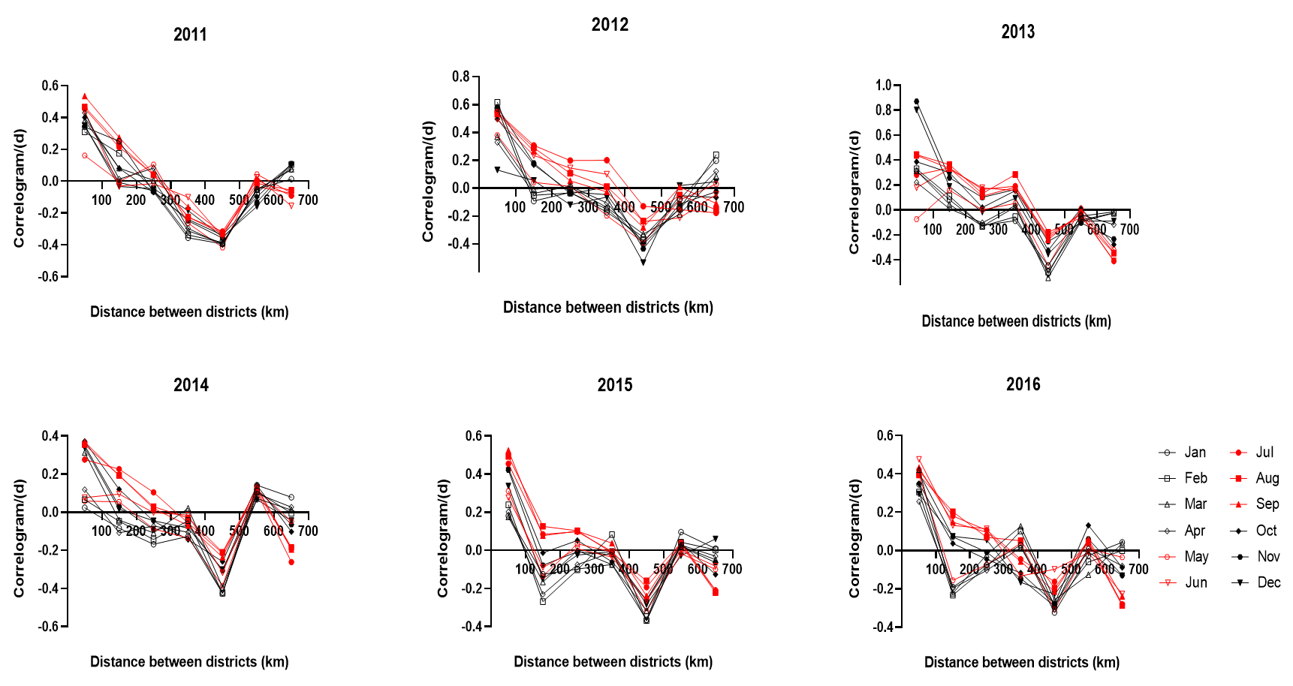

Supplementary figure 2. Monthly spatial correlograms with the API (annual parasite index) for combined malaria. API is calculated as the number of cases per 1000 people per year.
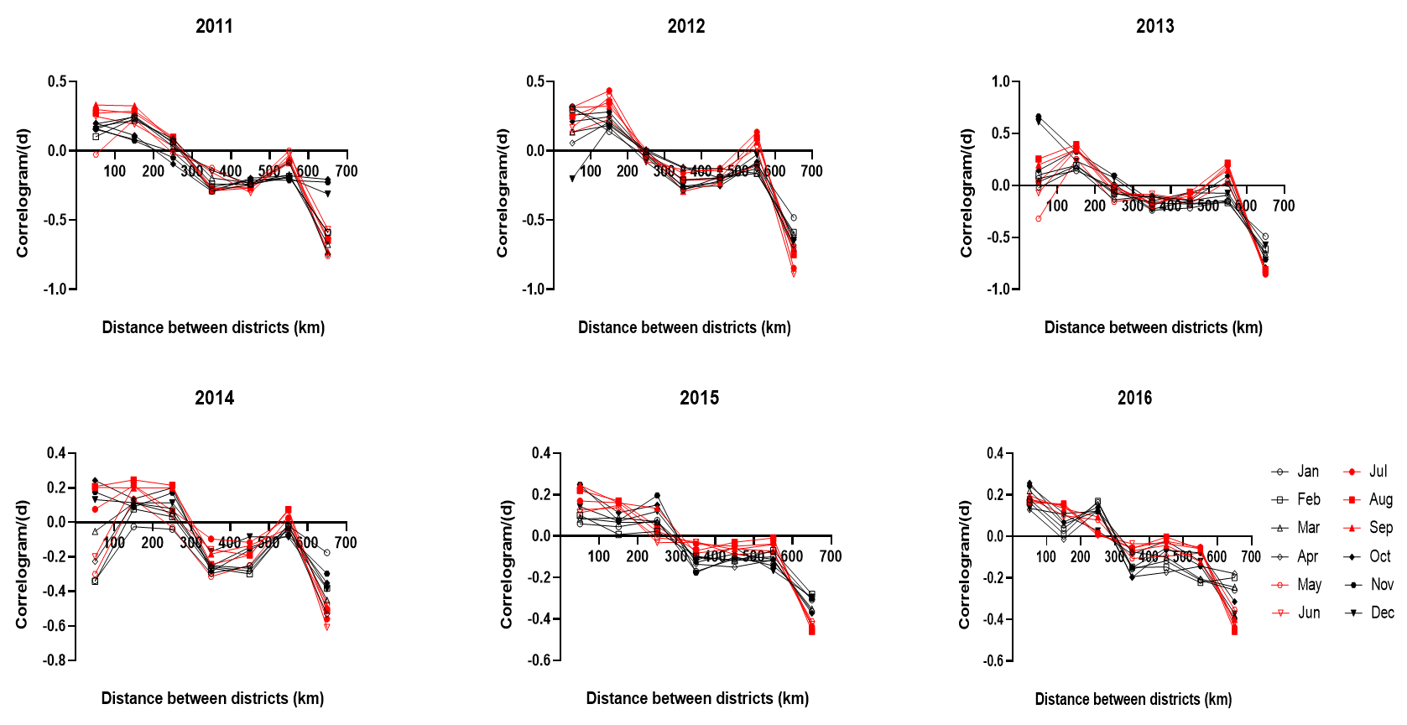

Supplementary figure 3. Monthly spatial correlograms with SEB API for combined malaria.
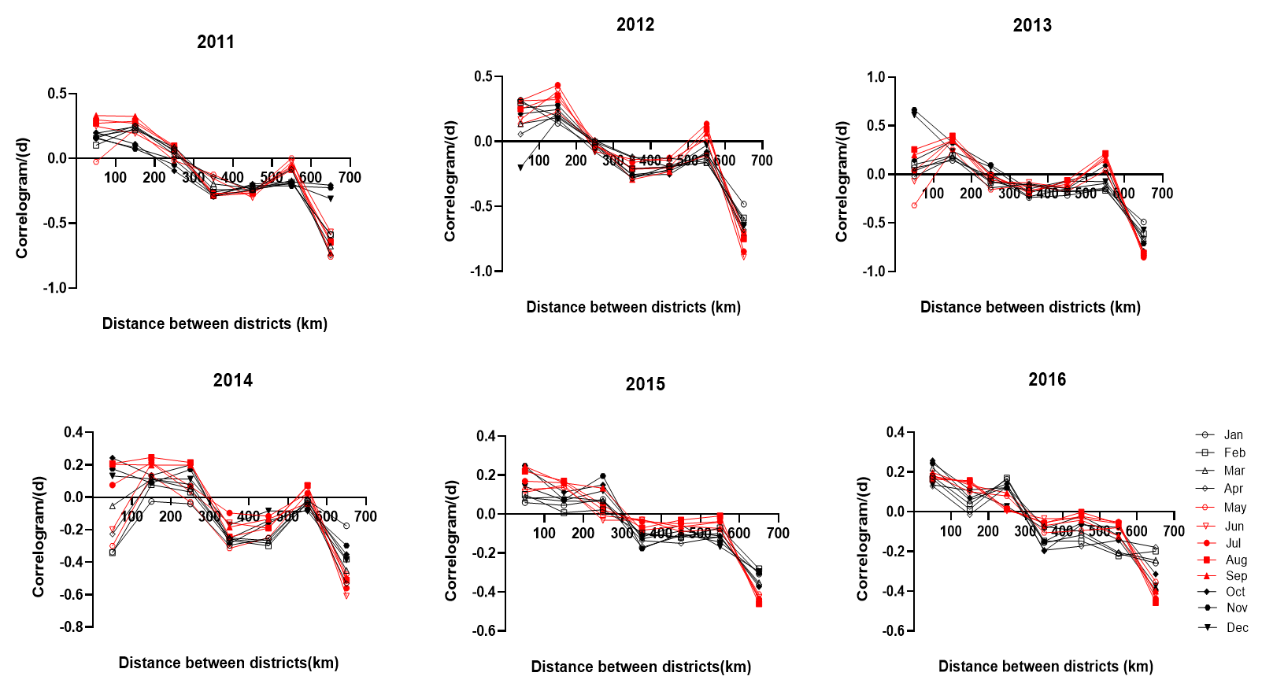

Supplementary figure 4. P. falciparum malaria distribution and spatial autocorrelation statistic using the test positivity (TP).
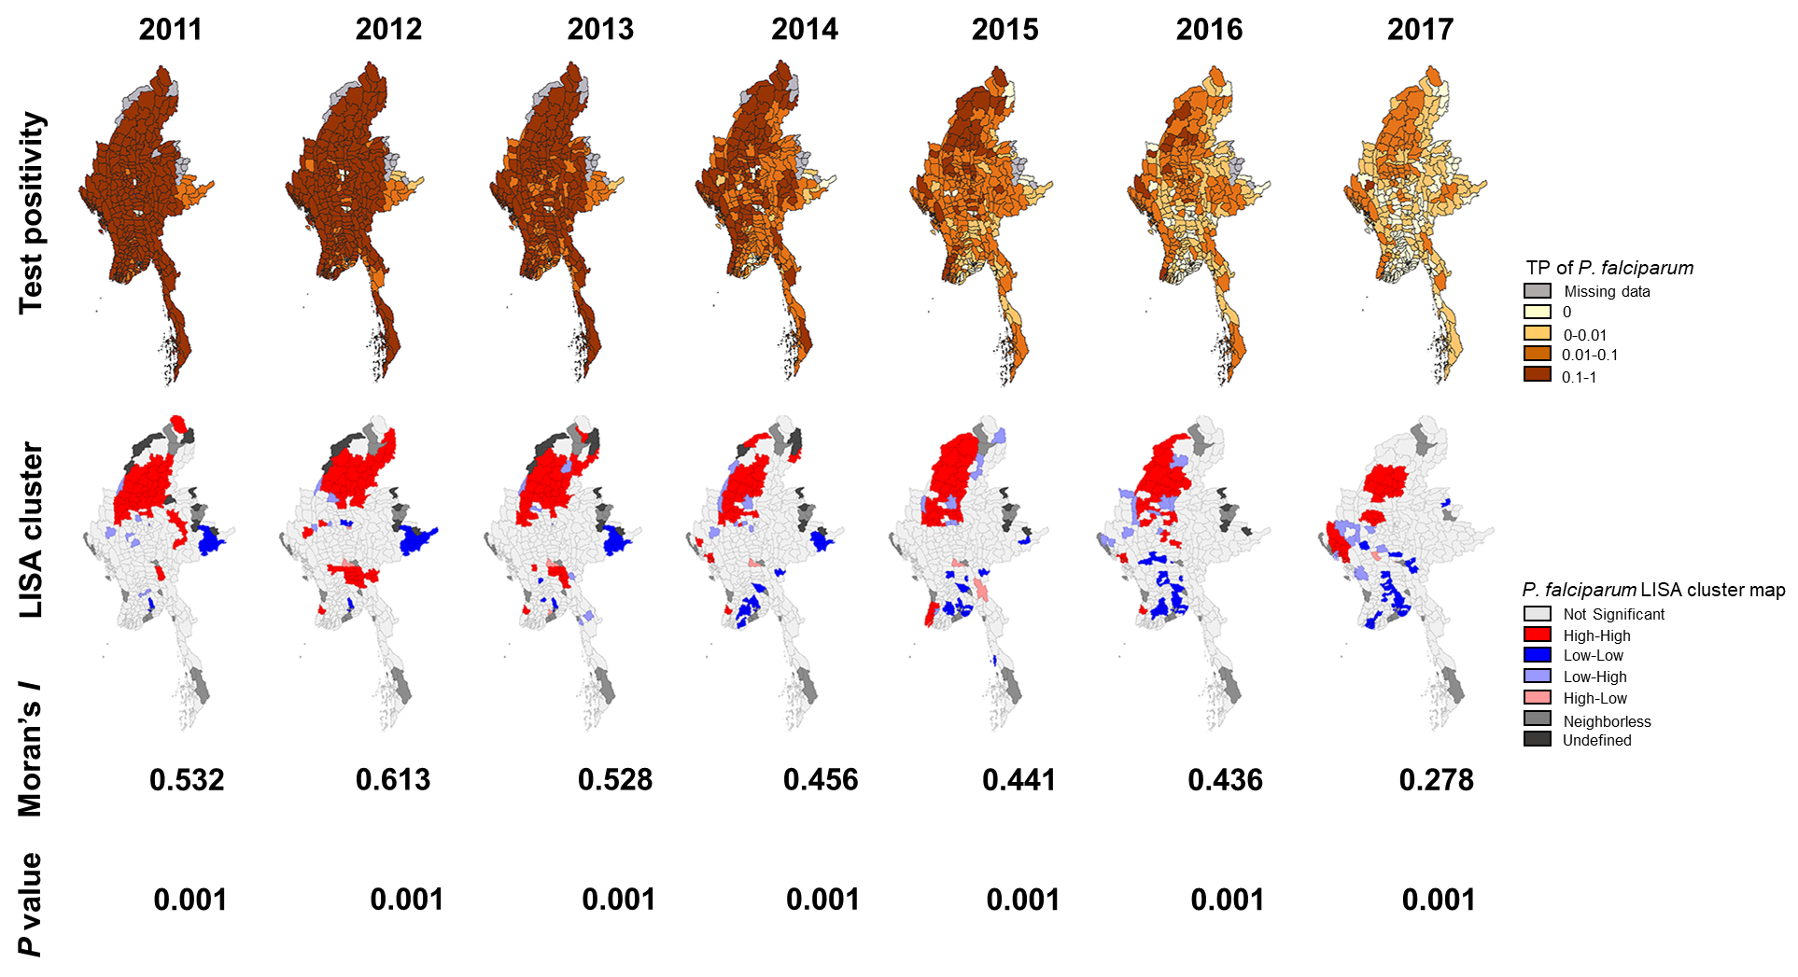

Supplementary figure 5. P. falciparum malaria distribution and spatial autocorrelation statistic using the annual parasite incidence (API), calculated as the number of cases per 1000 people per year.
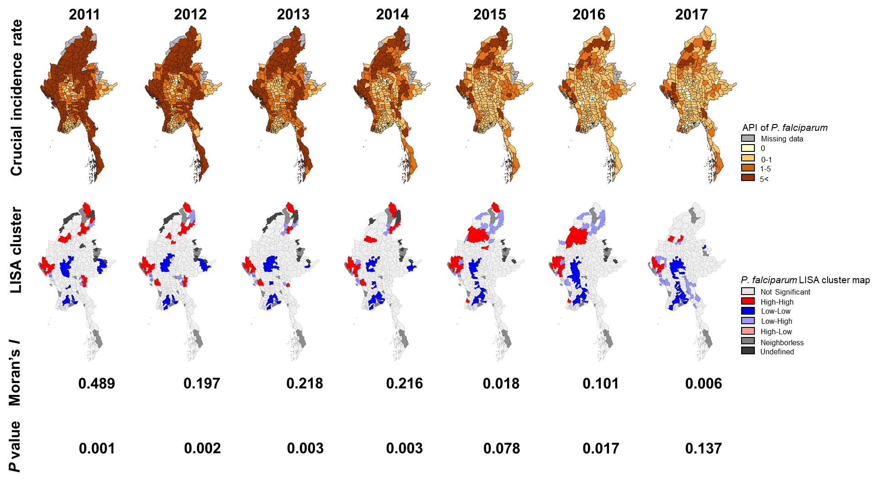

Supplementary figure 6. P. vivax malaria distribution and spatial autocorrelation statistic using the test positivity (TP).
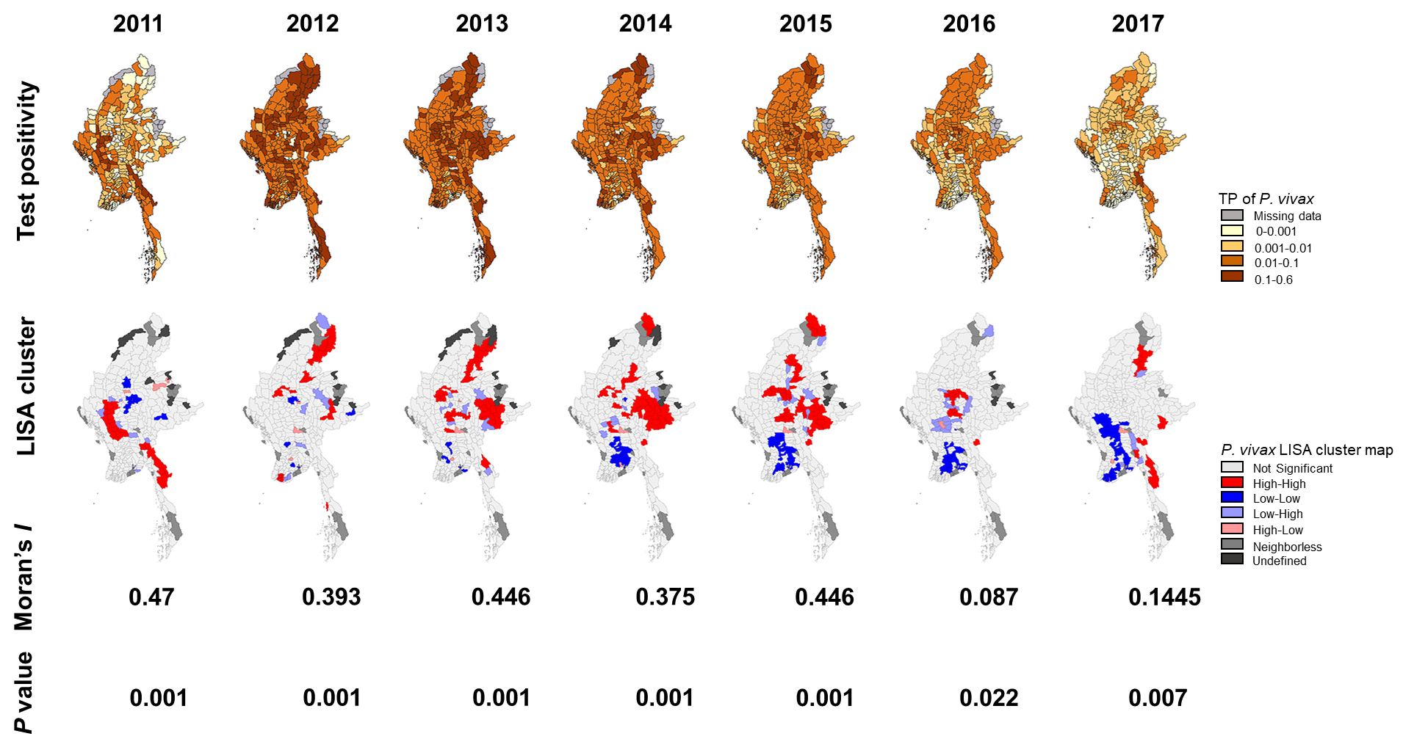

Supplementary figure 7. P. vivax malaria distribution and spatial autocorrelation statistic using the annual parasite incidence (API) calculated as the number of cases per 1000 people per year.
