Attributing extreme precipitation characteristics in South China Pearl River Delta region to anthropogenic influences based on pseudo global warming

Supporting information

Rui Zhao^{1,2} $∙$ Chi-Yung Tam¹ $∙$ Sai-Ming Lee³ $∙$ Junwen Chen⁴ $∙$ Peng Gao⁵

✉ Chi-Yung Francis Tam
Francis.Tam@cuhk.edu.hk
¹ Earth System Science Programme, The Chinese University of Hong Kong, Hong Kong, China
² Fujian Key Laboratory of Severe Weather, Fujian Institute of Meteorological Sciences, Fuzhou, 350001, Fujian, China
³ Hong Kong Observatory, Hong Kong, China
⁴ Shenzhen Wiselec Technology Co., Ltd., Shenzhen, 518048, Guangdong, China
⁵ Meteorological Bureau of Liupanshui, Liupanshui, 553001, Guizhou, China

Table S1. Date of extreme rainfall events used in this study.
MJJAS (23 cases) |  | Non-MJJAS (17 cases)
09 - 14/06/2000 | 13 - 18/06/2010 | 13 - 18/02/1998 | 06 - 11/11/2011
07 - 12/05/2001 | 22 - 27/06/2010 | 29/03 - 03/04/2004 | 13 - 18/01/2012
09 - 14/06/2002 | 03 - 08/08/2010 | 21 - 26/03/2006 | 29/11 - 04/12/2012
29/06 - 04/07/2002 | 08 - 13/09/2010 | 19 - 24/11/2006 | 28/04 - 03/05/2013
11 - 16/06/2003 | 20 - 25/06/2012 | 22 - 27/04/2007 | 13 - 18/12/2013
10 - 15/05/2004 | 18 - 23/05/2013 | 23 - 28/01/2008 | 10 - 15/01/2015
06 - 11/06/2006 | 16 - 21/05/2014 | 03 - 08/10/2008 | 18 - 23/03/2016
24 - 29/07/2006 | 21 - 26/05/2015 | 20 - 25/04/2010 | 04 - 09/01/2018
17 - 22/05/2007 | 01 - 06/06/2017 | 10 - 15/10/2011
06 - 11/06/2007 | 05 - 10/09/2017
26 - 31/05/2008 | 05 - 10/05/2018
15 - 20/06/2008

Table S2. Descriptions of the CMIP5 GCMs used in this study.
No. | IPCC ID | Institute and Country | Resolution  (Lon$×$Lat) | Mean anomaly of initial T_{sfc} in D02 ($℃$)
1 | Bcc-csm1-1 | Beijing Climate Center, China Meteorological Administration, China | 128×64 | 0.63
2 | CanESM2 | Canadian Centre for Climate Modelling and Analysis, Canada | 128×64 | 0.61
3 | CCSM4 | National Center for Atmospheric Research, USA | 288×192 | 0.74
4 | GFDL_ESM2M | Geophysical Fluid Dynamics Laboratory, USA | 144×90 | 0.72
5 | IPSL-CM5A-LR | L’Institut Pierre-Simon Laplace, France | 96×96 | 1.03
6 | IPSL-CM5A-MR | L’Institut Pierre-Simon Laplace, France | 96×96 | 0.79
7 | MRI-CGCM3 | Meteorological Research Institute, Japan | 256×128 | 0.62

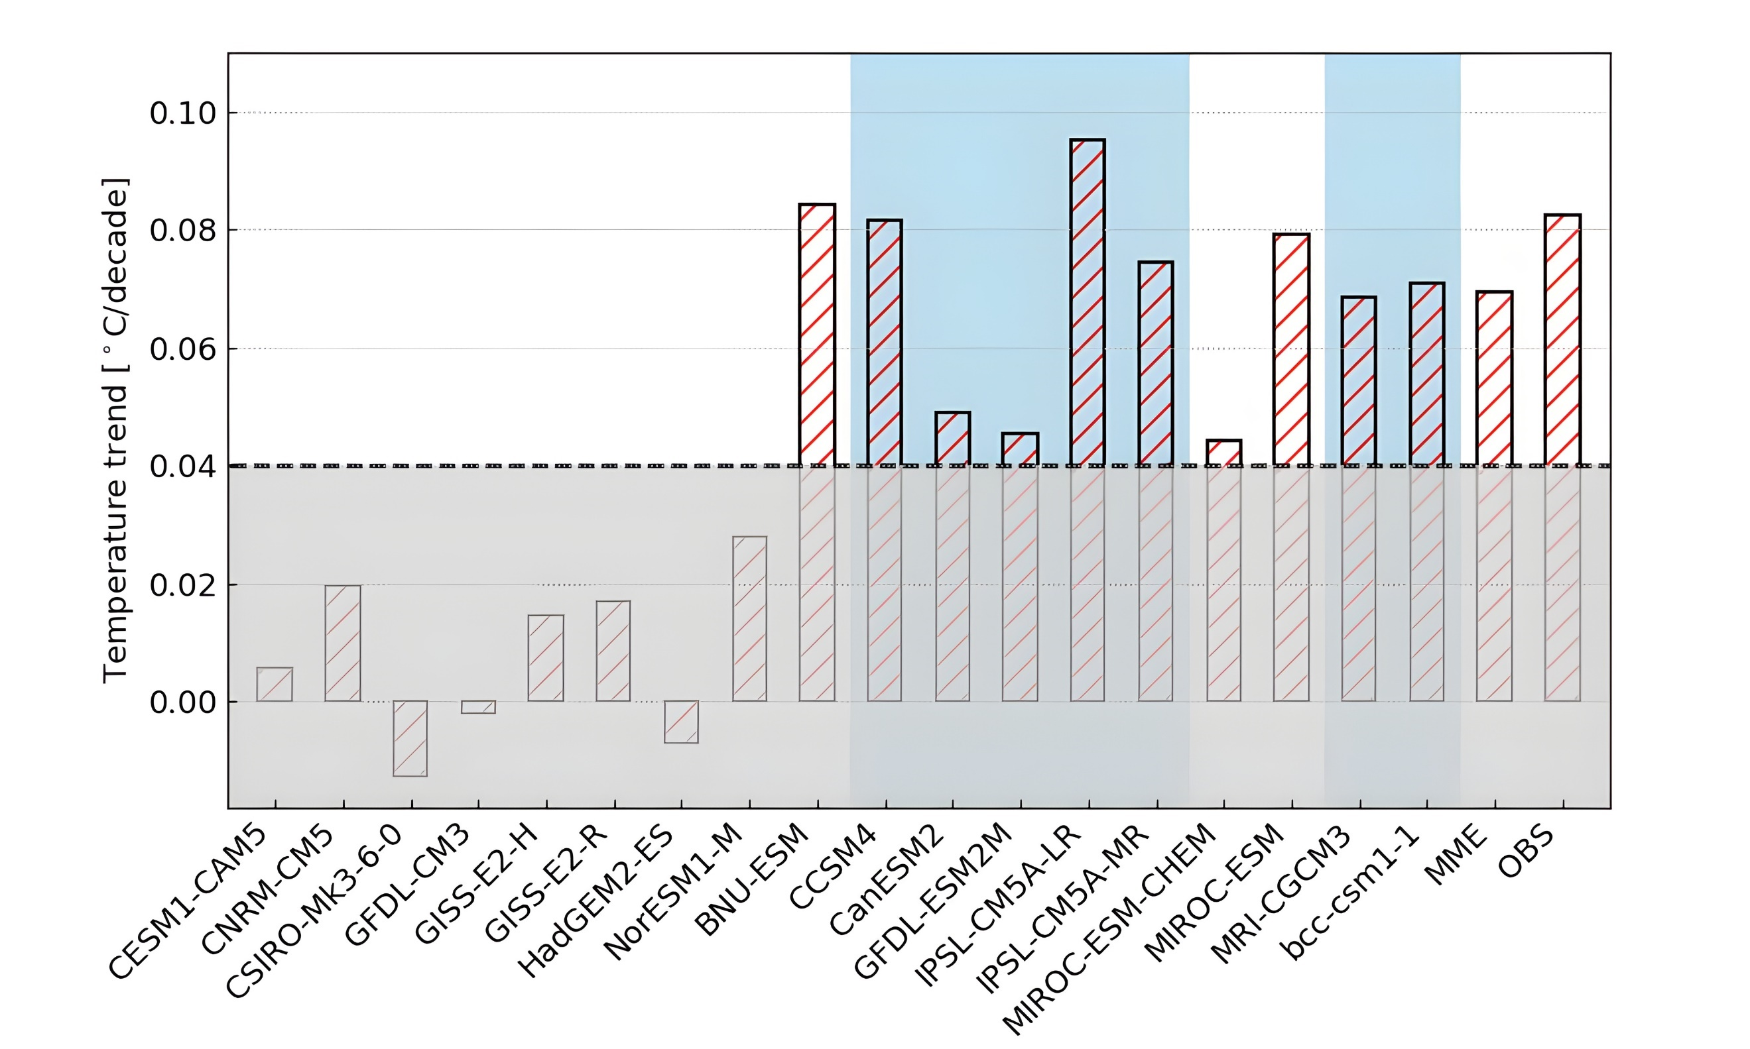
Figure S1. Surface temperature trends ($°$C per decade) for the period of 1901 to 2005, averaged over domain 2 (SC), derived from the historical run of individual CMIP5 models. Also shown is the ensemble mean based on selected models (highlighted by blue background) as well as the observed trend. See text for details.

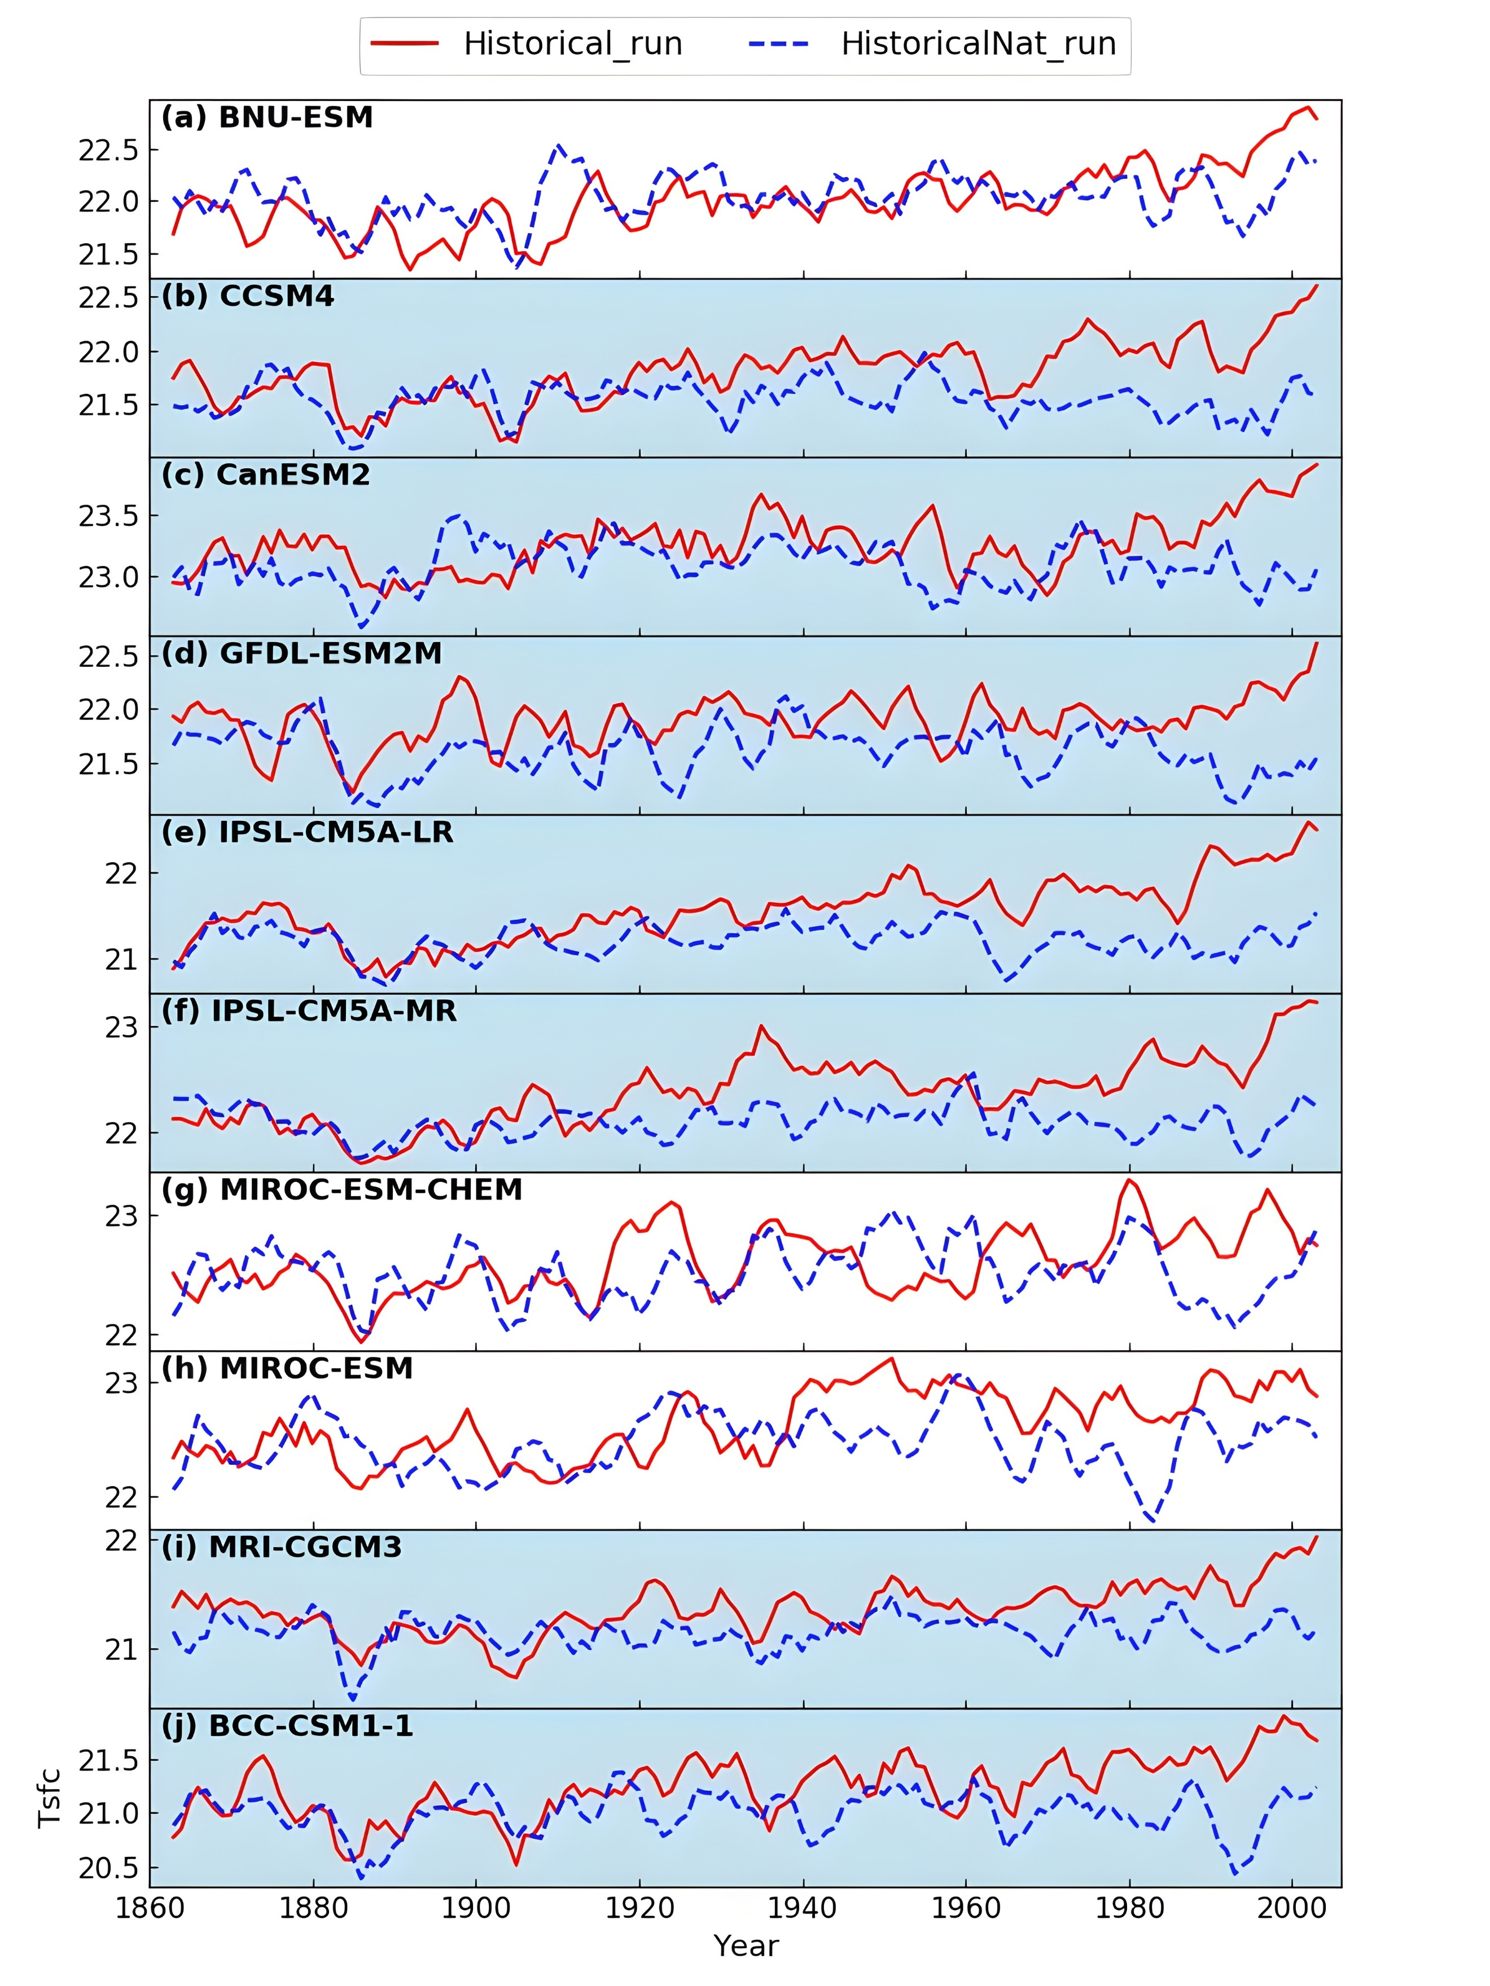
Figure S2. Time evolution of annual mean surface temperature ($°$C) over SC from 1861 to 2005 from the (a) BNU-ESM, (b) CCSM4, (c) CanESM2, (d) GFDL-ESM3M, (e) IPSL-CM5A-LR, (f) IPSL-CM5A-MR, (g) MIROC-ESM-CHEM, (h) MIROC-ESM, (i) MRI-CGCM3, (j) BCC-CSM1-1. Red and blue lines represent results from historical and historicalNat runs, respectively. Models selected for obtaining anthropogenic forcing signals are highlighted by the blue background. See text for details.
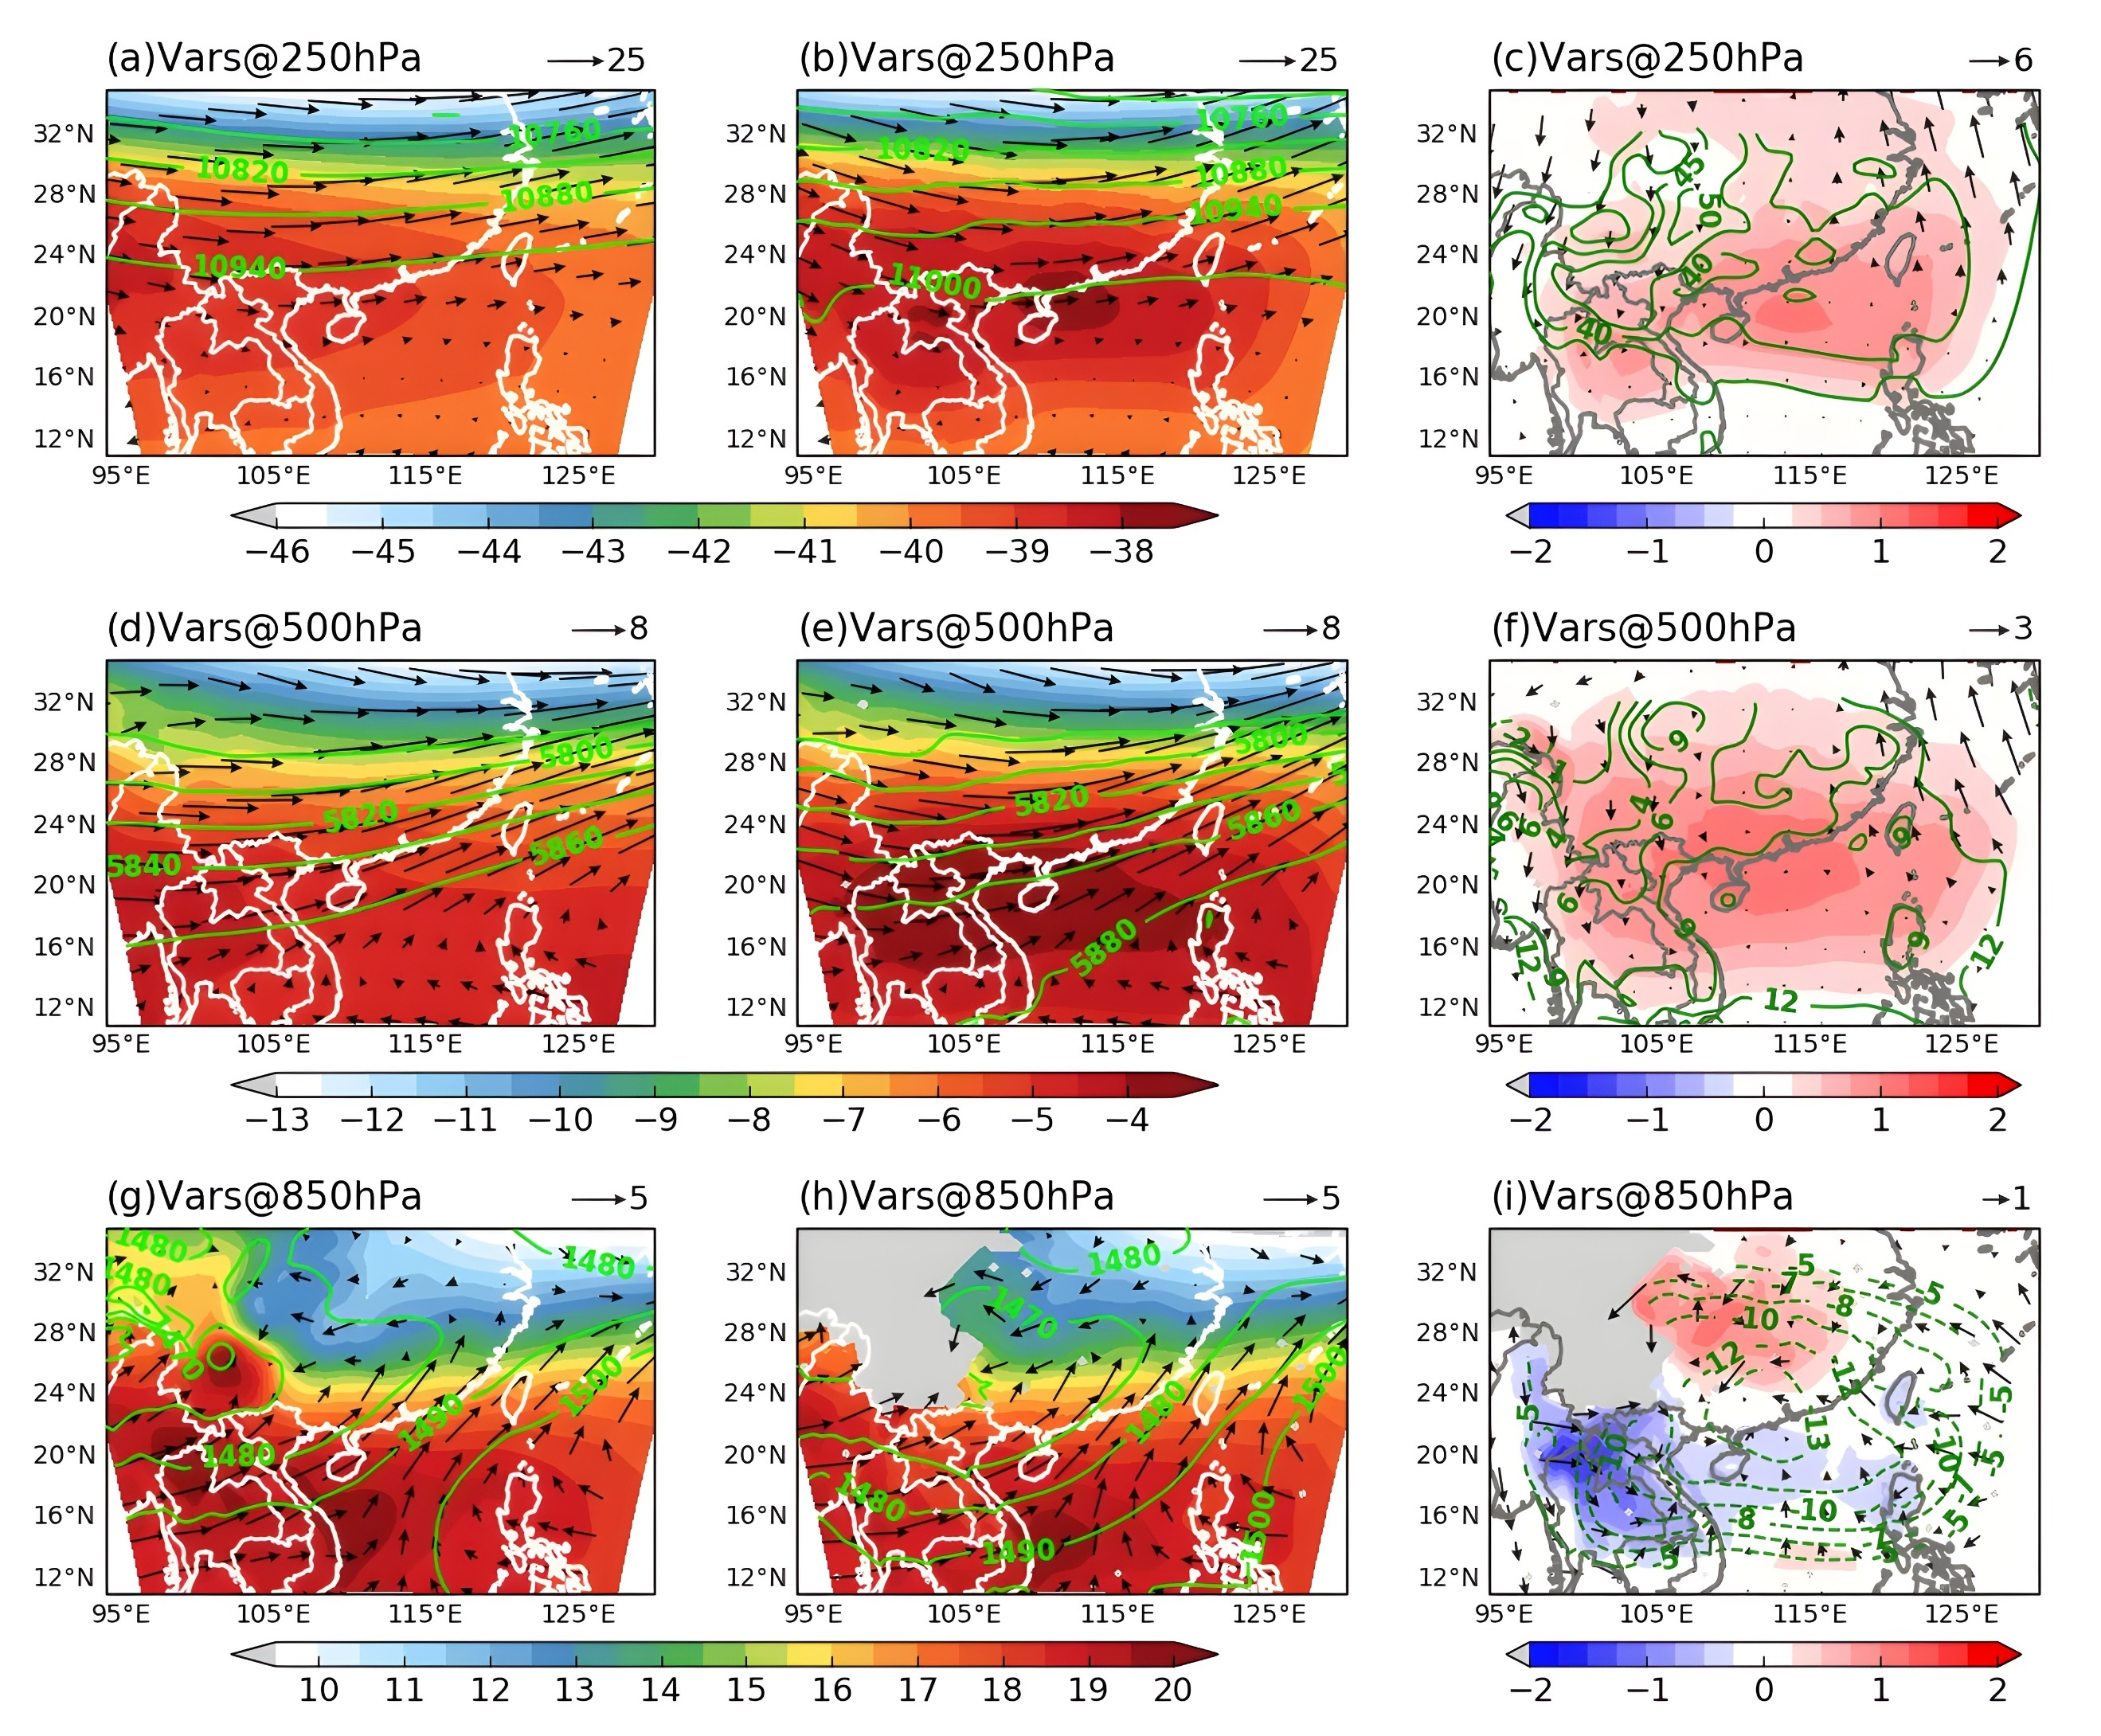
Figure S3. Comparison in composite fields between the model simulations and ERA-Interim reanalysis. Air temperature (shading, units: $℃$), geopotential height (green contour, units: m), and horizontal wind circulation (vectors, units: m s⁻¹) over the outermost domain at (a, b, c) 250 hPa, (d, e, f) 500 hPa and (g, h, i) 850 hPa, respectively. These fields are computed from the temporal average of the entire extreme rainfall cases from (a, d, g) ERA-Interim and (b, e, h) WRF CTL simulations, as well as (c, f, i) their differences, i.e., CTL simulations minus ERA-Interim. The reference scale vectors are shown at the top right of each panel.

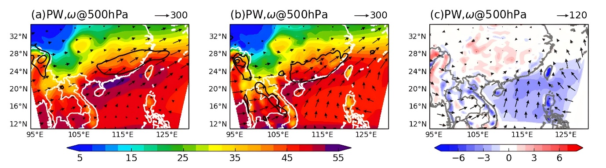
Figure S4. Same as Figure 1, but for precipitable water (shading, units: mm), 500-hPa pressure velocity (< -0.1 Pa s⁻¹, represents upward motion shown by black contours), and column-integrated moisture flux transport (vectors, see reference scale vectors at the top right in the unit of kg m⁻¹ s⁻¹).

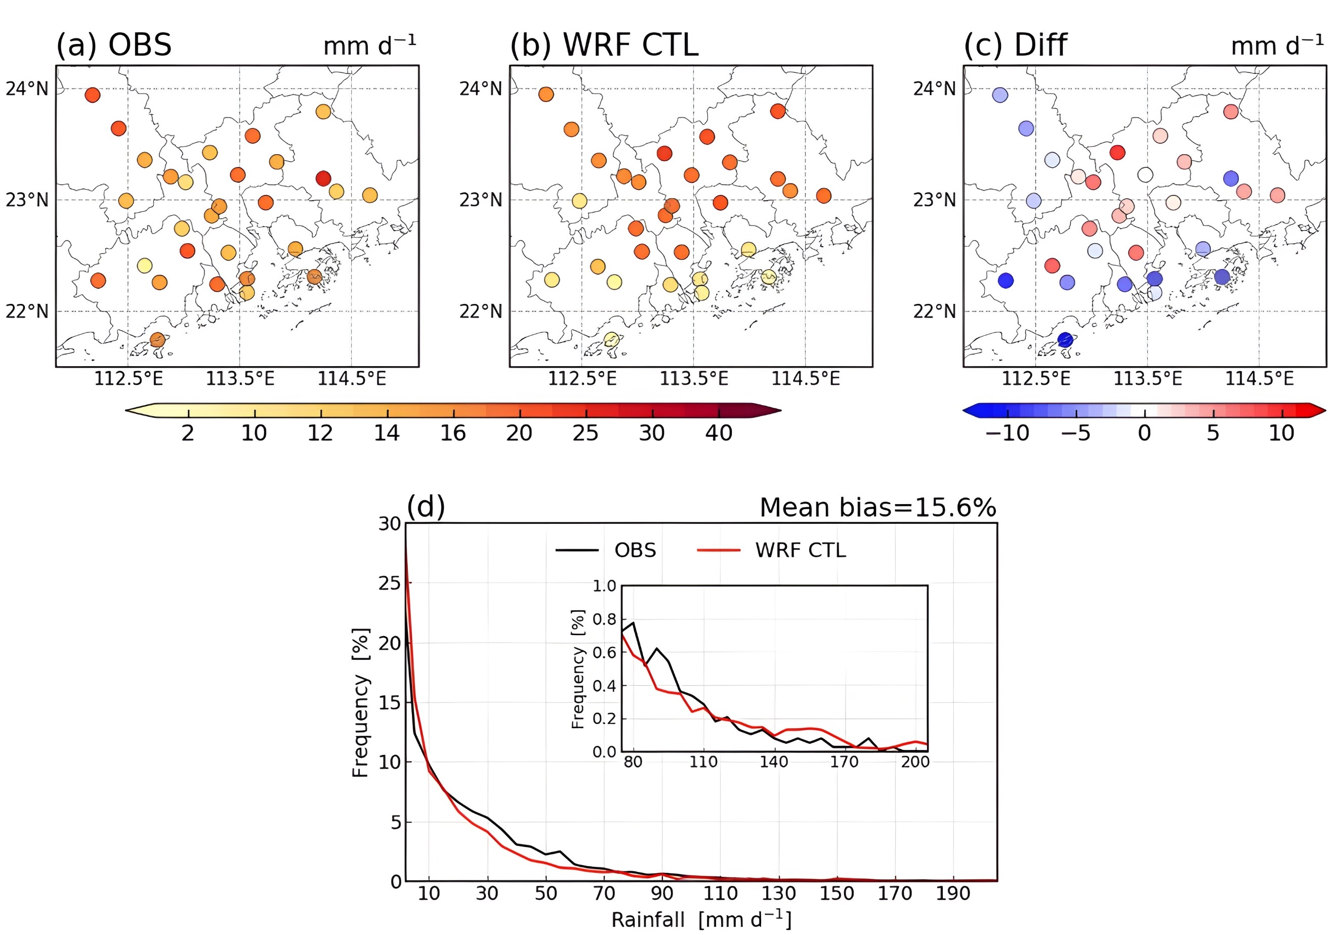
Figure S5. Daily precipitation (units: mm d⁻¹) averaged from all extreme rainfall events over PRD, from (a) station observations (OBS), (b) WRF control runs (CTL), and (c) their difference, i.e., CTL minus OBS. (d) Probability density function (PDF) distribution of daily rainfall over PRD from OBS (black) and CTL (red). Mean bias shown in the upper right, is defined as the frequency difference between CTL and OBS relative to OBS. The insert figure depicts the PDF of heavy to very extreme rainfall that rain rates greater than 80 mm d⁻¹.

