Highly stable visible-light photocatalytic properties of black rutile TiO₂ hydrogenated in ultrafast flow
Junzheng Gaoª, Jing Zhang^{b}, Wanxia Huang^{a*}, Shuping Zheng^{c}, and Qiwu Shi^{a*}
ªCollege of Materials Science and Engineering, Sichuan University, Chengdu 610065, China
^{b}College of Architecture & Environment, Sichuan University, Chengdu 610065, China
^{c}Analytic and Testing Centre, Sichuan University, Chengdu 610065, China
E-mail: huangwanxia@scu.edu.cn, shiqiwu@scu.edu.cn

50mL K₂Cr₂O₇ aqueous solution (20mg/L, was adjusted by dilute H₂SO₄ to pH=2) with 20mg black TiO₂ were used for a photocatalytic experiment, and other parameters were the same as the RhB experiment. Our black TiO₂ could degrade 45.2% Cr⁶⁺ within 2h under visible light, which further demonstrated its improved visible-light photocatalytic activity.

Fig. S1 Cr⁶⁺ residual in visible-light photocatalytic reactions of 800℃-H-TiO₂

Normally, hydrogenation should have brought much more surface hydroxyls, but fast hydrogen flowing in our experiments gave limited help to increase the contents of surface hydroxyls. The peaks of surface hydroxyl exhibited were almost all caused by absorbing water in the air rather than hydrogenating, which explained why black TiO₂ and white TiO₂ had similar low amounts of surface hydroxyls. This result further indicated that black TiO₂ prepared by annealing in ultrafast hydrogen flow could have good visible-light photocatalytic performance without dependence on surface defects.

Fig. S2 XPS spectra (O1s) of white TiO₂ and 800℃-H-TiO₂

TiO₂ surface would experience a reconstruction process induced by titanium suboxides during reduction processes, and (110) planes were preferentially affected in the formation of suboxides as shown in Fig. S3. The sharply reduced diffraction intensity of (110) in 850℃-H-TiO₂ and 900℃-H-TiO₂ reflected decreased proportions of these crystal planes, while many other crystal planes such as (101) (36.1°) were not affected. Different crystal planes exhibited various activity to be photoexcited, while (111) and (110) planes were so important for rutile TiO₂. Given the small percentage of (111) planes in our samples, (110) planes played a dominant role in these photocatalysis processes. Therefore, the weakening in (110) planes brought great negative effects to forming photogenerated electrons and holes.
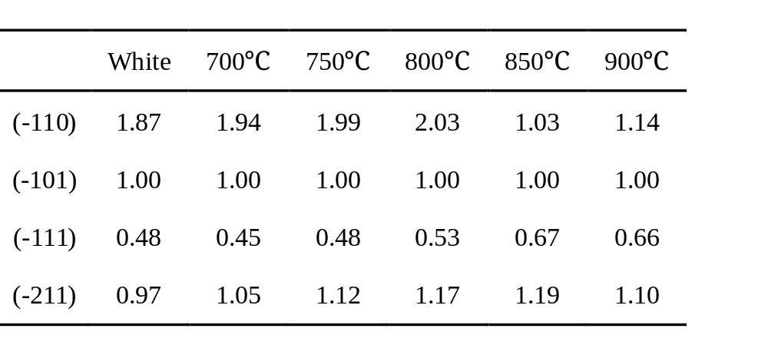

Tab. S1 Diffraction intensity of different crystal plane in TiO₂

Fig. S3 The magnified figures of the peaks around 27.38°, 36.04°, 41.20°, and 54.26°

The conclusion as above was further revealed by two experiments whose results were exhibited in Fig. S4. The intensity of PL spectra in Fig. S4a was inversely proportional to the recombination of carriers, so 850℃-H-TiO₂ and 900℃-H-TiO₂ had weaker recombination of electron-hole pairs than that of 800℃-H-TiO₂, due to the higher content of V_{O} which could increase carries density. The commonly used theory that the photocatalytic activity of black TiO₂ was damaged by easy recombination of carriers did not tally with our experiments. Final results were obtained by combining PL spectra with photocurrent experiments shown in Fig. S4b. Partial electron-hole pairs would recombine during the diffusion process to the surface of TiO₂ nanoparticles after photoexcitation, and the remnant carrier concentration reflected in photocurrent intensity. The photocurrent of 800℃-H-TiO₂ was 3.2 µA, while 850℃-H-TiO₂ and 900℃-H-TiO₂ had extremely weak photocurrent intensity. Although the recombination in these samples was slow, the final carrier concentration showed low levels, indicating reduced generation of electrons and holes, so 850℃-H-TiO₂ and 900℃-H-TiO₂ had significantly decreased photocatalytic activities.

Fig. S4 a PL spectra of X℃-H-TiO₂ (X=800, 850, and 900), b Photocurrent intensity of X℃-H-TiO₂ (X=800, 850, and 900)

