Supplementary Data

S1: Questionnaire Sample:
Assessment for Water Networks Performance Indicators Questionnaire

Part 1: General Information
Please fill below the required personal information:
- Which best describes your current occupation/position?
☐ Utility Manager ☐ Operational Engineer
☐ Department Manager ☐ Senior Design Engineer
☐ Projects Manager
☐ Other

- Which best describes your working experience?
☐ 6 - 10 years
☐ 11 - 15 years
☐ 16 - 20 years
☐ More than 20 years

Part 2: Performance Assessment Model
The main goal of this part is to confirm and assess the importance level of the suggested indicators and factors that might be affecting the decision-making process for the rehabilitation of water distribution network elements¹. The scope of the study includes distribution networks, including customer house connections, while the primary system is excluded.
Five main categories were suggested, as shown in the Figure below:

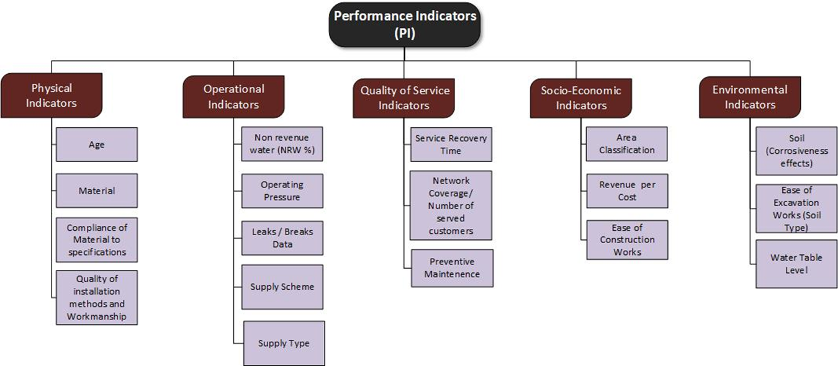
¹: water networks elements are assumed to be (pipes, valves, or any needed network accessories)

2-1: Score of Factors
To determine the score of the suggested influencing factors for each indicator from your point of view, kindly fill the following tables with a suitable score that reflects the impact level of each factor on your decision regarding rehabilitation of the network.
The scores ranged between (1) and (10), where (1) represents the lowest impact/score and (10) represents the highest impact/score.
*Note: the qualitative descriptions and quantitative ranges (where available) in the below tables were reflected to comply with the conditions of supply and operating water distribution networks in Jordan.
* Below is an example where the decision-maker gave a score of 10 to a very old age network which means the highest priority for rehabilitation, and a score of 1 to the newly installed network, which means the lowest priority for rehabilitation, and so on.
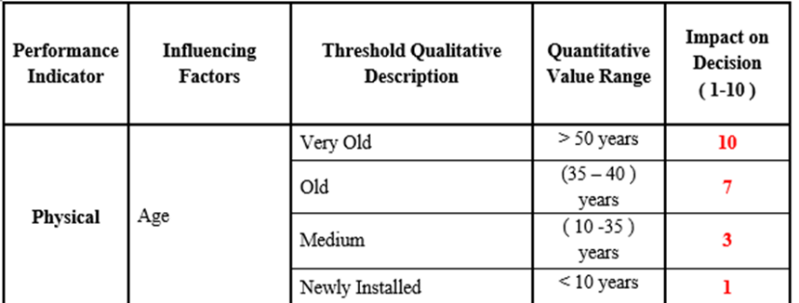
2-1-1: Scores of Physical Indicator Factors:
Performance  Indicator | Influencing Factors | Threshold Qualitative Description | Quantitative Value Range | Impact on Decision  ( 1-10)
Physical | Age | Very Old | > 50 years
Physical | Age | Old | (35-40) years
Physical | Age | Medium | (10-35) years
Physical | Age | Newly Installed | < 10 years
Physical | Material | Ductile Iron | NA
Physical | Material | HDPE | NA
Physical | Material | Steel | NA
Physical | Material | Galvanized | NA
Physical | Compliance of the used material with the suitable technical specifications for each project | All used material complies with specifications | NA
Physical |  | Some of the used materials comply with specifications | NA
Physical |  | Material is not according to specifications | NA
Physical | Quality of Installation methods and Workmanship | Excellent | > 90 %
Physical | Quality of Installation methods and Workmanship | Moderate | (60- 90) %
Physical | Quality of Installation methods and Workmanship | Poor | (50 - 60) %
 | Quality of Installation methods and Workmanship | Very Poor | < 50 %

2-1-2: Scores of Operational Indicator Factors:

Performance Indicator | Influencing Factors | Threshold Qualitative Description | Quantitative Value Range | Impact on Decision  ( 1-10)
Operational | Non-Revenue Water (NRW %) | High | > 40 %
Operational | Non-Revenue Water (NRW %) | Medium | (30 – 40) %
Operational | Non-Revenue Water (NRW %) | Low | < 30 %
Operational | Operating Pressure | Very High | > 7 bars
Operational | Operating Pressure | High | (5-7) bars
Operational | Operating Pressure | Moderate | 2.5-5 bars
Operational | Operating Pressure | Very Low | < 2.5
Operational | Number of Leaks / Breaks in the pipes of the distribution network | High | > 3 leaks / Km / year
Operational |  | Medium | (1 – 3) leaks / Km /year
Operational |  | Low | < 1 leaks / Km / year
Operational | Number of Leaks / Breaks for the house connections (h. c) | High | > 5 leaks /20 h. c /Km/ year
Operational | Number of Leaks / Breaks for the house connections (h. c) | Medium | (3 – 5) leaks /20 h. c /Km/ year
Operational | Number of Leaks / Breaks for the house connections (h. c) | Low | < 3 leaks /20 h. c /Km/year
Operational | Supply Scheme | Intermittent | NA
Operational | Supply Scheme | Continuous | NA
Operational | Supply Type | Gravity | NA
Operational | Supply Type | Pumping | NA

2-1-3: Scores of Quality-of-Service Indicator Factors:

Performance Indicator | Influencing Factors | Threshold Qualitative Description | Quantitative Value Range | Impact on Decision  ( 1-10)
Quality of Service | Customer Satisfaction (in terms of Service Recovery Time) for any type of complaint:  - No. of complaints related to water quality.  - No. of complaints related to the elements of the distribution network.  - No. complaints related to the integrity of house connections.  - No. of complaints related to water shortage or disconnection.  Where Service recovery time indicates the needed time to recover the complaints from the time it was reported. | Long Service Recovery Time | > 6 hours
Quality of Service |  | Medium Service Recovery Time | (3- 6) hours
Quality of Service |  | Short Service Recovery Time | < 3 hours
Quality of Service | Network Coverage (served Subscribers by water network in the supply zone | Most subscribers are served by the water network | NA
Quality of Service |  | Some of the subscribers are still not served by the water network | NA
Quality of Service |  | Most of the subscribers are still not served by the water network | NA
Quality of Service | Preventive maintenance (indicates for valves and network elements) | Scheduled | NA
Quality of Service |  | Not Scheduled | NA

2-1-4: Scores of Socioeconomic Indicator Factors:

Performance Indicator | Influencing Factors | Threshold Qualitative Description | Quantitative Value Range | Impact on Decision  ( 1-10)
Socio-Economic | Area Classification | Urban | > 20 house connection/ km
Socio-Economic | Area Classification | Rural | < 20 house connection/ km
Socio-Economic | Revenue per Cost | Positive | NA
Socio-Economic | Revenue per Cost | Negative | NA
Socio-Economic | Ease of Construction Works in the area (i.e., crowded, narrow streets, etc.) | Easy | NA
Socio-Economic |  | Medium | NA
Socio-Economic |  | Hard | NA

2-1-5: Scores of Environmental Indicator Factors:

Performance Indicator | Influencing Factors | Threshold Qualitative Description | Quantitative Value Range | Impact on Decision  ( 1-10)
Environmental | Ease of Excavation Works (according to Soil Type) | Rocks | NA
Environmental | Ease of Excavation Works (according to Soil Type) | Clay | NA
Environmental | Ease of Excavation Works (according to Soil Type) | Sand | NA
Environmental | Soil Effect (according to corrosiveness effect-if applicable) | Aggressive Effect | NA
Environmental |  | Normal Effect | NA
Environmental | Water Table Level (if applicable) | Deep | > 5 m
Environmental | Water Table Level (if applicable) | Moderate | (3 – 5) m
Environmental | Water Table Level (if applicable) | Shallow | (1 – 3) m
Additional Suggestions / Other Comments:

2-2: Pairwise Comparison
The following presents a pairwise comparison between different indicators and factors, using the scale of importance shown in the figure below:
Kindly fill the matrices-tables below by ticking (☒) the appropriate box from your point of view:
*This example may guide you:
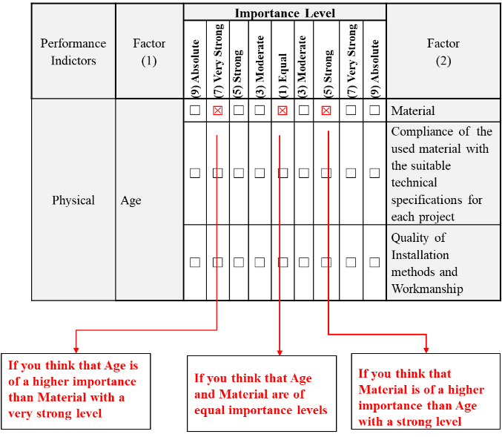

2-2-1: Pairwise Comparison for Factors:
- Pairwise Comparison for Physical Factors
Performance Indicators | Factor- 1 | Importance Level |  |  |  |  |  |  |  |  | Factor- 2
Performance Indicators | Factor- 1 | (9) Absolute | (7) Very Strong | (5) Strong | (3) Moderate | (1) Equal | (3) Moderate | (5) Strong | (7) Very Strong | (9) Absolute | Factor- 2
Physical | Age | ☐ | ☐ | ☐ | ☐ | ☐ | ☐ | ☐ | ☐ | ☐ | Material
Physical | Age | ☐ | ☐ | ☐ | ☐ | ☐ | ☐ | ☐ | ☐ | ☐ | Compliance of the used material with the suitable technical specifications for each project
Physical | Age | ☐ | ☐ | ☐ | ☐ | ☐ | ☐ | ☐ | ☐ | ☐ | Quality of Installation methods and Workmanship
Physical | Material | ☐ | ☐ | ☐ | ☐ | ☐ | ☐ | ☐ | ☐ | ☐ | Compliance of the used material with the suitable technical specifications for each project
Physical | Material | ☐ | ☐ | ☐ | ☐ | ☐ | ☐ | ☐ | ☐ | ☐ | Quality of Installation methods/workmanship
Physical | Compliance of the used material with the suitable technical specifications for each project | ☐ | ☐ | ☐ | ☐ | ☐ | ☐ | ☐ | ☐ | ☐ | Quality of Installation methods and Workmanship

- Pairwise Comparison for Operational Factors
Performance Indicators | Factor- 1 | Importance Level |  |  |  |  |  |  |  |  | Factor- 2
Performance Indicators | Factor- 1 | (9) Absolute | (7) Very Strong | (5) Strong | (3) Moderate | (1) Equal | (3) Moderate | (5) Strong | (7) Very Strong | (9) Absolute | Factor- 2
Operational | Non-Revenue Water (NRW %) | ☐ | ☐ | ☐ | ☐ | ☐ | ☐ | ☐ | ☐ | ☐ | Operating Pressure
Operational | Non-Revenue Water (NRW %) | ☐ | ☐ | ☐ | ☐ | ☐ | ☐ | ☐ | ☐ | ☐ | Leaks/Breaks data
Operational | Non-Revenue Water (NRW %) | ☐ | ☐ | ☐ | ☐ | ☐ | ☐ | ☐ | ☐ | ☐ | Supply Scheme
Operational | Non-Revenue Water (NRW %) | ☐ | ☐ | ☐ | ☐ | ☐ | ☐ | ☐ | ☐ | ☐ | Supply Type
Operational | Operating Pressure | ☐ | ☐ | ☐ | ☐ | ☐ | ☐ | ☐ | ☐ | ☐ | Leaks/Breaks data
Operational | Operating Pressure | ☐ | ☐ | ☐ | ☐ | ☐ | ☐ | ☐ | ☐ | ☐ | Supply Scheme
Operational | Operating Pressure | ☐ | ☐ | ☐ | ☐ | ☐ | ☐ | ☐ | ☐ | ☐ | Supply Type
Operational | Leaks/Breaks data | ☐ | ☐ | ☐ | ☐ | ☐ | ☐ | ☐ | ☐ | ☐ | Supply Scheme
Operational | Leaks/Breaks data | ☐ | ☐ | ☐ | ☐ | ☐ | ☐ | ☐ | ☐ | ☐ | Supply Type
Operational | Supply Scheme | ☐ | ☐ | ☐ | ☐ | ☐ | ☐ | ☐ | ☐ | ☐ | Supply Type

- Pairwise Comparison for Quality-of-Service Factors

Performance Indicators | Factor- 1 | Importance Level |  |  |  |  |  |  |  |  | Factor- 2
Performance Indicators | Factor- 1 | (9) Absolute | (7) Very Strong | (5) Strong | (3) Moderate | (1) Equal | (3) Moderate | (5) Strong | (7) Very Strong | (9) Absolute | Factor- 2
Quality of Service | Customer Satisfaction/ Service Recovery Time | ☐ | ☐ | ☐ | ☐ | ☐ | ☐ | ☐ | ☐ | ☐ | Network Coverage (served customers)
Quality of Service | Customer Satisfaction/ Service Recovery Time | ☐ | ☐ | ☐ | ☐ | ☐ | ☐ | ☐ | ☐ | ☐ | Preventive Maintenance
Quality of Service | Network Coverage (served customers) | ☐ | ☐ | ☐ | ☐ | ☐ | ☐ | ☐ | ☐ | ☐ | Preventive Maintenance

- Pairwise Comparison for Socioeconomic Factors
Performance Indicators | Factor- 1 | Importance Level |  |  |  |  |  |  |  |  | Factor- 2
Performance Indicators | Factor- 1 | (9) Absolute | (7) Very Strong | (5) Strong | (3) Moderate | (1) Equal | (3) Moderate | (5) Strong | (7) Very Strong | (9) Absolute | Factor- 2
Socio-Economic | Area Classification | ☐ | ☐ | ☐ | ☐ | ☐ | ☐ | ☐ | ☐ | ☐ | Revenue per Cost
Socio-Economic | Area Classification | ☐ | ☐ | ☐ | ☐ | ☐ | ☐ | ☐ | ☐ | ☐ | Ease of Construction Works
Socio-Economic | Revenue per Cost | ☐ | ☐ | ☐ | ☐ | ☐ | ☐ | ☐ | ☐ | ☐ | Ease of Construction Works

- Pairwise Comparison for Environmental Factors
Performance Indicators | Factor- 1 | Importance Level |  |  |  |  |  |  |  |  | Factor- 2
Performance Indicators | Factor- 1 | (9) Absolute | (7) Very Strong | (5) Strong | (3) Moderate | (1) Equal | (3) Moderate | (5) Strong | (7) Very Strong | (9) Absolute | Factor- 2
 | Ease of Excavation Works (Soil Type) | ☐ | ☐ | ☐ | ☐ | ☐ | ☐ | ☐ | ☐ | ☐ | Soil Corrosiveness Effects
Environmental | Ease of Excavation Works (Soil Type) | ☐ | ☐ | ☐ | ☐ | ☐ | ☐ | ☐ | ☐ | ☐ | Water Table Level
 | Soil Corrosiveness Effects | ☐ | ☐ | ☐ | ☐ | ☐ | ☐ | ☐ | ☐ | ☐ | Water Table Level

2-2-2: Pairwise Comparison for Performance Indicators:
Indicator -1 | Importance Level |  |  |  |  |  |  |  |  | Indicator -2
Indicator -1 | (9) Absolute | (7) Very Strong | (5) Strong | (3) Moderate | (1) Equal | (3) Moderate | (5) Strong | (7) Very Strong | (9) Absolute | Indicator -2
Physical | ☐ | ☐ | ☐ | ☐ | ☐ | ☐ | ☐ | ☐ | ☐ | Operational
Physical | ☐ | ☐ | ☐ | ☐ | ☐ | ☐ | ☐ | ☐ | ☐ | Quality of Service
Physical | ☐ | ☐ | ☐ | ☐ | ☐ | ☐ | ☐ | ☐ | ☐ | Environmental
Physical | ☐ | ☐ | ☐ | ☐ | ☐ | ☐ | ☐ | ☐ | ☐ | Socio-Economical
Operational | ☐ | ☐ | ☐ | ☐ | ☐ | ☐ | ☐ | ☐ | ☐ | Quality of Service
Operational | ☐ | ☐ | ☐ | ☐ | ☐ | ☐ | ☐ | ☐ | ☐ | Environmental
Operational | ☐ | ☐ | ☐ | ☐ | ☐ | ☐ | ☐ | ☐ | ☐ | Socio-Economic
Quality of | ☐ | ☐ | ☐ | ☐ | ☐ | ☐ | ☐ | ☐ | ☐ | Environmental
Service | ☐ | ☐ | ☐ | ☐ | ☐ | ☐ | ☐ | ☐ | ☐ | Socio-Economic
Socio-Economic | ☐ | ☐ | ☐ | ☐ | ☐ | ☐ | ☐ | ☐ | ☐ | Environmental

