Supplementary Information for: “Species traits and invasion history as predictors of freshwater fish’s invasion success in Europe”
Journal name: Biological Invasions
Author names: Fabio Marcolin*, Paulo Branco, José Maria Santos, Luís Reino, Joana Santana, Joana Ribeiro, Pedro Segurado
*Corresponding author: Fabio Marcolin; email address: fabiomarcolin@isa.ulisboa.pt
Postal address: Forest Research Centre, School of Agriculture, University of Lisbon, Tapada da Ajuda, 1349‑017 Lisbon, Portugal

Table S1 Trait data retrieved for the 127 non-native fish species (number of values, number of missing values, and percentage of missing values per trait).
Trait |  |  | N° Values | N° Missing values |  | % Missing values
Functional trait
Female maturity |  |  | 118 | 9 |  | 7
Length of breeding season |  |  | 124 | 3 |  | 2
Maximum adult size |  |  | 127 | 0 |  | 0
Maximum fecundity |  |  | 119 | 8 |  | 6
Maximum lifespan |  |  | 118 | 9 |  | 7
Migratory behaviour |  |  | 123 | 4 |  | 3
Parental care |  |  | 122 | 5 |  | 4
Reproductive guild |  |  | 125 | 2 |  | 2
Spawning frequency |  |  | 118 | 9 |  | 7
Ecological trait
Acid tolerance |  |  | 80 | 47 |  | 37
Adult trophic status |  |  | 125 | 2 |  | 2
Feeding habitat |  |  | 125 | 2 |  | 2
Flow preferences |  |  | 126 | 1 |  | 1
General tolerance † |  |  | 94 | 33 |  | 26
Habitat degradation tolerance |  |  | 83 | 44 |  | 35
Salinity tolerance |  |  | 127 | 0 |  | 0
Spawning habitat preferences |  |  | 118 | 9 |  | 7
Temperature tolerance |  |  | 114 | 13 |  | 10
Trophic level/index |  |  | 127 | 0 |  | 0
Water quality tolerance general |  |  | 83 | 44 |  | 35
Water quality tolerance O2 |  |  | 90 | 37 |  | 29
Water quality tolerance TOX |  |  | 74 | 53 |  | 42
Climate zone |  |  | 125 | 2 |  | 2
European native |  |  | 127 | 0 |  | 0
Invasion history
Cause of introduction |  |  | 126 | 1 |  | 1
Fraction of European countries with established populations |  |  | 127 | 0 |  | 0
Invasive status ‡ |  |  | 38 | 89 |  | 70
Number of causes of introduction |  |  | 127 | 0 |  | 0
Number of European countries with established populations |  |  | 127 | 0 |  | 0
Prior invasion success outside Europe |  |  | 127 | 0 |  | 0
Propagule pressure |  |  | 127 | 0 |  | 0
† This trait is the result of the aggregation of Acid tolerance, Habitat degradation tolerance, Water quality tolerance general, Water quality tolerance oxygen, Water quality tolerance toxic following the “Precautionary Principle” (PP) approach: the level of the combined trait (tolerant, intermediate, or intolerant) resulted from the highest tolerance score found among the five tolerance traits.
‡The ‘Invasive status’ considers only the data retrieved from the several sources. The following step was an a priori evaluation of the invasive status for the missing values of the trait (as done in Vilizzi et al., 2019).

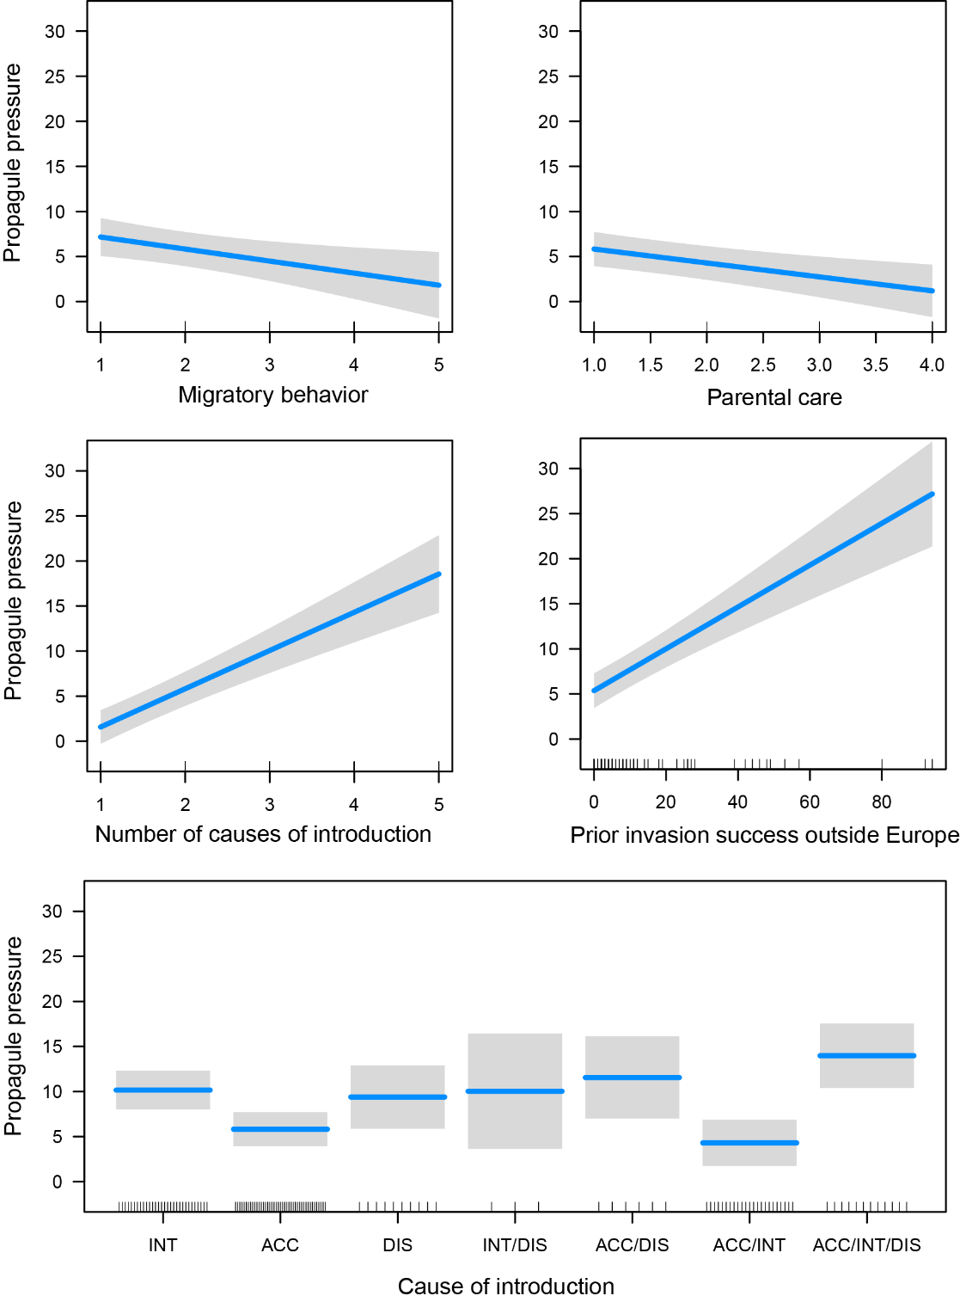

Fig. S1- Partial dependence plots of the mean predicted values for the release stage model (response variable: propagule pressure) for explanatory variables whose 95% confident intervals (grey bands) of the regression coefficients do not contain zero (migratory behaviour, parental care, number of causes of introduction, prior success outside Europe and cause of introduction). Categories of cause of introduction: INT – intentional; ACC – Accidental, DIS – dispersal; and combinations of the three single categories when multiple causes are referred to. Blue lines in the boxplot represent the mean predicted values for the propagule pressure. For variable explanation see Marcolin et al. (2022).

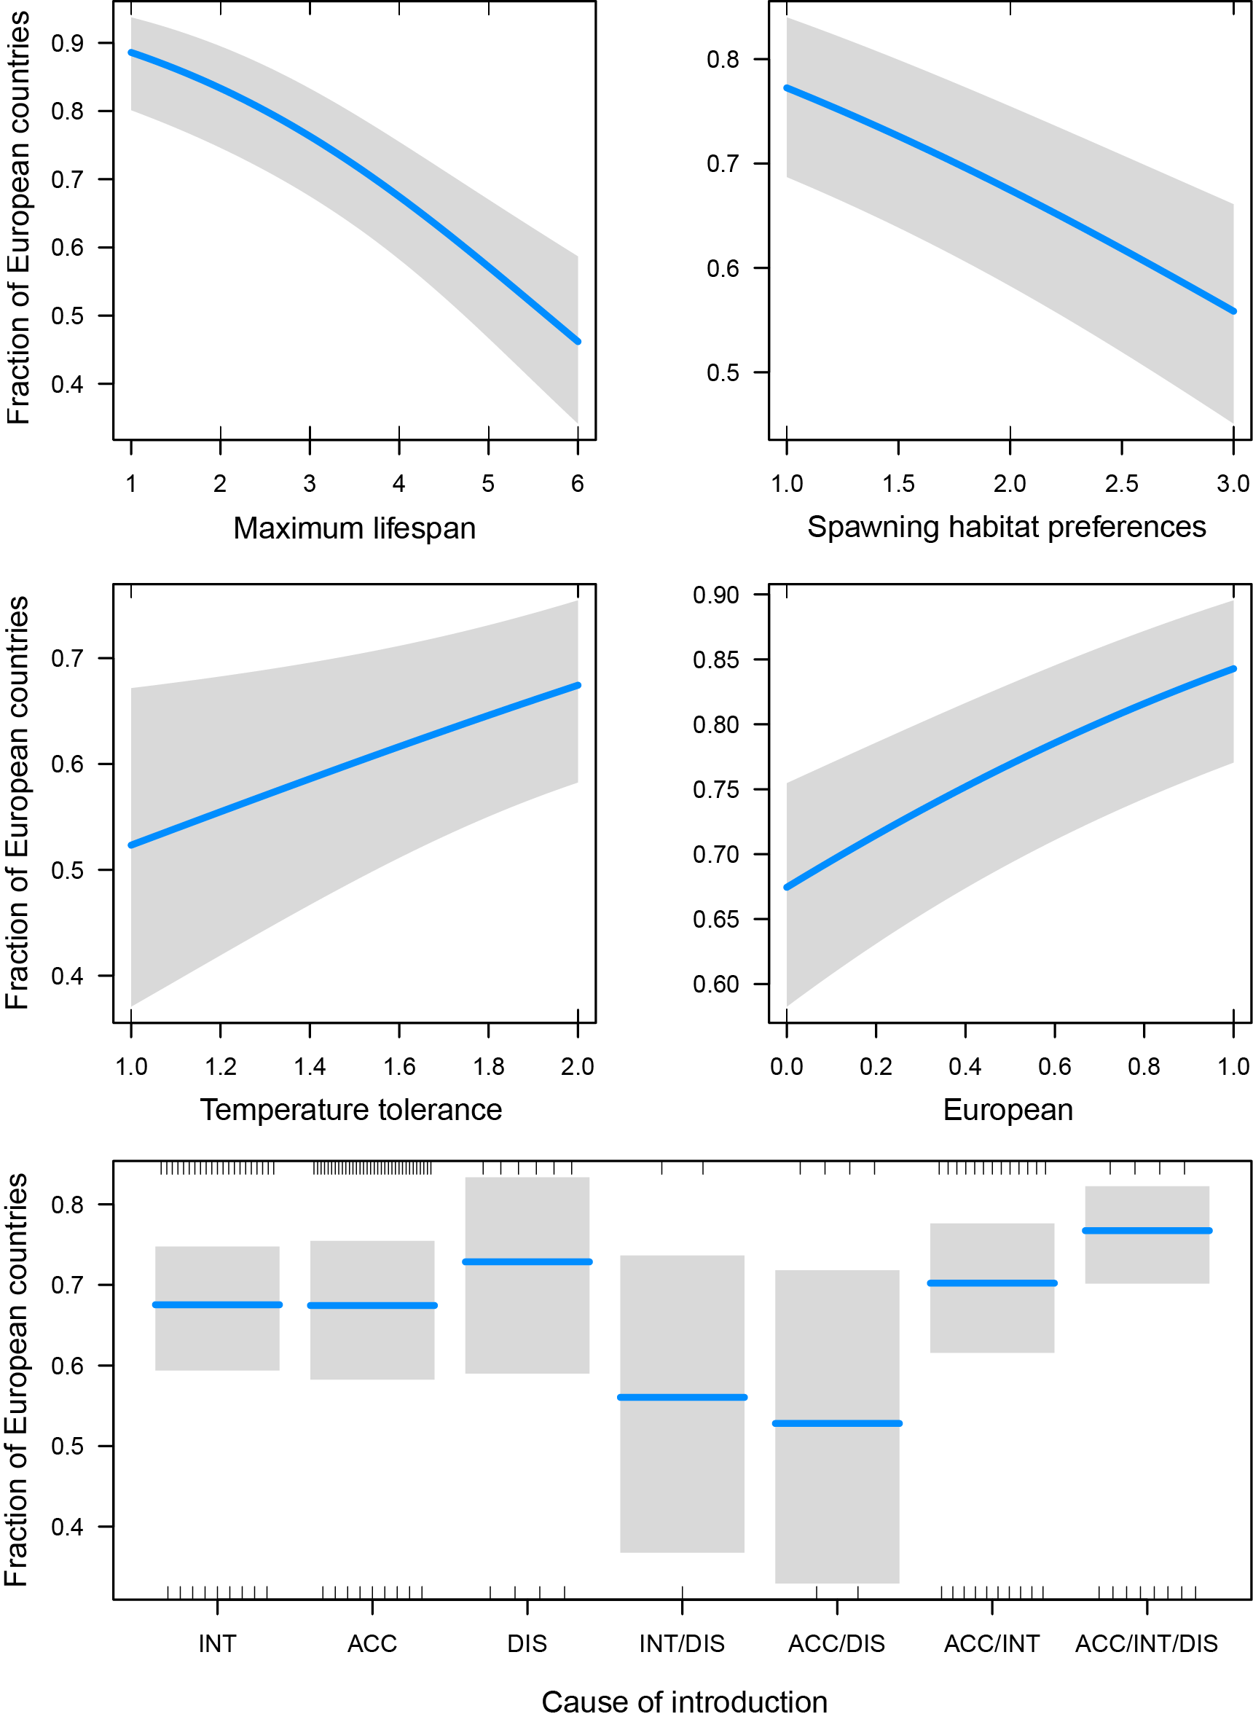
Fig. S2 - Partial dependence plots of the predicted values for the establishment stage model (response variable: fraction of European countries with established populations), showing only the explanatory variables whose confident intervals of the regression coefficients do not contain zero (maximum lifespan, spawning habitat preferences, temperature tolerance, native European, cause of introduction). . Grey bands represent 95% Confidence Interval. Categories of cause of introduction: INT – intentional; ACC – Accidental, DIS – dispersal; and combinations of the three single categories when multiple causes are referred to. Blue lines in the boxplot represent the mean predicted values for the Fraction of European countries. For variable explanation see Marcolin et al. (2022).
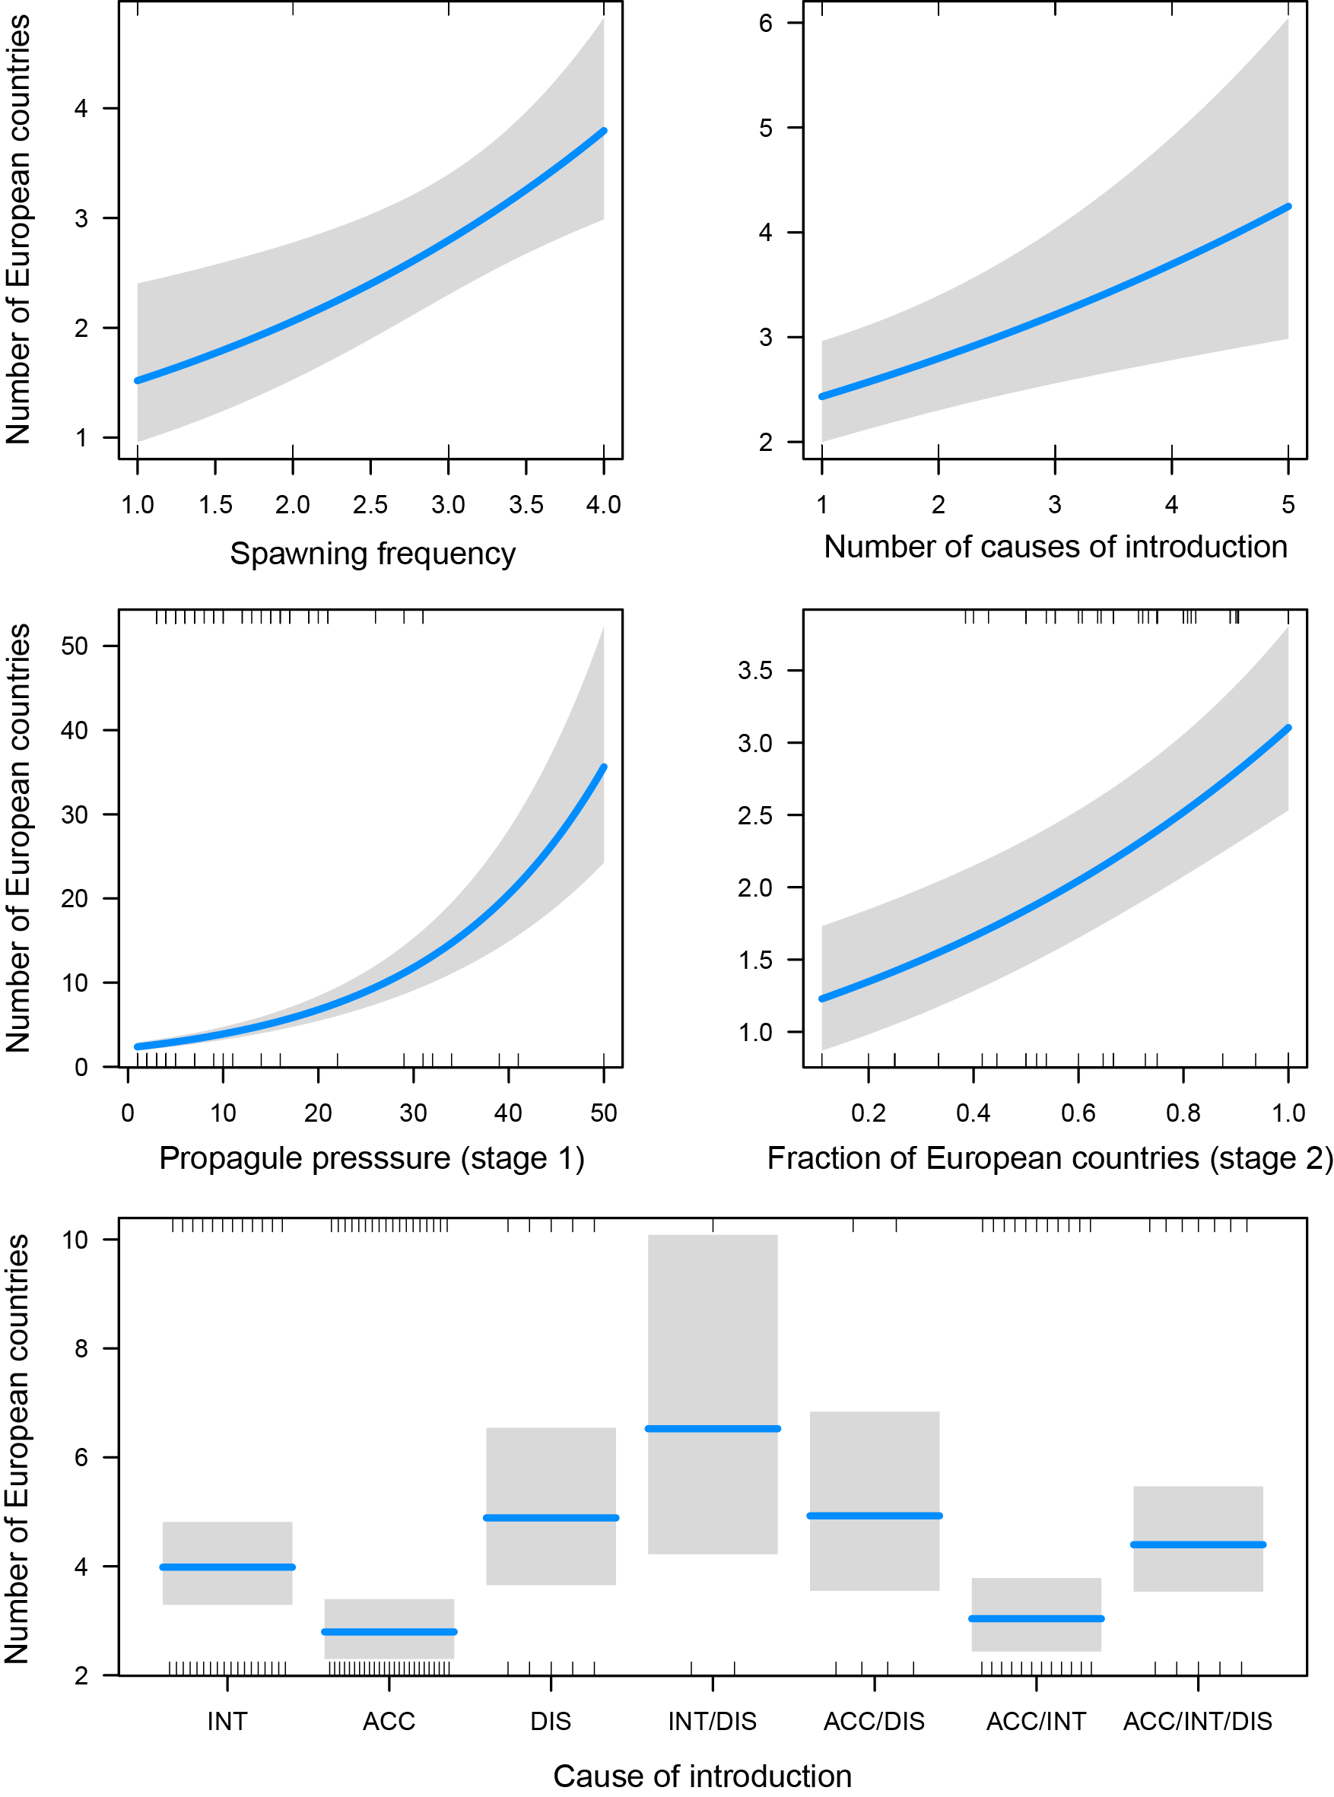

Fig. S3 Partial dependence plots of the predicted values for the spread stage model (number of European countries with established populations), showing only the explanatory variables whose confident intervals of the regression coefficients do not contain zero (spawning frequency, number of causes of introduction, propagule pressure (release stage response), proportion of European countries with established populations (establishment stage response) and cause of introduction). Grey bands represent 95% Confidence Interval. Categories of cause of introduction: INT – intentional; ACC – Accidental, DIS – dispersal; and combinations of the three single categories when multiple causes are referred to. Blue lines in the boxplot represent the mean predicted values for the Number of European countries. For variable explanation see Marcolin et al. (2022).
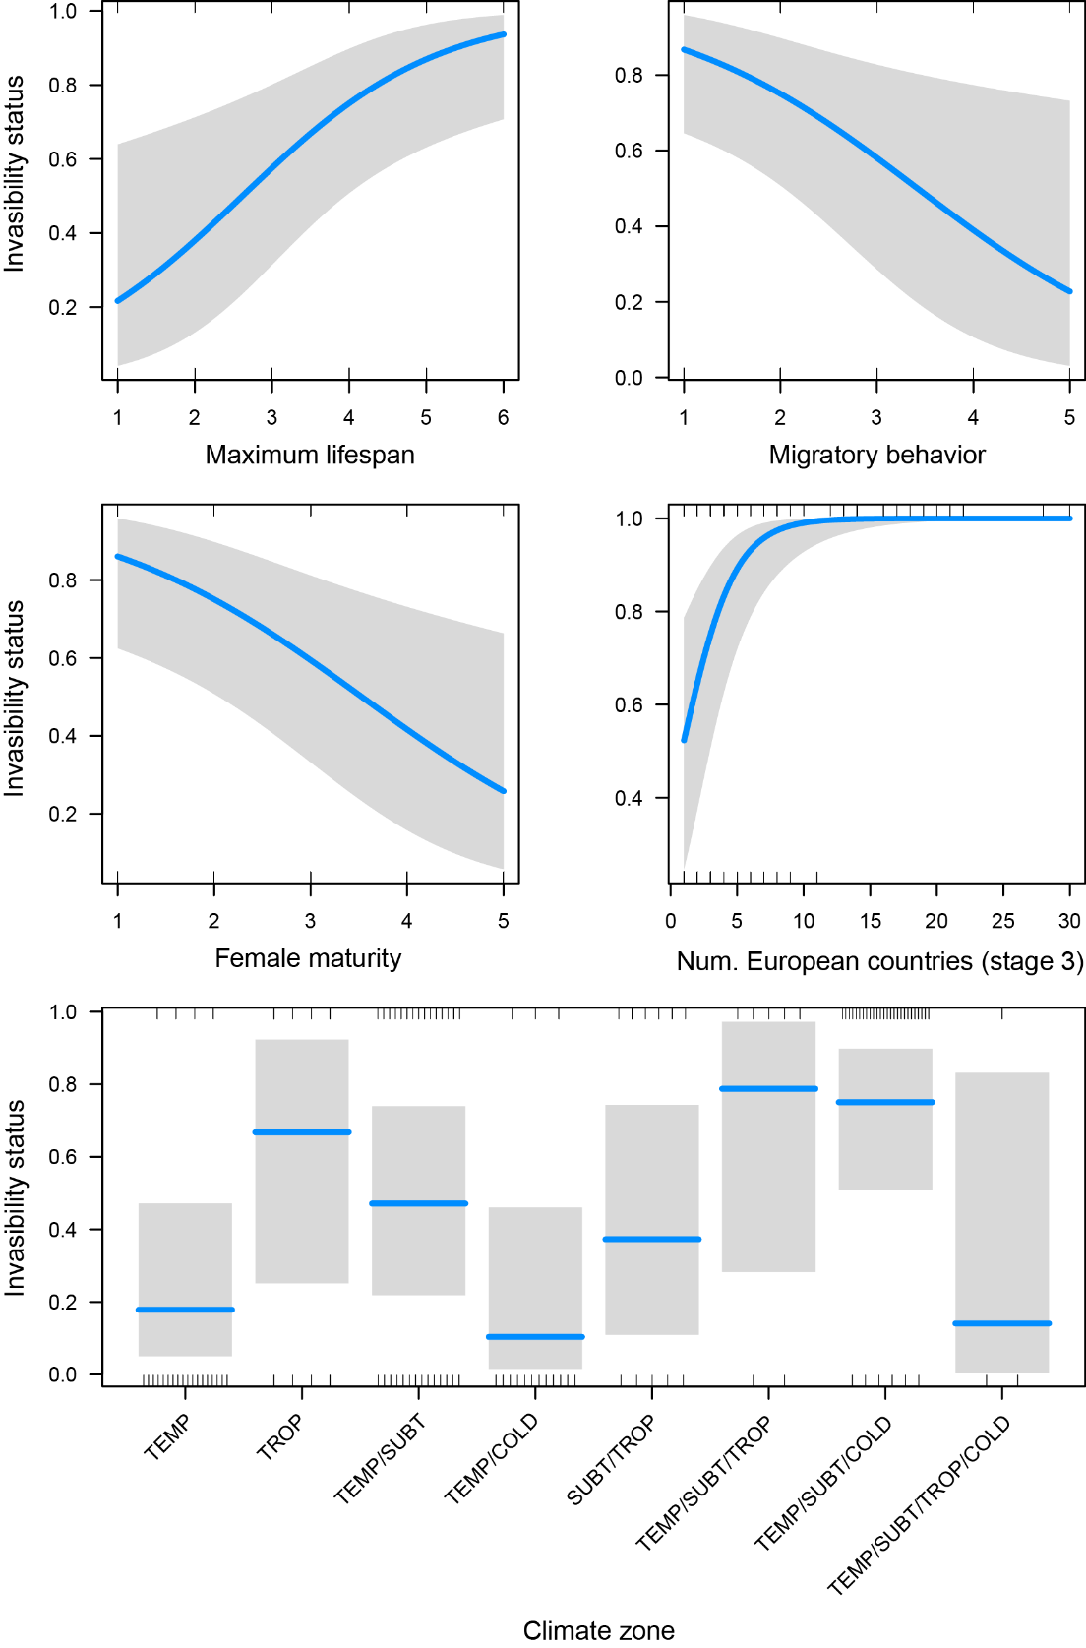

Fig. S4 Partial dependence plots of the predicted values for the impact stage model (response variable: invisibility status), showing only the explanatory variables whose confident intervals of the regression coefficients do not contain zero (maximum lifespan, migratory behaviour, female maturity, number of European countries with established populations (spread stage response) and cause of introduction). Grey bands represent 95% Confidence Interval. Categories of cause of introduction: INT – intentional; ACC – Accidental, DIS – dispersal; and combinations of the three single categories when multiple causes are referred to. Blue lines in the boxplot represent the mean predicted values for the Invasibility status. For variable explanation see Marcolin et al. (2022).

