Supplementary Information

Spin and Wavelength Multiplexed Eight-Channel Surface Plasmon Metalensing

Xiaohan Jiang¹, Quan Xu¹*, Yuanhao Lang¹, Wanying Liu¹, Xieyu Chen¹, Yuehong Xu¹, Hang Ren², Xibin Wang², Su Xu², Xueqian Zhang¹, Chunmei Ouyang¹, Zhen Tian¹, Jianqiang Gu¹, Jiaguang Han^{1,3}* and Weili Zhang⁴*

¹ Center for Terahertz Waves, College of Precision Instrument and Optoelectronics Engineering, and the Key Laboratory of Optoelectronic Information and Technology (Ministry of Education), Tianjin University, Tianjin 300072, China.

² State Key Laboratory of Integrated Optoelectronics, College of Electronic Science and Engineering, Jilin University, Changchun 130012, China.

³ Guangxi Key Laboratory of Optoelectronic Information Processing, School of Optoelectronic Engineering, Guilin University of Electronic Technology, Guilin 541004, China

⁴ School of Electrical and Computer Engineering, Oklahoma State University, Stillwater, Oklahoma 74078, USA.

*Correspondence: quanxu@tju.edu.cn; jiaghan@tju.edu.cn; weili.zhang@okstate.edu;

A. Single dipole excitation
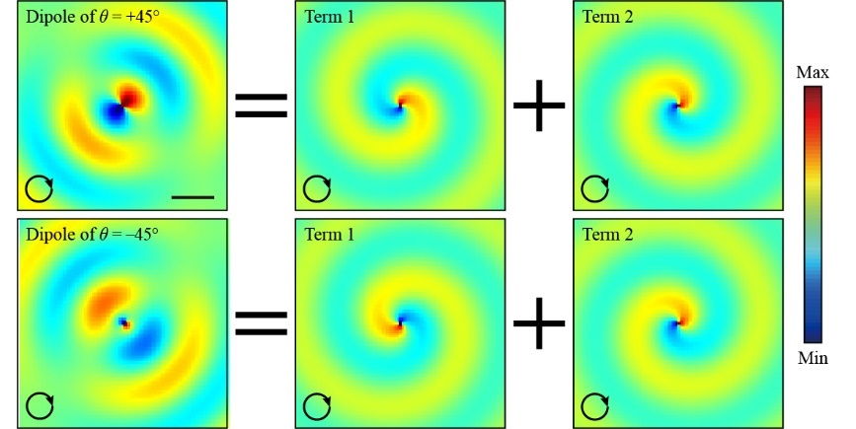
Figure S1. The calculated SP field (real part) distributions from the dipole sources of θ = +45° and θ = –45°, respectively, and the corresponding components under RCP incidences compared with Figure 1b-g. Scale bar is λ_{SP}/2 same with in Figure 1b.

B. Detailed analysis of the SP excitations
In order to discuss the interaction of the term exp(iσξ)/2 in the Equation 2, we choose the single SP focusing at the (6,0) with the unit of millimeter and compare two parts of excitations in the surface plane. Figure S2a shows the orientation distribution of the resonators at the wavelength of 400 μm. According to the extracted equations with the term 1 Equation S1 and the term 2 Equation S2 from the Equation 2 as below,
, (S1)
, (S2)
the calculated field distributions are respectively illustrated in the Figure S2b and S2c, where the dash circles outline the emitting region with the radius of 3 mm. Here, we normalize these two profiles with the maximum focusing intensity in Figure S2b. The intensity colormap displayed in the Figure S2c is the 1/100 magnitude of the Figure S2b, which indicates the ignore of the term exp(iσξ)/2 in the holographic design is reasonable.
Figure S2. Compare the influence of term 1 and term 2 in the Equation 2. a The calculated resonator orientation angle distribution. b Calculated field intensities of the term 1 in the Equation 2. c Calculated field intensities of the term 2 in the Equation 2.

C. Simulated response of the connected-double-ring slit resonator
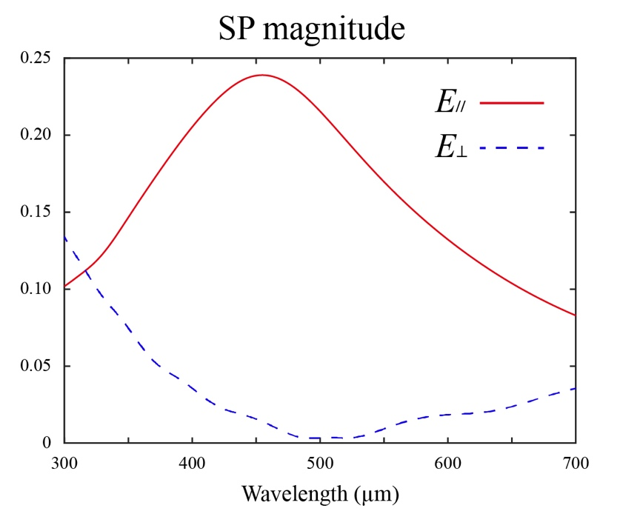
Figure S3. The simulated SP excitations of E∥ and E⊥, respectively, under the linear incidences polarized parallel and perpendicular to the connect arm of the resonator. In a broadband range, the SP excitation of E∥ is much larger than that of E⊥, complying the condition that can only be excited by incidence component polarized along its orientation direction. As shown in the Fig. 2a, the connected-double-ring resonator is located in xy-plane (lower surface at z = 0), open boundary conditions are applied to the x and z directions, and periodic boundary condition is applied to the y direction. The excitation source is an x-polarized plane wave imping from the substrate side. By rotating the resonator connected arm to be parallel and perpendicular to x-axis, E∥ and E⊥ can thus be obtained by setting a E_{z}-field probe at the position (1750, 0, 50 μm).

D. Metalens III
Figure S4. a Schematics of the metalensing towards opposite directions under the CP incidences of four wavelengths and two spin directions. b and c The calculated resonator orientation angle distributions and the microscopic image of the Metalens III. d and e Calculated and measured SP intensity distributions under the different CP incidences. The colormaps of each wavelength are normalized by the maximum intensity at the focus spots of two spins, respectively, in calculation and measurements.

E. Metalens IV
Figure S5. a Schematics of the metalensing towards the same direction under the CP incidences of four wavelengths and two spin directions. b and c The calculated resonator orientation angle distributions and the microscopic image of the Metalens IV. d and e Calculated and measured SP intensity distributions under the different CP incidences. The colormaps of each wavelength are normalized by the maximum intensity at the focus spots of two spins, respectively, in calculation and measurements.

F. Quantitative analysis from Metalens I II III IV
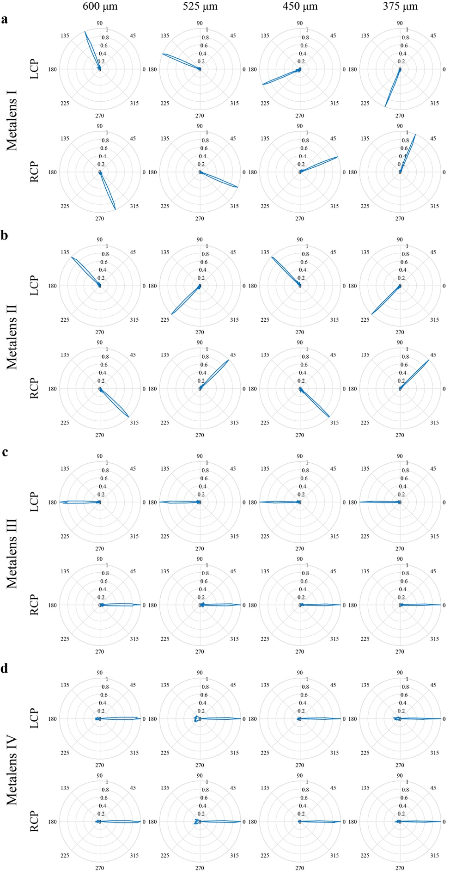
Figure S6. Corresponding spatial direction results extracted from the 6-mm radius in each measured SP profile. We normalized intensity spectra at each focal spot for the wavelengths of 600 μm, 525 μm, 450 μm, and 375 μm under the LCP and RCP incidences.

G. Ten-channel metalens
Figure S7. By utilizing the holographic design principle, a ten-channel multiplexed focusing of SPs can easily be constructed with the identical metasurface region. The predefined focusing positions are located at a circle with radius of 6 mm as well. Five wavelengths of 550 μm, 500 μm, 450 μm, 400 μm, and 350 μm are chosen and respectively route to the azimuth angles of 3π/5, 4π/5, π, –4π/5, and –3π/5 for LCP incidences. For RCP incidences the focusing positions are opposite to that of the LCP cases. In the simulation, a CP plane wave is set to the incidence from the bottom of a 2 μm-thick silicon substance with a 200 nm-thick patterned Al film covered a 10 μm-thick polyimide layer and open boundary conditions are applied to all directions. The simulated Ez-field distributions are extracted at the 50 μm surface above the dielectric layer. The colormaps of each wavelength are normalized by the maximum intensity at the focus spots of two spins.

H. Multi-channel focal intensity analysis
Figure S8. The stacked focus intensities are respectively extracted from the calculated results from one to five wavelengths multiplexing. Due to the complete phase controllability and the simplicity of assigning all the imaginary source S_{n} to 1 in the holographic process, the intensity distributions are not absolutely uniform for different wavelengths. According to the constant capacity of multiplexing energy, the SP excitation from a given metasurface will be divided by all the wavelengths.

I. Other metalenses design
Figure S9. Calculated Ez-field intensity distributions for the spin and wavelength of 600 μm, 500 μm, 400 μm, and 300 μm multiplexed focusing. a Focusing symmetrically about y axis. b Focusing at different focal radiuses. The wavelengths of 600 μm and 500 μm focus at the radius of 6 mm, while 400 μm and 300 μm focus at the radius of 9 mm. The colormaps of each wavelength are normalized by the maximum intensity at the focus spots of two spins, respectively, in two designs.

J. Compare two types of resonators
Figure S10. Compare two types of resonators: connected-double-ring slit resonator and normal slit resonator. The Resonator I have the higher efficiency than the Resonator II within the wavelength region concerned from the right chart.

K. Coupling efficiencies of Metalenses
In simulation, we integrate E_{z} field intensities on the cross section extracted along each own travel direction where the width is twice of wavelength and the height is 1 mm above the metallic surface. There are 2821 double-connected-ring resonators used in all metalensing designs to couple free space light. The income beam can illuminate the whole metasurface area and be scattered through the apertures. Thus, the estimated couple efficiencies for these metalenses with different wavelengths and spins can be clearly listed in the Table S1.
Table S1. Channel coupling efficiencies for four Metalenses.

Metalens |  | LCP |  |  |  |  | RCP
Metalens |  | 600 µm | 525 µm | 450 µm | 375 µm |  | 600 µm | 525 µm | 450µm | 375 µm
I |  | 9.68% | 17.49% | 13.60% | 10.35% |  | 9.88% | 16.63% | 14.07% | 9.18%
II |  | 10.88% | 11.87% | 14.39% | 9.34% |  | 10.98% | 12.31% | 14.71% | 9.53%
III |  | 11.20% | 14.12% | 12.73% | 9.06% |  | 11.20% | 14.14% | 12.73% | 9.06%
IV |  | 8.90% | 8.10% | 11.37% | 4.44% |  | 8.32% | 8.38% | 12.67% | 4.28%

L. Duty cycles of meta-atoms
A four-wavelength multiplexed focusing was fabricated without the limit of chirality by use of the same PB meta-atom, as illustrated in Figure S10a. The SP waves with the wavelengths of 500 μm, 450 μm, 400 μm, and 350 μm are respectively propagating to four symmetrical directions, where the focal spots of the 500 μm and 450 μm are respectively at 6[−sin(π/4), cos(π/4)] and 6[−sin(3π/4), cos(3π/4)] with the LCP incidences, and the other focal spots of the 400 μm and 350 μm are respectively at 6[−sin(5π/4), cos(5π/4)] and 6[−sin(7π/4), cos(7π/4)] with the RCP incidences. Here, the spin of circular polarization incidences can be used to switch the in-plane SPs states. The experimental profiles can be completely mapped by the near-field scanning terahertz microscope system. Furthermore, we compare another proposed design approach for linear polarizations based on holographic principle to realize the same functionality of four-channel SPs focusing as above. The detailed implement is to determine the wavefronts of SPs that would propagate out from the imaginary point sources located at the focus spots. The intersections of the wavefronts from two imaginary point sources are the available positions where we place the unit structures. If all of the unit structures are excited in phase, then the reradiated SPs will constructively interfere at the predefined foci. In this way, we can combine four foci on a plane by steering two orthogonal linear polarization at most. This metalens sample is also fabricated with the same PB meta-atoms drilled on the metallic surfaces, as illustrated in Figure S10b. We can clearly notice the different duty cycles of meta-atoms between the Figure S10a and S10b, which will directly influence the excited efficiency under the same coupling region. Figure S10c further compares the intensities of these two metalens measured above each focal spot at different wavelengths. As for the consistent incidence, the fields are similarly superposed by use of the same polarizers generating two orthogonal polarizations so that the circular polarization or linear polarization incidences can be regarded as the equal energy. Therefore, the new holographic principle cannot only overcome the limit of the arrangement of resonators placed on the intersections, but also improve the freedom of the focusing design. We both theoretically and experimentally demonstrate the strengths of novel holographic principle on the focusing efficiency and flexible manipulation of SP waves.
Figure S11. Samples images and focal intensity comparisons. a and b Fabricated metalens with the same meta-atoms by the two different methods, respectively. c Intensities of each metalens measured at the focal spots under the identical energy incidences.

