Supplementary information 1Table 01: BBD experimental design and response
 |  | Factor 1 | Factor 2 | Factor 3 | Response 1 | Response 2
Std | Run | A:Solvent for 1 part of solute | B:Temperature | C:Time | Yield | Andrographolide
 |  |  | oC | Minute | % (w/w) | % (w/w)
14 | 1 | 5 | 100 | 60 | 18.213 | 0.1823
17 | 2 | 5 | 100 | 60 | 18.213 | 0.1823
11 | 3 | 5 | 50 | 90 | 15.36 | 0.0062
6 | 4 | 10 | 100 | 30 | 17.12 | 0.01812
7 | 5 | 1 | 100 | 90 | 13.154 | 0.0034
9 | 6 | 5 | 50 | 30 | 14.29 | 0.0041
3 | 7 | 1 | 150 | 60 | 13.168 | 0.0034
8 | 8 | 10 | 100 | 90 | 18.23 | 0.1824
10 | 9 | 5 | 150 | 30 | 16.34 | 0.016
5 | 10 | 1 | 100 | 30 | 11.194 | 0.0031
15 | 11 | 5 | 100 | 60 | 18.213 | 0.1823
4 | 12 | 10 | 150 | 60 | 18.23 | 0.1824
13 | 13 | 5 | 100 | 60 | 18.213 | 0.1823
16 | 14 | 5 | 100 | 60 | 18.213 | 0.1823
12 | 15 | 5 | 150 | 90 | 18.23 | 0.1824
2 | 16 | 10 | 50 | 60 | 14.81 | 0.0061
1 | 17 | 1 | 50 | 60 | 10.1 | 0.0022

Supplementary information Table 02: Optimum conditions, experimental and predicted value of response at optimized conditions.

Optimized condition | Coded levels | Predicted levels
A-Solvent for 1 part of solute | 0.7256 | 8.628
B-Temperature | 0.49512 | 124.756 ºC
C-Time | 002115 | 66.345 min
Response | Predicted levels | Actual levels
% Yield (w/w) | 19.410 | 19.049±0.122
% Andrographolide (w/w) | 0.225 | 0.21±0.04

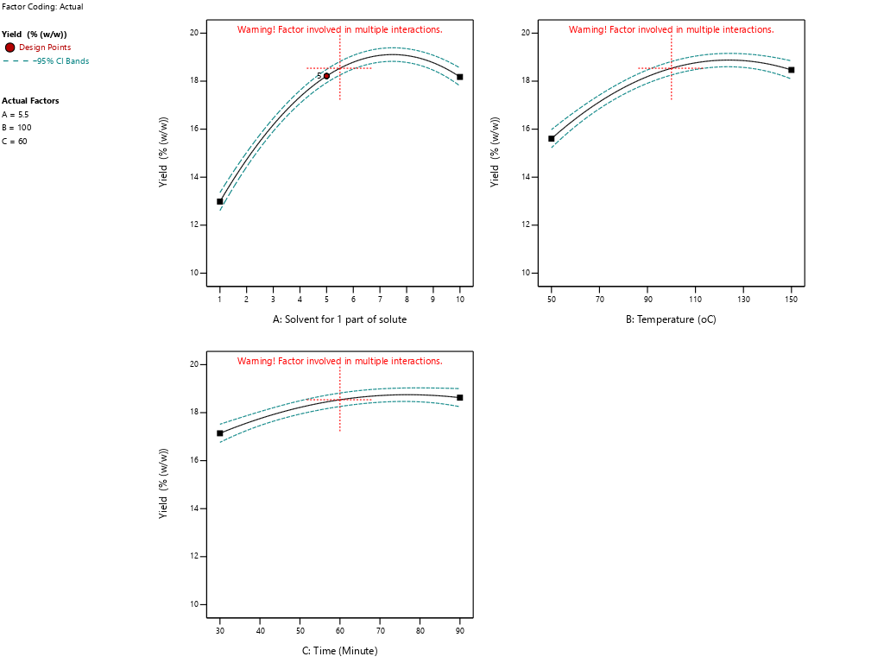

Supplementary information Fig. 01 (A) Effect of different paprameter on % Extraction and efficiency

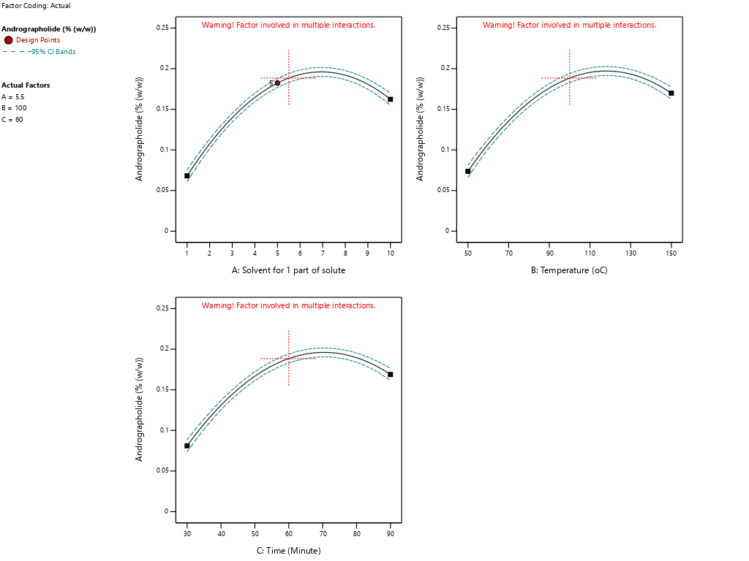

Supplementary information Fig. 01 (B) Effect of different paprameter on % %AGL efficiency

