Supplementary Materials

Oxidation towards enrofloxacin degradation over nanoscale zero-valent copper: Mechanism and products
Zhiqiang Gong^{a, b}, Junpu Xie^{a, b}, Jingxin Liu^{b}, Ting Liuª, Jianwu Chenª, Jinping Li^{b}, Jinhua Gan^{a, *}
ª Yangtze River Fisheries Research Institute, Chinese Academy of Fishery Sciences, Wuhan, Hubei 430223, China
^{b} School of Environmental Engineering, Wuhan Textile University, Wuhan, Hubei 430073, P R China
*Corresponding author.
E-mail address: gjh@yfi.ac.cn (J. Gan).

List of Table and Figures

Table S1 Proposed fragmentation pathways for oxidation products of ENR reaction with nZVC

Fig.S1. Proposed structures for the fragment ions of the protonated ENR

Fig.S2. MS/MS spectra of main dissociation products of ENR by HPLC-Q-TOF-MS

Fig.S3. The location of different elements in the structure of ENR

Table S1 Proposed fragmentation pathways for oxidation products of ENR
reaction with nZVC
Compounds | Retention time (min) | Proposed formula  [M+H]⁺ | Experimental mass (m/z) | Theoretical mass (m/z) | Fragment Ions
P1 | 9.28 | C₁₇H₂₁FN₃O₃⁺ | 334.1204 | 334.1561 | /
P1 | 9.28 | C₁₇H₂₀N₃O₃⁺ | 314.1487 | 314.1499 | HF
P1 | 9.28 | C₁₇H₁₈N₃O₂⁺ | 296.1032 | 296.1394 | H₂O
P1 | 9.28 | C₁₇H₁₉FN₃O₂⁺ | 316.1103 | 316.1456 | H₂O
P1 | 9.28 | C₁₅H₁₅FN₃O₂⁺ | 288.1134 | 288.1143 | C₂H₄
P1 | 9.28 | C₁₃H₁₀FN₂O₂⁺ | 245.0756 | 245.0721 | C₂H₅N
P2 | 9.28 | C₁₈H₂₁FN₃O₄⁺ | 362.1502 | 362.1511 | /
P2 | 9.28 | C₁₈H₁₉FN₃O₃⁺ | 344.1393 | 344.1405 | H₂O
P2 | 9.28 | C₁₆H₁₄FN₂O₄⁺ | 317.0927 | 317.0932 | C₂H₅N
P2 | 9.28 | C₁₅H₁₄FN₂O₂⁺ | 273.1024 | 273.1034 | CO₂
P2 | 9.28 | C₁₄H₁₄FN₂O⁺ | 245.1086 | 245.1085 | CO
P3 | 9.34 | C₁₉H₂₃FN₃O₅⁺ | 392.1624 | 392.1616 | /
P3 | 9.34 | C₁₉H₂₁FN₃O₄⁺ | 374.1505 | 374.1511 | H₂O
P3 | 9.34 | C₁₉H₁₉FN₃O₃⁺ | 356.1395 | 356.1405 | CO
P3 | 9.34 | C₁₈H₂₁FN₃O₂⁺ | 330.1620 | 330.1613 | CO
P3 | 9.34 | C₁₃H₁₂FN₂O₃⁺ | 263.0831 | 263.0826 | C₆H₁₁NO₂
P3 | 9.34 | C₁₃H₁₂FN₂O₃⁺ | 245.0727 | 245.0721 | H₂O
ENR | 9.36 | C₁₉H₂₂FN₃O₃⁺ | 360.1714 | 360.1718 | /
ENR | 9.36 | C₁₉H₂₂FN₃O₃⁺ | 316.1812 | 316.1820 | CO₂
ENR | 9.36 | C₁₉H₂₂FN₃O₃⁺ | 245.1080 | 245.1085 | C₂H₅N、  C₂H₄
ENR | 9.36 | C₁₉H₂₂FN₃O₃⁺ | 203.0579 | 203.0615 | C₃H₆
ENR | 9.36 | C₁₉H₂₂FN₃O₃⁺ | 342.1619 | 342.1612 | H₂O
ENR | 9.36 | C₁₉H₂₂FN₃O₃⁺ | 286.0976 | 286.0986 | C₂H₅、  C₂H₄
Compounds | Retention time (min) | Proposed formula  [M+H]⁺ | Experimental mass (m/z) | Theoretical mass (m/z) | Fragment Ions
P4 | 9.40 | C₁₉H₂₃FN₃O₄⁺ | 376.1677 | 376.1667 | /
P4 | 9.40 | C₁₉H₂₁FN₃O₃⁺ | 358.1561 | 358.1561 | H₂O
P4 | 9.40 | C₁₈H₂₁FN₃O⁺ | 314.1667 | 314.1663 | CO₂
P5 | 10.17 | C₁₉H₂₁FN₃O₅⁺ | 390.1463 | 390.1460 | /
P5 | 10.17 | C₅H₁₀NO⁺ | 100.0765 | 100.0757 | C₁₄H₁₁FN₂O₄
P5 | 10.17 | C₁₉H₁₉FN₃O₄⁺ | 372.1359 | 372.1354 | H₂O
P5 | 10.17 | C₁₅H₁₂FN₂O₂⁺ | 271.0512 | 271.0877 | C₄H₇NO₂
P5 | 10.17 | C₁₄H₁₄FN₂O⁺ | 245.0729 | 245.1085 | CO
P5 | 10.17 | C₁₈H₁₉FN₃O₃⁺ | 344.1405 | 344.1405 | CO
P6 | 10.79 | C₁₉H₂₁FN₃O₃⁺ | 358.1550 | 358.1561 | /
P6 | 10.79 | C₁₈H₂₁FN₃O⁺ | 314.1629 | 314.1663 | CO₂
P6 | 10.79 | C₁₉H₁₉FN₃O₂⁺ | 340.1496 | 340.1456 | H₂O
P7 | 19.06 | C₁₃H₁₂FN₂O₃⁺ | 263.0806 | 263.0826 | /
P7 | 19.06 | C₁₃H₁₀FN₂O₂⁺ | 245.0724 | 245.0721 | H₂O
P7 | 19.06 | C₁₂H₁₀FN₂O⁺ | 217.0768 | 217.0772 | CO
P7 | 19.06 | C₁₁H₁₀FN₂⁺ | 189.0826 | 189.0823 | CO
P7 | 19.06 | C₁₀H₅FN₂O₂⁺ | 204.0332 | 204.0330 | C₃H₅
P8 | 19.12 | C₁₄H₁₂FN₂O₄⁺ | 291.0785 | 291.0776 | /
P8 | 19.12 | C₁₄H₁₀FN₂O₃⁺ | 273.0671 | 273.0670 | H₂O
P8 | 19.12 | C₁₃H₁₀FN₂O₂⁺ | 245.0716 | 245.0721 | CO
P8 | 19.12 | C₁₂H₁₀FN₂O⁺ | 217.0782 | 217.0772 | CO
P8 | 19.12 | C₁₁H₁₀FN₂⁺ | 189.0835 | 189.0823 | CO

P1
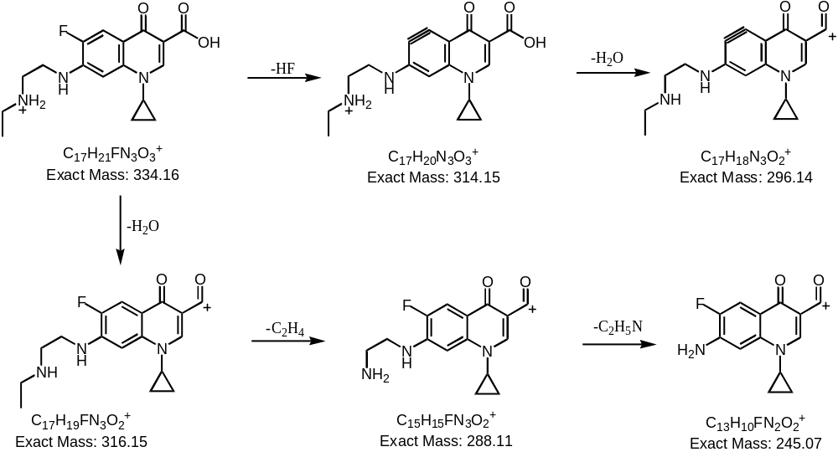

P2
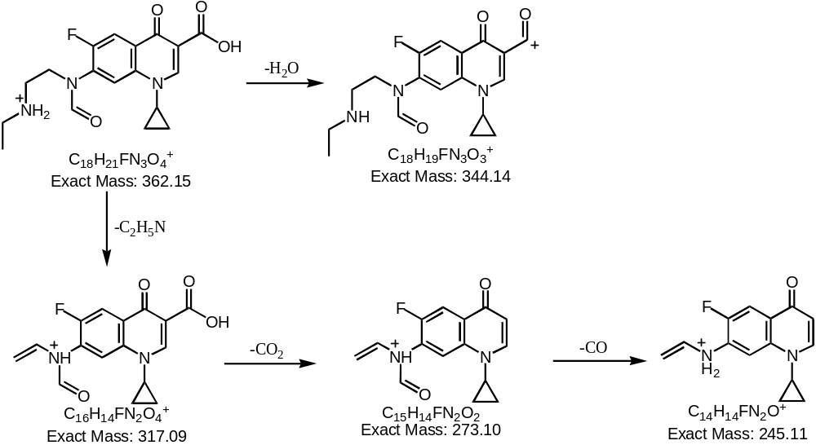

P3
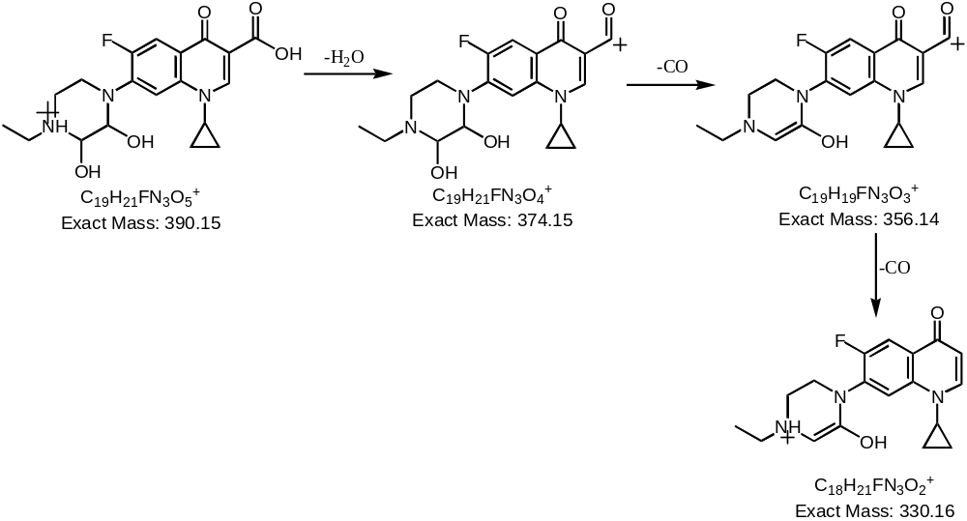

ENR
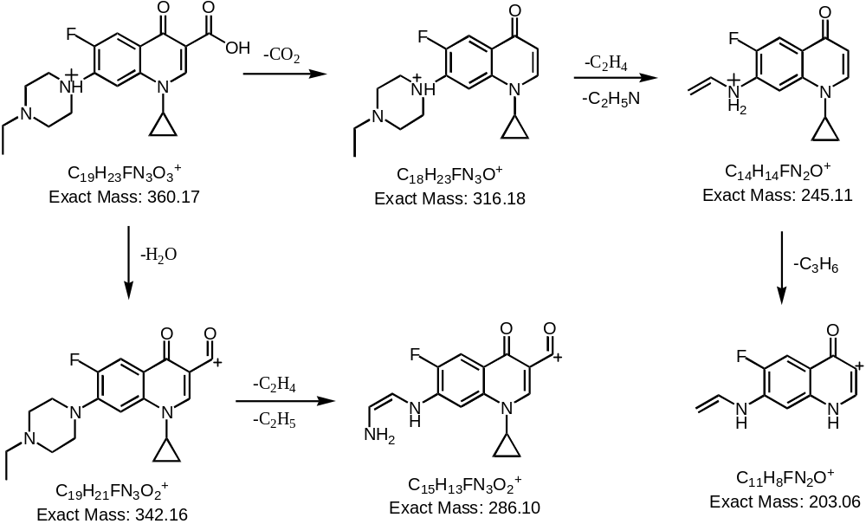

P4
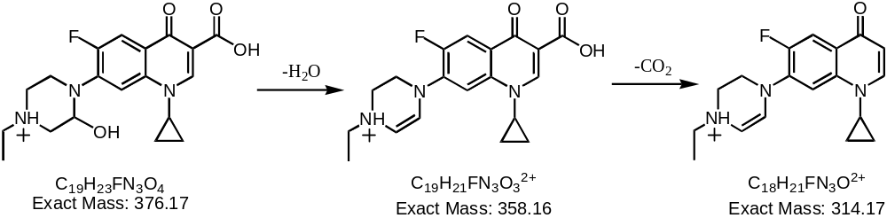

P5
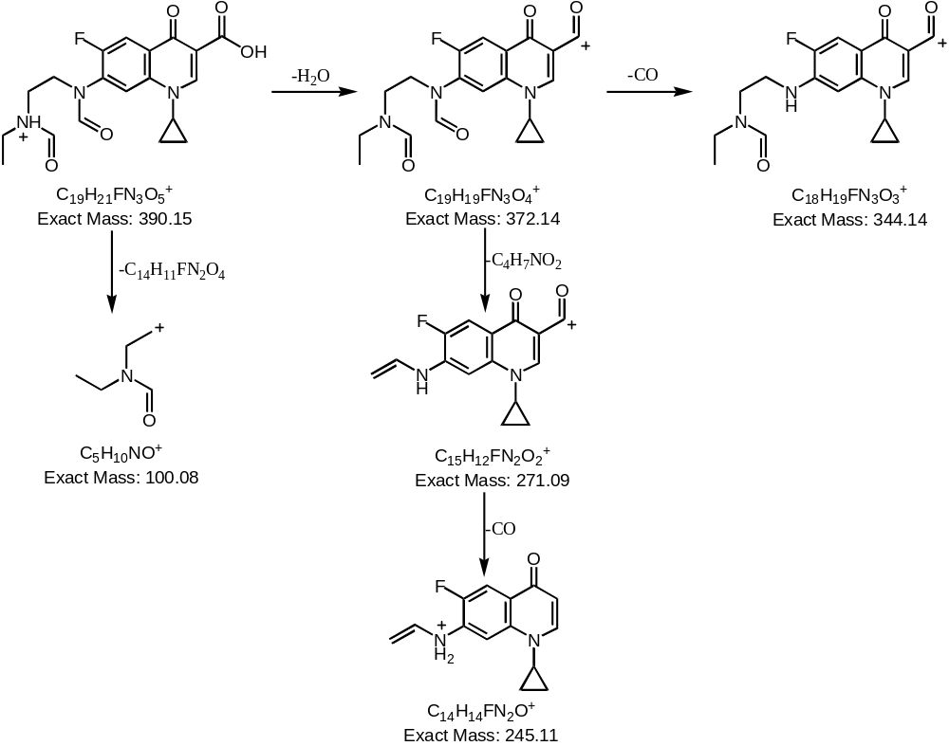

P6
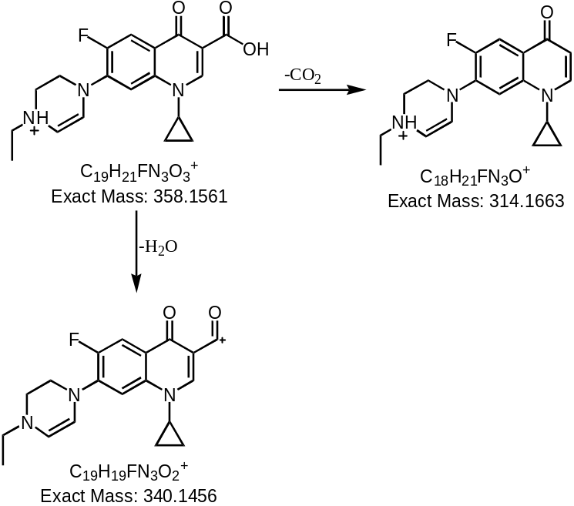

P7
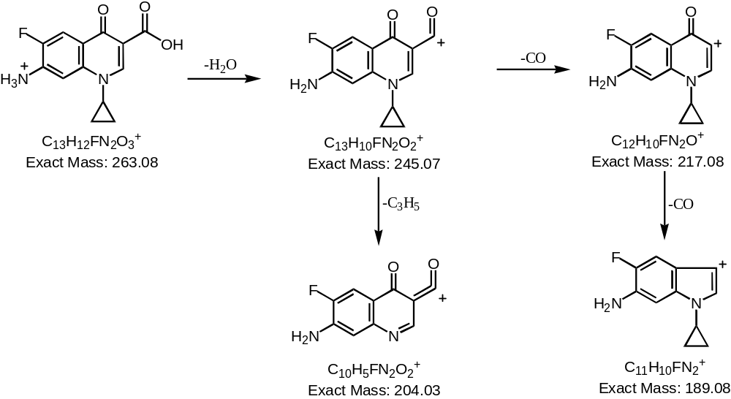

P8
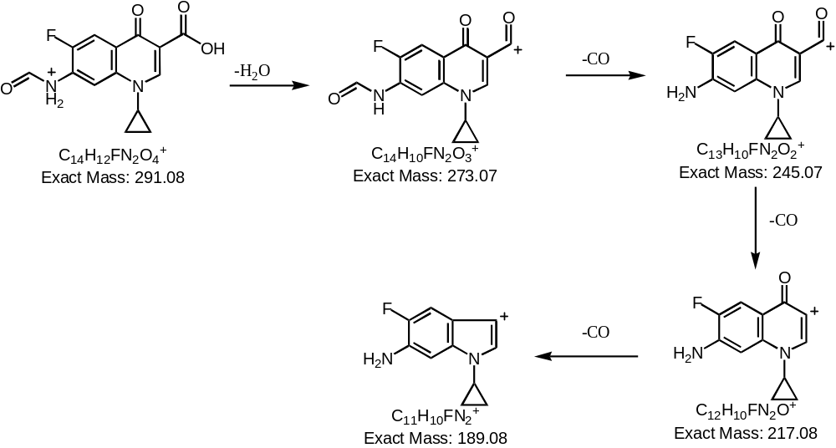

Fig.S1. Proposed structures for the fragment ions of the protonated ENR

P1

P2

P3

ENR

P4

P5

P6

P7

P8

Fig.S2. MS/MS spectra of main dissociation products of ENR by HPLC-TOF-MS

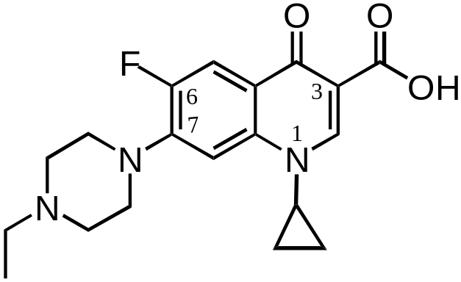
Fig.S3. The location of different elements in the structure of ENR

