Additional files
Supplementary Tables
Table S1. Relationship between STRIP2 expression in NSCLC and clinicalpathological characteristics
Variables | Low expression group (n=51) | High expression  group (n=138) | χ² | p
Gender |  |  | 0.178 | 0.673
Female | 23 | 67
Male | 28 | 71
Age |  |  | 0.007 | 0.934
>65 | 24 | 64
≤65 | 27 | 74
Smoking history |  |  | 0.014 | 0.905
Ever | 26 | 69
Never | 25 | 69
Tumor size (cm) |  |  | 0.043 | 0.836
>3.0 | 14 | 40
≤3.0 | 37 | 98
Tumor differentiation |  |  | 2.984 | 0.041*
Well/Moderate | 43 | 103
Poor | 8 | 35
Lymphatic invasion |  |  | 3.928 | 0.026*
Present | 14 | 52
Absent | 37 | 86
Cancer thrombus |  |  | 3.166 | 0.045*
Present | 16 | 62
Absent | 35 | 76
Stage |  |  | 3.711 | 0.038*
I+II | 36 | 79
III+ IV | 15 | 59

Table S2. Sequence of primers used for qRT-PCR
Genes | Primers
STRIP2-forward | 5’-AGGTGGTCAGTAGGGAACGG-3’
STRIP2-reverse | 5’-TGTAGCACATCGACCTCTGAA-3’
IGF2BP3-forward | 5’-TATATCGGAAACCTCAGCGAGA-3’
IGF2BP3-reverse | 5’-GGACCGAGTGCTCAACTTCT-3’
TMBIM6-forward | 5’-CATATAACCCCGTCAACGCAG-3’
TMBIM6-reverse | 5’-GCAGCCGCCACAAACATAC-3’
TSPAN17-forward | 5’-GCTGCTGCGGGAAATACTTC-3’
TSPAN17-reverse | 5’-AGAGGCCGATAGCCAGGAA-3’
KREMEN1-forward | 5’-CCCGAGTGTTTCACAGCCAAT-3’
KREMEN1-reverse | 5’-GGATGCTGGAAAGTCTCGTTC-3’
BCL3-forward | 5’-CCGGAGGCGCTTTACTACC-3’
BCL3-reverse | 5’-TAGGGGTGTAGGCAGGTTCAC-3’
OTUD6B-forward | 5’-TGAGAAGGCATCGCAAAGAGA-3’
OTUD6B-reverse | 5’-ATCTTCGGTGAGTTGCTTCCT-3’
CDK2AP1-forward | 5’-ATGTCTTACAAACCGAACTTGGC-3’
CDK2AP1-reverse | 5’-GCCCGTAGTCACTGAGCAG-3’
ABHD14B-forward | 5’-TCACTGAGTGGCATGTACTCC-3’
ABHD14B-reverse | 5’-GTTGGCAGCATTGATTTTGTCA-3’
EIF5-forward | 5’-AGCGTGTCAGACCAGTTCTAT -3’
EIF5-reverse | 5’-CTGTCTTGATTCCATTGCCTTTG-3’
c-MYC-forward | 5’-TTCGGGTAGTGGAAAACCAG -3’
c-MYC-reverse | 5’-AGTAGAAATACGGCTGCACC -3’
P300-forward | 5’-GCTTCAGACAAGTCTTGGCAT-3’
P300-reverse | 5’-ACTACCAGATCGCAGCAATTC-3’
CBP-forward | 5’-CGGCTCTAGTATCAACCCAGG-3’
CBP-reverse | 5’-TTTTGTGCTTGCGGATTCAGT-3’
18sRNA-forward | 5’-GTAACCCGTTGAACCCCATT-3’
18sRNA-reverse | 5’-CCATCCAATCGGTAGTAGCG-3’

Table S3. Downregulated gene expression of STRIP2 knockdown RNA-sequence data
Number | Gene name | Number | Gene name | Number | Gene name
1 | AL136295 | 86 | BMF | 171 | AEN
2 | ISY1-RAB43 | 87 | WNT4 | 172 | SLC26A2
3 | AC234781 | 88 | AL109615 | 173 | TMEM201
4 | AC008763 | 89 | AC010733 | 174 | MGAM
5 | AC016747 | 90 | KREMEN1 | 175 | ABHD14B
6 | AP003071 | 91 | CSPG4 | 176 | RTKN2
7 | MIR1244-1 | 92 | ANKRD36C | 177 | SULT1A3
8 | AC008878 | 93 | PLIN4 | 178 | CDK2AP1
9 | CLDN4 | 94 | CHD5 | 179 | PALM2AKAP2
10 | AC244197 | 95 | STRIP2 | 180 | EIF5
11 | CCL20 | 96 | ZNF133 | 181 | CHAC2
12 | UBE2F-SCLY | 97 | PDK4 | 182 | FAM216A
13 | NPIPP1 | 98 | MICAL2 | 183 | NCLN
14 | AL121594 | 99 | AL109615 | 184 | F11R
15 | AC009133 | 100 | DUBR | 185 | SERPINB7
16 | EGR2 | 101 | TREML4 | 186 | LINC01836
17 | AC015712 | 102 | AL732372 | 187 | UBE2D4
18 | CEP170P1 | 103 | SRRM3 | 188 | NBPF14
19 | LRRC32 | 104 | ALDH1A1 | 189 | AL135905
20 | NDUFC2-KCTD14 | 105 | CXCL1 | 190 | MPZL1
21 | IQCN | 106 | CA2 | 191 | HTR7
22 | ZNF843 | 107 | TSN | 192 | SGSH
23 | HERC2P7 | 108 | RHCG | 193 | TMEM198
24 | SHLD2P1 | 109 | MRPS9 | 194 | MTAP
25 | TRAPPC5 | 110 | ANXA2R | 195 | OTUD6B
26 | MAP1A | 111 | MOGS | 196 | ENTPD1
27 | IL1A | 112 | PDP2 | 197 | SOCS2
28 | TRIM31 | 113 | SPRR1B | 198 | SUSD2
29 | GRIN3B | 114 | NR1D1 | 199 | MRPL20-AS1
30 | G0S2 | 115 | SPRR1A | 200 | GABBR2
31 | FBN2 | 116 | PDZK1IP1 | 201 | GRB2
32 | LTB | 117 | SIRPG | 202 | NABP2
33 | S100A8 | 118 | CYP2T1P | 203 | RN7SL1
34 | AL121761 | 119 | TNS1 | 204 | AL162595
35 | AP002990 | 120 | SENP3-EIF4A1 | 205 | VGF
36 | TH | 121 | BCL2L11 | 206 | DIO2
37 | IL1B | 122 | CAPN5 | 207 | DDX20
38 | TOMM6 | 123 | KCTD18 | 208 | RAPH1
39 | TOLLIP-AS1 | 124 | SLC30A3 | 209 | PSG5
40 | CES1 | 125 | STARD4 | 210 | EPGN
41 | LINC02029 | 126 | VIM | 211 | FSTL4
42 | ADORA2A | 127 | PER1 | 212 | GALNT4
43 | AC009812 | 128 | SGPP2 | 213 | SIX2
44 | PDXDC2P | 129 | WDR6 | 214 | NEXN
45 | RDH16 | 130 | SLC28A3 | 215 | SNX27
46 | ATP6V1G2-DDX39B | 131 | GABARAPL1 | 216 | GJA5
47 | CORO2B | 132 | SAMD11 | 217 | CCDC137
48 | SGK2 | 133 | PNRC1 | 218 | SCARA3
49 | PTX3 | 134 | PECAM1 | 219 | Z92544
50 | SLX1A-SULT1A3 | 135 | S100A9 | 220 | MYOZ1
51 | ANXA10 | 136 | AL162151 | 221 | C5orf24
52 | AC073508 | 137 | PADI4 | 222 | FAM83H
53 | AC010323 | 138 | POLI | 223 | PEG10
54 | KRT6B | 139 | TSPAN17 | 224 | ZNF778
55 | RGCC | 140 | ARL14 | 225 | PRR5L
56 | GCNT3 | 141 | CLIP2 | 226 | C4BPB
57 | CDKN1C | 142 | AC024560 | 227 | DKK1
58 | AC027644 | 143 | LINC00514 | 228 | BDNF
59 | BDKRB1 | 144 | GBP2 | 229 | ANKRD1
60 | RALB | 145 | BTN3A2 | 230 | SLC15A2
61 | AC004997 | 146 | ST6GALNAC2 | 231 | CPA4
62 | ANPEP | 147 | HDAC9 | 232 | GREM1
63 | LINC00887 | 148 | DUSP6 | 233 | ZNF786
64 | MME | 149 | PEX2 | 234 | TLCD4-RWDD3
65 | SOD2 | 150 | NR5A2 | 235 | RN7SL2
66 | AP000696 | 151 | FAM167A | 236 | ADAT3
67 | TIAF1 | 152 | CDON | 237 | AC092032
68 | AC012181 | 153 | TMC8 | 238 | NKX1-2
69 | SCNN1G | 154 | ZNF862 | 239 | HLX
70 | BX537318 | 155 | ALDOC | 240 | PVRIG2P
71 | TNF | 156 | DOCK4 | 241 | ZNF8-ERVK3-1
72 | AC015660 | 157 | TMBIM6 | 242 | MRPS31P5
73 | RGS17 | 158 | WFDC2 | 243 | AC004593
74 | ZNF467 | 159 | AKR1C1 | 244 | IGFBP5
75 | RGS2 | 160 | JAK3 | 245 | AC004922
76 | TFAP2E | 161 | SPATA2 | 246 | KRT4
77 | AC006064 | 162 | AOC1 | 247 | AC023055
78 | BDKRB2 | 163 | ATXN7 | 248 | C8orf44-SGK3
79 | KLF4 | 164 | BCL3 | 249 | ARPIN-AP3S2
80 | ZNF490 | 165 | GPANK1 | 250 | BCL2L2-PABPN1
81 | BTBD3 | 166 | DUSP13 | 251 | AL133355
82 | NUDT16 | 167 | LNX1 | 252 | AC004069
83 | ZMIZ1-AS1 | 168 | TNFAIP3 | 253 | FP565260
84 | DEFB1 | 169 | MTCO1P12 | 254 | AC117378
85 | HEY1 | 170 | SPIN1 | 255 | MIR4707

Table S4. 16 overlapping genes of STRIP2 knockdown RNA-sequence data and two published IGF2BP3 RIP-sequence data and GEO database (GSE90684).
Number | Gene name
1 | CDK2AP1
2 | EIF5
3 | BTBD3
4 | ZNF133
5 | WDR6
6 | ATXN7
7 | ABHD14B
8 | STARD4
9 | KREMEN1
10 | GABARAPL1
11 | BCL3
12 | TSN
13 | TSPAN17
14 | MOGS
15 | OTUD6B
16 | TMBIM6

Supplementary Figures
Fig. S1: The expression levels of P300 and CBP were increased in NSCLC.
P300 and CBP mRNA levels were elevated in GEO database GSE32863.
Fig. S2: C646 does not affect A549 and PC9 cell viabilities.
Cells were treated with different concentrations of C646 for 24 hours, and cell viabilities were measured using CCK-8 assay.
Fig. S3: The number of different genes of STRIP2 knockdown RNA-sequence.
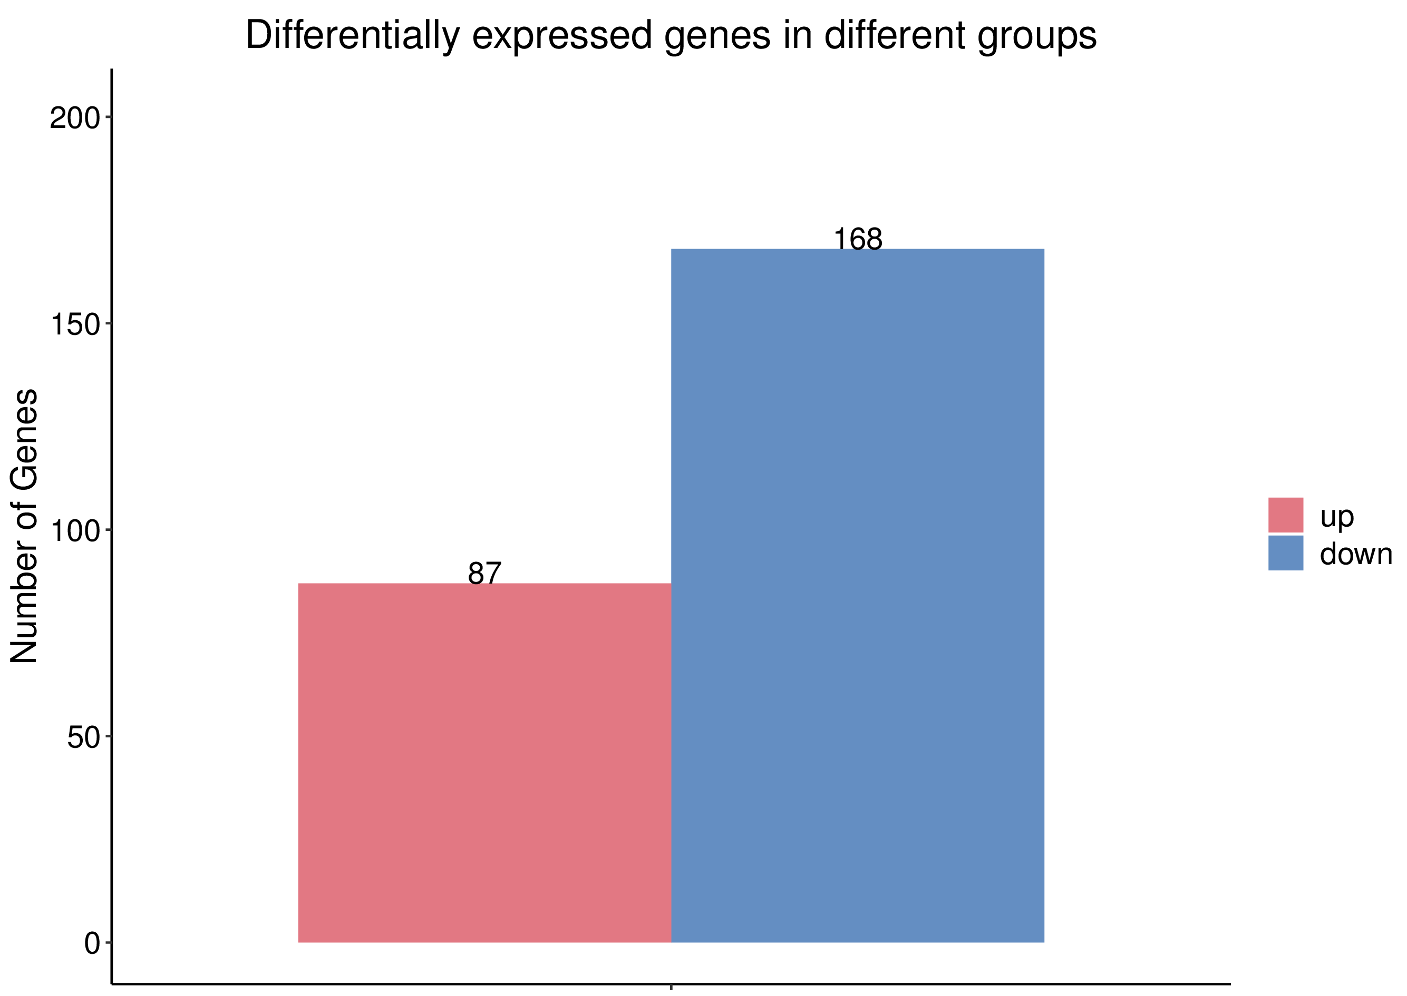
Abnormally expressed genes were analyzed in STRIP2 knockdown group compared with scramble control group.
Fig. S4: The correlations between STRIP2 or IGF2BP3 and TMBIM6.
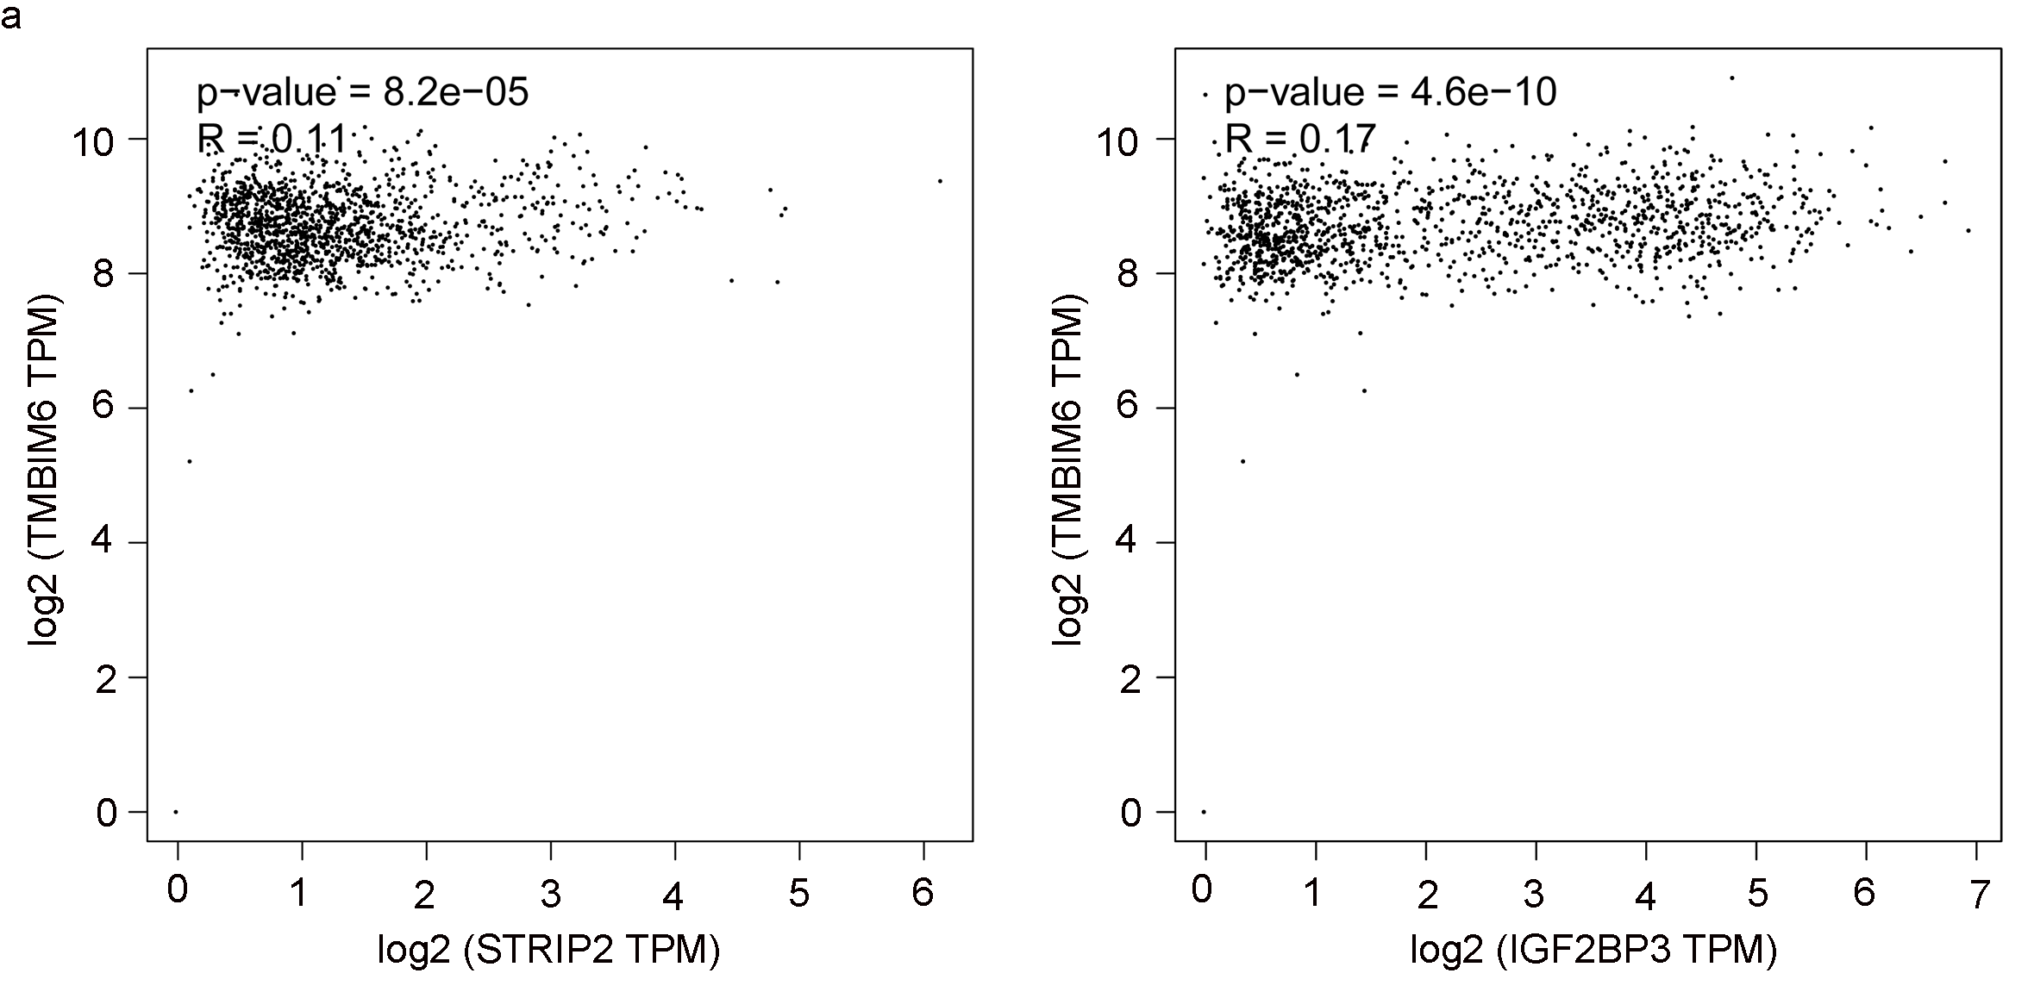
The data of STRIP2, IGF2BP3 and TMBIM6 expression levels were collected from GEPIA2 (http://gepia2.cancer-pku.cn) and the correlations between STRIP2 or IGF2BP3 and TMBIM6 were analyzed.

