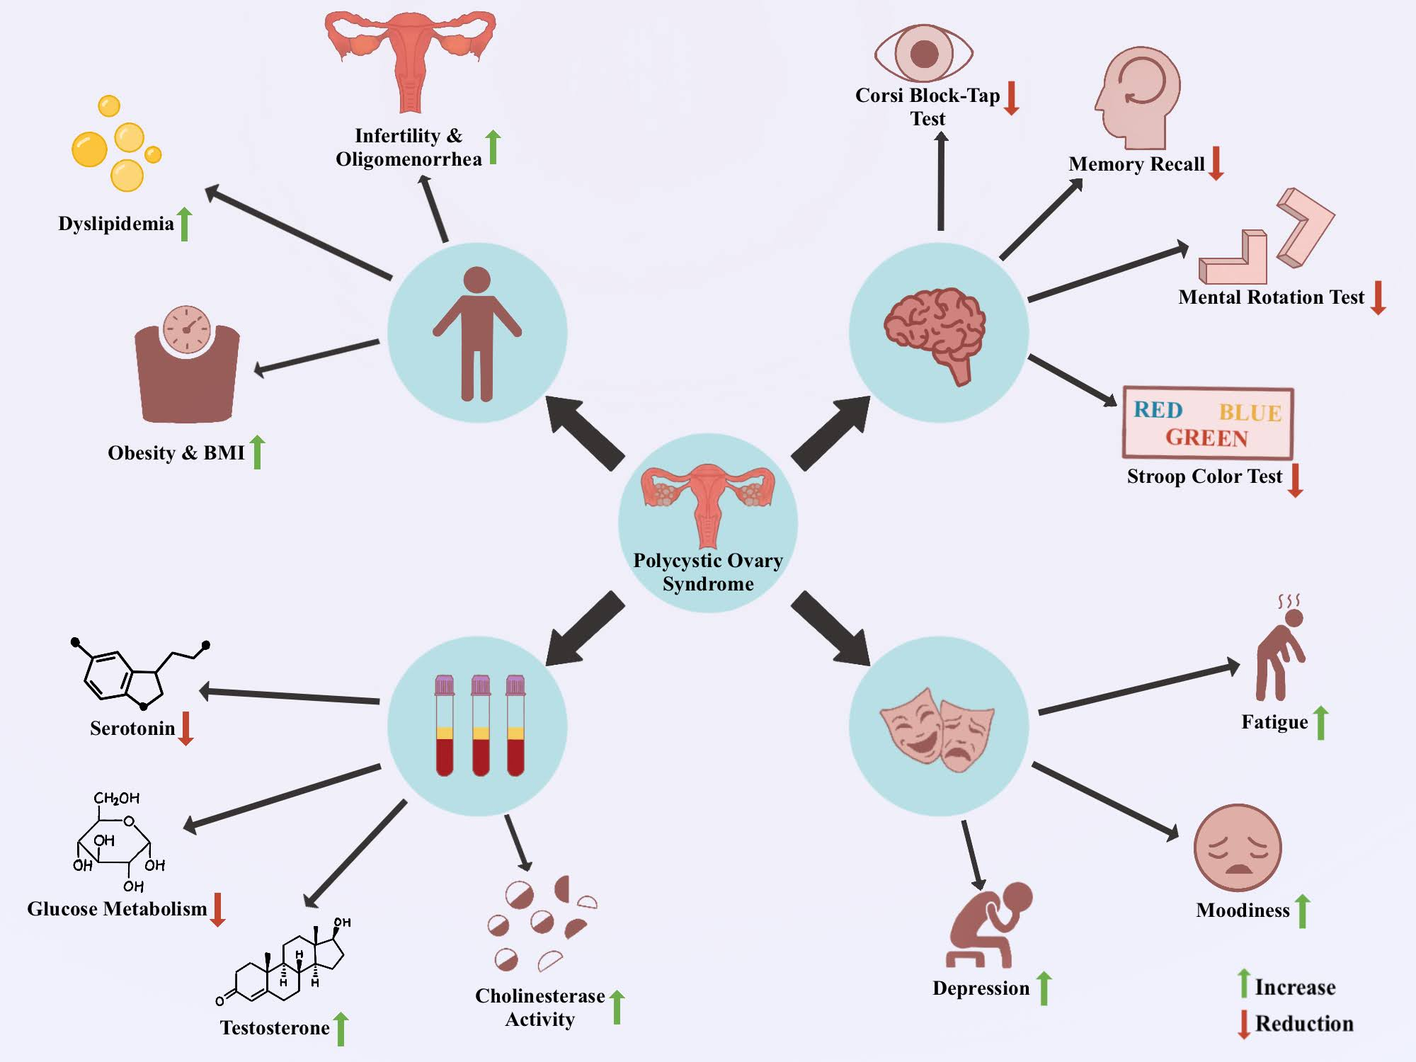
Graphical Abstract
The graphical abstract depicts the changes seen in Indian Women with Polycystic Ovary Syndrome (PCOS). In general, women with PCOS show an increase in dyslipidemia, obesity, higher BMI, infertility and oligomenorrhea. Cognitive failure is seen in the pathological condition with lower scores in the Corsi block-tap test, Stroop color test, Memory recall and Mental rotation. Further, emotional parameters show higher levels of fatigue, depression, and moodiness in women with PCOS accompanied by lower levels of serotonin in the serum. Additionally, there is a reduction in glucose metabolism and an increase in testosterone and cholinesterase activity.

