Appendix - A
Precipitation records by Emerald Hill meteorological weather station

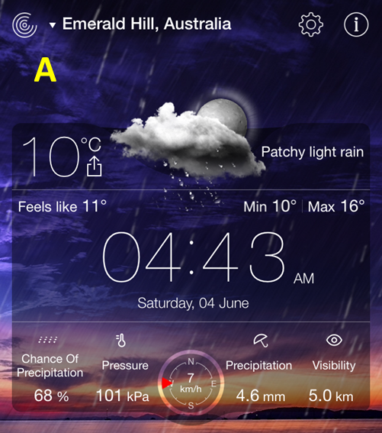 | 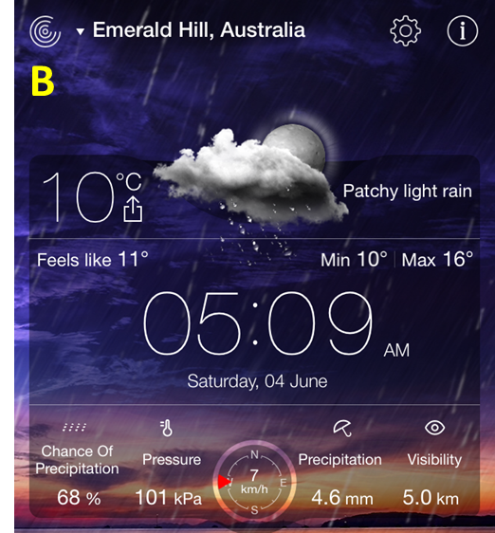
Fig. A.1 Measurements at point 1 (A), measurements at point 2 (B).

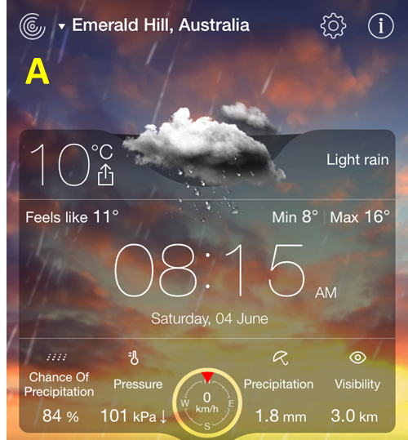 | 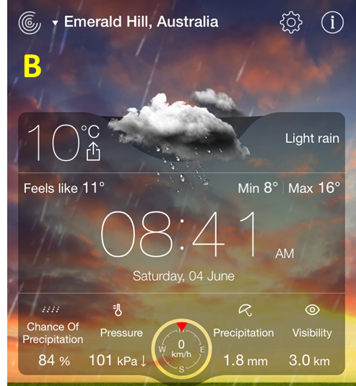
Fig. A.2 Measurements at point 1 (A), measurements at point 2 (B).

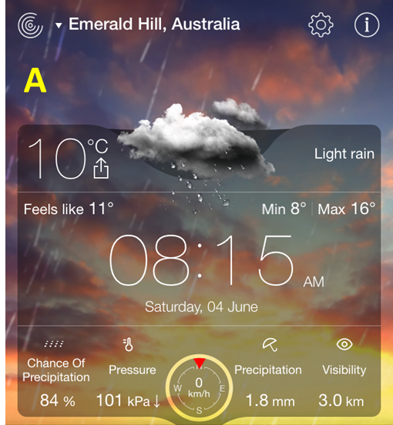 | 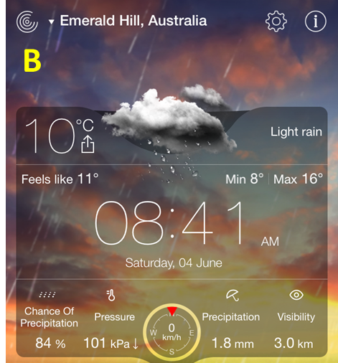
Fig. A.3 Measurements at point 3 (A), measurements at point 4 (B).

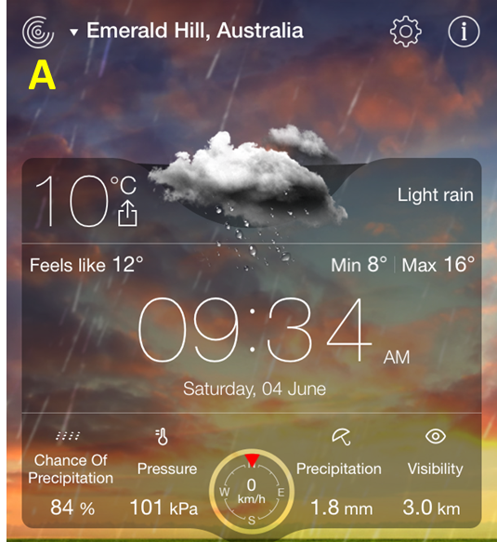 | 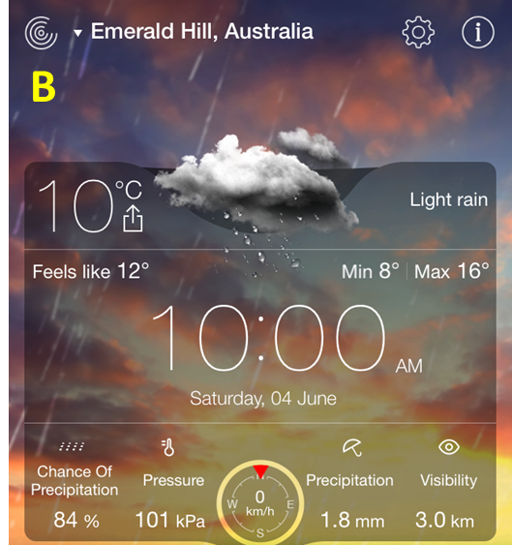
Fig. A.4 Measurements at point 5 (A), measurements at point 6 (B).

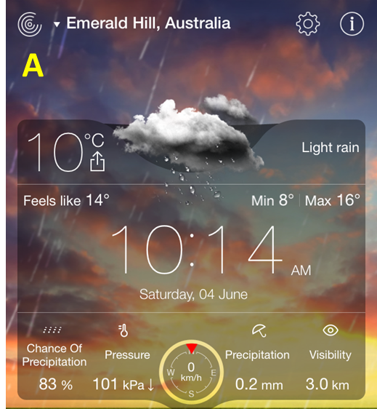 | 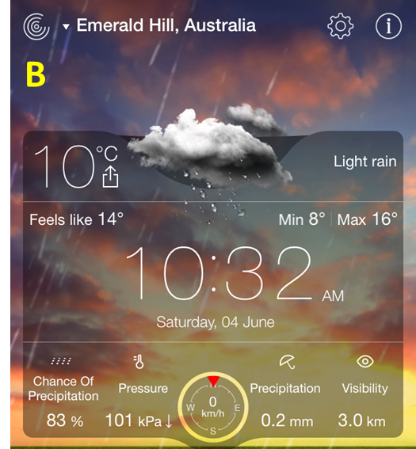
Fig. A.5 Measurements at point 7 (A), measurements at point 8 (B).

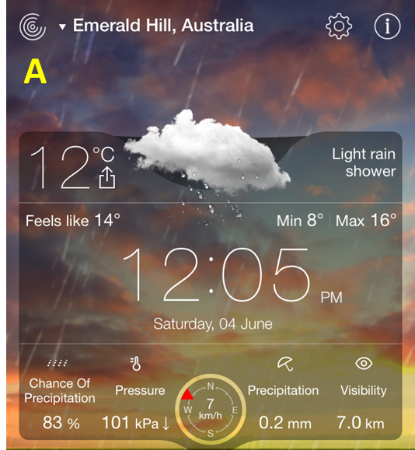 | 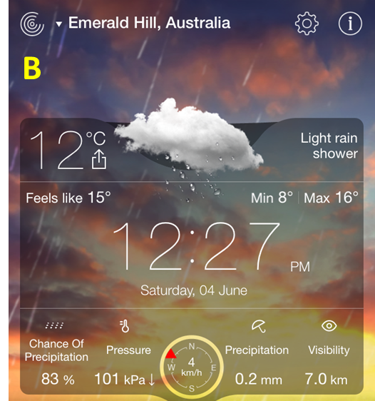
Fig. A.6 Measurements at point 1 (A), measurements at point 2 (B).

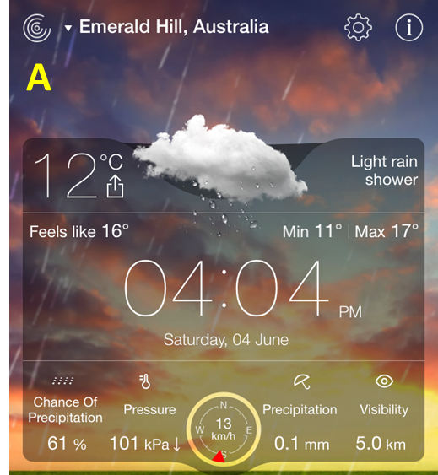 | 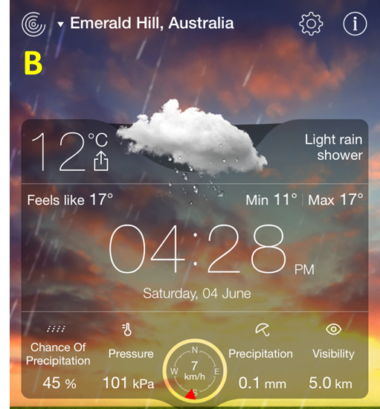
Fig. A.7 Measurements at point 1 (A), measurements at point 2 (B).

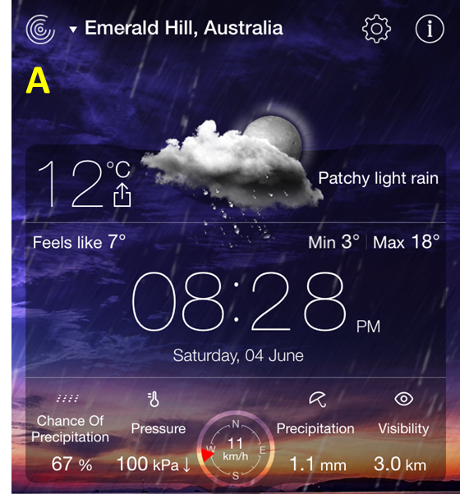 | 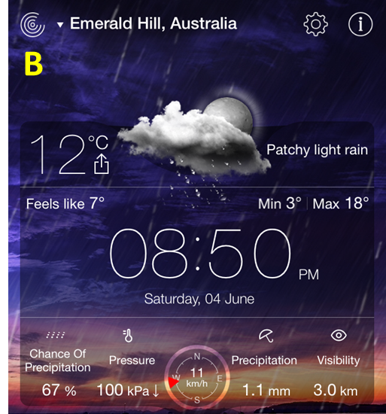
Fig. A.8 Measurements at point 1 (A), measurements at point 2 (B).

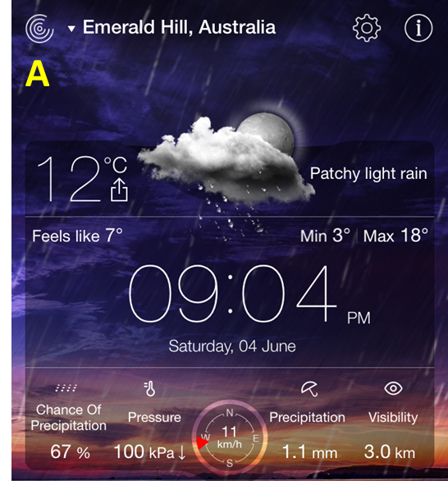 | 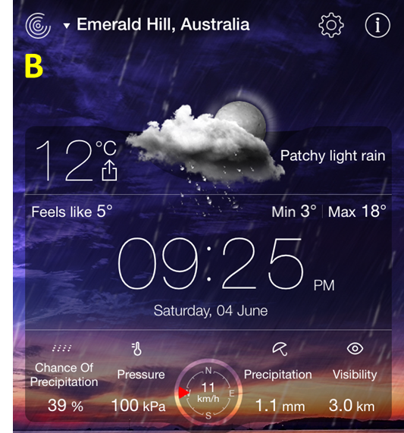
Fig. A.9 Measurements at point 3 (A), measurements at point 4 (B).

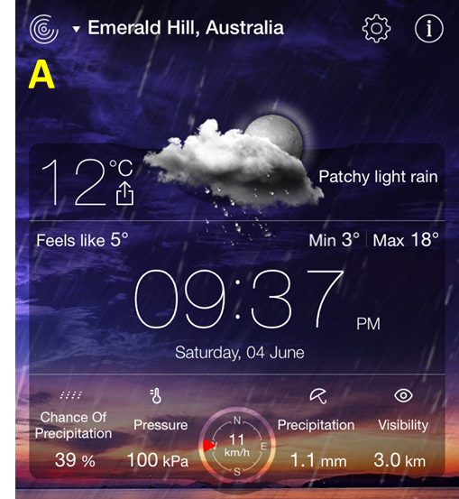 | 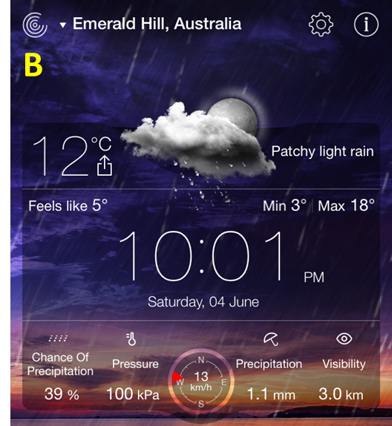
Fig. A.10 Measurements at point 3 (A), measurements at point 4 (B).

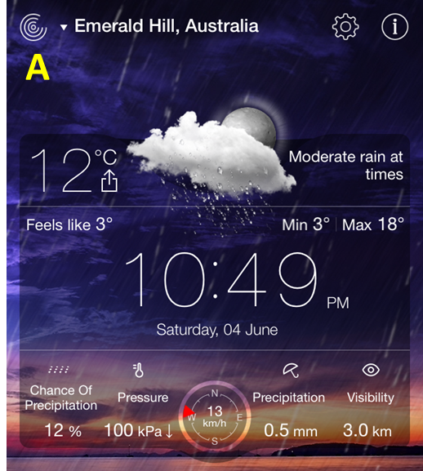 | 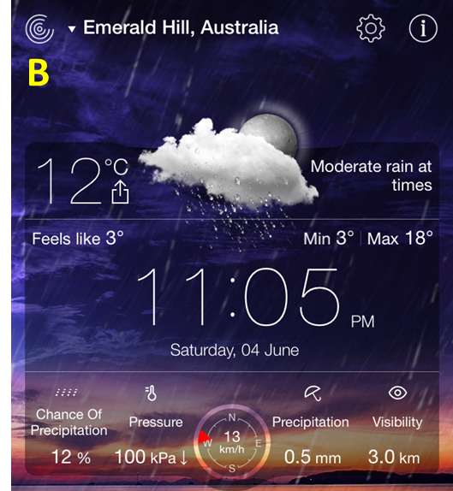
Fig. A.11 Measurements at point 7 (A), measurements at point 8 (B).

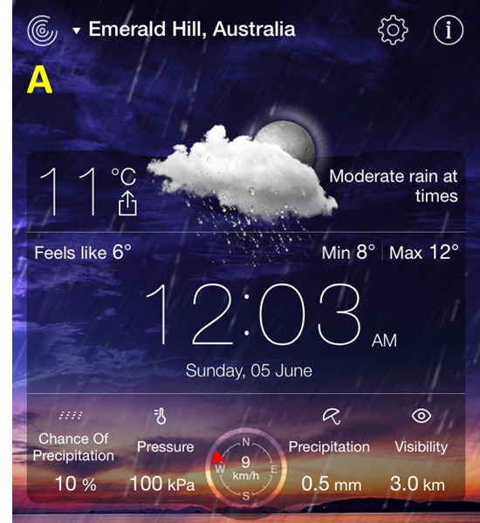 | 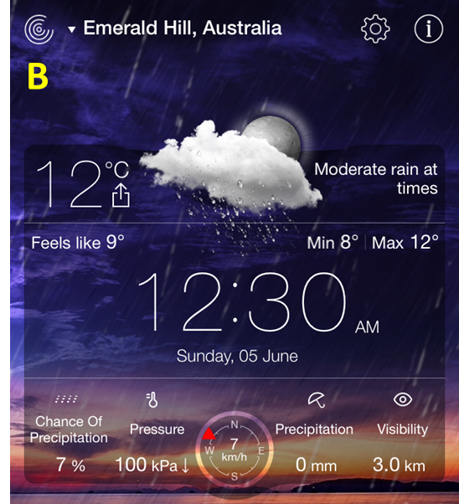
Fig. A.12 Measurements at point 1 (A), measurements at point 2 (B).

