Appendices

Additional file 1: Logic model

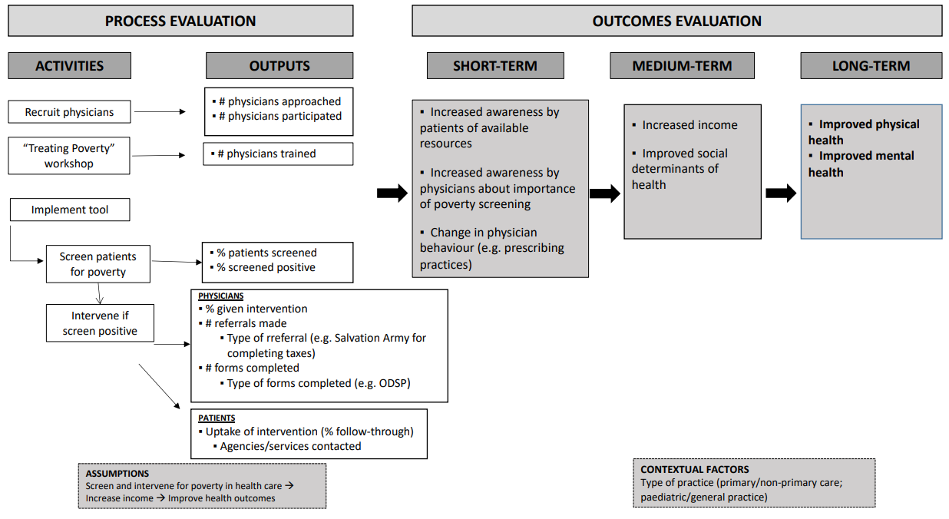

Additional File 2: Standardized template for poverty screening and workflow

