Supplementary Information:
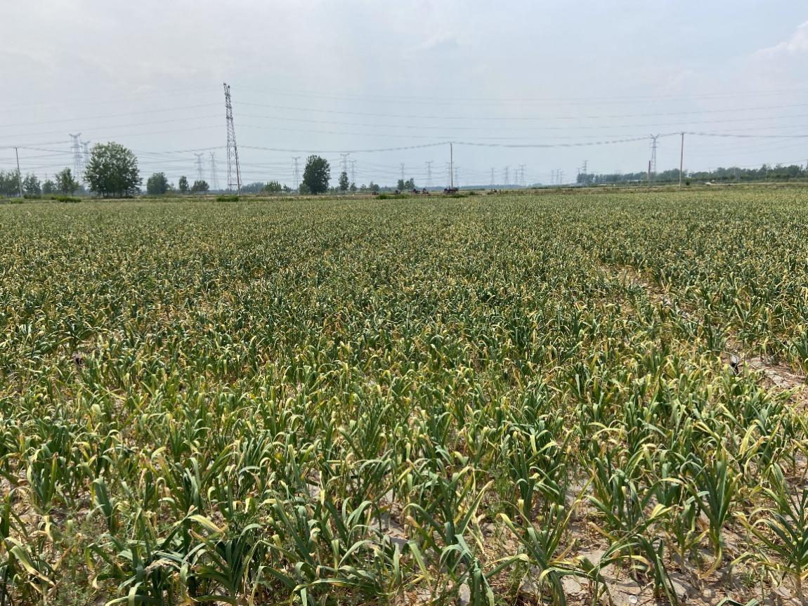
Figure S1. Photo of garlic experimental plot

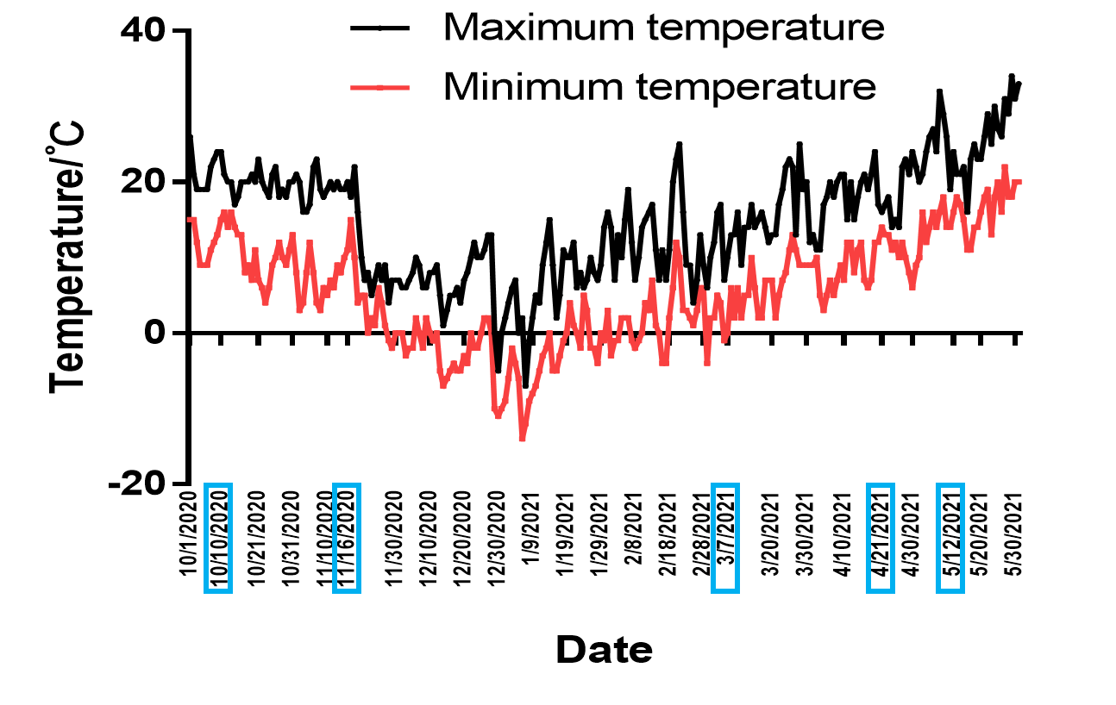
Figure S2. Variation in ambient temperature throughout the experimental period.

