Post-COVID-19-syndrome related symptoms | Referenced in
chronic fatigue | ^{9,13–15,23,24,27,33–39}
Dizziness | ^{9,16,33,34,40,41}
Dyspnea | ^{9,15,18,23,24,27,33–35,37,41}
low-grade fever | ^{15,33,37}
Anosmia | ^{13,17,23,33,34}
Ageusia | ^{13,17,23,33,34}
memory lapses | ^{15,35,42}
muscle pain/weakness | ^{9,13–15,23,25,33,35–39}
Diarrhea | ^{15,23,33,41}
Vomiting | ^{15,33,35}
concentration difficulties | ^{13–15,33}
sleep difficulties | ^{9,15,33,36,39,42}
mood disorders | ^{15,23,34–39,41}
Headache | ^{9,16,23,25,33,34,37,43}
chest tightness/pain | ^{14,23,33,35,37,41,44}
heart palpitations | ^{9,14,15,33,35,41,45}
cognitive impairment | ^{9,16,23,27,33,34,37,46}
motor deficits | ^{16,37,38,47}
exercise intolerance | ^{15,16,18,35,36}
new onset of diabetes | ^{15,19,20}
new onset of hypertension | ¹⁴
Table 1: Common symptoms of post-COVID-19 syndrome

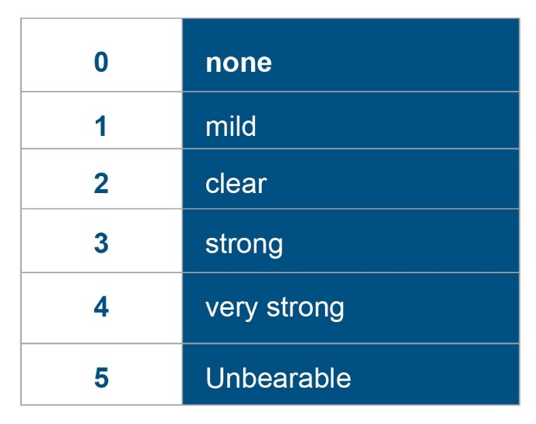
Table 2: Scoring table to describe the symptom severity of long-haul COVID symptoms

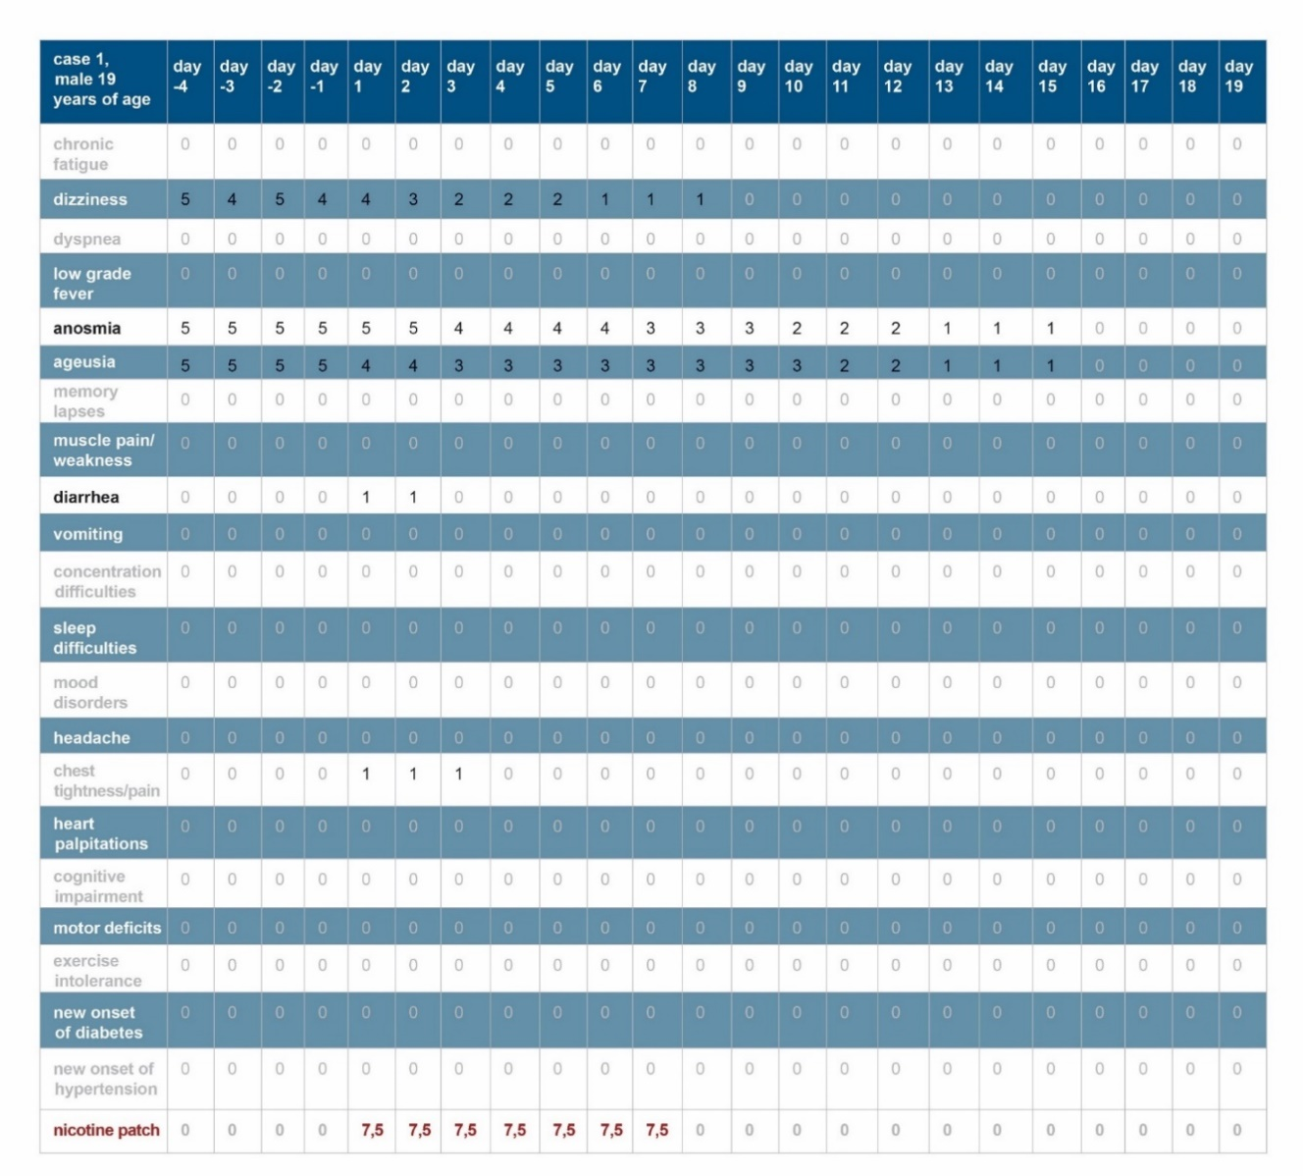
Table 3: Course of symptom severity of case 1. The last line shows the application history of the transcutaneous nicotine application.

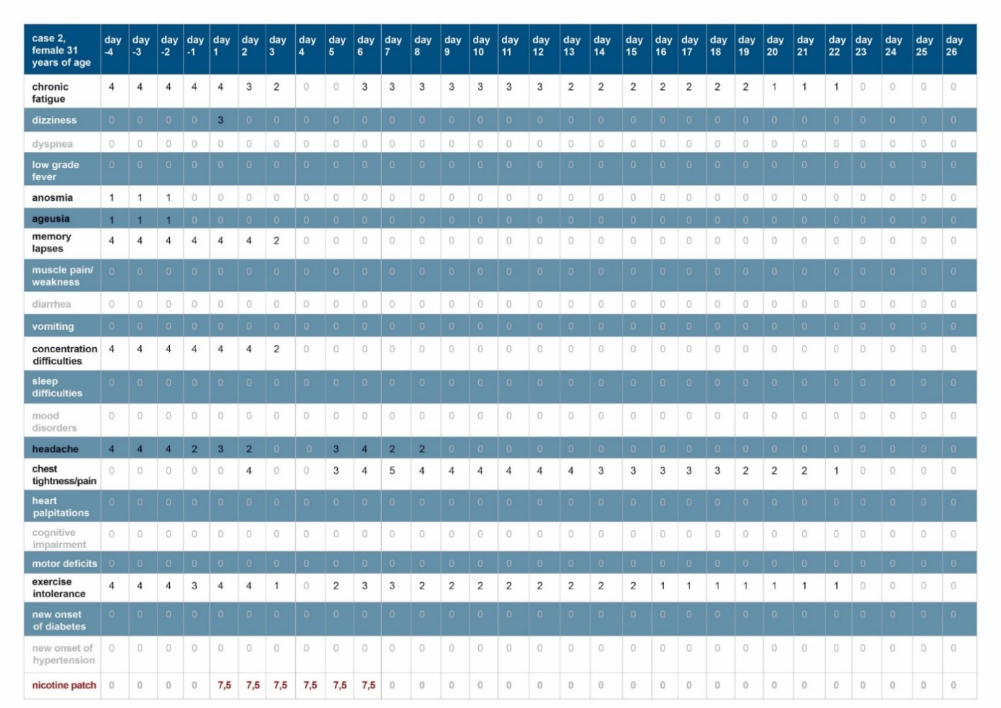
Table 4: Course of symptom severity of case 2. The last line shows the application history of the transcutaneous nicotine application.

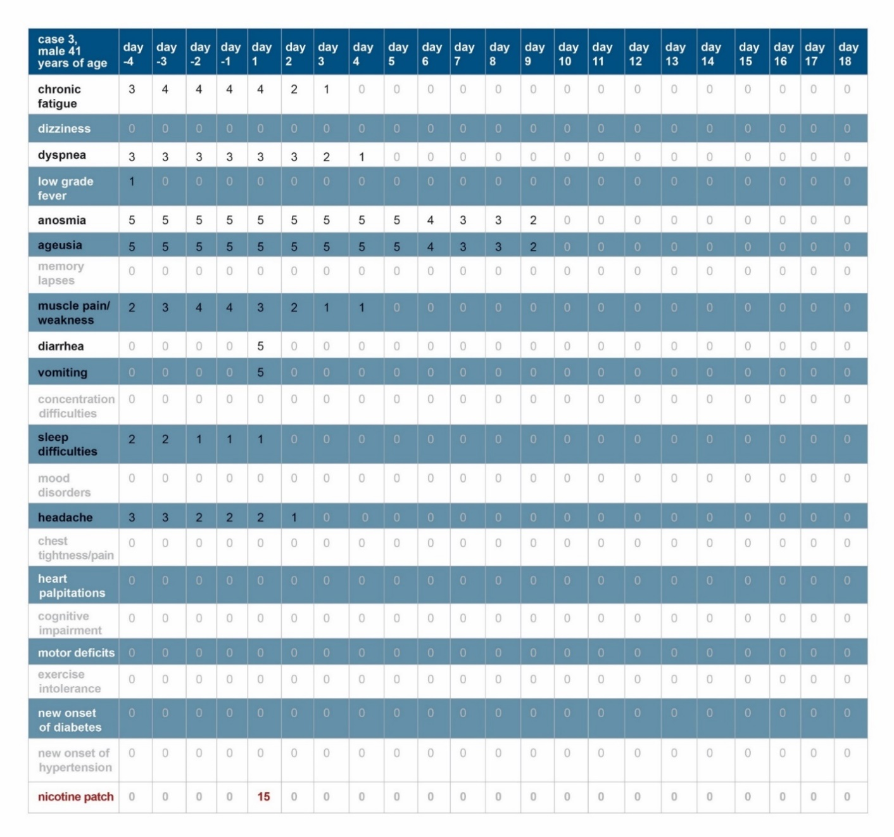
Table 5: Course of symptom severity of case 3. The last line shows the application history of the transcutaneous nicotine application.

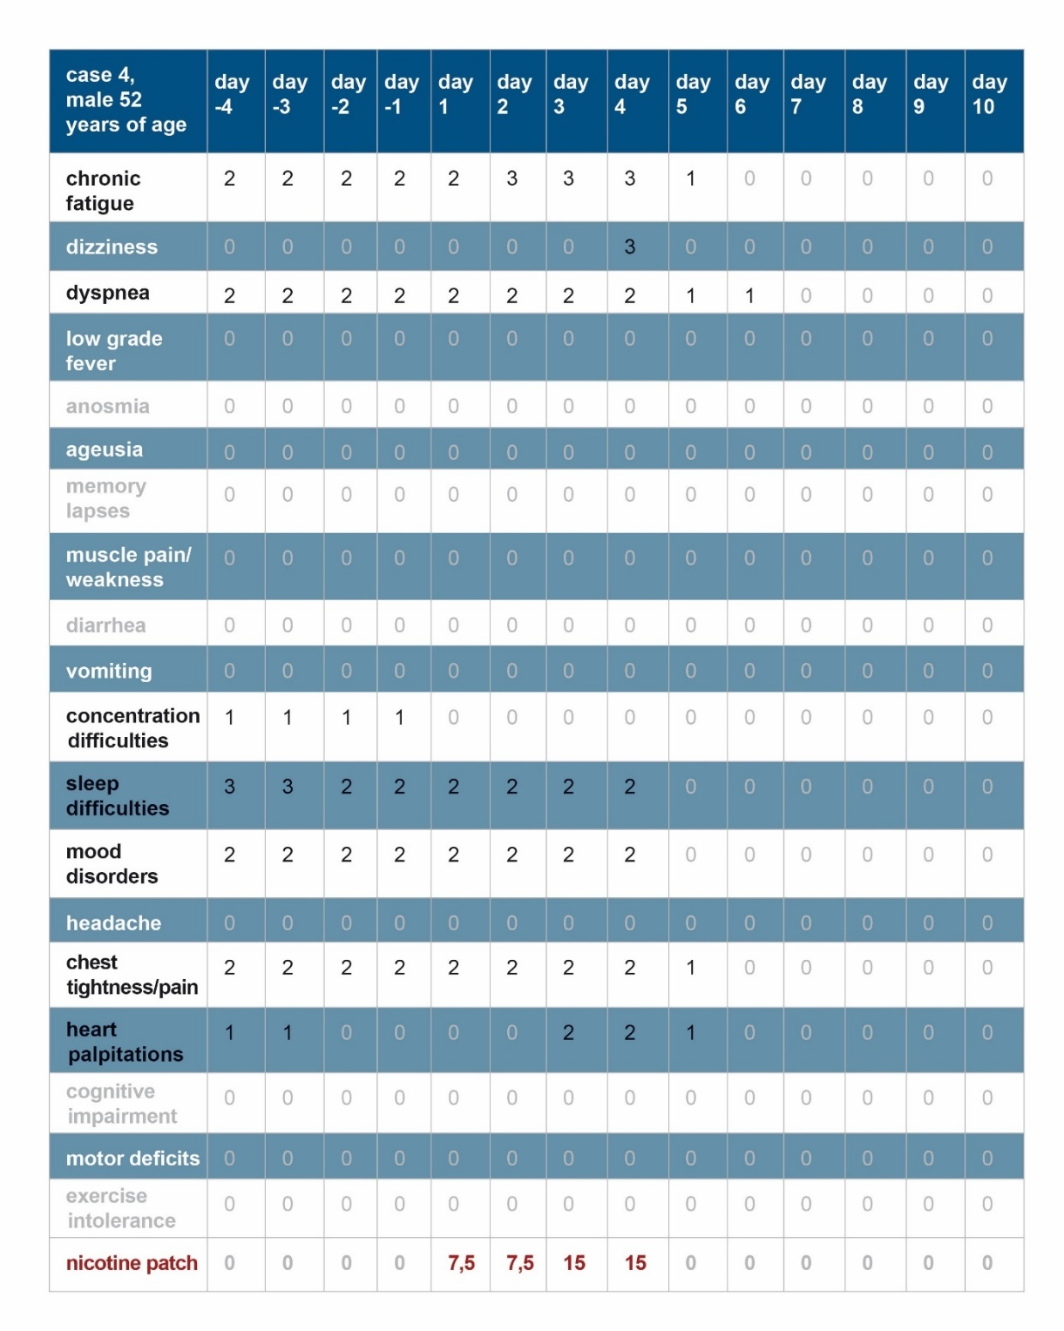
Table 6: Course of symptom severity of case 4. The last line shows the application history of the transcutaneous nicotine application.

