Supplementary material：

Supplementary Tables:
Table S1. Definition of treatment outcomes
Table S2. Grading of recommendations assessment, development, and evaluation (GRADE) methodology in assessment of evidence regarding bedaquiline-containing regimen compared no bedaquiline-containing regimen for patients with TB
Table S3. summary of results for the subgroup analyses, ,provided that excluded data for the imputed methods.
Supplementary Figures:
Figure S1. Risk of Bias, showing the domain assessment for individual trials
Figure S2. Forest plot of the rate of sputum culture conversion at 8 weeks.
Figure S3. Funnel plot of NRSs comparing culture conversion rates at 24 weeks in TB patients undergoing bedaquiline-containing regimen versus no bedaquiline-containing regimen.
Figure S4. Forest plot of the rate of complete at end of treatment
Figure S5 Funnel plot of NRSs comparing all-cause death at end of the treatment in TB patients undergoing bedaquiline-containing regimen versus no bedaquiline-containing regimen.
Figure S6 Funnel plot of NRSs comparing failure rate at end of the treatment in TB patients undergoing bedaquiline-containing regimen versus no bedaquiline-containing regimen.
Figure S7. Forest plot of the rate of lost to follow-up at end of treatment
Figure S8. Funnel plot of NRSs comparing the rate of lost to follow-up at the end of treatment at end of the treatment in TB patients undergoing bedaquiline-containing regimen versus no bedaquiline-containing regimen.
Figure S9. Forest plot of incidence of hepatotoxicity in studies tuberculosis patients receiving bedaquiline
Figure S10. Sensitivity analysis of the rate of sputum culture conversion at 8 weeks in RCTs
Figure S11. Sensitivity analysis of the rate of sputum culture conversion at 24 weeks in RCTs
Figure S12. Sensitivity analysis of the rate of complete at end of the treatment in RCTs
Figure S13. Sensitivity analysis of the rate of all-cause death at end of the treatment in RCTs
Figure S14. Sensitivity analysis of the failure rate at end of the treatment in RCTs
Figure S15. Sensitivity analysis of the incidence of cardiotoxicity in RCTs
Figure S16. Sensitivity analysis of the incidence of hepatotoxicity in RCTs
Figure S17. Sensitivity analysis of the incidence of grade 3-5 adverse events in RCTs

Table S1 Definition of treatment outcomes
Treatment outcome | definition
Sputum culture conversion | culture is considered to have converted to negative when two consecutive cultures, taken at least 30 days apart, are found to be negative.
Treatment completion | Treatment completed as recommended by the national policy without evidence of failure but no record that three or more consecutive cultures taken at least 30 days apart are negative after the intensive phase.
Cure | Treatment completed as recommended by the national policy without evidence of failure and three or more consecutive cultures taken at least 30 days apart are negative after the intensive phase.
All-cause death | A patient who dies for any reason during the course of treatment.
Treatment failure | Treatment terminated or need for permanent regimen change of at least two anti-TB drugs because of:  − lack of conversion by the end of the intensive phase , or  − bacteriological reversion in the continuation phase after conversion to negative, or  − evidence of additional acquired resistance to fluoroquinolones or second-line injectable drugs, or  − adverse drug reactions (ADRs).
Lost to follow-up | A patient whose treatment was interrupted for 2 consecutive months or more.

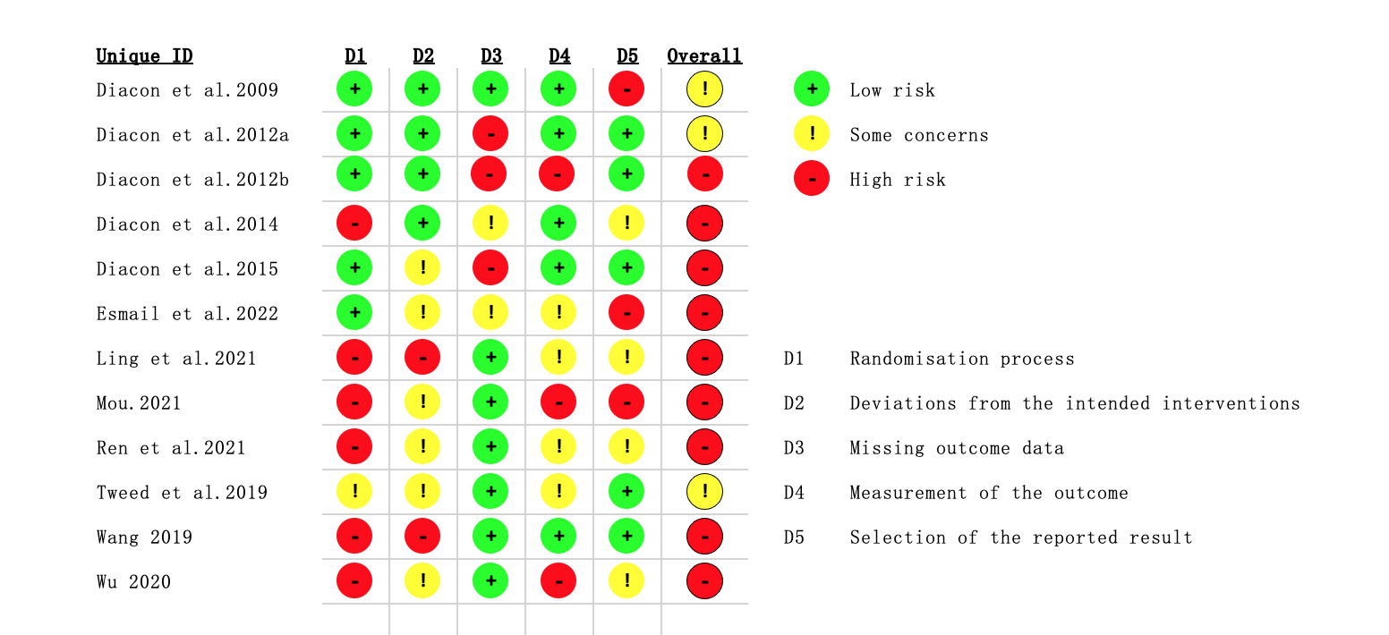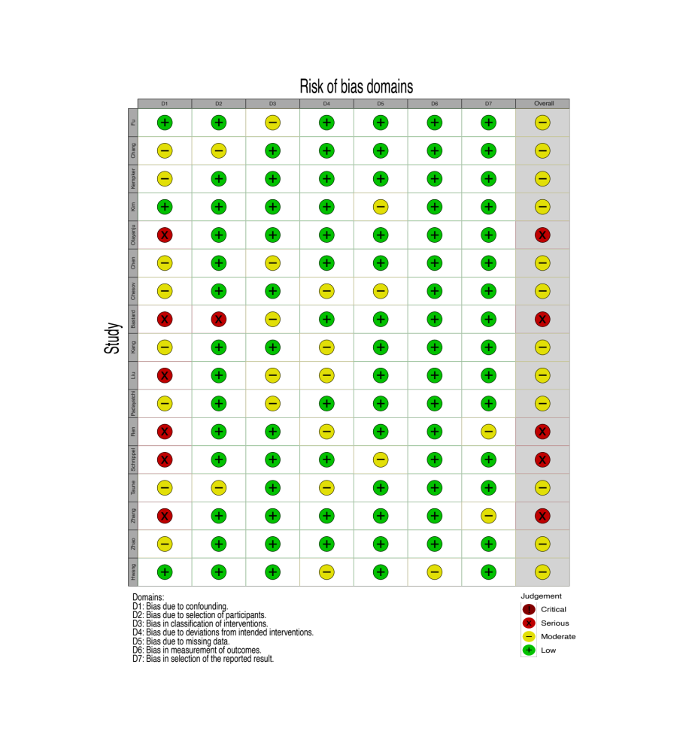
(b)
(a)
Figure S1. Risk of Bias, showing the domain assessment for individual trials
a. randomised controlled trials.
b. non-randomised controlled trials.

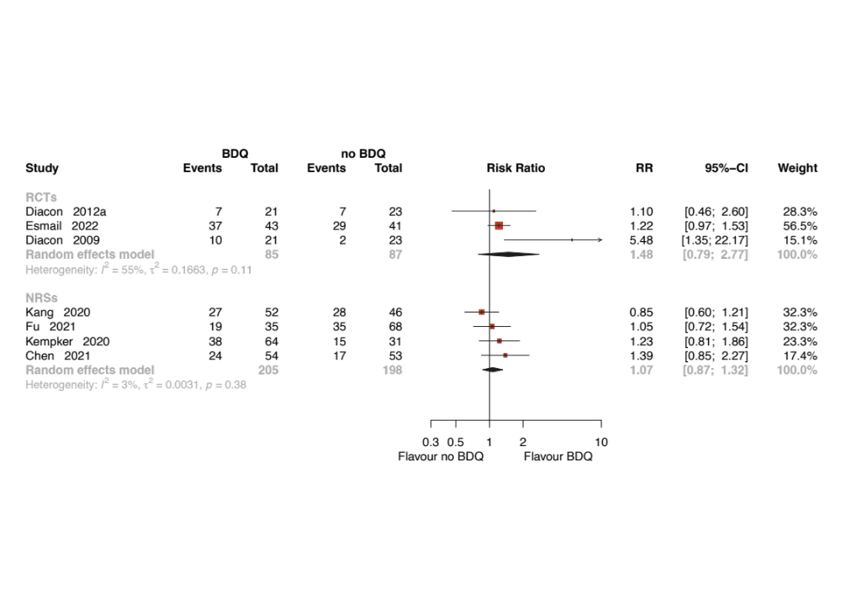
Figure S2. Forest plot of the rate of sputum culture conversion at 8 weeks.
BDQ: bedaquiline; RCTs: randomized controlled trials; NRSs: non-randomized studies; RR: relative risks CI: confidence interval.
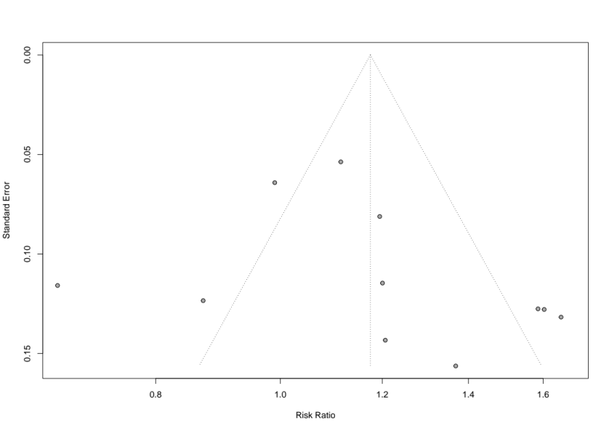
Figure S3. Funnel plot of NRSs comparing culture conversion rates at 24 weeks in TB patients undergoing bedaquiline-containing regimen versus no bedaquiline-containing regimen. No funnel plot of RCTs has been included as there were fewer than 10 studies.
NRS: non-randomised study; RCT: randomised controlled trial；TB: tuberculosis

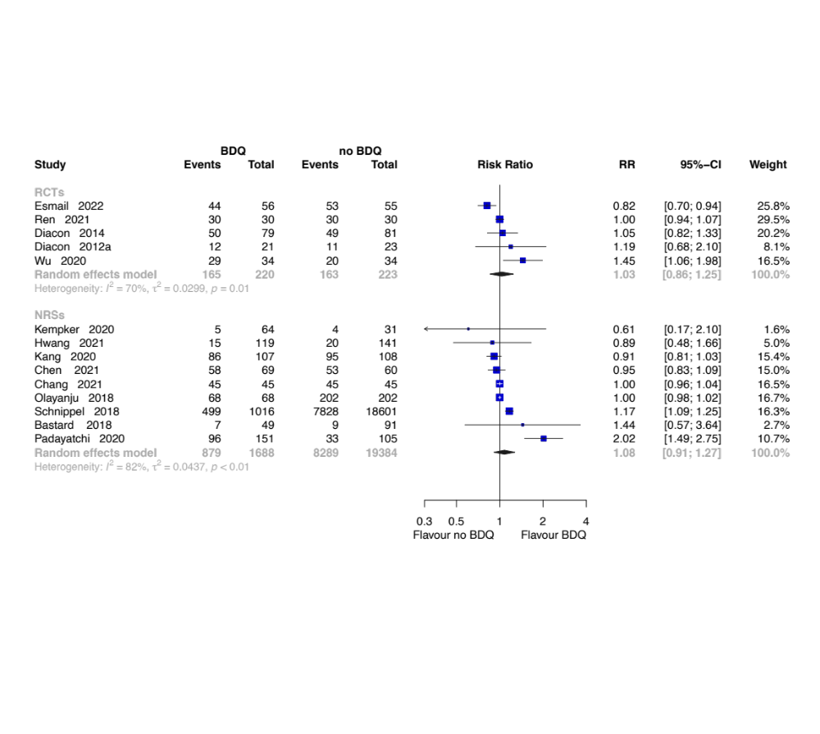
Figure S4. Forest plot of the rate of complete at end of treatment
BDQ: bedaquiline; RCTs: randomized controlled trials; NRSs: non-randomized studies; RR: relative risks CI: confidence interval.
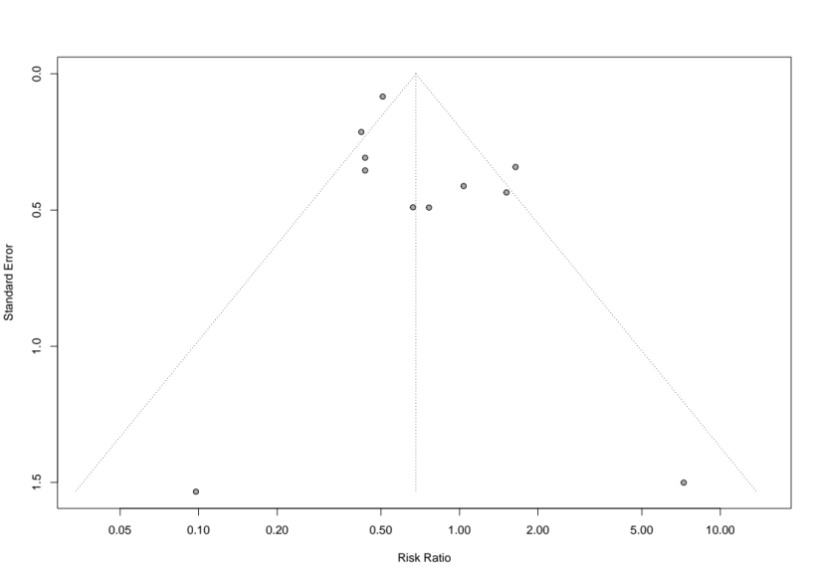
Figure S5 Funnel plot of NRSs comparing all-cause death at end of the treatment in TB patients undergoing bedaquiline-containing regimen versus no bedaquiline-containing regimen. No funnel plot of RCTs has been included as there were fewer than 10 studies.
NRS: non-randomised study; RCT: randomised controlled trial; TB: tuberculosis

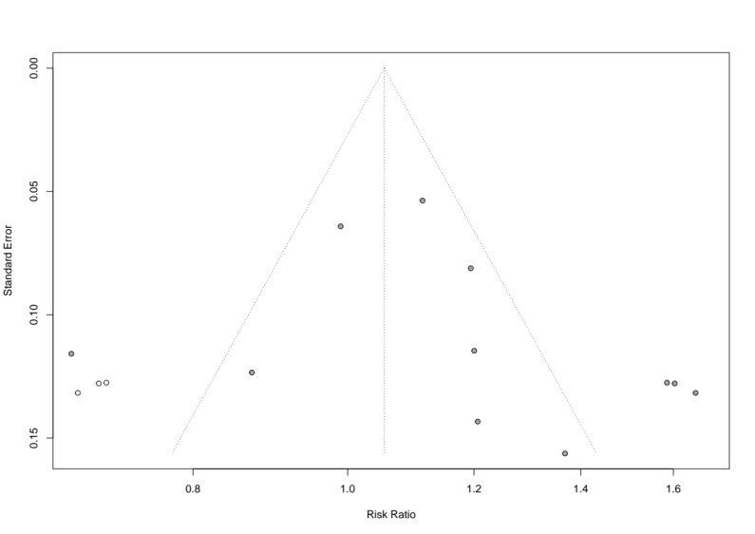
Figure S6 Funnel plot of NRSs comparing failure rate at end of the treatment in TB patients undergoing bedaquiline-containing regimen versus no bedaquiline-containing regimen. The solid circles represent the NRS units, and the empty circles represent studies trimmed. No funnel plot of RCTs has been included as there were fewer than 10 studies.
NRS: non-randomised study; RCT: randomised controlled trial; TB: tuberculosis.

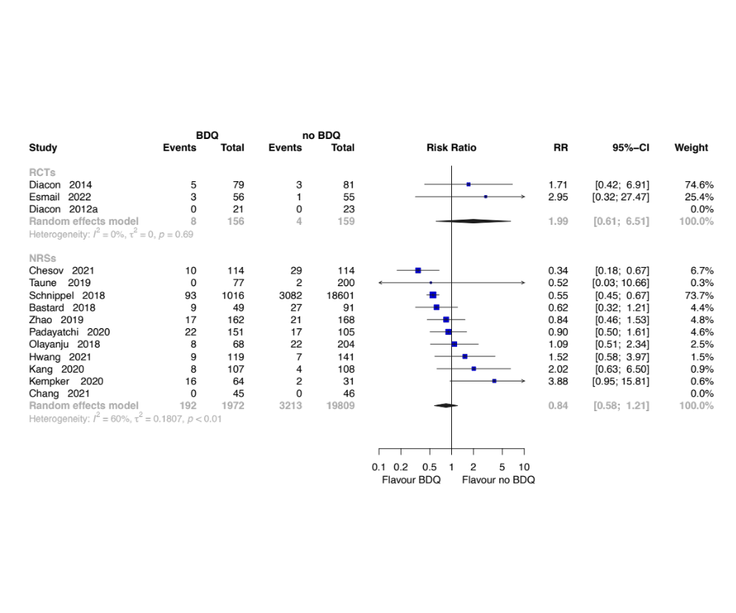
Figure S7 Forest plot of the rate of lost to follow-up at end of treatment
BDQ: bedaquiline; RCTs: randomized controlled trials; NRSs: non-randomized studies; RR: relative risks CI: confidence interval.
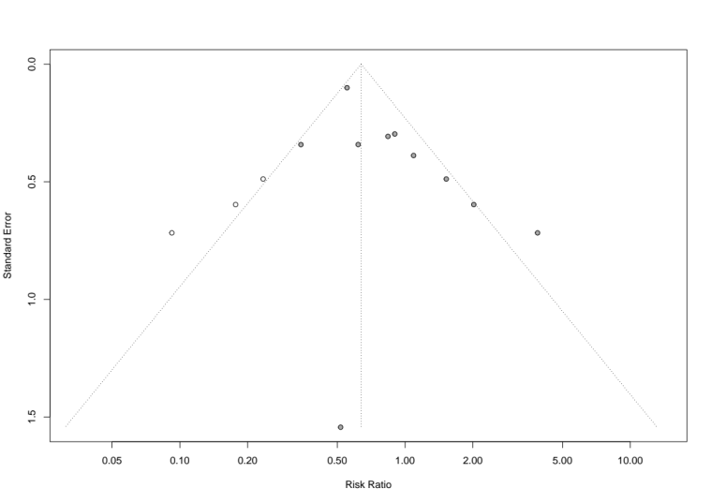
Figure S8 Funnel plot of NRSs comparing the rate of lost to follow-up at the end of treatment at end of the treatment in TB patients undergoing bedaquiline-containing regimen versus no bedaquiline-containing regimen. The solid circles represent the NRS units, and the empty circles represent studies trimmed. No funnel plot of RCTs has been included as there were fewer than 10 studies.
NRS: non-randomised study; RCT: randomised controlled trial; TB: tuberculosis
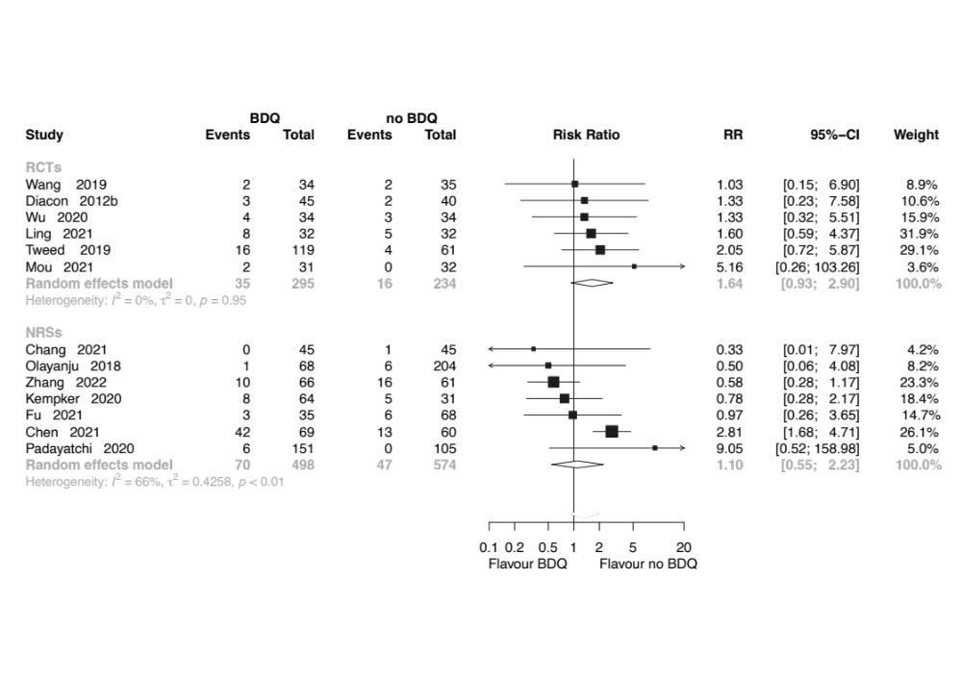
Figure S9 Forest plot of incidence of hepatotoxicity in studies tuberculosis patients receiving bedaquiline
BDQ: bedaquiline; RCTs: randomized controlled trials; NRSs: non-randomized studies; RR: relative risks CI: confidence interval.

Table S2 Grading of recommendations assessment, development, and evaluation (GRADE) methodology in assessment of evidence regarding bedaquiline-containing regimen compared no bedaquiline-containing regimen for patients with TB
Outcomes | studies | Number of patients |  | Effect |  | Certainty of the evidence  (GRADE)
Outcomes | studies | BDQ-containing regimen | No BDQ-containing regimen | Relative (95%Cl) | Absolute (95%Cl) | Certainty of the evidence  (GRADE)
The rate of sputum culture conversion at 8 weeks | Two RCTs | 54/85 (63.5%) | 38/87 (43.7%) | RR 1.48  (0.79 to 2.77) | 210 more per 1,000  (from 92 fewer to 773 more) | ⨁⨁◯◯  Low
The rate of sputum culture conversion at 8 weeks | Four observational studies | 108/205 (52.7%) | 95/198 (48.0%) | RR 1.07  (0.87 to 1.32) | 34 more per 1,000  (from 62 fewer to 154 more) | ⨁⨁⨁◯  Moderate
The rate of sputum culture conversion at 24 weeks | Seven RCTs | 241/257 (93.8%) | 165/158 (104.4%) | RR 1.27  (1.10 to 1.46) | 282 more per 1,000  (from 104 more to 480 more) | ⨁⨁◯◯  Low
The rate of sputum culture conversion at 24 weeks | Eleven observational studies | 576/770 (74.8%) | 483/853 (56.6%) | RR 1.17  (1.00 to 1.38) | 96 more per 1,000  (from 0 fewer to 215 more) | ⨁◯◯◯  Very low
The rate of sputum culture conversion with follow-up | Two RCTs | 63/87 (72.4%) | 49/89 (55.1%) | RR 1.33  (1.06 to 1.66) | 182 more per 1,000  (from 33 more to 363 more) | ⨁⨁⨁◯  Moderate
The rate of culture conversion with follow-up | Three observational studies | 643/1216 (52.9%) | 7913/18937 (41.8%) | RR 1.53  (1.07 to 2.20) | 221 more per 1,000  (from 29 more to 501 more) | ⨁◯◯◯  Very low
The rate of complete at end of the treatment | Four RCTs | 165/220 (75.0%) | 163/223 (73.1%) | RR 1.03  (0.86 to 1.25) | 22 more per 1,000  (from 102 fewer to 183 more) | ⨁◯◯◯  Very low
The rate of complete at end of the treatment | Nine observational studies | 879/1688 (52.1%) | 8289/19384 (42.8%) | RR 1.08  (0.91 to 1.27) | 34 more per 1,000  (from 38 fewer to 115 more) | ⨁◯◯◯  Very low
The rate of cure at end of the treatment | Two RCTs | 39/64 (60.9%) | 24/64 (37.5%) | RR 1.60  (1.13 to 2.26) | 225 more per 1,000  (from 49 more to 472 more) | ⨁⨁⨁◯  Moderate
The rate of cure at end of the treatment | Eight observational studies | 883/1626 (54.3%) | 8065/19332 (41.7%) | RR 1.86  (1.23 to 2.83) | 359 more per 1,000  (from 96 more to 763 more) | ⨁◯◯◯  Very low
The rate of all-cause death at end of the treatment | Five RCTs | 15/220 (6.8%) | 6/223 (2.7%) | RR 2.27  (0.64 to 8.13) | 34 more per 1,000  (from 10 fewer to 192 more) | ⨁⨁⨁◯  Moderate
The rate of all-cause death at end of the treatment | Twelve observational studies | 228/2030 (11.2%) | 4812/19868 (24.2%) | RR 0.68  (0.48 to 0.97) | 78 fewer per 1,000  (from 126 fewer to 7 fewer) | ⨁◯◯◯  Very low
The rate of failure at end of the treatment | Four RCTs | 20/164 (12.2%) | 36/158 (22.8%) | RR 0.56  (0.35 to 0.88) | 100 fewer per 1,000  (from 148 fewer to 27 fewer) | ⨁⨁⨁◯  Moderate
The rate of failure at end of the treatment | Ten observational studies | 94/1895 (5.0%) | 905/19608 (4.6%) | RR 0.57  (0.46 to 0.71) | 20 fewer per 1,000  (from 25 fewer to 13 fewer) | ⨁⨁◯◯  Low
The rate of lost to follow-up at end of the treatment | Three RCTs | 8/156 (5.1%) | 4/159 (2.5%) | RR 1.99  (0.61 to 6.51) | 25 more per 1,000  (from 10 fewer to 139 more) | ⨁⨁⨁◯  Moderate
The rate of lost to follow-up at end of the treatment | Eleven observational studies | 192/1972 (9.7%) | 3213/19809 (16.2%) | RR 0.84  (0.58 to 1.21) | 26 fewer per 1,000  (from 68 fewer to 34 more) | ⨁⨁⨁◯  Moderate
cardiotoxicity | Eight RCTs | 38/276 (13.8%) | 4/261 (1.5%) | RR 4.54  (1.74 to 11.87) | 54 more per 1,000  (from 11 more to 167 more) | ⨁⨁⨁◯  Moderate
cardiotoxicity | Six observational studies | 144/407 (35.4%) | 38/523 (7.3%) | RR 6.00  (1.32 to 27.19) | 363 more per 1,000  (from 23 more to 1,000 more) | ⨁⨁◯◯  Low
Hepatotoxicity | Six RCTs | 35/295 (11.9%) | 16/234 (6.8%) | RR 1.64  (0.93 to 2.90) | 44 more per 1,000  (from 5 fewer to 130 more) | ⨁⨁◯◯  Low
Hepatotoxicity | Seven observational studies | 70/498 (14.1%) | 47/574 (8.2%) | RR 1.10  (0.55 to 2.23) | 8 more per 1,000  (from 37 fewer to 101 more) | ⨁◯◯◯  Very low
Grade 3-5 adverse events | Five RCTs | 131/297 (44.1%) | 77/245 (31.4%) | RR 1.42  (1.17 to 1.73) | 132 more per 1,000  (from 53 more to 229 more) | ⨁⨁◯◯  Low
Grade 3-5 adverse events | Three observational studies | 22/170 (12.9%) | 19/189 (10.1%) | RR 1.56  (0.28 to 8.63) | 56 more per 1,000  (from 72 fewer to 767 more) | ⨁⨁◯◯  Low

Table S3 summary of results for the subgroup analyses, ,provided that excluded data for the imputed methods.
Outcomes |  | Type of intervention | RCT |  |  |  | NRS
 |  | Type of intervention | No. of studies | Result (95%Cl) | I² | P | No. of studies | Result (95%Cl) | I² | P
The rate of culture conversion at 8 weeks | Main analyses |  | 3 | 1.48(0.79,2.77) | 55% | 0.11 | 4 | 1.07(0.87,1.32) | 3% | 0.38
The rate of culture conversion at 8 weeks | Subgroup analyses | BR + BDQ VS BR + no other treatment | - | - | - | - | 2 | 1.17(0.86-1.58) | 0% | 0.39
The rate of culture conversion at 8 weeks | Subgroup analyses | BR + BDQ VS BR + placebo | 2 | 2.22(0.97-1.53) | 73% | 0.06 | - | - | - | -
The rate of culture conversion at 8 weeks | Subgroup analyses | BR + BDQ VS BR +SOC | 1 | 1.22(0.97-1.53) | - | - | - | - | - | -
The rate of culture conversion at 8 weeks | Subgroup analyses | BR + BDQ VS BR + DLM | - | - | - | - | 2 | 1.00(0.70-1.43) | 42% | 0.19
The rate of culture conversion at 24 weeks | Main analyses |  | 7 | 1.27(1.10-1.46) | 65% | <0.01 | 11 | 1.17(1.00-1.38)
The rate of culture conversion at 24 weeks | Subgroup analyses | BR + BDQ VS BR + no other treatment | 3 | 1.27(1.17-1.68) | 0% | 0.47 | 7 | 1.30(1.09-1.54) | 76% | <0.01
The rate of culture conversion at 24 weeks | Subgroup analyses | BR + BDQ VS BR + placebo | 3 | 1.32(1.13-1.55) | 0% | 0.91 | - | - | - | -
The rate of culture conversion at 24 weeks | Subgroup analyses | BR + BDQ VS BR +SOC | 1 | 1.32(1.13-1.55) | - | - | - | - | - | -
The rate of culture conversion at 24 weeks | Subgroup analyses | BR + BDQ VS BR + DLM | - | - | - | - | 4 | 0.99(0.76-1.28) | 81% | <0.01
The rate of culture conversion with follow-up | Main analyses |  | 2 | 1.33(1.06-1.66) | 0% | 0.49 | 3 | 1.53(1.07-2.20) | 91% | <0.01
The rate of culture conversion with follow-up | Subgroup analyses | BR + BDQ VS BR + no other treatment | - | - | - | - | 2 | 1.81(1.26-2.61) | 68% | 0.08
The rate of culture conversion with follow-up | Subgroup analyses | BR + BDQ VS BR + placebo | 2 | 1.33(1.06-1.66) | 0% | 0.49 | - | - | - | -
The rate of culture conversion with follow-up | Subgroup analyses | BR + BDQ VS BR +SOC | - | - | - | - | - | - | - | -
The rate of culture conversion with follow-up | Subgroup analyses | BR + BDQ VS BR +SLID | - | - | - | - | 1 | 1.17(1.10-1.25) | - | -
The rate of culture conversion with follow-up | Subgroup analyses | BR + BDQ VS BR + DLM | - | - | - | - | - | - | - | -
The rate of complete at end of treatment | Main analyses |  | 5 | 1.03(0.86-1.25) | 70% | 0.01 | 9 | 1.08(0.91-1.27) | 82% | <0.01
The rate of complete at end of treatment | Subgroup analyses | BR + BDQ VS BR + no other treatment | 2 | 1.17(0.81-1.67) | 81% | 0.02 | 4 | 1.24(0.84-1.82) | 89% | <0.01
The rate of complete at end of treatment | Subgroup analyses | BR + BDQ VS BR + placebo | 2 | 1.07 (0.85-1.34) | 0% | 0.67 | - | - | - | -
The rate of complete at end of treatment | Subgroup analyses | BR + BDQ VS BR +SLID | - | - | - | - | 1 | 1.17(1.09-1.25) | - | -
The rate of complete at end of treatment | Subgroup analyses | BR + BDQ VS BR +SOC | 1 | 0.82(0.70-0.94) | - | - | - | - | - | -
The rate of complete at end of treatment | Subgroup analyses | BR + BDQ VS BR + DLM | - | - | - | - | 4 | 1.08(0.91-1.27) | 0% | 0.40
The rate of cure at end of treatment | Main analyses |  | 2 | 1.60(1.13-2.26) | 0% | 0.71 | 8 | 1.86(1.23-2.83) | 93% | <0.01
The rate of cure at end of treatment | Subgroup analyses | BR + BDQ VS BR + no other treatment | 2 | 1.60(1.13-2.26) | 0% | 0.71 | 4 | 2.19(1.47-3.28) | 90% | <0.01
The rate of cure at end of treatment | Subgroup analyses | BR + BDQ VS BR + placebo | - | - | - | - | - | - | - | -
The rate of cure at end of treatment | Subgroup analyses | BR + BDQ VS BR +SLID | - | - | - | - | 1 | 1.17(1.09-1.25) | - | -
The rate of cure at end of treatment | Subgroup analyses | BR + BDQ VS BR +SOC | - | - | - | - | - | - | - | -
The rate of cure at end of treatment | Subgroup analyses | BR + BDQ VS BR + DLM | - | - | - | - | 3 | 1.86(1.23-2.83) | 97% | <0.01
The rate of all-cause death at end of treatment | Main analyses |  | 3 | 2.27(0.64-8.31) | 27% | 0.26 | 11 | 0.68 (0.48-0.97) | 62% | <0.01
The rate of all-cause death at end of treatment | Subgroup analyses | BR + BDQ VS BR + no other treatment | - | - | - | - | 7 | 0.59(0.40-0.87) | 26% | 0.23
The rate of all-cause death at end of treatment | Subgroup analyses | BR + BDQ VS BR + placebo | 2 | 4.73(1.23-18.12) | 0 | 0.80 | - | - | - | -
The rate of all-cause death at end of treatment | Subgroup analyses | BR + BDQ VS BR +SLID | - | - | - | - | - | - | - | -
The rate of all-cause death at end of treatment | Subgroup analyses | BR + BDQ VS BR +SOC | 1 | 0.98(0.26-3.73) | - | - | - | - | - | -
The rate of all-cause death at end of treatment | Subgroup analyses | BR + BDQ VS BR + DLM | - | - | - | - | 4 | 0.85(0.48-0.97) | 75% | <0.01
The rate of failure at end of treatment | Main analyses |  | 4 | 0.58(0.35-0.88) | 19% | 0.30 | 10 | 0.57(0.46-0.71) | 56% | 0.02
The rate of failure at end of treatment | Subgroup analyses | BR + BDQ VS BR + no other treatment | 2 | 0.35(0.16-0.77) | 0% | 0.94 | 6 | 0.53(0.39-0.71) | 51% | 0.06
The rate of failure at end of treatment | Subgroup analyses | BR + BDQ VS BR + placebo | 2 | 0.78(0.44-1.37) | 0 | 0.44 | - | - | - | -
The rate of failure at end of treatment | Subgroup analyses | BR + BDQ VS BR +SLID | - | - | - | - | 1 | 0.80(0.57-1.14) | - | -
The rate of failure at end of treatment | Subgroup analyses | BR + BDQ VS BR +SOC | - | - | - | - | - | - | - | -
The rate of failure at end of treatment | Subgroup analyses | BR + BDQ VS BR + DLM | - | - | - | - | 3 | 0.22(0.09-0.71) | 4% | 0.02
The rate of lost to follow-up at end of treatment | Main analyses |  | 3 | 1.99(0.61-6.51) | 0% | 0.69 | 11 | 0.84(0.58-1.21)
The rate of lost to follow-up at end of treatment | Subgroup analyses | BR + BDQ VS BR + no other treatment | - | - | - | - | 6 | 0.65(0.43-0.97) | 25% | 0.25
The rate of lost to follow-up at end of treatment | Subgroup analyses | BR + BDQ VS BR + placebo | 2 | 1.71(0.42-6.91) | 0% | 0.69 | - | - | - | -
The rate of lost to follow-up at end of treatment | Subgroup analyses | BR + BDQ VS BR +SLID | - | - | - | - | 1 | 0.55(0.45-0.67) | - | -
The rate of lost to follow-up at end of treatment | Subgroup analyses | BR + BDQ VS BR +SOC | 1 | 2.02(0.62-6.57) | - | - | - | - | - | -
The rate of lost to follow-up at end of treatment | Subgroup analyses | BR + BDQ VS BR + DLM | - | - | - | - | 4 | 1.56(0.95-2.57) | 0% | 0.45
Incidence of cardiotoxicity | Main analyses |  | 8 | 4.54(1.74-11.87) | 26% | 0.24 | 6 | 6.00(1.32-27.19) | 75% | <0.01
Incidence of cardiotoxicity | Subgroup analyses | BR + BDQ VS BR + no other treatment | 3 | 3.85(1.19-12.41) | 0% | 0.53 | 4 | 7.19(0.97-53.14) | 76% | <0.01
Incidence of cardiotoxicity | Subgroup analyses | BR + BDQ VS BR + placebo | 1 | 34.05(2.13-543.62) | - | - | - | - | - | -
Incidence of cardiotoxicity | Subgroup analyses | BR + BDQ VS BR +SOC | - | - | - | - | - | - | - | -
Incidence of cardiotoxicity |  | BR + BDQ VS BR + DLM | - | - | - | - | 2 | 5.67(0.18-177.61) | 83% | 0.02
Incidence of hepatotoxicity | Main analyses |  | 6 | 1.54(0.93-2.90) | 0% | 0.94 | 7 | 1.10(0.55-2.23) | 66% | <0.78
Incidence of hepatotoxicity | Subgroup analyses | BR + BDQ VS BR + no other treatment | 3 | 1.42(0.67-3.01) | 0% | 0.92 | 5 | 1.32(0.52-3.32) | 74% | <0.01
Incidence of hepatotoxicity | Subgroup analyses | BR + BDQ VS BR + placebo | 1 | 5.16(0.26-103.26) | - | - | - | - | - | -
Incidence of hepatotoxicity | Subgroup analyses | BR + BDQ VS BR +SOC | 1 | 2.50(0.92-2.85) | - | - | - | - | - | -
Incidence of hepatotoxicity | Subgroup analyses | BR + BDQ VS BR + DLM | - | - | - | - | 2 | 1.10(0.55-2.23) | 0% | 0.71
Incidence of Grade 3-5 adverse events | Main analyses |  | 6 | 1.42(1.17-1.73) | 0% | 0.86 | 3 | 1.56(0.28-8.63) | 66% | 0.05
Incidence of Grade 3-5 adverse events | Subgroup analyses | BR + BDQ VS BR + no other treatment | - | - | - | - | 3 | 1.56(0.28-8.63) | 66% | 0.05
Incidence of Grade 3-5 adverse events | Subgroup analyses | BR + BDQ VS BR + placebo | 3 | 1.20(0.82-1.76) | 0% | 0.96 | - | - | - | -
Incidence of Grade 3-5 adverse events | Subgroup analyses | BR + BDQ VS BR +SOC | 1 | 1.48(1.13-1.93) | - | - | - | - | - | -
Incidence of Grade 3-5 adverse events | Subgroup analyses | BR + BDQ VS BR + DLM | - | - | - | - | - | - | - | -
BR: background regimen BDQ: bedaquiline; SOC: standard-of-care; SLID: second-line injectable drug; DLM: delamanid; RCT: randomized controlled trial; NRC: nonrandomized controlled trial; VS:vensus

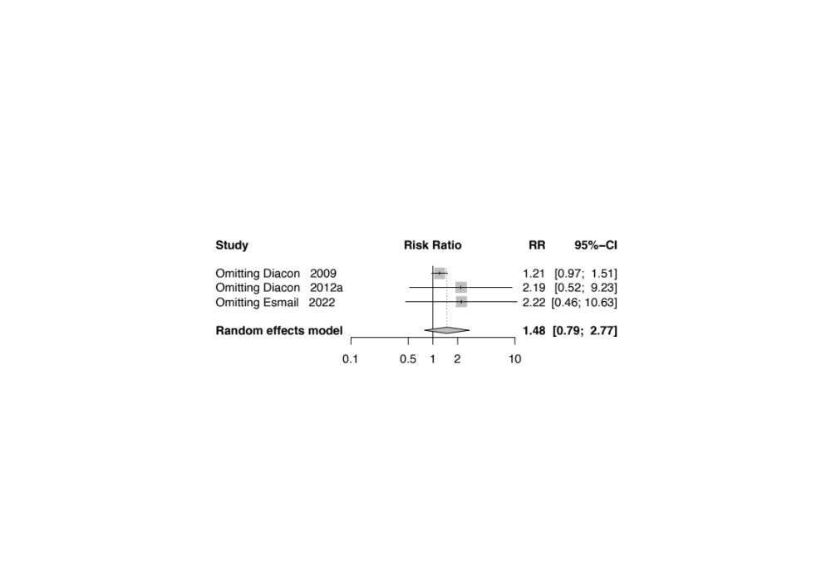
Figure S10 Sensitivity analysis of the rate of sputum culture conversion at 8 weeks in RCTs

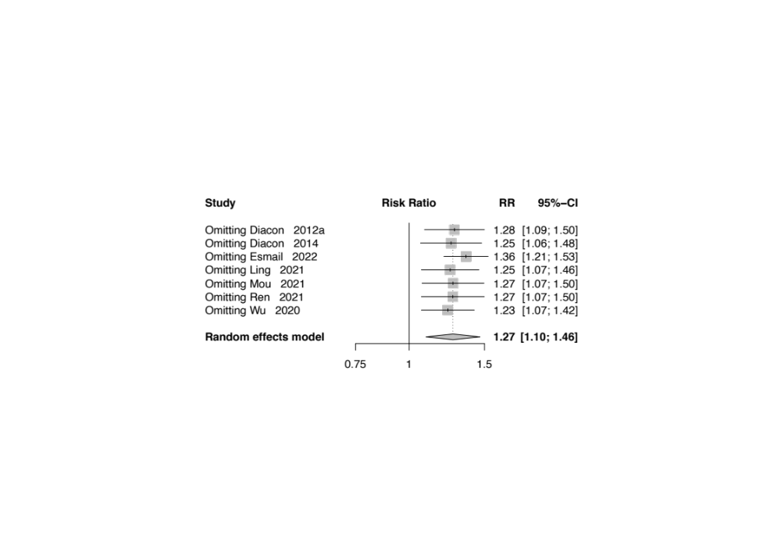
Figure S11 Sensitivity analysis of the rate of sputum culture conversion at 24 weeks in RCTs
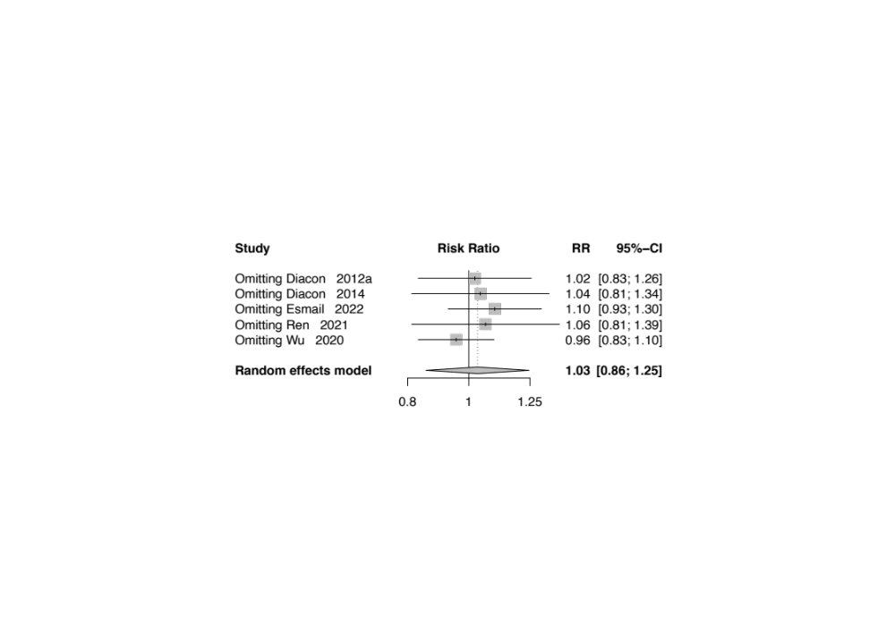
Figure S12 Sensitivity analysis of the rate of complete at end of the treatment in RCTs

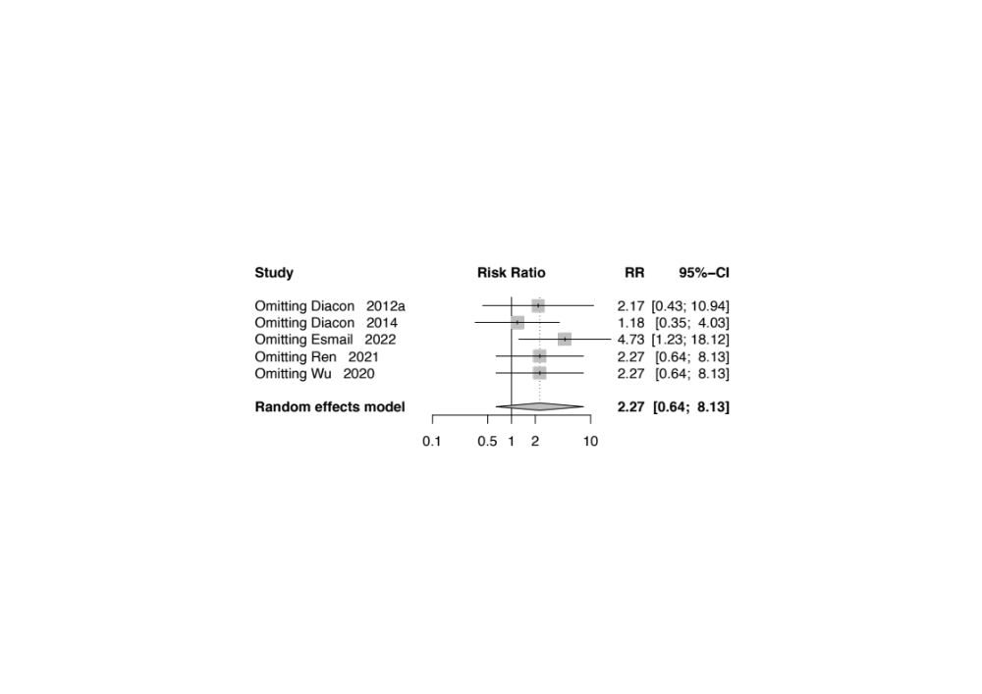
Figure S13 Sensitivity analysis of the rate of all-cause death at end of the treatment in RCTs
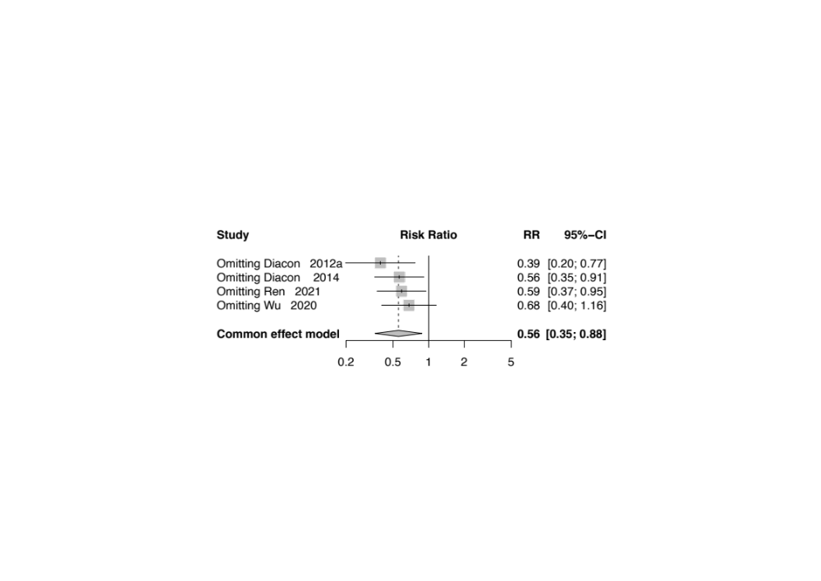
Figure S14 Sensitivity analysis of the failure rate at end of the treatment in RCTs
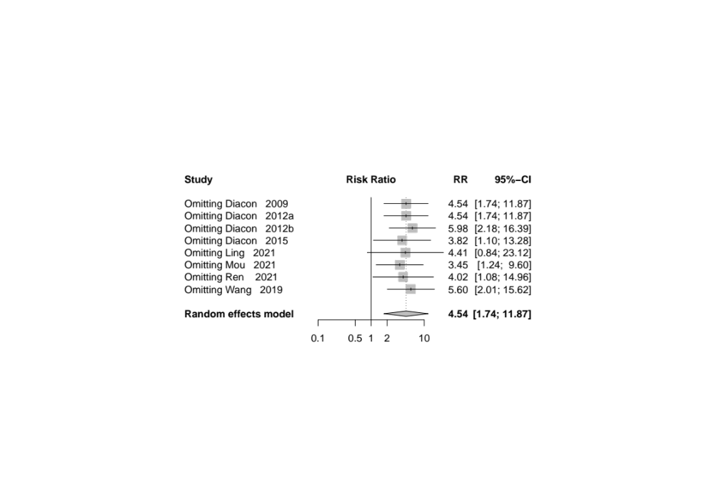
Figure S15 Sensitivity analysis of the incidence of cardiotoxicity in RCTs

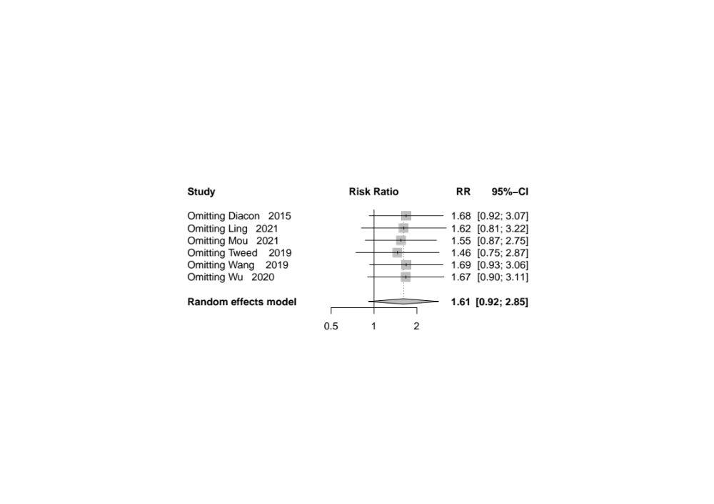
Figure S16 Sensitivity analysis of the incidence of hepatotoxicity in RCTs

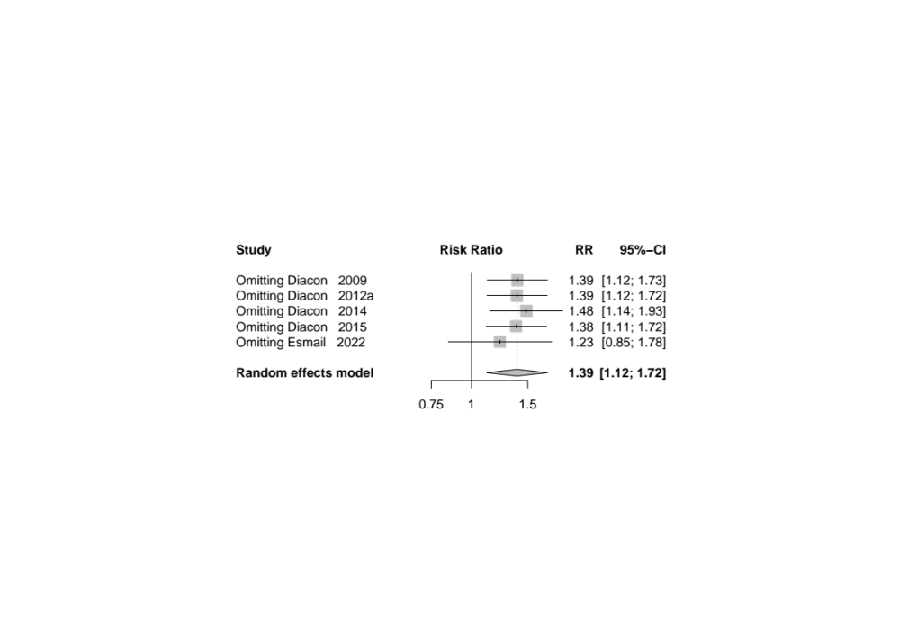
Figure S17 Sensitivity analysis of the incidence of grade 3-5 adverse events in RCTs

