Supplementary

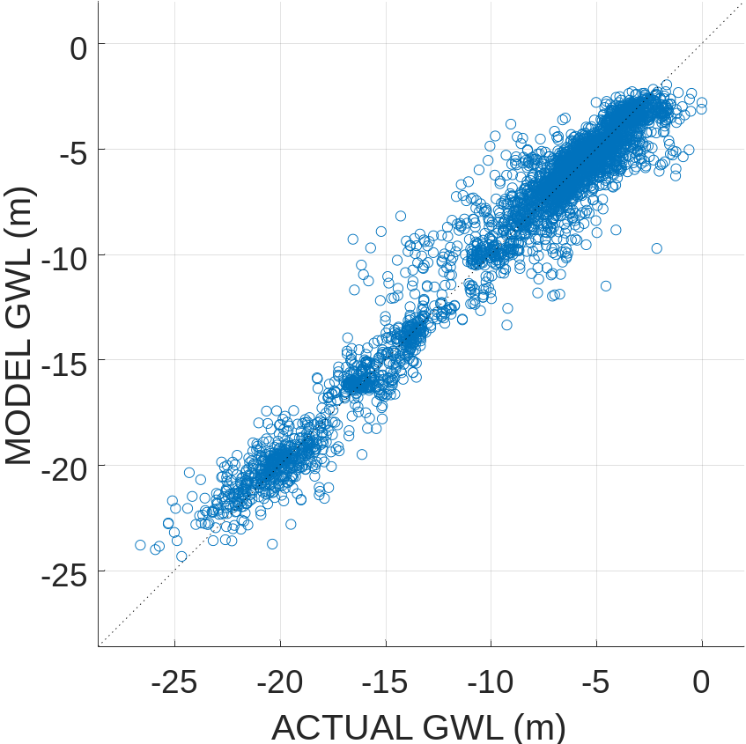
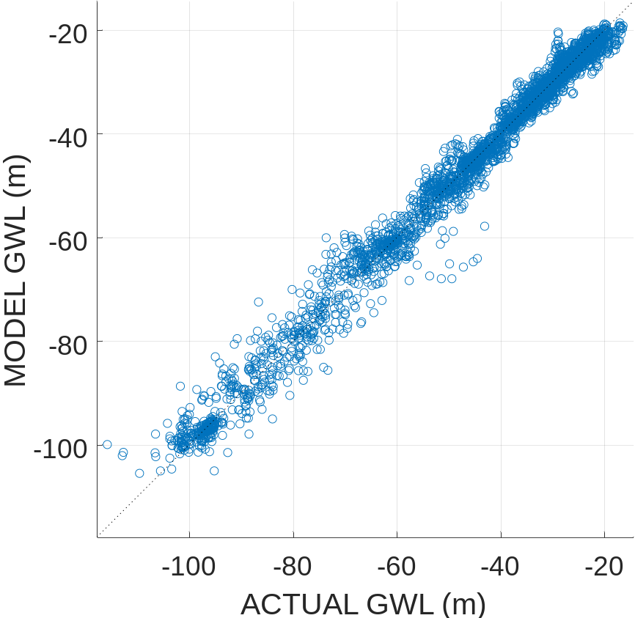
Fig S1. Correlation for out of bag of predictions for (a) shallow and (b) deep wells

 | Shallow | Deep
Correlation | 0.97745 | 0.99008
RMSE (m) | 1.2478 | 3.1412
R* | 0.21117 | 0.14061
NSE | 0.95539 | 0.98022
MAE (m) | 0.6036 | 1.5033
Table S1. Accuracy estimates for modeled results from Out-of-Bag (OOB) observations. Such results provide secondary validation results.

A. Shallow wells
SNo | Region | CORR | RMSE | RMSE* | NSE | MAE (m) | Trend (m yr⁻¹)
 |  |  |  |  |  |  | Actual | Model
1 | Beijing | 0.92 | 1.50 | 0.45 | 0.79 | 0.88 | -9.28±22.2 | -4.30±12.83
2 | Beijing | 0.93 | 0.85 | 0.40 | 0.84 | 0.54 | 46.83±7.73 | 32.06±3.69
3 | Beijing | 0.93 | 0.49 | 0.43 | 0.81 | 0.26 | 32.37±5.36 | 25.89±2.84
4 | Tianjin | 0.93 | 0.66 | 0.39 | 0.84 | 0.44 | -40.06±5.76 | -34.60±3.74
5 | Baoding | 0.98 | 0.48 | 0.23 | 0.95 | 0.32 | -54.08±9.91 | -51.62±7.78
6 | Baoding | 0.98 | 0.54 | 0.20 | 0.96 | 0.37 | -100.81±4.32 | -88.93±5.26
7 | Hengshui | 0.92 | 0.19 | 0.47 | 0.78 | 0.10 | -4.93±2.65 | -4.47±1.65
8 | Cangzhou | 0.93 | 0.76 | 0.38 | 0.86 | 0.59 | -115.65±4.08 | -85.33±8.54
9 | Langfang | 0.93 | 0.29 | 0.41 | 0.83 | 0.18 | 20.16±7.28 | 16.06±1.48
10 | Tangshan | 0.93 | 1.21 | 0.54 | 0.70 | 0.65 | -3.51±18.40 | -1.99±9.30
11 | Qinhuangdao | 0.82 | 0.26 | 0.58 | 0.67 | 0.16 | -12.40±2.99 | -9.25±1.97
Table S2. The accuracy and trend estimate for observed and modeled results for shallow wells in different prefectures of NCP.

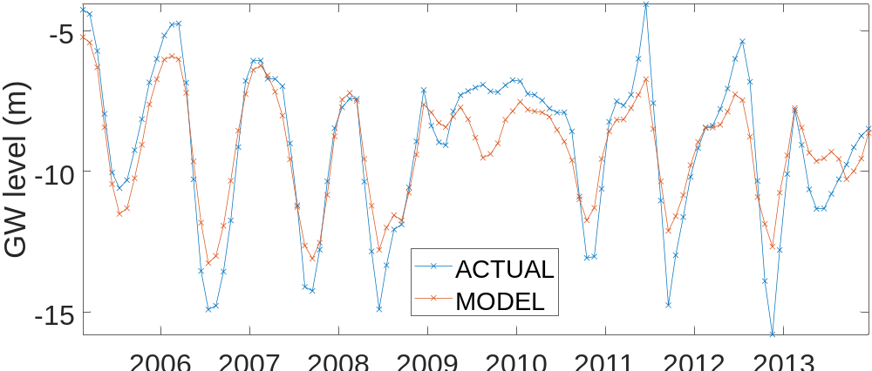
a
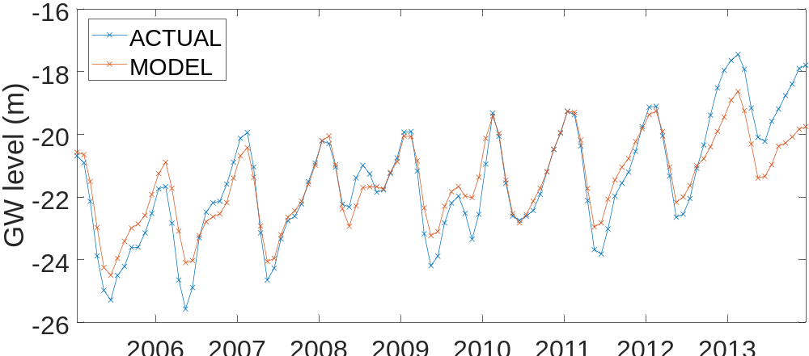
b

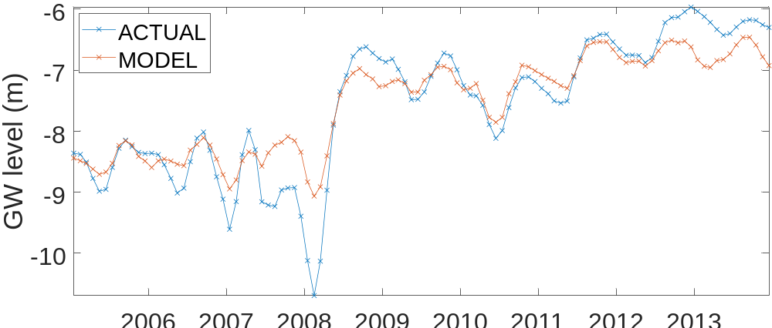
c
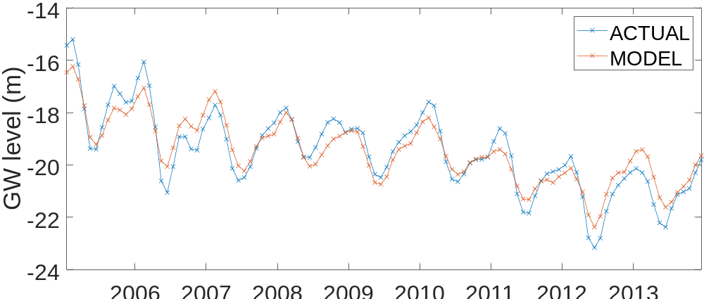
d

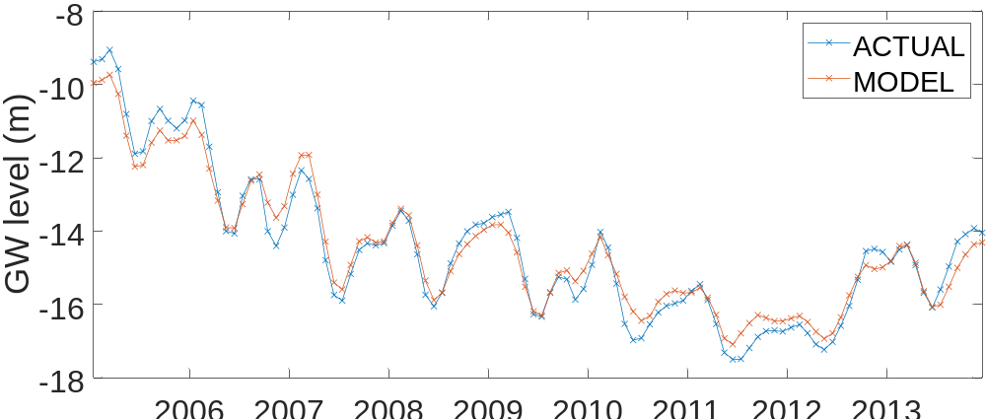
e
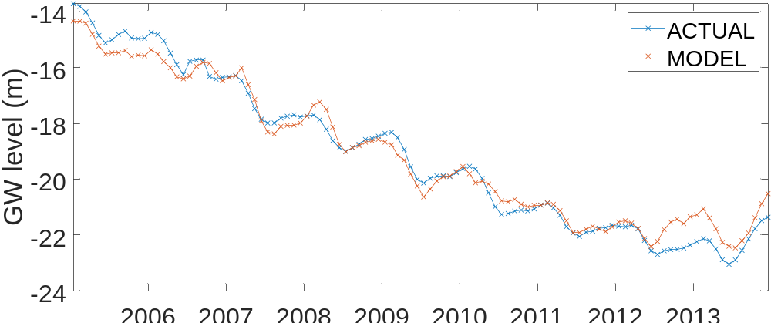
f

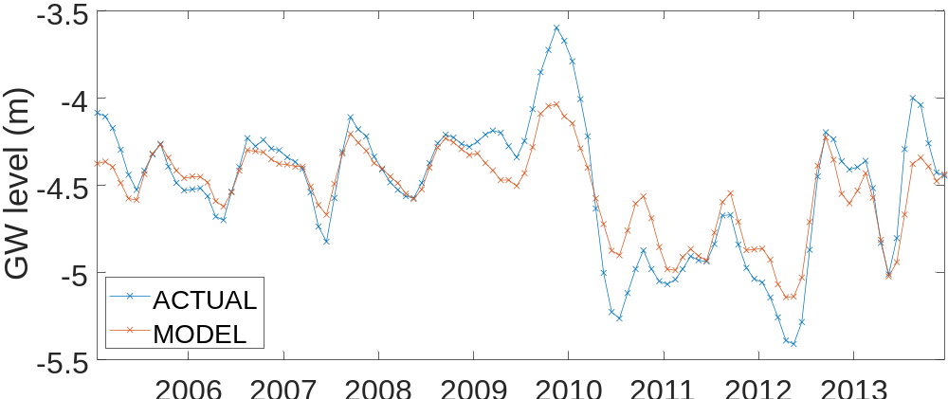
g
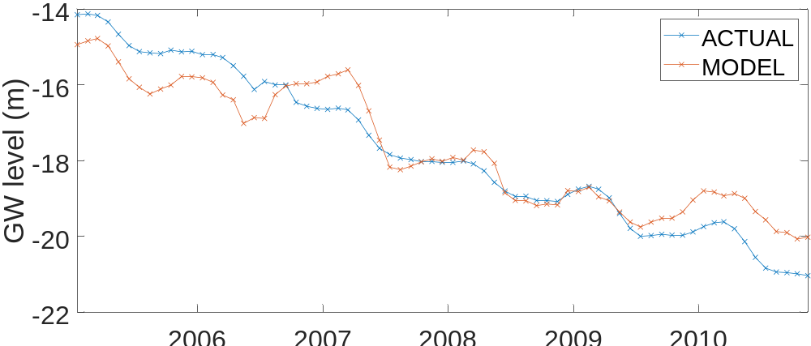
h

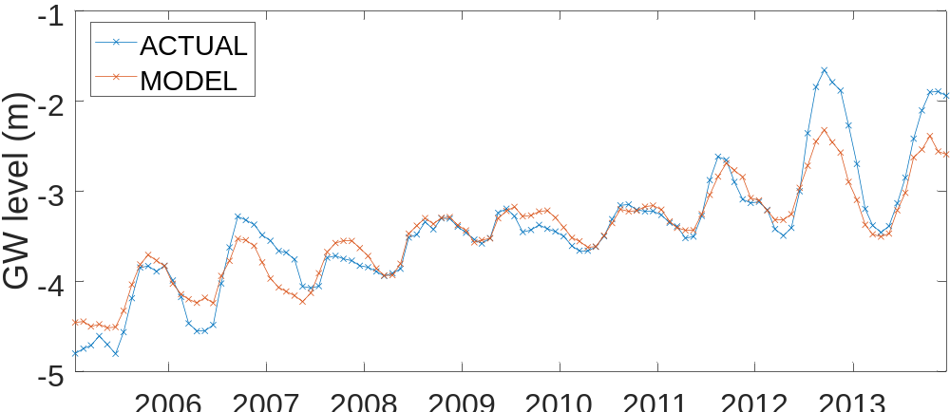
i
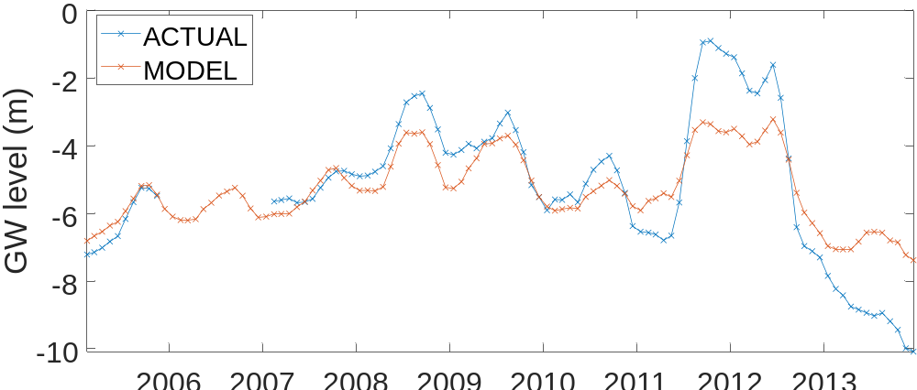
j

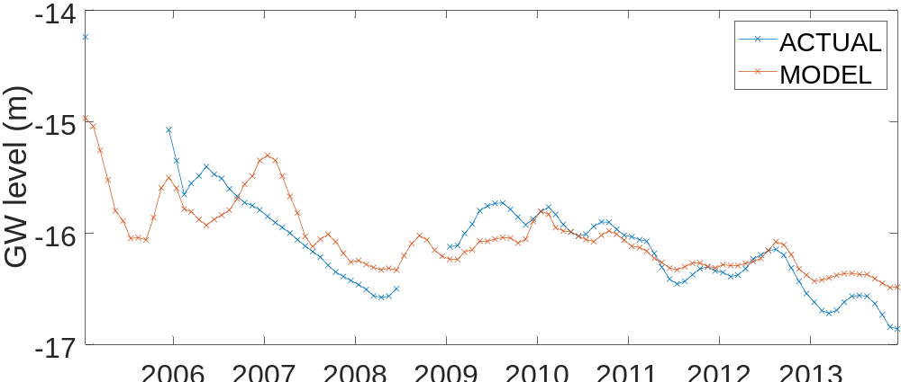
k
Fig S2. Time series analysis for ground wells in different prefectures and provinces in North China Plain. The description of the wells can be obtained from Table S2

B. DEEP WELLS
SNo | Region | CORR | RMSE (m) | RMSE* | NSE | MAD | Trend (m yr⁻¹)
 |  |  |  |  |  |  | Actual | Model
1 | Beijing | 0.95 | 1.31 | 0.35 | 0.87 | 1.05 | -91.78±20.80 | -89.55±13.34
2 | Beijing | 0.97 | 0.93 | 0.25 | 0.94 | 0.58 | -124.89±9.61 | -107.91±8.79
3 | Beijing | 0.94 | 1.22 | 0.38 | 0.86 | 0.83 | -89.57±14.31 | -71.49±9.01
4 | Beijing | 0.97 | 0.99 | 0.27 | 0.92 | 0.74 | -121.20±4.49 | -99.55±6.27
5 | Beijing | 0.96 | 0.81 | 0.29 | 0.91 | 0.44 | -44.50±11.53 | -39.89±7.08
6 | Tianjin | 0.95 | 0.63 | 0.36 | 0.87 | 0.35 | 48.10±7.87 | 41.97±5.12
7 | Tianjin | 0.96 | 1.46 | 0.29 | 0.91 | 1.06 | -178.99±12.18 | -146.47±12.67
8 | Tianjin | 0.95 | 1.01 | 0.37 | 0.86 | 0.54 | -101.11±3.60 | -74.97±3.68
9 | Baoding | 0.98 | 0.35 | 0.24 | 0.94 | 0.25 | -39.32±4.29 | -37.06±3.17
10 | Shijiazhuang | 0.97 | 0.33 | 0.23 | 0.94 | 0.23 | -49.59±4.49 | -47.18±3.31
11 | Hengshui | 0.96 | 1.62 | 0.29 | 0.92 | 1.18 | 44.42±21.58 | 39.34±11.67
12 | Hengshui | 0.97 | 2.97 | 0.27 | 0.93 | 2.11 | -77.14±38.69 | -52.44±
13 | Hengshui | 0.97 | 2.77 | 0.24 | 0.94 | 1.85 | -100.81±37.03 | -77.05±23.13
14 | Cangzhou | 0.91 | 3.42 | 0.50 | 0.75 | 1.43 | -99.57±46.38 | -72.33±22.83
15 | Cangzhou | 0.96 | 0.62 | 0.32 | 0.90 | 0.36 | -101.16±7.3 | -84.06±5.5
Table S3. The accuracy and trend estimate for observed and modeled results for deep wells in different prefectures of NCP.

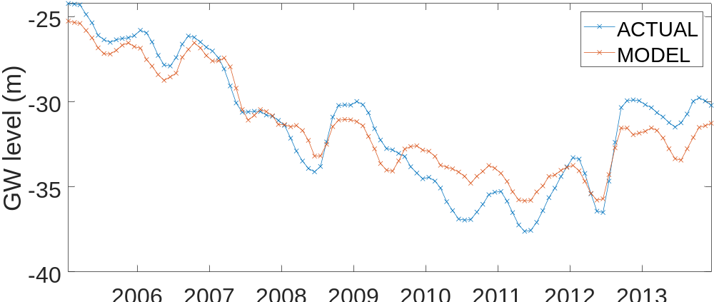
a

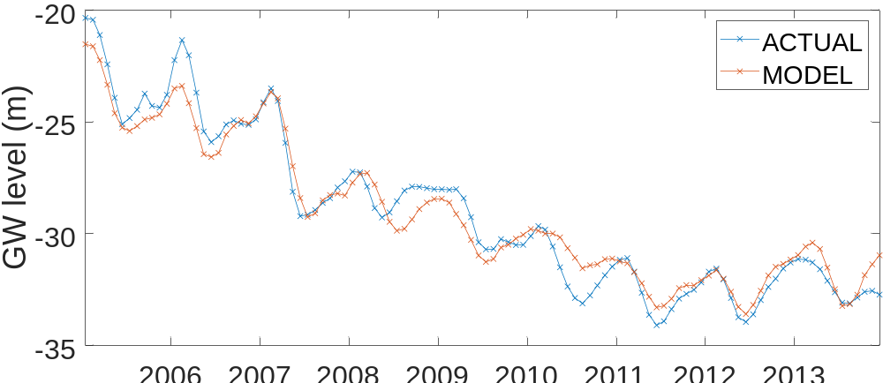
b

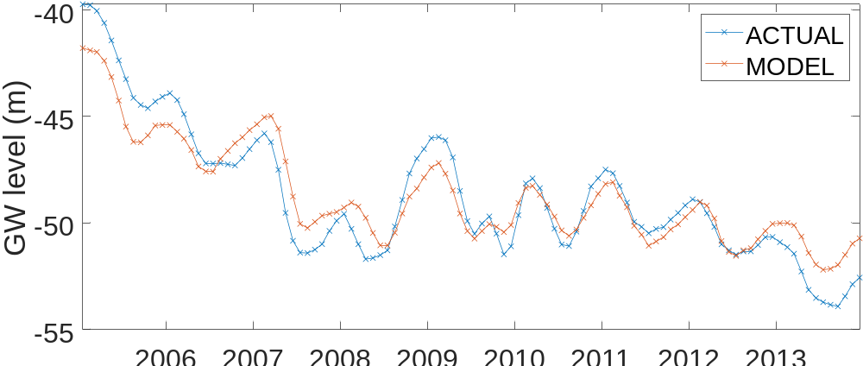
c

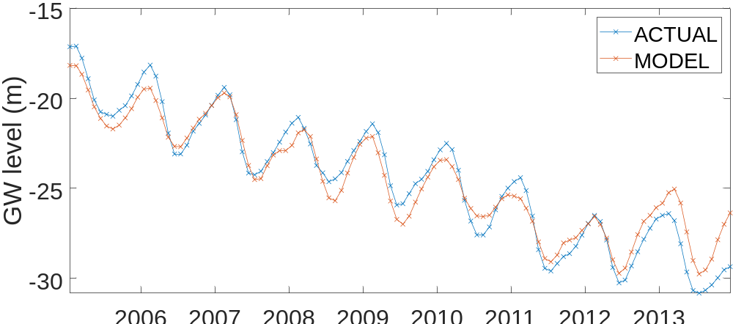

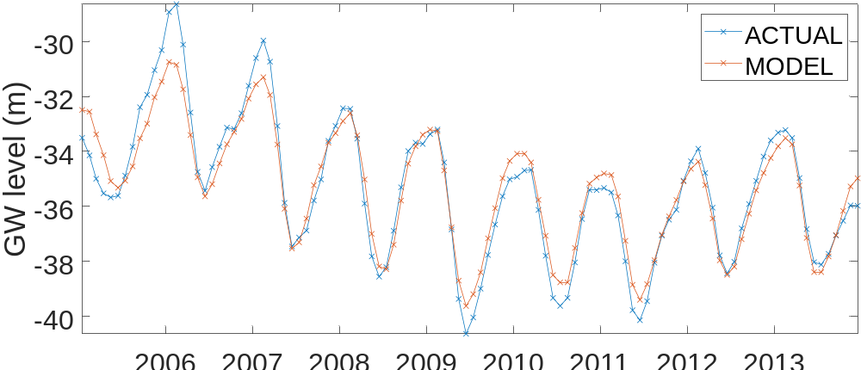
e

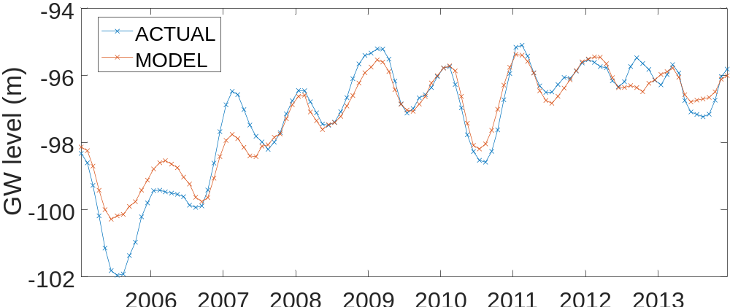
f
T
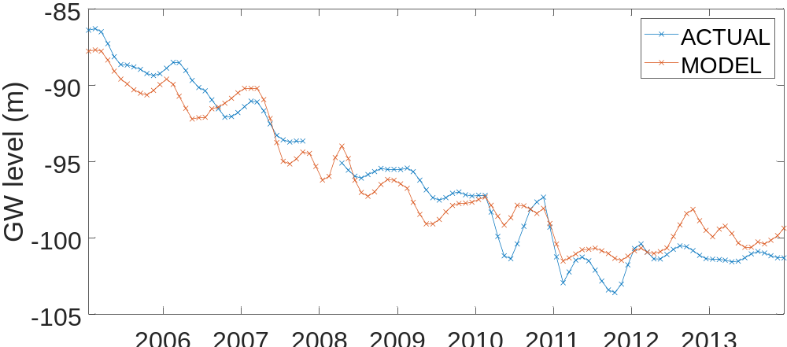
g
Tianjin
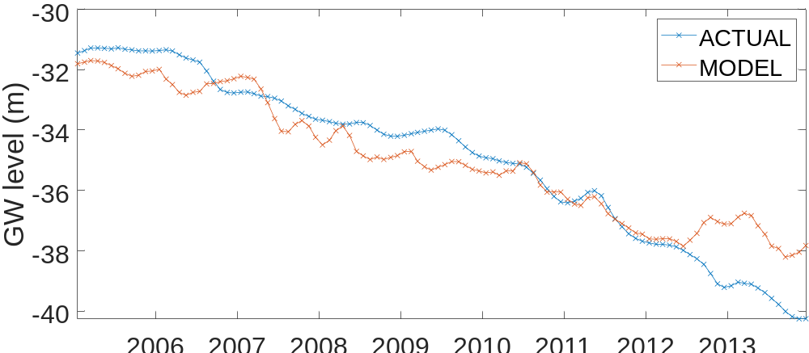
h

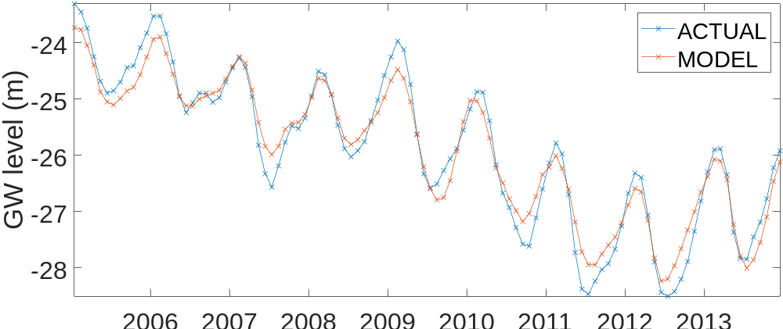
i

Shijiazhuang
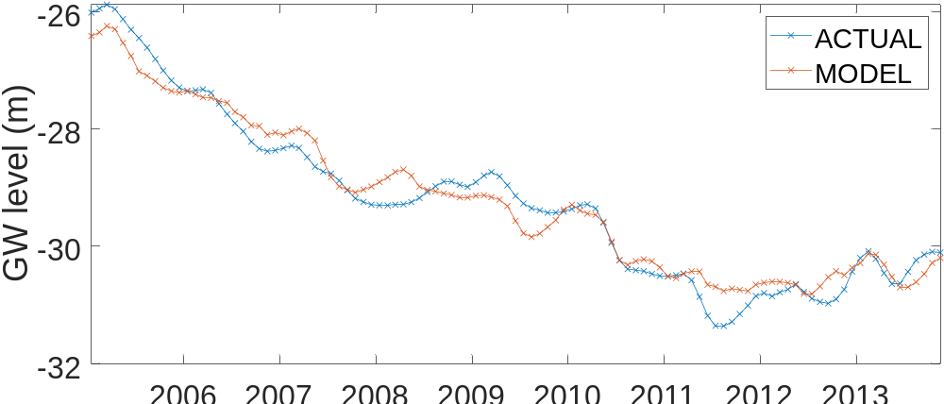
j

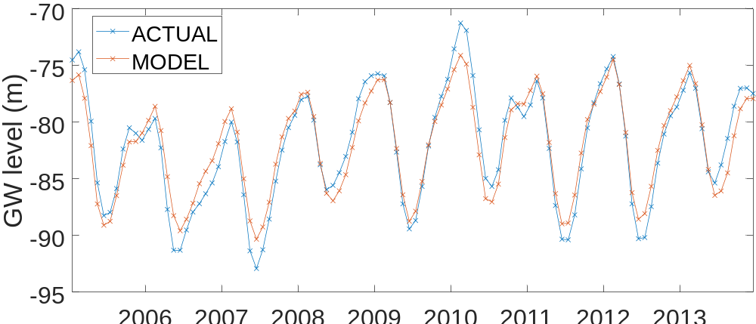
k

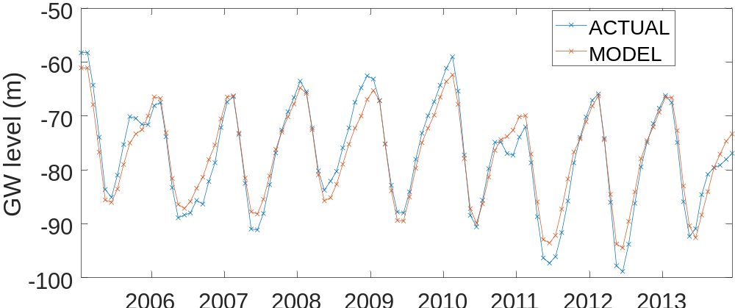
l

m
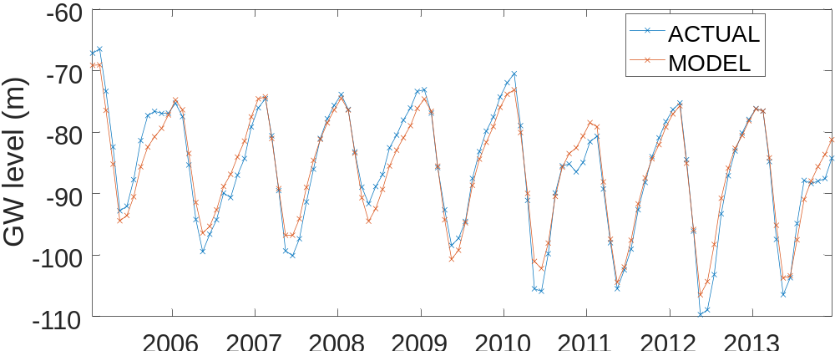

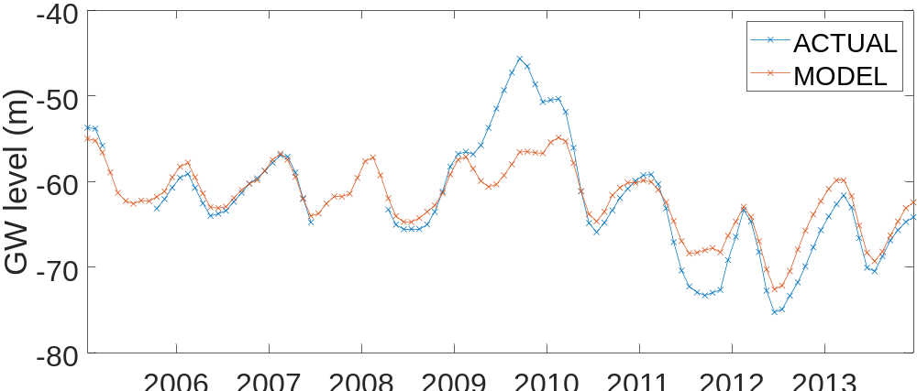
n

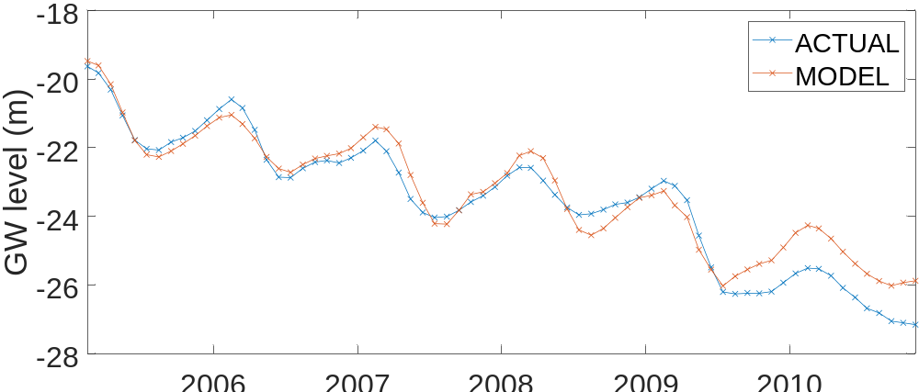
o

