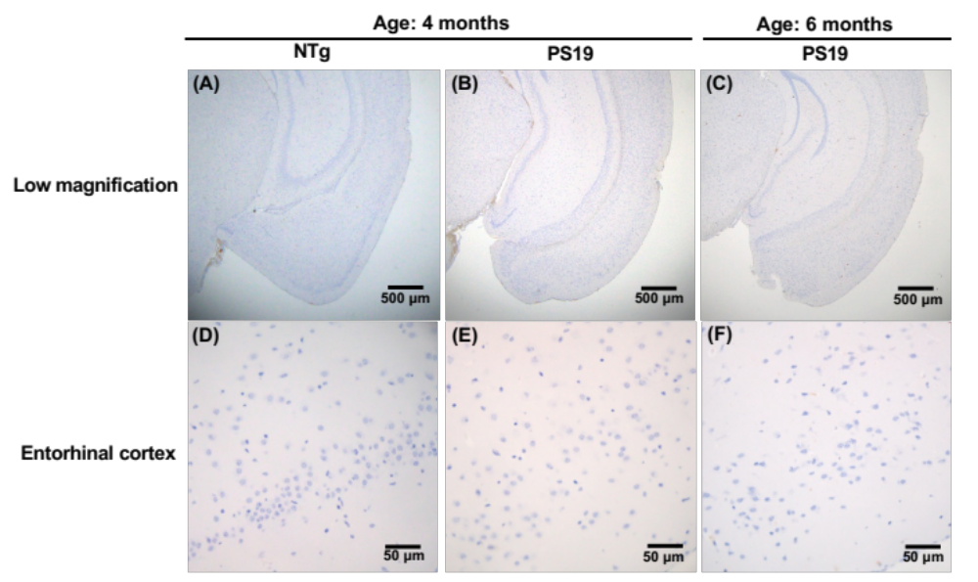

Supplemental Figure 1 Immunostaining of MC1-positive tau in PS19 mice that overexpress human P301S tau. Paraffin sections from PS19 mice and their nontransgenic littermates (NTg) were taken at 4 and 6 months old and immunostained with an MC1 antibody, which indicates a conformational change in tau¹. AT8-immunostained sections under low (A, B, C) and high (D, E, F) magnification were observed in NTg (A, D) and PS19 mice (B, C, E, F) at 4 (A, B) and 6 months of age (C).

Reference
1. Jicha, G.A., Bowser, R., Kazam, I.G., Davies, P. (1997). Alz-50 and MC-1, a new monoclonal antibody raised to paired helical filaments, recognize conformational epitopes on recombinant tau. J. Neurosci. Res. 48, 128-132.

