Characterization of a novel Escherichia coli recombineering selection/
counterselection cassette

Guoyi Zhang, Qiong Zhang, Junyu Wang, Jiao Zhang, Guangdong Shang*

Jiangsu Key Laboratory for Microbes and Functional Genomics, College of Life Sciences, Nanjing Normal University, Jiangsu Province, P. R. China.

*To whom correspondence should be addressed at: No.1 Wenyuan Rd., Xixia District, Nanjing 210023, Jiangsu Province, P. R. China. Phone: +86 25 85898332. Fax: +86 25 85891526. E-mail: shanggd@hotmail.com

Vector construction
pMB1-kan plasmid backbone was amplified from pET28a(+) with primers CS1–CS2; the chloramphenicol resistance gene cat was amplified from pCas9 with primers CS3–CS4. Two DNAs were each digested with XhoI–SpeI, ligated and transformed into E. coli DH10B, resulting in low copy number recombinant plasmid pLS4506.
With p11-LacY-wtx1 (Chen and Zhao et al. 2005; Addgene #69056) as template, CS5–CS6 PCR amplified the S-araC-pBAD fragment (S indicated the I-SceI recognition sequence, and for cloning convenience, the BamHI site in promoter pBAD was eliminated by mutating ggatcc to ggatct); CS7–CS8 PCR amplified the ccdB fragment. Overlap-extension PCR (OE-PCR) was carried out with primers CS5–CS8 and two DNAs as template, the amplified S-araC-pBAD-ccdB-S was digested with BamHI–SaII and cloned into pBluescript KS(–), getting pLS4507. Gentamicin resistance gene (aacC1) was amplified from E. coli LS2416 (Luo et al. 2015) with primers CS9–CS10, the amplicon was treated with XhoI–BamHI, ligated with the BamHI–SaII fragment isolated from pLS4507, and cloned into the BamHI site of pLS4506, giving S-araC-pBAD-ccdB-aacC1-S selection/counterselection cassette plasmid pLS4509.
With pST98AS (Posfai et al. 1999) as template, CS11–CS15 amplified S-tetR-ptetA fragment; with pMK2010 (House et al. 2004) as template, CS16–CS14 amplified ccdB fragment. OE-PCR with the two DNAs as template and primers CS11–CS14 generated S-tetR-ptetA-ccdB-S fragment. The amplicon was digested with BamHI–SaII and cloned into pBluescript KS(–), obtaining pLS4511 in which the original RBS sequence GAGAAAAGTGAA of ptetA was replaced by GATTGAAAACG. Sequencing showed that CcdB E87K mutation was generated. The BamHI–SaII fragment excised from pLS4511 and the XhoI–BamHI fragment of aacC1 were ligated into the BamHI site of pLS4506, giving S-tetR-ptetA-ccdB-aacC1-S selection/counterselection cassette plasmid pLS4512 harboring CcdB E87K. The second S-tetR-ptetA-ccdB-aacC1-S selection/counterselection cassette plasmid pLS4514 harboring CcdB L36R S70N was constructed as that of pLS4512 except primers CS17 and CS18 were used in the OE-PCR amplification of S-tetR-ptetA-ccdB fragment and the original RBS sequence GAGAAAAGTGAA of ptetA was replaced by AGGATCACATT.
With pKSacB (Luo et al. 2015) as template, CS19-CS20 amplified S-sacB fragment which was digested with BamHI-SaII and cloned into pBluescript KS(–), getting pLS4515. The BamHI–SaII fragment excised from pLS4515 and the XhoI–BamHI fragment of aacC1 were ligated into the BamHI site of pLS4506, obtaining the fourth S-sacB-aacC1-S selection/counterselection cassette plasmid pLS4516.
To facilitate S-tetR-petA-ccdB-aacC1-S cassette chromosomal knock-in, the cassette was amplified from pLS4512 with primers CS31–CS32, digested with EcoRI–HindIII and cloned into the same treated pR6KMCS (Luo et al. 2015), creating pLS4520. All plasmids were validated via restriction enzyme digestions and nucleotide sequencing.

Supplementary Table 1 Strains and plasmids used in this research
Strains | Characteristics | Source
Escherichia coli DH10B | F–mcrA (mrr-hsdRMS-mcrBC) φ80dlacZ M15 lacX74 deoR recA1 araD139(ara-leu)7697 galU galK rpsL endA1 nupG | Life Technologies (Carlsbad, CA, USA)
E. coli LS2416 | E. coli BL21(DE3)  ΔmalE::T7-TEV-aacC1 | (Luo et al. 2015)
E. coli LS4501 | E.coli DH10B  endA::S-tetR-ptetA-ccdB-aacC1-S, pLS2358 | This study
E. coli LS4502 | E.coli DH10B endA::gfp, pLS2358 | This study
E. coli LS4503 | E.coli DH10B endA::gfp | This study
E. coli LS4504 | E.coli DH10B endA::cas9,  pLS2358 | This study
E. coli LS4505 | E.coli DH10B endA::cas9 | This study
plasmids
pET28a(+) | T7, pMB1, Km^{R} | Novagen, USA
pCas9 | cas9, tracrRNA, p15A, Cm^{R} | (Jiang et al. 2013)
pBluescript KS(–) | Cloning vector, pUC, Ap^{R} | Invitrogen, USA
p11-LacY-wtx1 | lacY, araC-pABD-ccdB, pMB1,  Ap^{R} | (Chen and Zhao 2005)
pST98AS | tetR-P_{tetA}-I-SceI, pSC101, Ap^{R} | (Posafai et al. 1999)
pMK2010 | attP1-ccdB-attP2, oriT, pUC,  Km^{R}, Cm^{R} | (House et al. 2004)
pJOE4905.1 | His-MBP-egfp, pMB1, Km^{R} | (Motejadded and Altenbuchner 2009)
pR6KMCS | Cloning vector, R6K, Ap^{R} | (Luo et al. 2015)
pLS2358 | xylS-Pm-red αβγ ,rhaRS-PrhaB-  I-SceI, sacB, RK2, Tc^{R} | (Chen et al. 2016)
pLS4506 | cat, pMB1, Km^{R} | This study
pLS4507 | S-araC-pBAD-ccdB-S, pUC, Ap^{R} | This study
pLS4509 | S-araC-pBAD-ccdB-aacC1-S, pMB1, Km^{R} | This study
pLS4511 | S-tetR-ptetA-ccdB(E87K), pUC,  Ap^{R} | This study
pLS4512 | S-tetR-ptetA-ccdB(E87K)-aacC1-S, pMB1, Km^{R} | This study
pLS4513 | S-tetR-ptetA-ccdB (L36R S70N),  pUC, Ap^{R} | This study
pLS4514 | S-tetR-ptetA-ccdB (L36RS70N)-  aacC1-S, pMB1, Km^{R} | This study
pLS4515 | S-sacB, pUC, Ap^{R} | This study
pLS4516 | S-sacB-aacC1-S, pMB1, Km^{R} | This study
pLS4517 | TEV, pMB1, Km^{R} | This study
pLS4518 | sacB, pMB1, Km^{R} | This study
pLS4519 | cas9, pMB1, Km^{R} | This study
pLS4520 | S-tetR-ptetA-ccdB(E87K)-aacC1-S, R6K, Ap^{R} | This study

Supplementary Table 2 Primers used in this research
Name | Sequence (5'-3') | Purpose
CS1 | GGACTCGAGGGATCCTTGAAATAAGATCACTACCGGG | Construction of pLS4506
CS2 | GGAACTAGTGGATCCGCGTTTAAGGGCACCAATAAC | Construction of pLS4506
CS3 | GGA ACTAGTTCAAAGCCACGTTGTGTCTC | Construction of pLS4506
CS4 | GGACTCGAGGAAATCCCCCTTACACGGAGG | Construction of pLS4506
CS5 | GGATCCTAGGGATAACAGGGTAATTTATGACAACTTGACGGCTACATC | Construction of pLS4507
CS6 | GATAAAAAGCGTCAGGTAAGATCCGCTAATCTTATGGATAAAAATGCTAT | Construction of pLS4507
CS7 | ATAGCATTTTTATCCATAAGATTAGCGGATCTTACCTGACGCTTTTTATC | Construction of pLS4507
CS8 | GGAGTCGACGTAATGCTAGATTATATTCCC | Construction of pLS4507
CS9 | GGACTCGAGTCGAATTGACATAAGCCTGTTCG | Construction of pLS4509
CS10 | GGAGGATCCATTACCCTGTTATCCCTATTAGGTGGCGGTACTTGGGTC | Construction of pLS4509
CS11 | GGATCCTAGGGATAACAGGGTAATTTAAGACCCACTTTCACATTTAAG | Native S-tetR-petA-ccdB  cloning
CS12 | GGTGTAAACCTTAAACTGCATTTCACTTTTCTCTATCACTGATAG | Native S-tetR-petA-ccdB  cloning
CS13 | CTATCAGTGATAGAGAAAAGTGAAATGCAGTTTAAGGTTTACACC | Native S-tetR-petA-ccdB  cloning
CS14 | TTATATTCCCCAGAACATCAGGTTAATG | Native S-tetR-petA-ccdB  cloning
CS15 | GGTGTAAACCTTAAACTGCATCGTTTTCAATCTATCACTGATAGGGAGTGG | Construction of pLS4512
CS16 | CCACTCCCTATCAGTGATAGATTGAAAACGATGCAGTTTAAGGTTTACACC | Construction of pLS4512
CS17 | GGTGTAAACCTTAAACTGCATAATGTGATCCTTATCACTGATAGGGAGTGG | Construction  of pLS4514
CS18 | CCACTCCCTATCAGTGATAAGGATCACATTATGCAGTTTAAGGTTTACACC | Construction  of pLS4514
CS19 | GGAGGATCCTAGGGATAACAGGGTAATATCCTTTTATGATTTTCTATC | Construction of pLS4516
CS20 | GTCGACTTATTTGTTAACTGTTAATTGTCC | Construction of pLS4516
Seq3 | CGGCGTCACACTTTGCTATG | Sequencing of araC region
PSC | TCAGGTTCAGCCACATTTAC | Sequencing of sacB region
CS21 | GGCGGTTTTTTCCTGTTTGGTCACTGATGCCTCCGTGTAAGGGGGATTTCGGAGAAAGCTTGTTTAAGGGG | 702 bp TEV cloning
CS22 | TATCTTGTGCAATGTAACATCAGAGATTTTGAGACACAACGTGGCTTTGAATTCATGAGTTGAGTCGCTTCC | 702 bp TEV cloning
CS23 | GGCGGTTTTTTCCTGTTTGGTCACTGATGCCTCCGTGTAAGGGGGATTTCTCCTTTTATGATTTTCTATC | 1700 bp sacB cloning
CS24 | TATCTTGTGCAATGTAACATCAGAGATTTTGAGACACAACGTGGCTTTGATTATTTGTTAACTGTTAATTGTCC | 1700 bp sacB cloning
CS25 | TATCTTGTGCAATGTAACATCAGAGATTTTGAGACACAACGTGGCTTTGAATGGATAAGAAATACTCAATAGGC | 4107 bp cas9 cloning
CS26 | GGCGGTTTTTTCCTGTTTGGTCACTGATGCCTCCGTGTAAGGGGGATTTCTCAGTCACCTCCTAGCTGACTC | 4107 bp cas9 cloning
CS31 | GGAGAATTCAACAAATAGGGGTTCCGCGCTAGGGATAACAGGGTAATTTAAGACCCACTTTCACATTTAAG | Construction of pLS4520
CS32 | GGAAAGCTTTCCTTAGTTCCTATTCCGAAGATTACCCTGTTATCCCTATTAGGTGGCGGTACTTGGGTC | Construction of pLS4520
CS33 | GCACGAACTGGCACATTTGCTGGTATGGAAACATTTCGGCCGCGTAGCGCAACAAATAGGGGTTCCGCGC | S-tetR-ptetA-ccdB-aacC1-S cassette knock-in
CS34 | GGTGAATATGCAGCGGAGATTCGCGATCGTCGATCTGGCCTTCCAGCACCTCCTTAGTTCCTATTCCGAAG | S-tetR-ptetA-ccdB-aacC1-S cassette knock-in
CS35 | GCACGAACTGGCACATTTGCTGGTATGGAAACATTTCGGCCGCGTAGCGCAGCAAGGGCGAGGAGCTGTTC | egfp knock-in
CS36 | GGTGAATATGCAGCGGAGATTCGCGATCGTCGATCTGGCCTTCCAGCACCTTACTTGTACAGCTCGTCCATG | egfp knock-in
CS37 | GCACGAACTGGCACATTTGCTGGTATGGAAACATTTCGGCCGCGTAGCGCATGGATAAGAAATACTCAATAGGC | cas9 knock-in
CS38 | GGTGAATATGCAGCGGAGATTCGCGATCGTCGATCTGGCCTTCCAGCACCTCAGTCACCTCCTAGCTGACTC | cas9 knock-in
KI1 | ATGAAATTCGCCTCAATCCCG | Knock-in strain genotyping
KI4 | GTTCGATCGATTTCTGGATAG | Knock-in strain genotyping

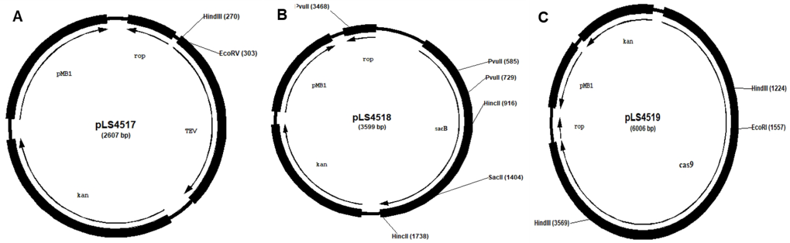

Fig S1. Restrcition enzyme digestion maps of recombinant plasmids. A TEV gene cloning plasmid pLS4517. B sacB gene cloning plasmid pLS4518. C cas9 gene cloning plasmid pLS4519. Only related restrcition enzyme clevage sites are shown

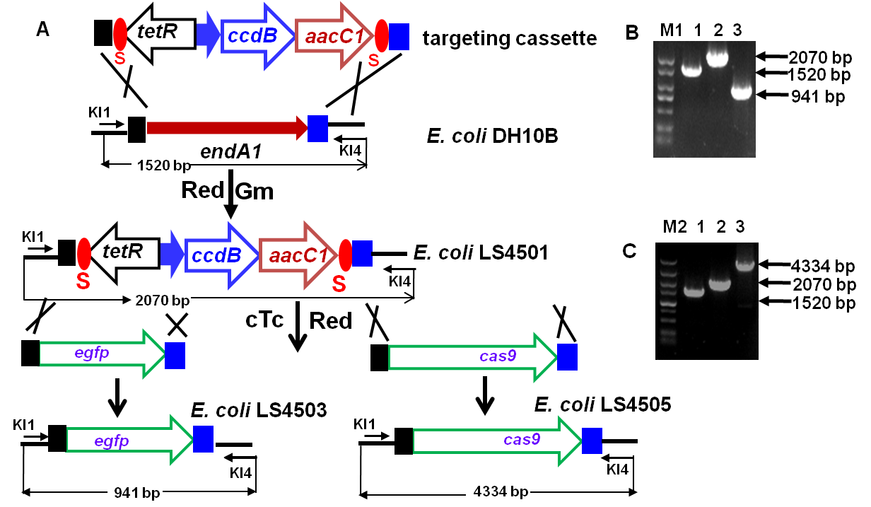

Fig S2. Scheme shown the S-tetR-petA-ccdB-aacC1-S cassette-mediated chromosomal gene knock-in. A PCR amplified HA-flanked cassette was electroporated into Red-proficient E. coli DH10B cells, and cassette knock-in clone was obtained under Gm selection. The non-essential, mutated endonuclease I encoding gene endA1 was selected as the knock-in locus which was deleted with the cassete knock-in. The seletion/counterselection cassstte was subsequently replaced by the GOI (gene of interest, herein egfp and cas9) via the combined counterselection of I-SceI and CcdB. Randomly selected Gm^{S} clones were genotyped with PCR. B PCR analysis of the egfp knock-in clone. Lane 1, 2, and 3 denote the PCR amplicon from E. coli DH10B endA1 locus, cassette knock-in clone, and the egfp replacement clone respectively. C PCR analysis of the cas9 knock-in clone. Lane 1, 2, and 3 denote the PCR amplicon from E. coli DH10B, cassette knock-in clone, and the cas9 replacement clone, respectively. M1: DL2000 DNA molecular marker with the sizes (in kb) are 2.0, 1.5, 1.0, 0.75, 0.5, 0.25, and 0.1. M2: DL5000 DNA molecular marker with the sizes (in kb) are 5.0, 3.0, 2.0, 1.5, 1.0, 0.75, 0.5, 0.25, and 0.1. Arrows point to the amplicons of expected sizes. The amplicons were further validated via nucleotide sequencing.

References
Chen Z, Ling W, Shang G (2016) Recombineering and I-SceI-mediated Pseudomonas putida KT2440 scarless gene deletion. FEMS Microbiol Lett 363:fnw231
Chen Z, Zhao H (2005) A highly sensitive selection method for directed evolution of homing endonucleases. Nucleic Acids Res 33:e154
House BL, Mortimer MW, Kahn ML (2004) New recombination methods for Sinorhizobium meliloti genetics. Appl Environ Microbiol 70:2806–2815
Jiang W, Bikard D, Cox D, Zhang F, Marraffini LA (2013) RNA-guided editing of bacterial genomes using CRISPR-Cas systems. Nat Biotechnol 31:233–239
Luo X, Li L, Chai M, Zhang Q, Shang G (2015) Escherichia coli BL21(DE3) chromosome-based controlled intracellular processing system for fusion protein separation. J Microbiol Methods 114:35–37
Luo X, Yang Y, Ling W, Zhuang H, Li Q, Shang G (2016) Pseudomonas putida KT2440 markerless gene deletion using a combination of λ Red recombineering and Cre/loxP site-specific recombination. FEMS Microbiol Lett 363:fnw014
Motejadded H, Altenbuchner J (2009) Construction of a dual-tag system for gene expression, protein affinity purification and fusion protein processing. Biotechnol Lett 31:543–549
Posfai G, Kolisnychenko V, Bereczki Z, Blattner FR (1999) Markerless gene replacement in Escherichia coli stimulated by a double-strand break in the chromosome. Nucleic Acids Res 27:4409–4415

