Supplementary Information for
New Empirical Models for Flood Loss Prediction and Implications for the Coterminous United States

This PDF file includes:

Supplementary Text
References
Figures S1 to S14
Tables S1 to S7

Supplementary Text

Controlling for Katrina in the Training of Stratified GAMs
Because Katrina exerts substantial leverage over the GAM fitting process for all models besides the ones trained when Katrina is held out, we investigate the effect of controlling for Katrina in the GAM fitting process. Importantly, because we stratify on FEMA Region, Katrina’s influence is limited to model fitting and prediction for observations in FEMA Regions 4 and 6. Based off the fact that Katrina composes an inordinate proportion of loss observations at depths greater than 4 feet, and Katrina observations at these depths constitute far larger losses on average than observations from all other events, we fit the following model:

$${{rel}_{i}}^{Obs}=D^{Depth}\left[{x_{i}}^{Obs},θ_{k(i)} \right]+{katLoss}_{i}*{highDepth}_{i} + ζ_{i}$$

Where $θ_{k(i)}$ is defined the same as for the main Stratified GAM model, ${katLoss}_{i}$ is a dummy variable equal to 1 when an observation is due to Katrina, and ${highDepth}_{i}$ is a dummy variable equal to 1 when a loss is incurred from greater than or equal to 4 feet of inundation.

This adjustment is ad-hoc and imperfectly captures the underlying mechanism that generates differences in loss magnitude due to Katrina. However, it improves prediction performance in FEMA Regions 4 and 6 at depths greater than or equal to 4 feet. The effect on the resulting damage function shapes is shown in Figure S14. The effect in validation is shown in Figure 6, and in extrapolation in Figures S12 and S13.

Foundation Type and First-Floor Elevation Adjustments
In extrapolation, foundation data is needed to translate modeled depths relative to grade into inundation depths relative to first-floor elevation. Section 5.6.1 and Tables 5-13 through 5-18 of the HAZUS Technical Manual outline a procedure for the distribution of foundation types and the associated first floor heights that depend on coastal/inland and pre/post-FIRM relationships that vary over space. Our first-floor elevation adjustment approach relies entirely on the information in the Technical Manual (Table S5). Our foundation type assignment approach relies first on the property level assessment records in ZTRAX, then the OpenFEMA National Flood Insurance Policy (NFIP) Redacted Policies dataset, and finally Tables 5-15 and 5-16 from the HAZUS Technical Manual (FEMA, 2021). The procedure is as follows:

- If foundation type is slab, crawl space, pier or piling, or basement as observed in ZTRAX, assign to property
  - Assign first-floor elevation adjustment based off foundation and damage scenario (Table S5)
- If foundation is unknown, use proportions of crawl space, basement and no basement at the flood zone x tract x zip, zip, tract, county or state level (whichever is highest resolution and has more than 30 observations in the policy data)
  - If property is located outside the coastal hazard exposure layer in the First Street Model, use the proportions as-is in the weighted proportion approach outlined in Pollack et al., (2022)
    - This implies that all inland homes with unknown foundation type are treated as slab foundation for the no basement portion of the weighted proportion approach
  - If the property is located in the coastal hazard exposure layer, adjust the proportions for slab with the following fractions (pier/piling gets the remaining proportion)
    - If pre-FIRM
      - FEMA Region <= 3: .15
      - FEMA Region == (4 or 6): .46
      - Other FEMA Regions: .71
    - If post-FIRM
      - If A zone:
        - FEMA Region <= 3: .23
        - FEMA Region == (4 or 6): .16
        - Other FEMA Regions: .44
      - If V zone:
        - .05
  - Assign first-floor elevation adjustment based off foundation and damage scenario (Table S5) and apply weighted proportion approach as outlined in Pollack et al., (2022)

References
FEMA. (2021). Hazus Inventory Technical Manual. https://www.fema.gov/sites/default/files/documents/fema_hazus-inventory-technical-manual-4.2.3.pdf
Pollack, A. B., Sue Wing, I., Nolte, C., & Adam Pollack, C. B. (2022). Aggregation bias and its drivers in large-scale flood loss estimation: A Massachusetts case study. Journal of Flood Risk Management, e12851. https://doi.org/10.1111/JFR3.12851

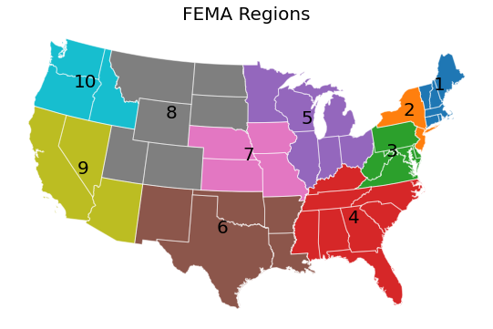

Figure S1: FEMA Regions

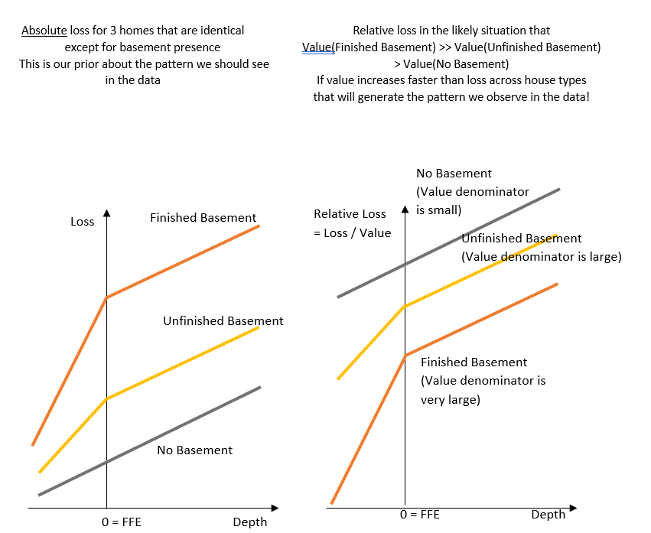

Figure S2: The role of structure value and basement type in relative loss

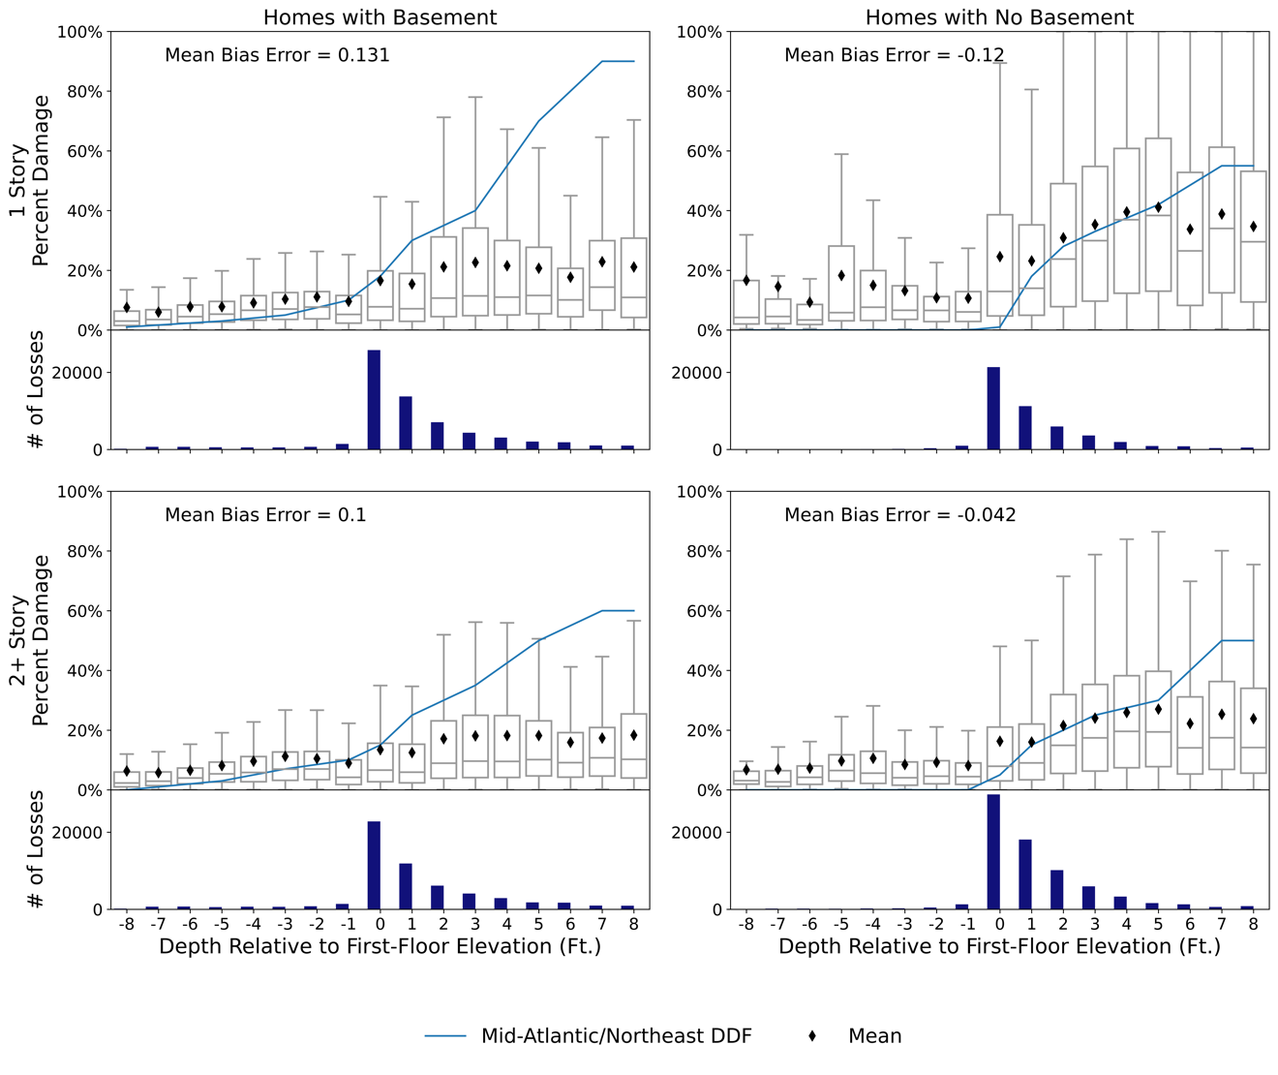
Figure S3: North Atlantic Coast Comprehensive Study Most Likely USACE DDFs stratified by number of stories and basement presence plotted over the distribution of percent damage for these stratifications. The black diamonds reflect the mean percent damage at each depth for all observations in the stratification in the appropriate FEMA Regions (1-3).

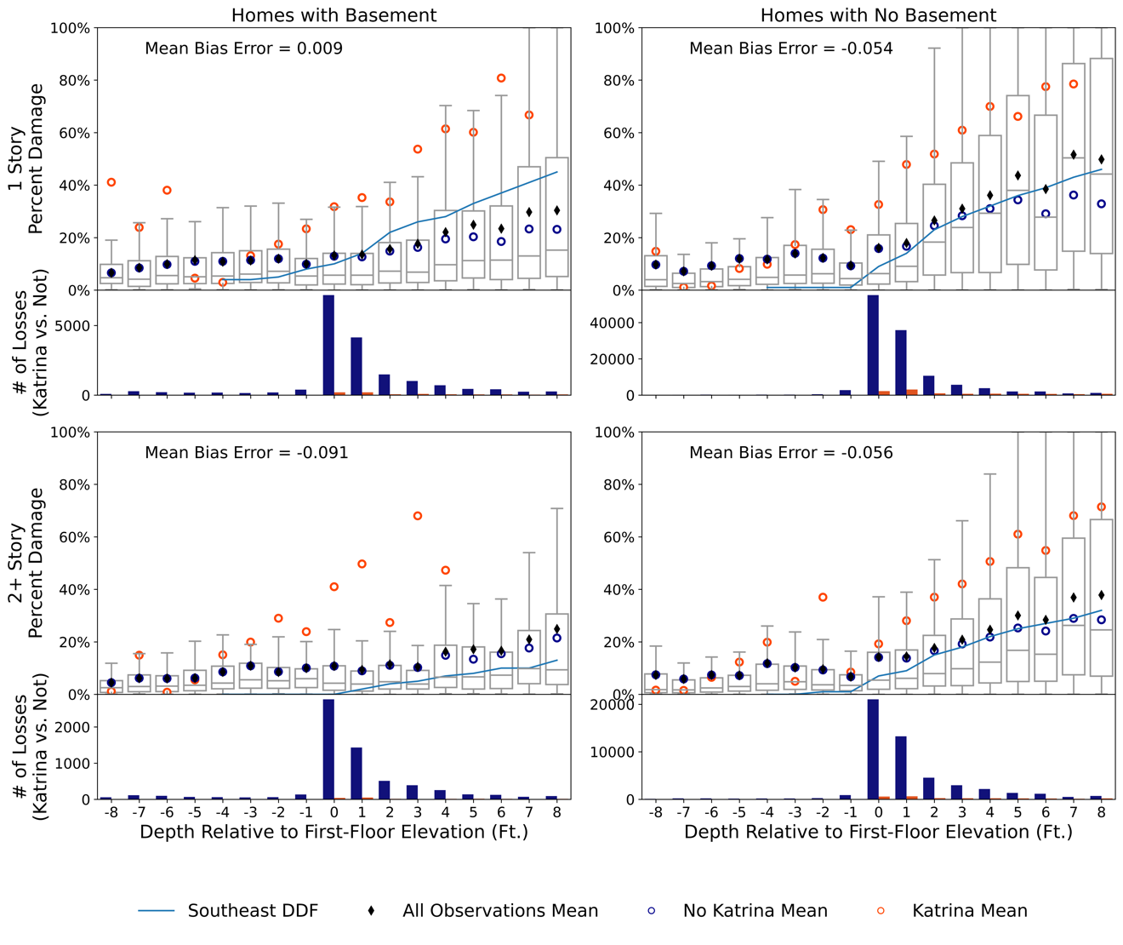
Figure S4: Southeast USACE DDFs stratified by number of stories and basement presence plotted over the distribution of percent damage for these stratifications. The black diamonds reflect the mean percent damage at each depth for all observations in the stratification in the appropriate FEMA Region (4).

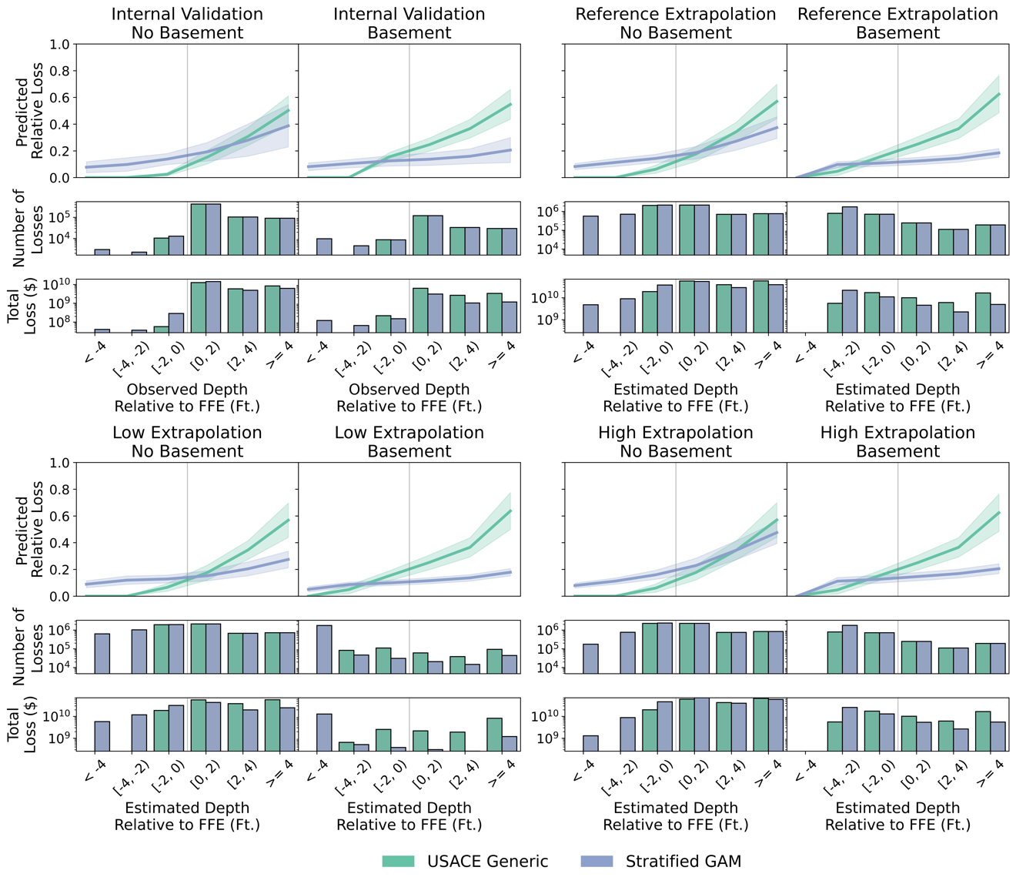
Figure S5: Differences between predictions in validation and extrapolation across damage functions, structure types and damage scenarios. The top left quadrant of the plot shows average predicted relative loss for no basement and basement homes in validation, with a one standard deviation band around the average on top of the number of losses and total losses, all across depth bins. This is shown in the top right quadrant for reference damage scenario in extrapolation, and the bottom left and bottom right quadrant shows this for the low and high damage scenarios, respectively.

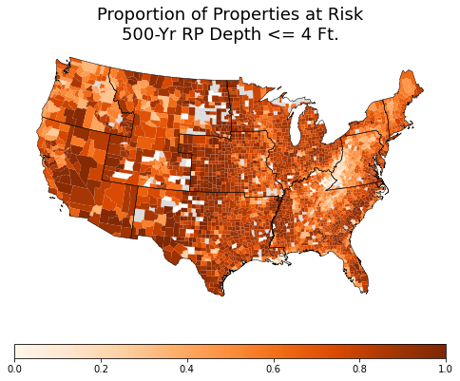
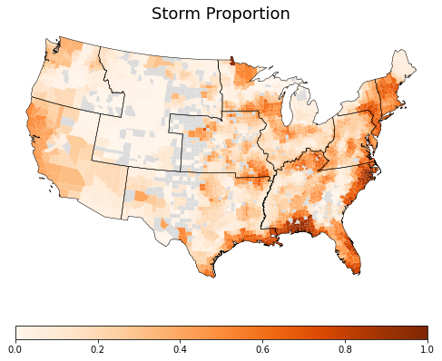
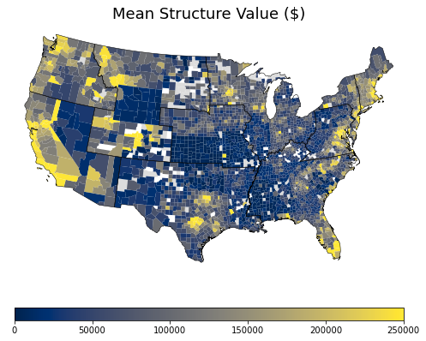
Fig. S6: Proportion of properties with losses with 500-yr return period depths <= 4 feet relative to grade (top), proportion of losses in the NCEI database that are due to storm events (middle) and mean structure value of properties with losses (bottom), all at the county level

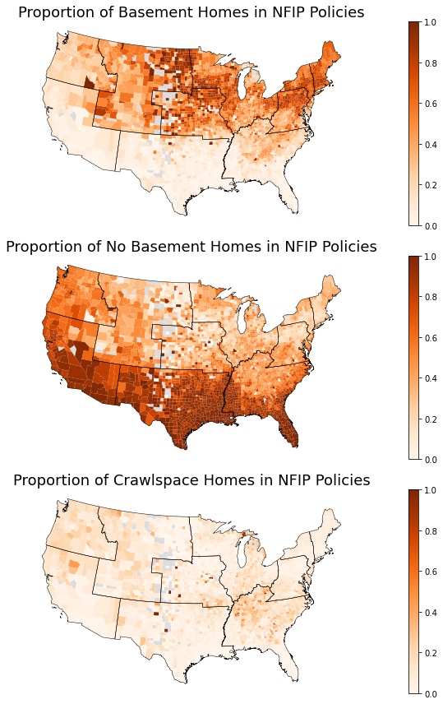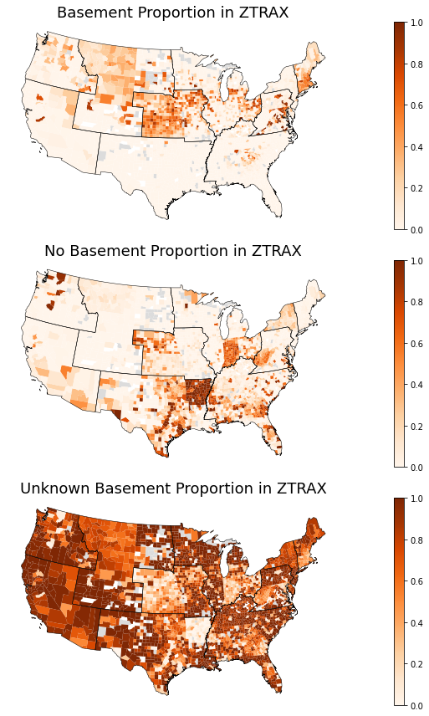

Fig. S7: Structure characteristic data in extrapolation at the property level and in aggregate (See Methods). Proportion of properties with basements in the NFIP policy (ZTRAX) data in the top left (right), with no basements in the NFIP policy (ZTRAX) data in the middle left (right), and with crawl space or unknown type in the NFIP policy (ZTRAX) data in the bottom left (right). The proportions reflected in the maps on the left side are used for properties with unknown basement type.

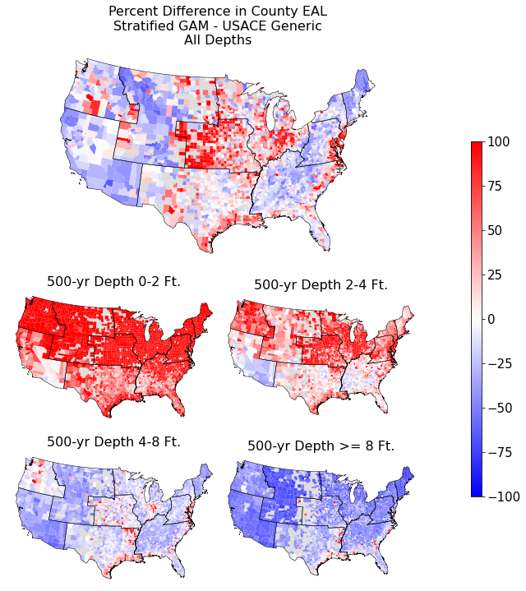
Figure S8: Percent difference in county level expected annual loss for the Stratified GAM damage functions benchmarked to the USACE DDFs for all properties with losses (top), properties with 500-yr depth relative to grade below 2 feet (middle left), between 2 and 4 feet (middle right), between 4 and 8 feet (lower left), and over 8 feet (lower right).

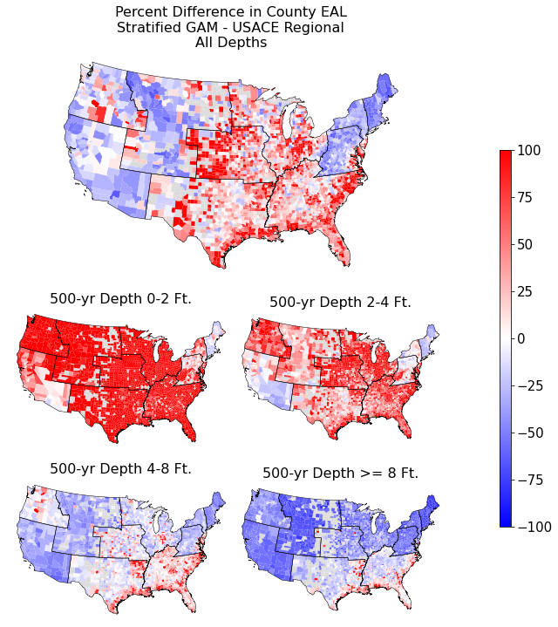

Fig. S9: Percent difference in county expected annual loss for the Stratified GAM damage functions benchmarked to the Generic USACE DDFs for all properties with losses (top), properties with 500-yr depth relative to grade below 2 feet (middle left), between 2 and 4 feet (middle right), between 4 and 8 feet (lower left), and over 8 feet (lower right). FEMA Regions 7-10 apply the Generic USACE DDFs. Grayed out counties indicate no loss observations.

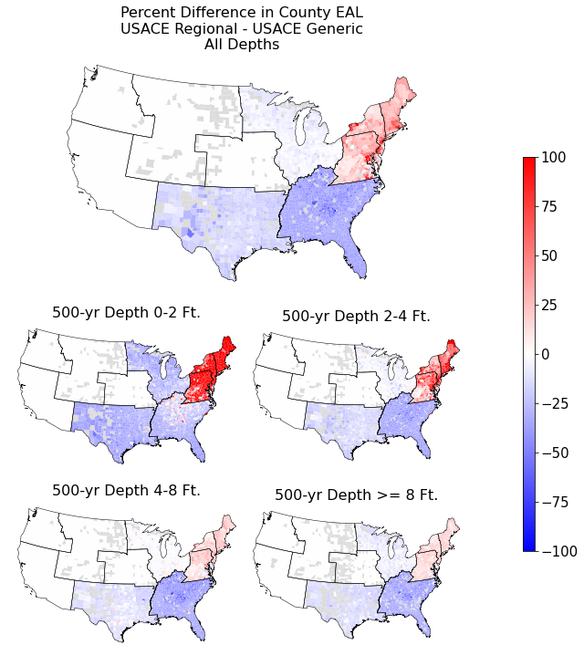

Fig. S10: Percent difference in county expected annual loss for the Regional USACE DDFs damage functions benchmarked to the Generic USACE DDFs for all properties with losses (top), properties with 500-yr depth relative to grade below 2 feet (middle left), between 2 and 4 feet (middle right), between 4 and 8 feet (lower left), and over 8 feet (lower right). FEMA Regions 7-10 apply the Generic USACE DDFs for both.

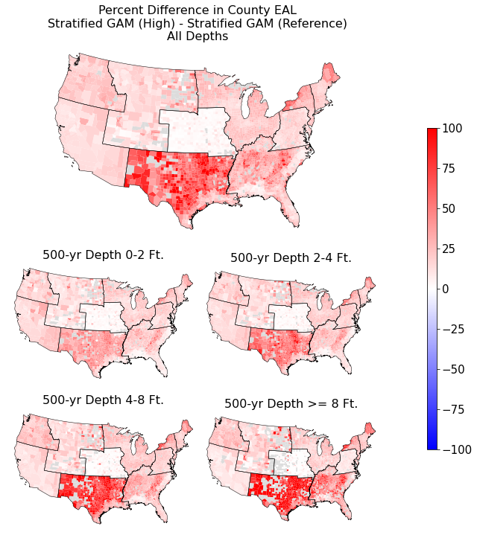
Fig. S11: Percent difference in county expected annual loss for the Stratified GAM damage functions under the high damage scenario benchmarked to the Stratified GAM damage functions under the reference damage scenario for all properties with losses (top), properties with 500-yr depth relative to grade below 2 feet (middle left), between 2 and 4 feet (middle right), between 4 and 8 feet (lower left), and over 8 feet (lower right).

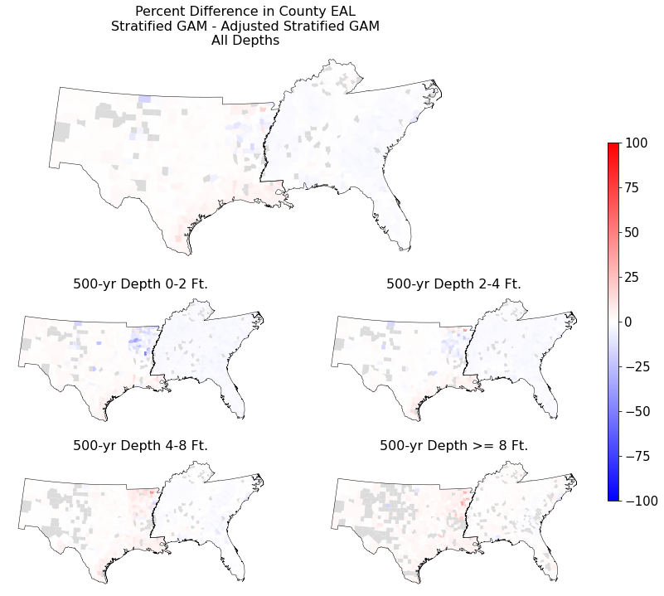

Fig. S12: Percent difference in county expected annual loss for the Stratified GAM damage functions in the main results benchmarked to the Stratified GAM damage functions devised with adjustments for losses from Hurricane Katrina for all properties with losses (top), properties with 500-yr depth relative to grade below 2 feet (middle left), between 2 and 4 feet (middle right), between 4 and 8 feet (lower left), and over 8 feet (lower right).

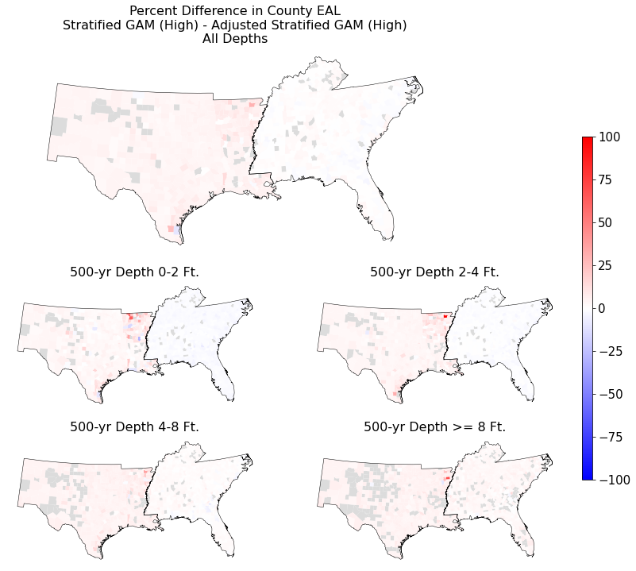
Fig. S13: Percent difference in county expected annual loss for the Stratified GAM damage functions under the high damage scenario benchmarked to the Stratified GAM damage functions devised with adjustments for losses from Hurricane Katrina under the high damage scenario for all properties with losses (top), properties with 500-yr depth relative to grade below 2 feet (middle left), between 2 and 4 feet (middle right), between 4 and 8 feet (lower left), and over 8 feet (lower right).

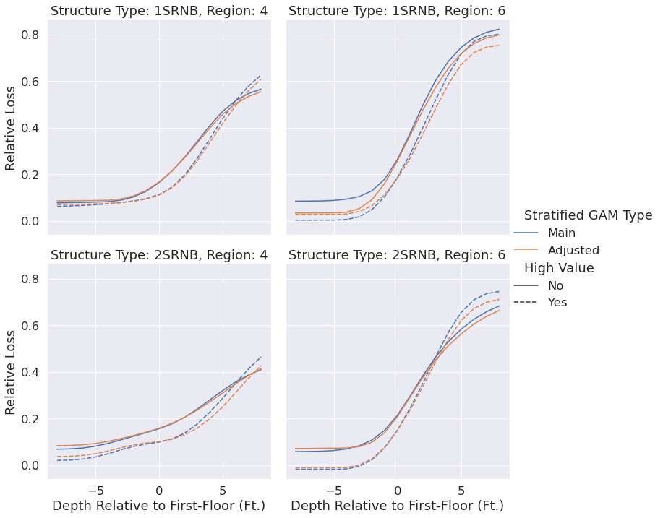

Figure S14: Storm-based Stratified GAMs, main and adjusted for the influence of Hurricane Katrina, plotted by depth, structure type and FEMA Region, limited to regions influenced by Katrina.

Relevant Variable Identified in Literature | Required for a FEMA/USACE  DDF | Empirical Estimation Source | Coverage in NFIP Loss Data | PLACES Source | Coverage in PLACES
Depth | ✔️ | Survey/Modeled (first floor elevation or grade) | High  (Relative to first floor elevation) | Fathom,  First Street  (Modeled) | High  (Relative to grade)
Return Period | ✔️ | Modeled | n/a | Fathom, First Street  (Modeled) | High
Duration |  | Modeled | Low | n/a | n/a
Flow Velocity |  | Survey/Modeled | Low | n/a | n/a
Contamination |  | Modeled | Low | n/a | n/a
Erosion |  | Modeled | n/a | n/a | n/a
Waves |  | Modeled | n/a | n/a | n/a
Number Stories | ✔️ | Survey/Modeled | High | ZTRAX | High
Basement | ✔️ | Survey/Modeled | High | ZTRAX | Low
Building Age | ✔️ | Survey/Modeled | High | ZTRAX | Moderate-High
Foundation Type |  | Survey/Modeled | Low | ZTRAX | Low
Value | ✔️ | Survey/Modeled | High | ZTRAX | Moderate-High
Loss |  | Survey/Appraised/  Modeled | High | n/a | n/a
Construction  Quality |  | Survey/Modeled | n/a | ZTRAX | Low
Square Footage |  | Survey/Modeled | n/a | ZTRAX | Moderate
First Floor Elevation | ✔️ | Survey/Modeled | n/a | n/a | n/a
Mitigation/  Preparedness |  | Survey/Modeled | n/a | FEMA  (Proxies) | High
Note: PLACES flood loss estimation uses aggregate indicators where property level specifications aren’t available (See Methods).

Table S1: Data Constraints on Property Level Hazard and Structures for Damage Functions
Reference | Sample |  | Models Considered in Validation |  |  |  | Validation
Reference | #  Ev. | # Obs.  (K) | Expert  DDF | Depth Only | Interpretable  Multivariate | ML/BN
Merz et al (2013) | 3 | 1 |  | ✔️ |  | ✔️ | 100-fold random CV from all events
Schroter et al (2014) | 3 | 1 |  | ✔️ |  | ✔️ | Train/validation on 1 event with 2/3 train/test split and 2 event hold out tests
Wagenaar et al (2018) | 7 | 6 |  |  |  | ✔️ | Train/test on events from one country to events from other (with some test-country observations allowed in training)
Carisi  et al  (2018) | 1 | 1 | ✔️ | ✔️ |  | ✔️ | Training and testing performance from all data
Amadio et al (2019) | 3 | 1 | ✔️ | ✔️ |  | ✔️ | Training and testing performance from all data
Paprotny et al (2021) | 11 | 7 |  | ✔️ |  | ✔️ | Train on all events and validate on each individual event, then test on two unobserved event
This Study | 446 | 846 | ✔️ | ✔️ | ✔️ | ✔️ | Leave-one-out cross validation for all events
Table S2: Methodological Approaches to Capture Heterogeneity

Notes: DDF = depth-damage function, ML = machine learning, BN = Bayesian network.

Processing Step | Number of Observations Remaining | % of Observations From Previous Filter | Necessary Filter
Raw Data | 2,085,015 | -- | ✔️
Retain single family homes | 1,669,462 | 20% | ✔️
Drop observations without number of stories data | 1,656,126 | .8% | ✔️
Drop observations without basement data | 1,656,103 | <.1% | ✔️
Drop observations with loss date after construction date | 1,401,361 | 15% | ✔️
Drop observations without structure value data | 1,200,682 | 14% | ✔️
Drop observations with damages only to appurtenant structures | 1,099,375 | 8% | ✔️
Drop observations with zero assessed damages | 1,032,973 | 6%
Drop observations whose labeled flood zone isn’t one of the flood zone labels in the NFHL DFIRM database | 1,021,534 | 1%
Drop observations whose zip code and/or county codes can’t be used to assign housing price index deflators to structure value | 1,008,949 | 1%
Drop observations with less than $100 in damage | 1,005,449 | <.1%
Drop observations in the bottom and top 1%-ile of structure values ($8000 and $12,300,000) | 995,780 | 1%
Retain observations with absolute value of water depth <= 8 | 845,776 | 15%
Table S3 Processing steps to NFIP Loss data and the effect on sample size

Domain |  | Variables (selection) |  | Source | PLACES Processing Steps (simplified)
Parcel Boundaries | id, geometry, area, owner name & type, address, parcel number |  | MassGIS  Regrid |  | Re-project, standardize variables, repair geometry, fill gaps, aggregate stacked polygons
Tax Assessor & Transaction Data | sale date, price, buyer & seller, market value, tax valuation, buildings |  | ZTRAX |  | Link to parcels, aggregate, identify arms-length sales, price quality checks
Buildings | number, size of footprint |  | Microsoft US Building Footprints |  | Spatial join
Spatial Reference | county subdivision, census tract, block group, zip code |  | National Historical Geographic Information System (NHGIS) |  | Spatial join
Rivers,  Lakes, HUC8 Boundaries | lake frontage, river frontage |  | National Hydrographic Dataset |  | Buffering, intersections
Flood Zone Boundaries | FEMA flood zone |  | National Flood Hazard Layer |  | Building footprint within flood zone
Flood Zone Building Characteristics | Proportion of basements and stories in flood zones and census tracts |  | National Flood Insurance Policy (NFIP) Open data |  | Intersections, attribute merge
Flood Hazard | flood depths for different return periods and storm proportions |  | First Street Foundation  NOAA Storm Events Database (NCDC) |  | Zonal statistics  Spatial Join
Housing Price Deflators | deflated sales price |  | Federal Reserve Economic Data |  | Link to parcels through 3-digit zip code tabulation area
Depth Damage Functions and Empirical Alternatives | interpolated damage function |  | FEMA  Hazus  NACCS  NFIP Loss Data |  | Link to parcels through building structure data

Table S4: Raw Data Sources and Processing Steps in PLACES

Foundation | Pier/Pile |  | Basement |  | Crawl Space |  | Slab
 | Reference Damage Scenario
FIRM Status | Pre | Post | Pre  4 | Post | Pre  3 | Post | Pre | Post
FFE* Above Grade (ft) | 7 | 8 | Pre  4 | 4 | Pre  3 | 4 | 1 | 1
Adjustment to Depth  Relative to Grade | Depth - FFE* |  | Depth - FFE* |  | Depth - FFE* |  | Depth - FFE*
 | Low Damage Scenario
FFE* Above Grade (ft) | 8 |  | 4 |  | 4 |  | 1
Adjustment to Depth  Relative to Grade | Depth - FFE* |  | Depth - FFE* - 9 |  | Depth - FFE* |  | Depth - FFE*
 | High Damage Scenario
FFE* Above Grade (ft) | 5 |  | 4 |  | 3 |  | 1
Adjustment to Depth  Relative to Grade | Depth - FFE* |  | Depth - FFE* |  | Depth - FFE* |  | Depth - FFE*

Table S5: First-floor elevation assumptions in extrapolation for damage scenarios

