Supp. Fig. 1: ROC curve analysis of group 1

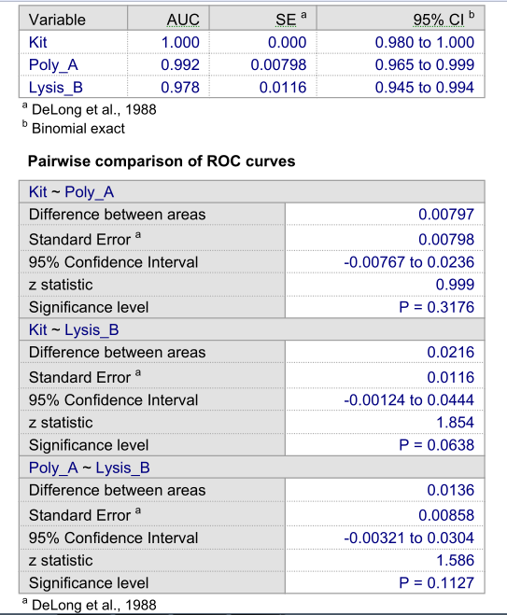

Supp. Figure. 2: ROC curve analysis of group 2

