Supporting Information for
Design of B/N co-doped heterostructural carbon electrodes from CNF/BNNS/ZIF-8 nanocomposites for advanced supercapacitor
Zhen Shang^{a,c,d}, Xingye An^{a,c*}, Liqin Liu^{a,c}, Shuangxi Nie^{b}, Fiona Baker^{c}, Haibing Cao^{e}, Zhengbai Cheng^{e}, Hongbin Liuª, Yonghao Ni^{a,c*}
ª Tianjin Key Laboratory of Pulp and Paper, Tianjin University of Science and Technology, Tianjin 300457, China
^{b} Guangxi Key Laboratory of Clean Pulp & Papermaking and Pollution Control, College of Light Industry and Food Engineering, Guangxi University, Nanning 530004, P. R. China
^{c} Department of Chemical Engineering, University of New Brunswick, Fredericton, NB E3B 5A3, Canada
^{d} Institute of Nuclear and New Energy Technology, Tsinghua University, Beijing 100084, China
^{e} Zhejiang Jing Xing Paper Joint Stock Co., Ltd., No. 1, Jing Xing Industry Zone, Jing Xing First Road, Caoqiao Street, Pinghu, Zhejiang Province, 314214, P. R. China
Corresponding Author E-mail: Xingye An (anxingye@tust.edu.cn); Yonghao Ni (yonghao@unb.ca)

(1) Schematic for the preparation of BNPC from wheat straw fiber, BNNS and ZIF-8 NPs
Fig. S1. Schematic for the preparation of BNPC from wheat straw fibers, BNNS and ZIF-8 NPs
Fig. S1 shows the schematic for the preparation of BNPC from wheat straw bleached fiber based CNF, BNNS and ZIF-8 NPs. CNF was prepared from wheat straw bleached fibers by an integrated approach including enzymatic pretreatment, NaOH pretreatment and high pressure homogenization process, respectively. CNF has a length of several micrometers and a ca. width range of 50 nm to 300 nm. As shown in Fig. S2(c), ZIF-8 NPs have a very uniform dodecahedron shape with a ca. diameter range of 100 nm to 400 nm. BNNS was prepared within CNF dispersion to form CNF/BNNS composites. ZIF-8 NPs were in-situ synthesized in CNF/BNNS composites suspension to form CNF/BNNS/ZIF-8 nanocomposites. Once subjected to carbonization treatment of CNF/BNNS/ZIF-8, BNPC was prepared for supercapacitor electrode, as shown in Fig. S1 and Fig. S2.
(2) SEM images of BNPC and control ZIF-8 samples
Fig. S2. (a) high-resolution SEM image of BNPC-2; (b) SEM image of the side view of BNPC-2; (c) SEM image of ZIF-8 nanoparticles
(3) SEM images of BNPC-2 and the corresponding EDS mappings
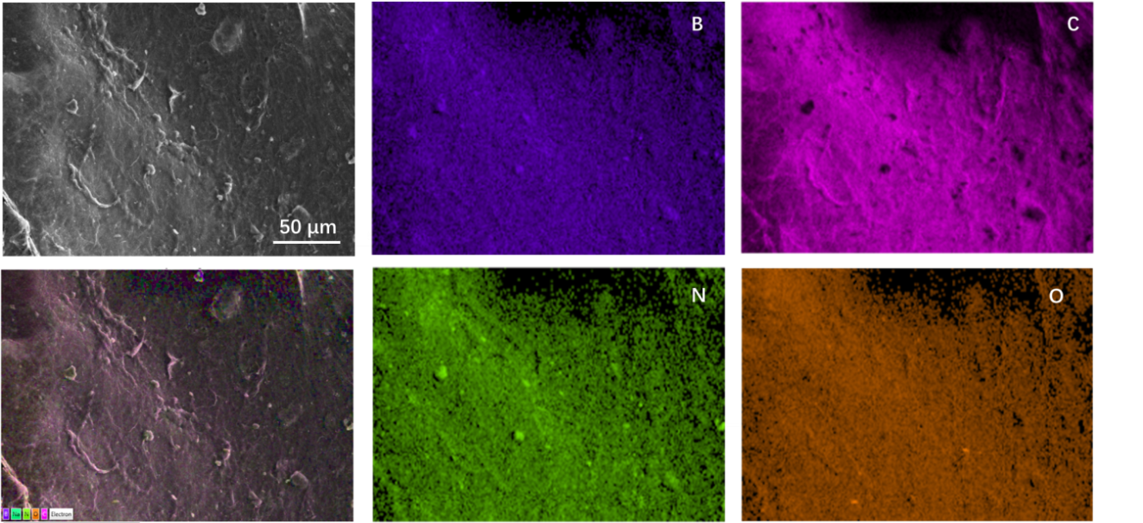
Fig. S3. Images of BNPC-2 and the corresponding EDS mappings

(4) Porosity parameters and the elemental content of carbon, oxide, nitrogen of samples
Table S1. Porosity parameters and the elemental content of carbon, oxide, nitrogen of all carbon samples measured by XPS
Sample | Pore structure parameter |  | Elemental composition
Sample | S_{BET} (m²/g) | V_{pore} (cm³/g) | C (wt%) | O (wt%) | N (wt%) | B(wt%)
NPC | 183.2 | 0.12 | 86.38 | 10.44 | 3.08 | -
BNPC-1 | 400.7 | 0.31 | 80.68 | 9.73 | 6.05 | 3.44
BNPC-2 | 505.4 | 0.40 | 73.98 | 10.38 | 9.81 | 5.53
BNPC-3 | 433.5 | 0.35 | 67.61 | 10.34 | 13.32 | 8.42

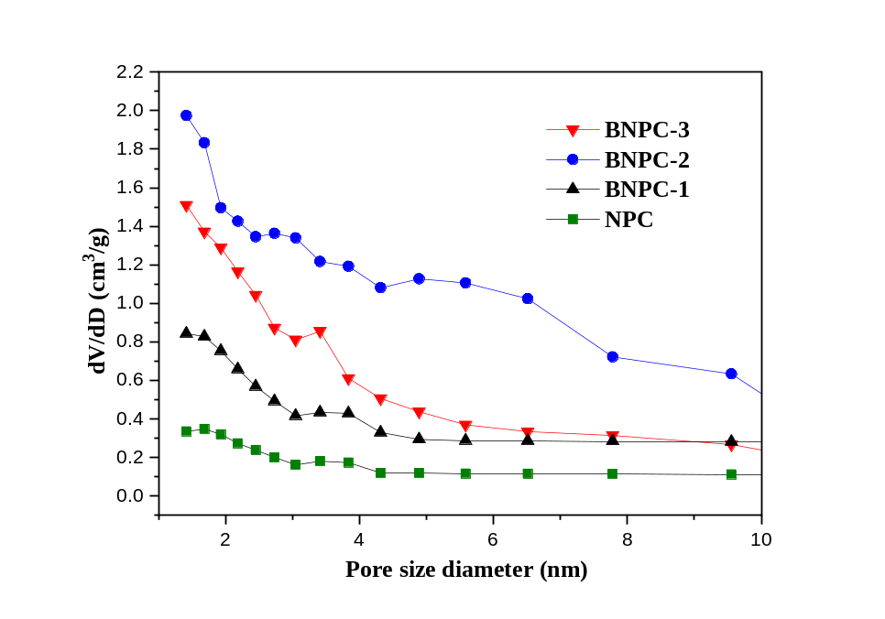
Fig. S4. Pore size distribution NPC, BNPC-1, BNPC-2, BNPC-3 samples.

(5) Electrochemical performance of prepared carbon samples as electrode assembled supercapacitor
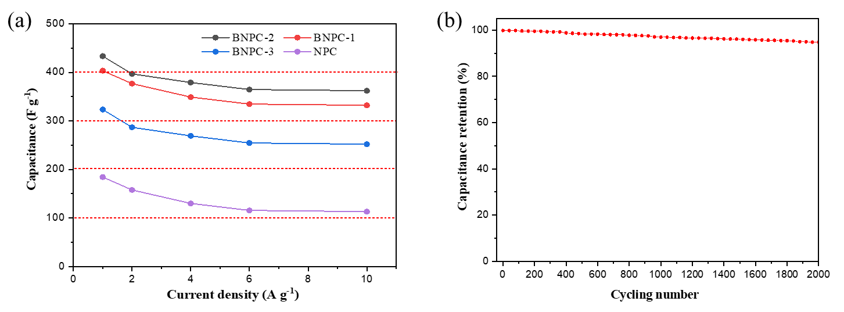
Fig. S5. Electrochemical performance of BNPC and NPC samples as electrode assembled supercapacitor tested in a three-electrode configuration in 6.0 M KOH electrolyte: (a) specific capacity of BNPC and NPC samples calculated from GCD curves at different current densities; (b) the cycling stability of BNPC-2 electrode measured at 1.0 A/g.

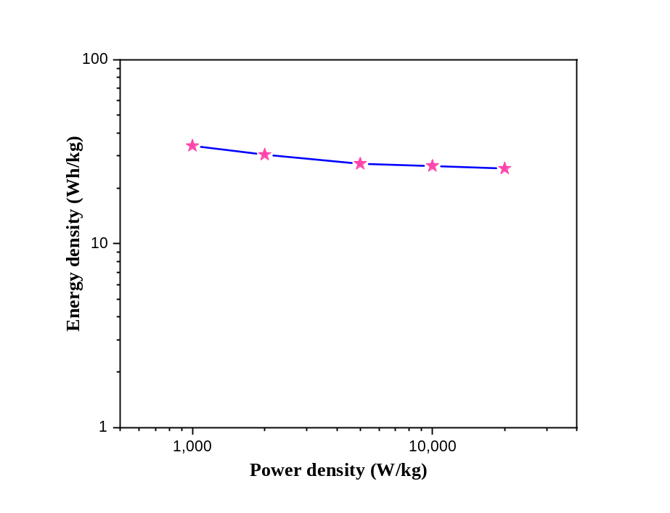
Fig. S6. Ragone plots of BNPC-2 sample-based symmetric supercapacitor with 6 M KOH as electrolyte.
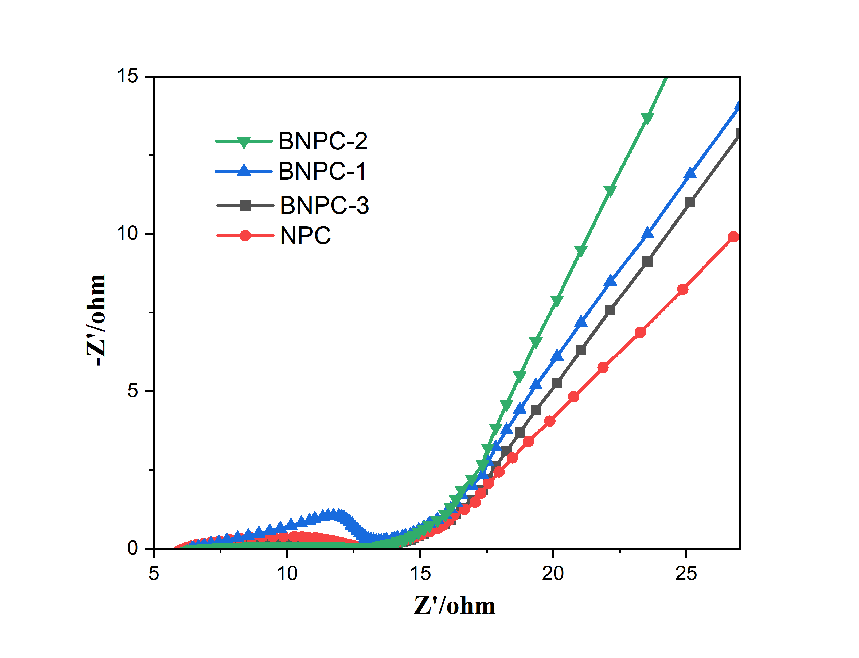
Fig. S7. The corresponding Nyquist impedance plots of BNPC and NPC samples
The EIS curves consist of quasi-semicircular parts at high frequency and linear parts at low-frequency, as shown in Fig. S7. The simulated equivalent circuit is shown in inset, where Rs is the electrode internal resistance, including resistance of the electrolyte and the internal of the electrode, Warburg impedance Zw, is the ion diffusion/ transport at the electrode/electrolyte interface, Rst is the charge transfer resistance in the surface of electrolyte/electrode. Notably, the sample BNPC-2 has the smaller semicircle at high frequencies corresponding to the lower Rs (1.052Ω) , which low internal resistance and good conductivity. At same time, the sample BNPC-2 line at low frequencies exhibited a relatively vertical straight line at low frequencies, reflects the ideal electrical double-layer capacitive behavior and a lower diffusion resistance than others.

Table S2. Comparisons of the specific capacitances with other carbon material electrodes in the previous literature.
Material | Preparation  method | Maximum specific  capacitance (F/g) | Cycling  Stability | Ref.
B/N co-doped  CNF | ZIF-8 activation | 433.4 (1A/g) | 95.01% after  2000 cycles | This work
N doped CNF | ZIF-8/ZnO activation | 394 (1A/g) | 67.3% after  5000 cycles | (Nie et al., 2019)
B/N co-doped hollow cellular carbon | Encapsulation/  Carbonization | 272 (0.1A/g) | Nearly on lose after 2000 cycles | (Fu et al., 2018)
PAN and (ZIF-8) fabricated CNFs | ZIF-8 activation | 295 (0.5A/g) | 94.5 % after  10000 cycles | (Dahal et al., 2019)
B/N co-doped sisal  carbon | Carbonization | 304 (1A/g) | 95.4% after  3000 cycles | (Wu et al., 2019)
Polyaniline supported B/N co-doped graphene | KOH activation | 596 (0.5A/g) | 81% after  5000 cycles | (Liao et al., 2017)
B/N co-doped reduced oxide graphene | Boric acid and ammonium bicarbonate | 350 (0.5A/g) | —— | (Zhu et al., 2019)
B/N-doped carbon | Arc synthesis method | 277 (0.2 A/g) | —— | (Kim et al., 2014)
B/N co-doped carbon nanosheets | Annealing method | 358 (0.1 A/g) | 105% after  10000 cycles | (Ling et al., 2016)

References:
Martelli-Tosi, M., Masson, M., Silva, N. et al., 2018. Soybean straw nanocellulose produced by enzymatic or acid treatment as a reinforcing filler in soy protein isolate films. Carbohydrate Polymers 198(2016) 61-68.
Rezanezhad, S., Nazanezhad, N., Asadpur, G., 2013. Isolation of nanocellulose from rice waste via ultrasonication. Bioresources 2(1) 282-291.
Nehra, P., Chauhan, R.P., 2022. Facile synthesis of nanocellulose from wheat straw as an agricultural waste. Iran Polym J. https://doi.org/10.1007/s13726-022-01040-0
Dahal, B., Mukhiya, T., Ojha, G.P., Muthurasu, A., Chae, S.-H., Kim, T., Kang, D., Kim, H.Y., 2019. In-built fabrication of MOF assimilated B/N co-doped 3D porous carbon nanofiber network as a binder-free electrode for supercapacitors. Electrochimica. Acta 301, 209-219.
Fu, S., Fang, Q., Li, A., Li, Z., Han, J., Dang, X., Han, W., 2018. Fabrication of nitrogen and sulfur co-doped hollow cellular carbon nanocapsules as efficient electrode materials for energy storage. Energy Storage Materials 13, 72-79.
Kim, N.D., Buchholz, D.B., Casillas, G., José-Yacaman, M., Chang, R.P.H., 2014. Hierarchical Design for Fabricating Cost-Effective High Performance Supercapacitors. Adv. Funct. Mater. 24, 4186-4194.
Liao, K., Gao, J., Fan, J., Mo, Y., Xu, Q., Min, Y., 2017. Rod-like polyaniline supported on three-dimensional boron and nitrogen-co-doped graphene frameworks for high-performance supercapacitors. Journal of Nanoparticle Research 19, 397-408.
Ling, Z., Wang, Z., Zhang, M., Yu, C., Wang, G., Dong, Y., Liu, S., Wang, Y., Qiu, J., 2016. Sustainable Synthesis and Assembly of Biomass-Derived B/N Co-Doped Carbon Nanosheets with Ultrahigh Aspect Ratio for High-Performance Supercapacitors. Adv. Funct. Mater. 26, 111-119.
Nie, H., Mi, K., Song, L., Zheng, X., 2019. Nitrogen-doped hierarchical porous CNF derived from fibrous structured hollow ZIF-8 for a high-performance supercapacitor electrode. RSC Advances 9, 40636-40641.
Wu, H., Yuan, W., Zhao, Y., Han, D., Yuan, X., Cheng, L., 2019. B, N-dual doped sisal-based multiscale porous carbon for high-rate supercapacitors. Rsc Advances 9, 1476-1486.
Zhu, T., Li, S., Ren, B., Zhang, L., Dong, L., Tan, L., 2019. Plasma-induced synthesis of boron and nitrogen co-doped reduced graphene oxide for super-capacitors. J. Mater. Sci. 54, 9632-9642.

