Supplementary information for
Deposition of ultra-thin coatings by a nature-inspired Spray-on-Screen technology

Supplementary information S1
Ultrasonic spray coating(USSC) is a R2R compatible technique, which can deposit a uniform thin coating¹ on any substrate with high accuracy, good resolution and very high transfer rate. However, achieving these homogeneous layers for thicknesses below 15nm on large areas possesses extreme difficulties due to the nature of the droplet dynamics. Ultrasonic spray coating utilizes the vibrations produced by the mechanical expansion and contraction of piezoelectric transducers inside the nozzle to atomize the droplet^{2–4}. The atomization produces droplets in the range of 20 - 90µm⁵, which are forced to impinge on the substrate by using a carrier gas (often nitrogen). Here, amongst many properties, the surface tension of the liquid and the surface energy of the substrate play a key role in the formation of an ultra-thin coating. Droplet size and shape when the droplet touches the substrate, determine the regime of wetting. For a very small droplet such as is the case for ultrasonic spray coating the size of which is less than the capillary length 𝑙_{𝑐}=(𝜌𝑔/𝛾)^{1/2}, (where 𝜌 is the density, 𝛾 is the surface tension of the liquid), the effect of surface tension is dominant over gravity. Therefore, the shape of the droplet is found to be a spherical cap for USSC.
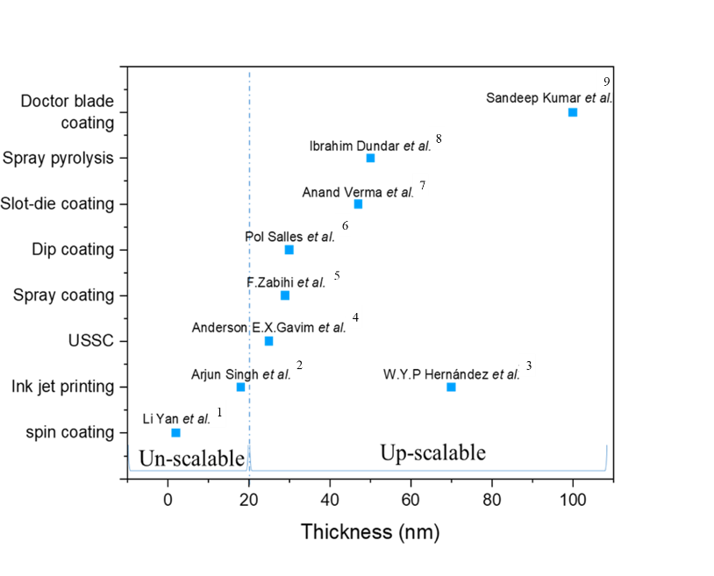
Figure S1 dipicts the regimes of different solution processing techniques in relationship with the scalability and minimal layer thickness as described in the literature.

Figure S1. Minimum achieved thickness and up-scalability of various solution processing techniques
Supplementary information S2
The spray on screen technology is inspired by the hydrophobic behavior of the water striders, which also induces dynamic wetting is shown in the Figure S2
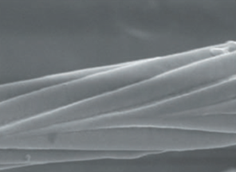
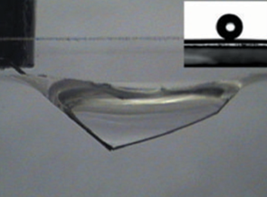
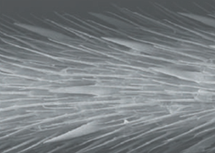
(A) (B) (C)
Figure S2. (A) Scanning electron microscope images of a leg showing numerous oriented spindly macrosetae (B) and the fine nanoscale grooved structures on a seta (C) Typical side view of a maximal-depth dimple just before the leg pierces the water surface. Inset, a water droplet on a leg; this makes a contact angle of 167.6 $±$4.4°. (Image taken from) ⁶
Measurement of the water contact angle on the screen (S 3)
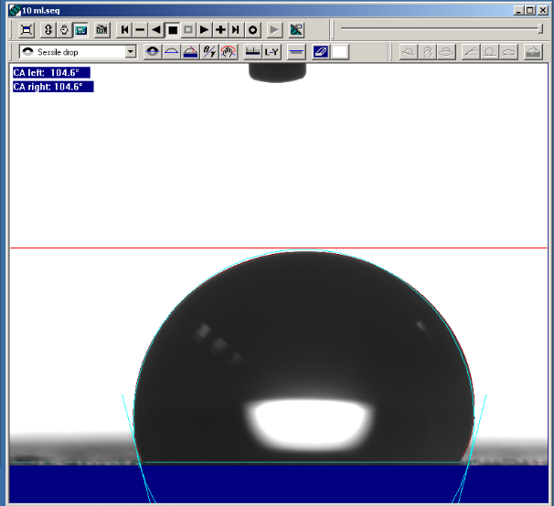
To measure the behavior of the water droplet on the screen mesh, contact angle measurements were done and as can be seen from Figure S3, the screen mesh has a water contact angle of ~104 degrees, which signifies that the screen is hydrophobic in nature. The image was taken on the same mesh screen (Figure 24) with micro-droplets showing the conversion of microdroplets into milli-droplets with an equilibrium contact angle, these droplets are later used to create the thin liquid film over the substrate of interest.

Figure S3. Water contact angle on the screen mesh

Conversion of microdroplets into milli droplets on the screen mesh (S 4)
The microdroplets from the USSC are made to imping on the screen mesh, and irrespective of the surface tension of the formulation being used, the micro droplets get converted in to milli droplets on the screen mesh
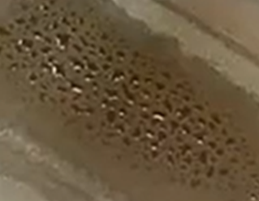

Figure S4. Formation of milli droplets on the mesh upon using water as a solvent to deposit silver nanoparticles

Surface energy calculation (S 5)
For the surface energy measurements by using equilibrium contact angle we have used Fowkes theory⁷. Fowkes theory incorporates the equilibrium contact angle of polar and disperses solutions to determine the overall surface free energy of the substrate Super yellow and ITO substrate. In our experiments, we have used water as a polar component and diiodomethane as a dispersive component. Equilibrium contact angle measurements show a water contact angle of 90 deg and diiodomethane contact angle of 44 deg for super yellow and water contact angle of 10 deg and a diiodomethane contact angle of 26.3 deg for ITO substrates.
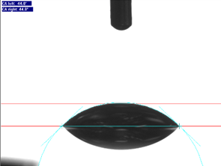
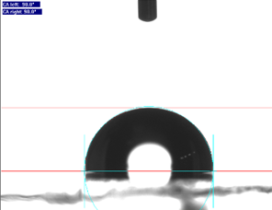
(A) (B)

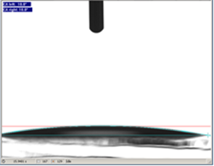
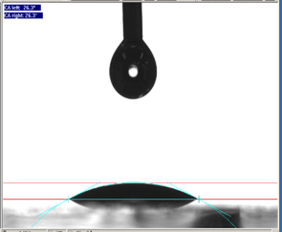
(C) (D)

Figure S5. Contact angle measurements by using (a)(c) Water (polar component) with a contact angle of 90º on SY and the surface tension of 72.8 mN m⁻¹, contact angle of 10º on ITO substrate and (b) (d) Diiodomethane (dispersive component) with a contact angle of 44º on SY and the surface tension value of 50.8 mN m⁻¹, contact angle of 26.3º on ITO substrate
By using the relation given by Fowke’s,
$$γ (dispersive) = \frac{γ_{diiodomethane}{\left(cosθ+1\right)}^{2}}{4}$$
$$γ (polar) = \frac{γ_{water}{\left(cosθ+1\right)}^{2}}{4}$$
$$\left.γ (solid) = γ (dispersive)+ γ (polar\right)$$
where $γ$ is the surface tension. The total surface free energy according to Fowke’s theory was found to be 56 mN m⁻¹. Similarly, the surface energy of the ITO is calculated and it was found to be around 117.37 mN m⁻¹.
The screen on the substrate for a long duration (S 6)
The situation where the screen is made to stay on the substrate for a long time where the deposited formulation evaporated with the screen still on the substrate is shown in Figure S6, as can be seen clearly, there exists a regular pattern of the material deposited, which results due to the accumulation of the deposited materials in the gaps where each thread overlaps with each other.

Figure S6. Regular patterns of the material of interest upon leaving the mesh for a minute

AFM images for the deposited coating (S 7-9)
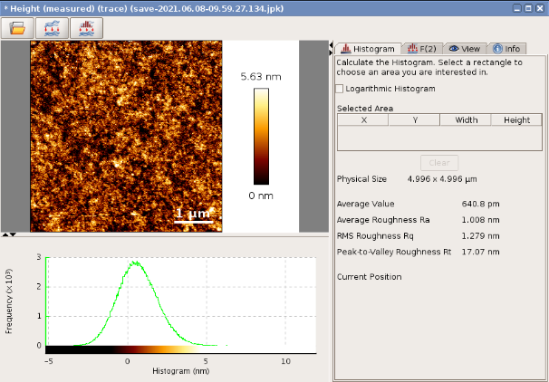
Figure S 7, 8 and 9, shows AFM images for the samples consisting of PEDOT:PSS, PEIE and ZnO-PEIE composite on the substrate of interest. These samples were fabricated by using spin coating as the deposition technique. These are measured as a reference for spray on screen technology.

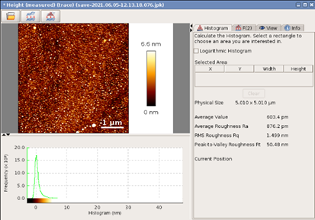
Figure S7. The topographical image of the PEDOT:PSS deposited by spin coating showing average surface roughness of 1.008 nm
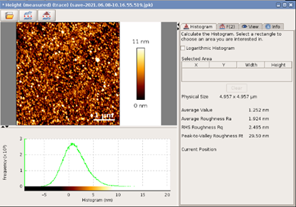
Figure S8. The topographical image of the PEIE deposited by spin coating showing average surface roughness of 0.8 nm

Figure S9. The topographical image of the PEIE+ZnO deposited by spin coating showing average surface roughness of 1.9 nm
Table S1. Thickness variation by Spray-on-Screen for different materials
The versatility of the Spray-on-Screen to tune the thickness of the deposited film by using the optimized parameters of the USSC and the screen mesh, but varying the solution concentration, is demonstrated in Table S 1 for different materials.
Table S1. Thickness variation for different material for varying concentration
Material | 0.01 ml PEIE/35 ml IPA | 0.025 ml PEIE/35 ml IPA | 0.05 ml PEIE/35 ml IPA | 0.07 ml PEIE/35 ml IPA | 0.1 ml PEIE/35 ml IPA
PEIE | 4.8 nm | 10.08 nm | 20.1 nm | 25.6 nm | 38.2 nm

Material | 1 ml PEDOT:PSS/30 ml water | 1 ml PEDOT:PSS/20 ml water | 1 ml PEDOT:PSS/15 ml water | 1 ml PEDOT:PSS/10 ml water | 1 ml PEDOT:PSS/5 ml water
PEDOT:PSS | 15.8 nm | 22.6 nm | 31.9 nm | 38.2 nm | 48.9 nm

Material | 2ml ZnO+0.01 ml PEIE/30 ml IPA | 2ml ZnO+0.01 ml PEIE/20 ml IPA | 2ml ZnO+0.01 ml PEIE/15 ml IPA | 2ml ZnO+0.01 ml PEIE/10 ml IPA | 2ml ZnO+0.01 ml PEIE/5 ml IPA
ZnO+PEIE | 15.3 nm | 21.07 nm | 33.7 nm | 42.5 nm | 57.7 nm

Thickness measured by using AFM (S 10-12)
Figure S 10,11 and 12 shows some of the examples of the measured thickness by AFM. The trench is made by scratching the substrate with a needle⁸. Then the thickness is measured along the trench by using tapping mode AFM. Then a profiling is performed over the scratch 10times, the position of the scratches are shown in the Figure S 10-12. Then with the aid of the average of the 10 profiles we estimated the thickness of the deposited thin film. The 3D topography image taken by the AFM along with the measured correctional average thickness profile helps us visualize the estimation of the thickness measured.
b) show the average of the 10 profiles in the figure and estimate the thickness from this average
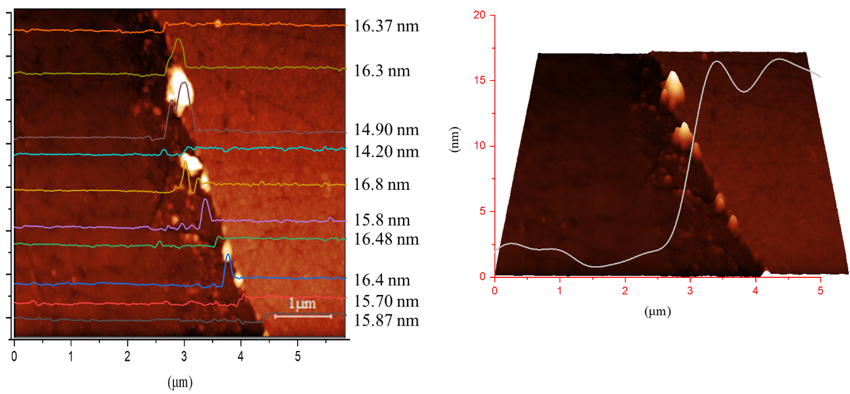
Figure S10. Example of the thickness measured from the AFM on a PEDOT:PSS coated sample showing the average thickness of 15.8 nm
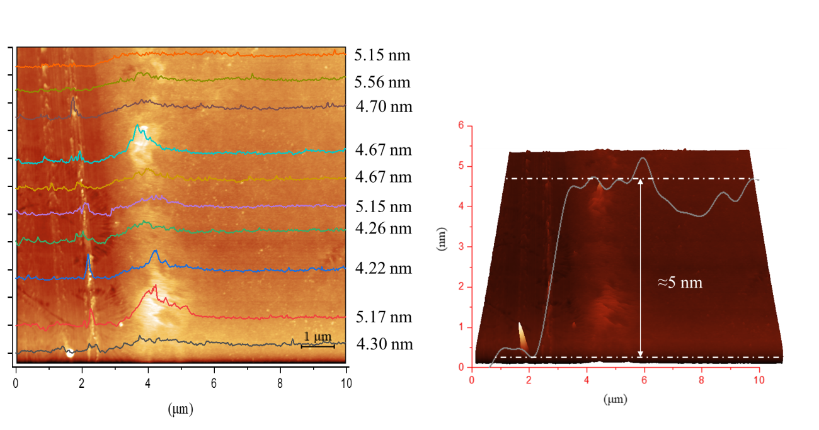
Figure S11. Example of the thickness measured from the AFM on a PEIE coated sample showing the average thickness of 4.8 nm
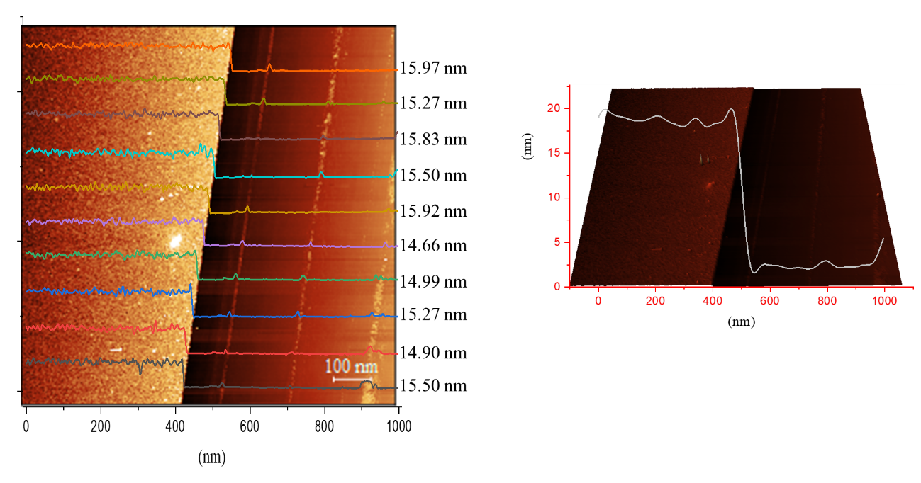
Figure S12. Example of the thickness measured from the AFM on a ZnO + PEIE coated sample showing the average thickness of 15.3 nm

Thickness and surface roughness measured on large 5×5 cm² ITO substrate (S 13 and 14.)
In order to establish the versatility of the spray on screen, the large ITO substrate with area of 25cm² is considered for depositing the PEIE polymer. And the results show that, thickness of 5.9 nm is achieved which is as same as for the small substrate, which shows the upscaling capabilities of the spray on screen. Also the surface roughness is 0.5 nm, which is also similar to the spin coated as well as the small spray on screen coated sample. 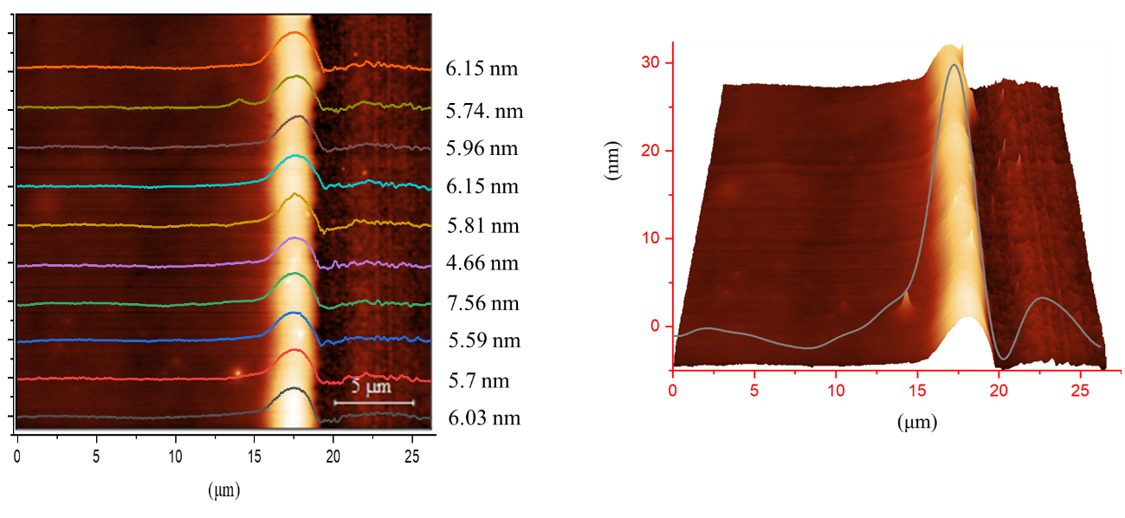
Figure S13. Thickness measurement for the PEIE film over large 5×5 cm² ITO substrate. The obtained thickness of 5.93nm is almost as same as shows the upscalability of the spray-on-screen.
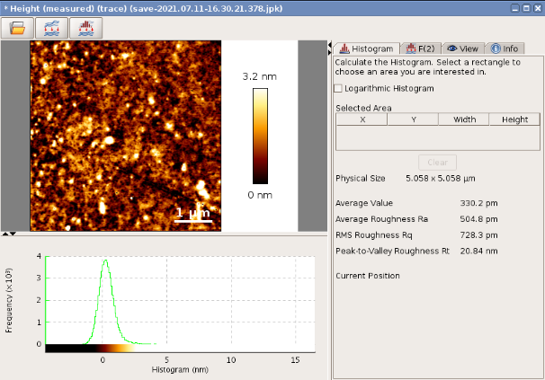

Figure S14. The surface roughness for the PEIE film over a large 5×5 cm² ITO with a surface roughness of 0.5nm
Youngs modulus calculation on the super yellow substrate (S 15,16 and 17)
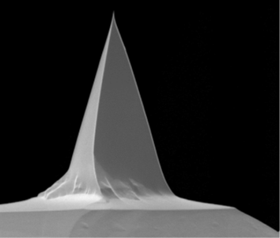
An Au coated tip is used with a tip calibration was done using a clean ultra-flat gold substrate On each region of 10 µm², a grid of 100 points was set and force curves were taken at each of those points applying 2 nN. Young’s modulus was calculated using the data processing software of the AFM applying the Hertz/Snedon model. All measurements were carried out in contact mode in air. The sample for the force spectroscopy was prepared by using a glass substrate following the cleaning protocol and Super yellow (SY) solution is spin coated on the glass substrate. The SY is rotated at 750 rpm for 60 seconds.

Figure S15. Triangular Au coated tip used in the experiments
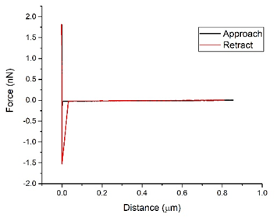

Figure S16. Calibration curve of the Au-tip
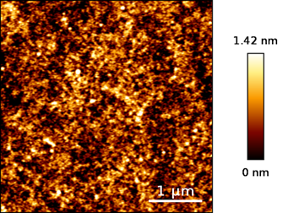
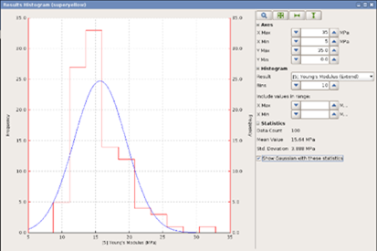
(A) (B)

Figure S17. Calculated Young’s modulus of the super yellow substrate using the data processing software of the AFM applying the Hertz/Snedon model and the surface topography of the scanned region.
OLEDs construction (S18)
The architecture chosen for the present study involves, ITO (135nm) as an anode, PEDOT:PSS (30nm) as an electron injection layer, super yellow (80nm) as an active layer, ZnO-PEIE nanocomposite (~16nm) or calcium (30nm) as an electron inejction layer and finally aluminium (80nm) as a cathode. The prepatterned ITO ssubtrates are thoroughly cleaned at first by ultrasonication and later with UV-Ozone. The ultrasonication involves 30 min in soap solution, 20 min in demineralized water, 10 min in acetone and 10 min in isopropanol alcohol. The ultrasonicated samples are dried by nitrogen gas for 1 min. Later these samples were transferred into a UV-ozone system. For the state-of the-art standard devices, the PEDOT:PSS is spin coated outside the glovebox and transferred into the glovebox where SY is spin coated. For calcium based devices, the samples were transferred into the evaporation chamber where calcium and aluminium are evaporated. For spin coated standard devices, the ZnO-PEIE nanocomposite is spin coated and transferred into the evaporation chamber to deposite aluminium. For spray-on-screen devices, at first PEDOT:PSS is SoS deposited outside the glovebox followed by SY deposition inside the glovebox and later ZnO-PEIE nanocomposite layer is deposited by SoS outside the glovebox. Finally, the devices were transferred into evaporation chamber for the aluminium deposition. All the samples are characterized inside the glovebox. Where the combination of Keithly power source and integrating sphere is used for JVL measurements. An home built silicon photodetector is used for EQE measurements.
Supplementary video 1
Supplementary video 1 shows the formation of microdroplets in the range of <100 μm with the USSC. To capture the slow-motion video of the droplets generated, A high-speed camera, Photron Mini AX100 200 K-M- 32 GB, is mounted together with a bi-telecentric objective,
Thorlabs, X2, MVTC23200, as a reference measurement system is used.
Illumination of the view field is done with a white light source, SCHOTT, KL 2500 LCD, in combination with a telecentric back-light illuminator, Techspec, 52 mm.
Since the velocity of the droplets was high, to capture a precise video, a frame rate of 20,000 frames/second was selected. However, this is done at the expense of a reduction in the field of view for the camera to attain this frame rate. Therefore, in the present experiment, the resolution for a 20 μm particle is almost equal to 4 pixels. The video is slowed down by 2000 times.
The printing parameters for the video captured are Shroud pressure: 1 psi, flow rate of 1.5 ml min⁻¹, nozzle power of 2.5 W, the solvent being used is water.
Supplementary video 2
The supplementary video 2 shows the working principle of SoS technology, where the microdroplets are generated in the nozzle head of USSC, and these microdroplets are made to deposited on the screen mesh. the microdroplets are converted into milli droplets on the screen mesh. This is followed by applying external pressure on the screen where due to capillary force, the liquid is drawn onto the substrate underneath the screen mesh.

Supplementary Video 3
The supplementary video 3 shows the small area and large area OLEDs built by SoS. The OLEDs were lit up by passing the current. The light illumination as well as change in intensity of the light output with respect to the applied potential could be seen. The uniformity of the deposition of the EIL layer on the highly sensitive SY layer over a large area provides a new avenue for the SoS to be used for other application where ultrathin films are crucial.

References:
1. Gavim, A. E. X. et al. Water-suspended MoO3 nanoparticles prepared by LASIS and fast processing as thin film by ultrasonic spray deposition. Sol. Energy Mater. Sol. Cells 200, (2019).
2. Engineering, U. S. & Weldon, P. E. United States Patent (19). (1996).
3. Stephan, I., Bush, G. & Stahley, R. E. United States Patent (19). (2000).
4. Erickson, S. J. et al. (12) Patent Application Publication (10) Pub. No.: US 2008/0314314 A1. 1, (2008).
5. Verding, P., Deferme, W. & Steffen, W. Velocity and size measurement of droplets from an ultrasonic spray coater using Photon Correlation Spectroscopy and Turbidimetry. arXiv 59, 7496–7503 (2020).
6. Xuefeng, G. & Lei, J. Water-repellent legs of water striders. Nature 432, 2004–2004 (2004).
7. Fowkes, F. M. ATTRACTIVE FORCES AT INTERFACES. Ind. Eng. Chem. 56, 40–52 (1964).
8. Ton-That, C., Shard, A. G. & Bradley, R. H. Thickness of spin-cast polymer thin films determined by angle-resolved XPS and AFM tip-scratch methods. Langmuir 16, 2281–2284 (2000).

