Supporting information for
Spatial distribution characteristics and ecological assembly process of bacteria and aerobic anoxygenic photosynthesis bacteria in Three Gorges Reservoir

Lixin Huo^{a, b, c, d}, Anran Ma^{a, b, c, e}, Hong Liu^{a, b, c, d} *, Xingzu Wang^{a, b, c, d} *, Cheng Song ^{a, c}

ª Chongqing Institute of Green and Intelligent Technology, Chinese Academy of Sciences, Chongqing, 400714, China
^{b} Chongqing School, University of Chinese Academy of Sciences, College of Resources and Environment, Chongqing, 400714, China
^{c} Key Laboratory of Reservoir Aquatic Environment, Chinese Academy of Sciences, Chongqing, 400714, China
^{d} University of Chinese Academy of Sciences, Beijing, 100049, China
^{e} Chongqing Jiaotong University, Chongqing, 400074, China

* Corresponding author: No. 266 Fangzhen Avenue, Shuitu High-Tech Park, Beibei, Chongqing 400714, China.
E-mail address: liuhong@cigit.ac.cn (H. Liu), wangxingzu@cigit.ac.cn (X. Wang)
Text S1. The PCR amplification and sequencing of 16S rRNA and pufM gene
The primer pairs for 16S rRNA gene were: 515F (5'-GTGCCAGCMGCCGCGG-3')/907R (5'- CCGTCAATTCMTTTRAGTTT -3') [1, 2]. The PCR mixtures contain 5 × TransStart FastPfu buffer 4 μL, 2.5 mM dNTPs 2 μL, forward primer (5μM) 0.8μL, reverse primer (5 μM) 0.8μL, TransStart FastPfu DNA Polymerase 0.4μL, BSA 0.2μL, template DNA 10 ng, and finally ddH₂O up to 20μL. The PCR amplification of 16S rRNA was performed as follows: initial denaturation at 95 ℃ for 3 min; followed by 27 cycles of denaturing at 95 ℃ for 30 s, annealing at 55 ℃ for 30 s and extension at 72 ℃ for 45 s, and single extension at 72 ℃ for 10 min.
The primer pairs for pufM gene were: pufM-557F (5`-CGCACCTGGACTGGAC-3`)/pufM-WAWR (5`- AYNGCRAACCACCANGCCCA -3`) [3, 4]. The PCR mixtures contain 5 × TransStart FastPfu buffer 4 μL, 2.5 mM dNTPs 2 μL, forward primer (5 μM) 0.8 μL, reverse primer (5 μM) 0.8 μL, TransStart FastPfu DNA Polymerase 0.4 μL, BSA 0.2 μL, template DNA 10 ng, and finally ddH₂O up to 20 μL. The PCR amplification of 16S rRNA was performed as follows: initial denaturation at 95 ℃ for 3 min; followed by 40 cycles of denaturing at 95 ℃ for 30 s, annealing at 40 ℃ for 30 s and extension at 72 ℃ for 45 s, and single extension at 72 ℃ for 10 min.
PCR products were extracted from 2% agarose gels and purified, and then measured by a Quantus™ Fluorometer (Promega, USA). According to the standard protocol of Majorbio Bio-Pharm Technology Co. Ltd (Shanghai, China), the purified amplicons were pooled in equimolar concentration on the Illumina Miseq PE300 platform (Illumina, San Diego, USA), and high-throughput sequencing was performed at the paired end.
Text S2. Processing of sequencing data
The raw 16S rRNA and pufM gene sequencing reads were demultiplexed, quality-filtered by Fastp version 0.20.0 [5] and merged by Flash version 1.2.7 [6] with the following criteria: (i) the 300 bp reads were truncated at any site receiving an average quality score of < 20 over a 50 bp sliding window, and discarding the truncated reads shorter than 50 bp and ambiguous characters of reads; (ii) only overlapping sequences longer than 10 bp were assembled. Reads that could not be assembled were discarded; (iii) Samples were distinguished by according to the barcode and primers, and the sequence direction was adjusted, exact barcode matching, two nucleotide mismatch in primer matching. Operational Taxonomic Units (OTUs) with 97% similarity cutoff were clustered using UPARSE version 7.1, and chimeric sequences were identified and removed.

Text S3. The qPCR of pufM gene
The assay mixture contained 2× ChamQ SYBR Color qPCR Master Mix 10 μL, 0.8 μL of forward and reverse primer (5 μM), 50× ROX Reference Dye 1 0.4 μL, 2 μL of template DNA, and 6 μL of ddH₂O. Thermal cycling conditions for the pufM gene were as follows: an initial cycle of 95 ℃ for 3 min; followed by 40 cycles of denaturing at 95 ℃ for 5 s, annealing at 58 ℃ for 30 s and extension at 72 ℃ for 60 s.

Text S4. The null model analysis
For null model analysis, the process governing community assembly was identified based on the βNTI and Raup-Crick metric (RC). The fraction of pairwise comparisons with βNTI > 2 was considered as the percentages of heterogeneous selection, whereas those with βNTI < -2 as the percentages of homogeneous selection, both these selections are deterministic processes. Next, taxonomic diversity metric RC was used to partition the remaining pairwise comparison with |βNTI| ≤ 2. |βNTI| ≤ 2 is belonged to stochastic processes, which could be classified into 3 ecological processes: homogenizing dispersal (RC < 0.95), dispersal limitation (RC > 0.95) and ecological drift (|RC| ≤ 0.95).
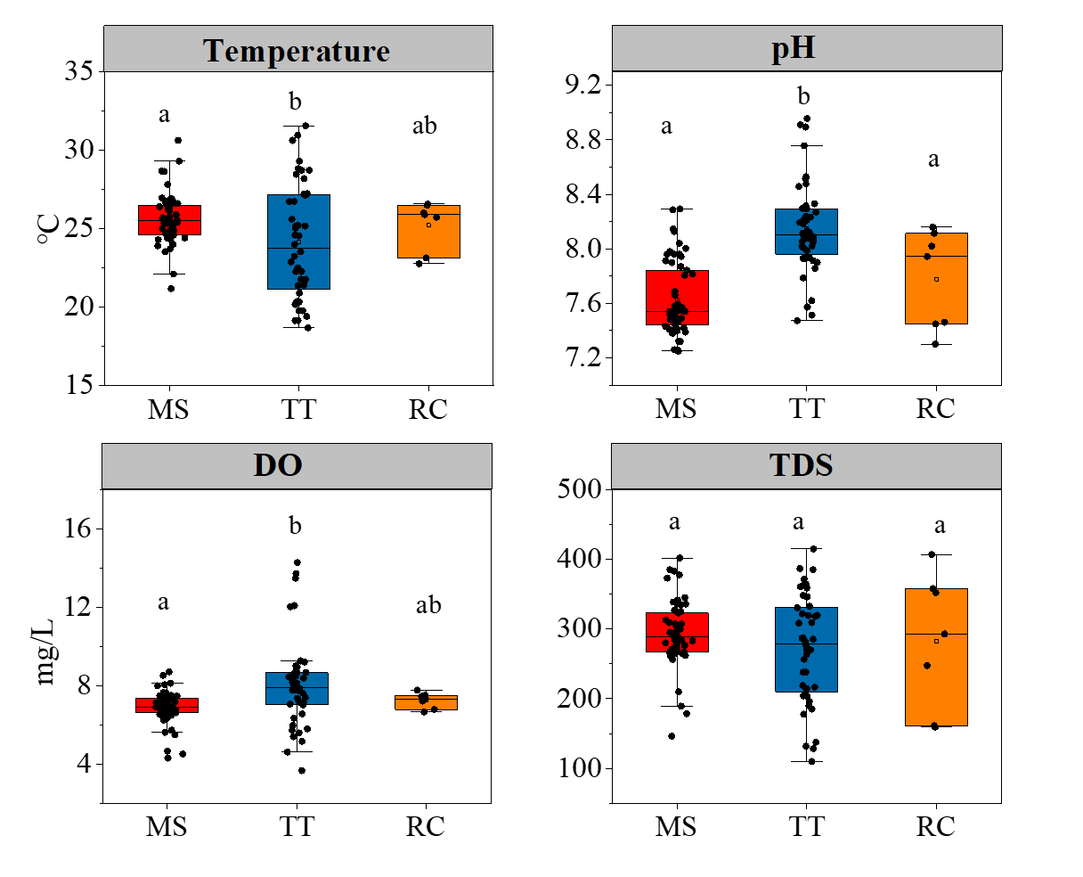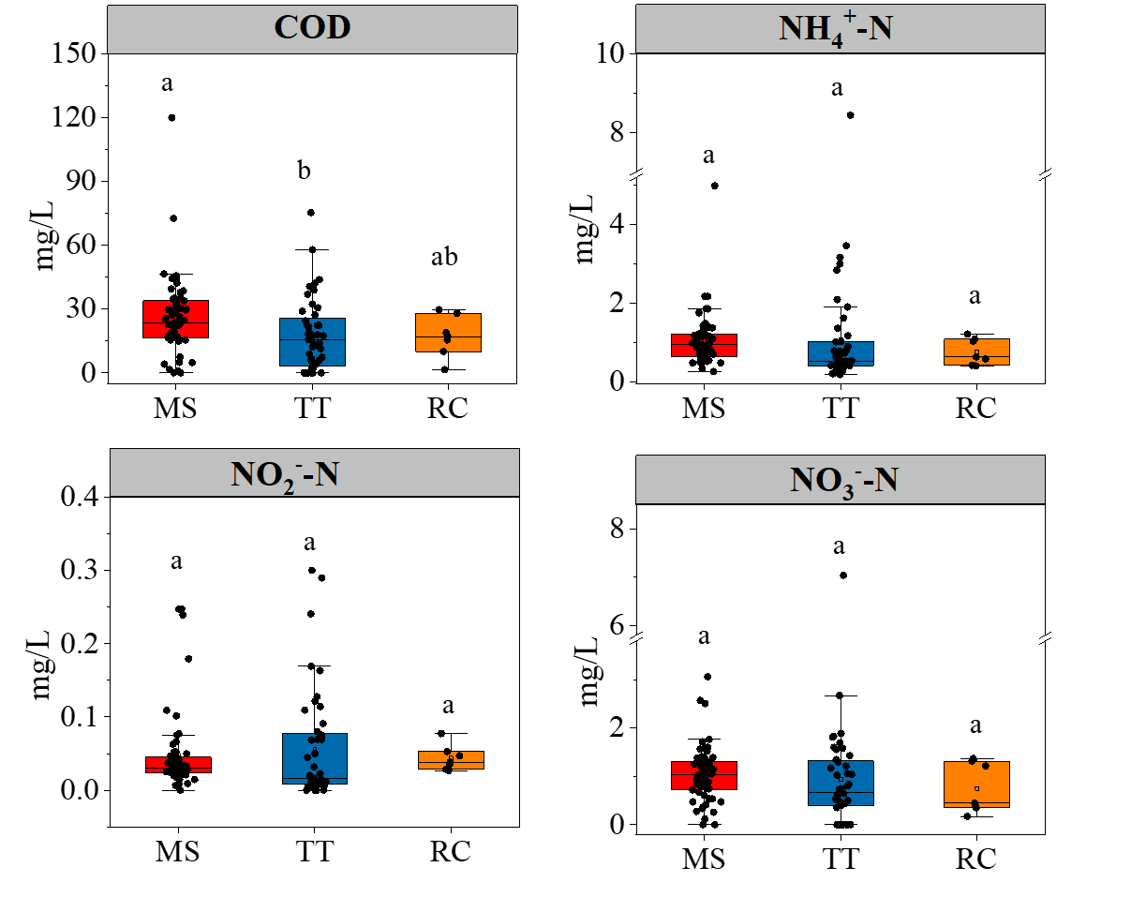
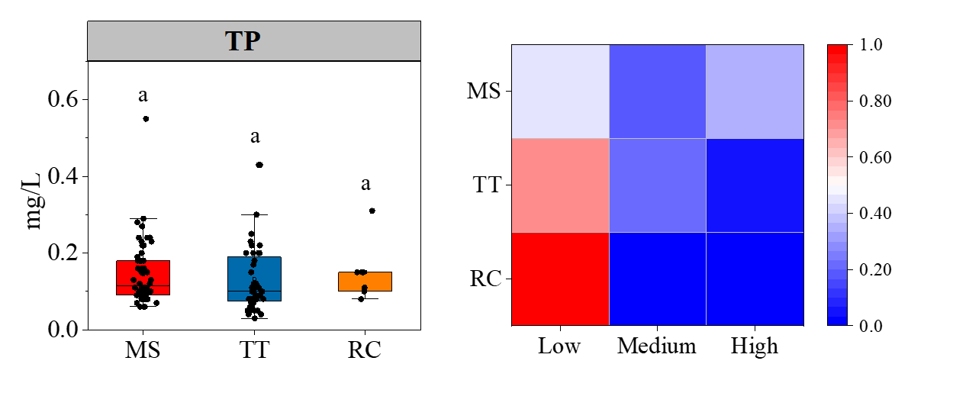
Fig S1. Water quality parameters of sampling points and living conditions of population. Low, no houses nearby; Medium, sporadic houses; High, towns. (n=109) Different lowercases letters above each box in the same subfigure represent significant differences between areas (p < 0.05).
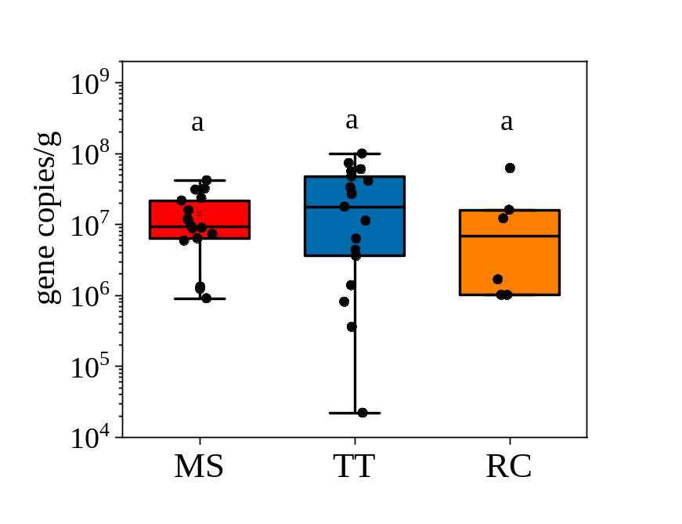
Fig S2. The qPCR of AAPB in sediment of the TGR. Different lowercases letters above each box in the same subfigure represent significant differences between areas (p < 0.05).
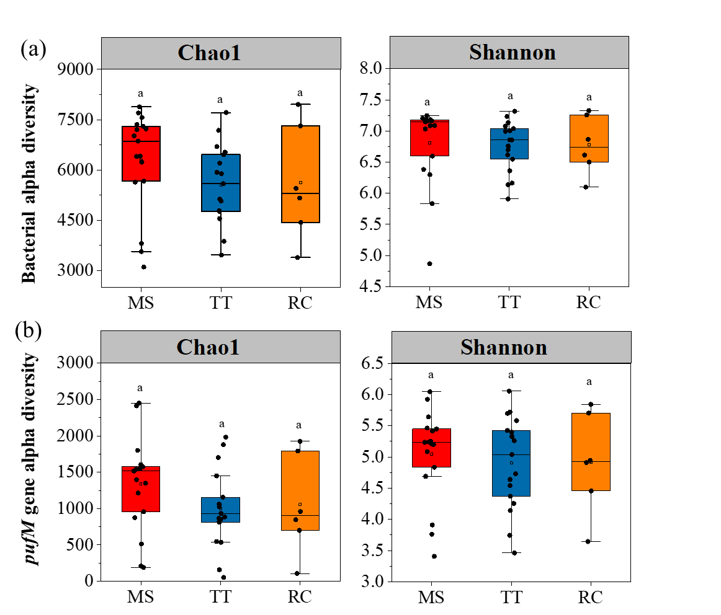
Fig S3. Differences in alpha diversity indices of bacterial and AAPB communities among different regions in the Three Gorges Reservoir. Different lowercases letters above each box in the same subfigure represent significant differences between areas (p < 0.05).
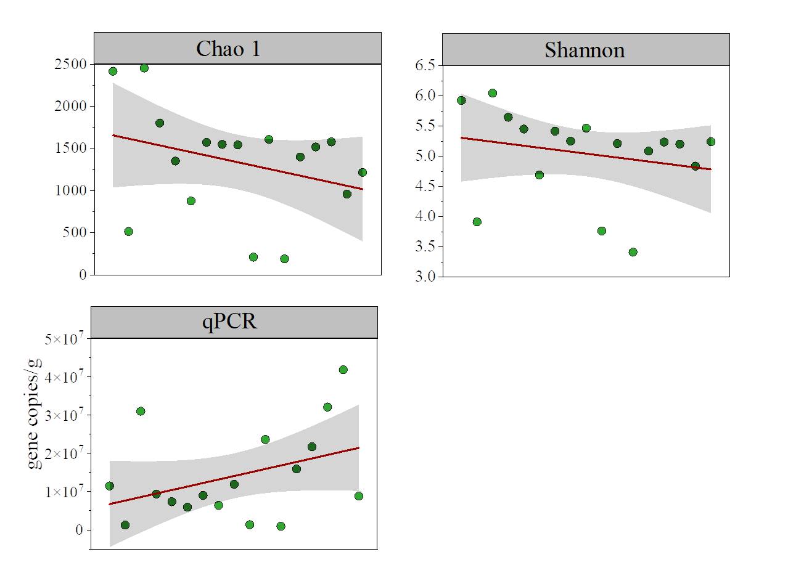
Fig S4. The biodiversity indices and qPCR of pufM gene changed from upstream to downstream in the mainstream.
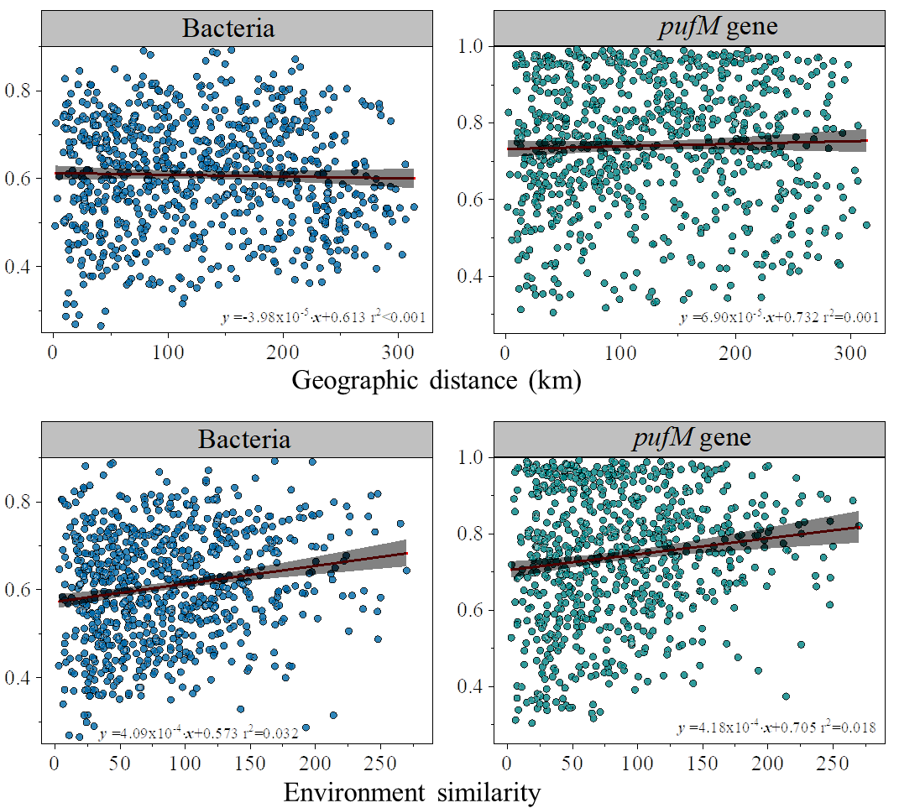
Fig S5. Linear regression of environmental similarity based on Euclidean distance and geographic distances with the similarities of bacterial and pufM gene communities based on Bray-Curtis distance between each two samples from the sediment.
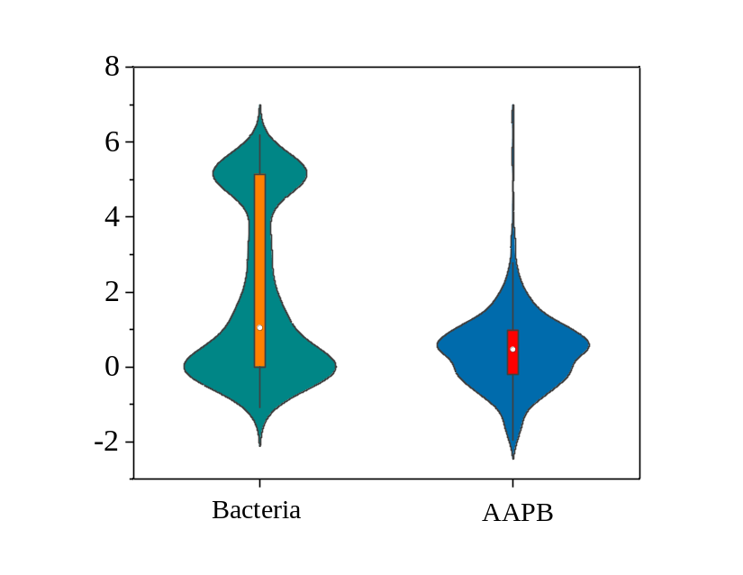
Fig S6. βNTI of bacterial and AAPB community in sediments of TGR.
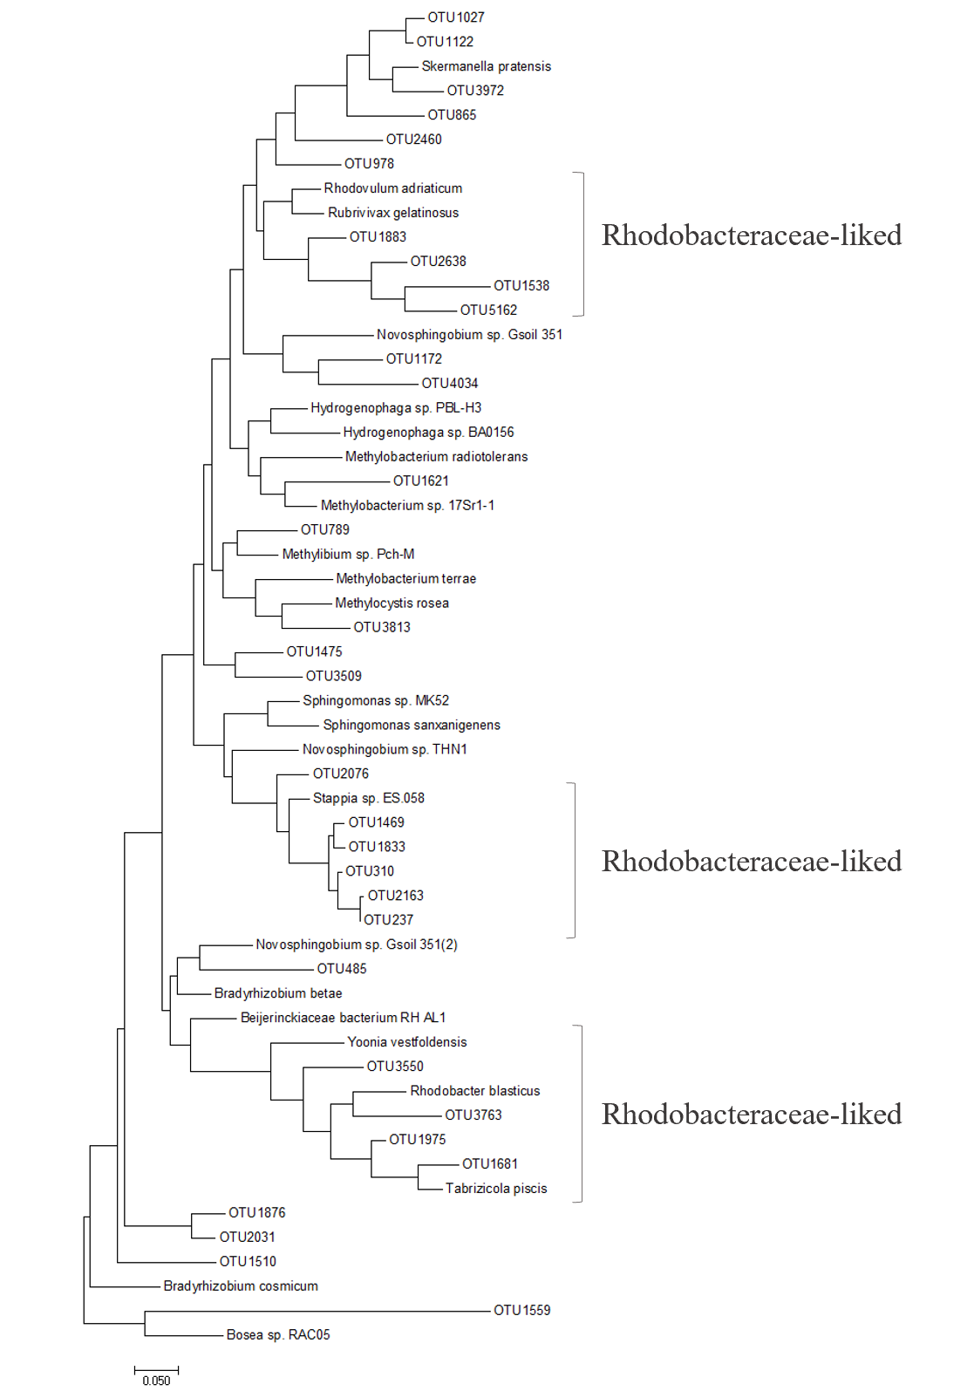
Fig S7. Molecular Phylogenetic analysis of pufM gene in sediment by Maximum Likelihood method.
Table S1. Statistics of 16S rRNA gene and pufM gene sequencing
 | Bacteria | AAPB
Sample numbers | 40 | 40
Total count | 2209318 | 899047
Min | 30512 | 11938
Max | 88364 | 46880
Median | 53940 | 20815
Mean | 55233 | 22476
Std.dev | 17418 | 6966
Min-length | 201 | 200
Max-length | 544 | 264
Mean-length | 381 | 230

Table S2. Statistics of taxonomy annotation
 | Bacteria | AAPB
Phylum | 67 | 11
Class | 202 | 16
Order | 481 | 34
Family | 796 | 54
Genus | 1560 | 107
OTU | 13874 | 5438

References
- Liu T, Zhang AN, Wang JW, Liu SF, Jiang XT, Dang CY, Ma T, Liu ST, Chen Q, Xie SG, Zhang T, Ni JR (2018) Integrated biogeography of planktonic and sedimentary bacterial communities in the Yangtze River. Microbiome 6: 1-14.
- Wang F, Li WY, Li Y, Zhang JP, Chen JP, Zhang W, Wu X (2018) Molecular analysis of bacterial community in the tap water with different water ages of a drinking water distribution system. Front. Environ. Sci. Eng. 12.
- Bibiloni-Isaksson J, Seymour JR, Ingleton T, van de Kamp J, Bodrossy L, Brown MV (2016) Spatial and temporal variability of aerobic anoxygenic photoheterotrophic bacteria along the east coast of Australia. Environ. Microbiol. 12: 4485-4500.
- Zhang HH, Wang Y, Huang TL, Wang CX, Lu LC, Si F, Li N, Liu KW, Yan MM, Miao YT (2020) Spatial and temporal succession characteristics of aerobic anoxygenic photosynthesis bacteria in a stratified reservoir. Environmental Sci. (China) 41: 2188-2197.
- Chen SF, Zhou YQ, Chen YR, Gu J (2018) Fastp: An ultra-fast all-in-one FASTQ preprocessor. Bioinformatics 34: i884-i890.
- Magoč T, Salzberg SL (2011) FLASH: Fast length adjustment of short reads to improve genome assemblies. Bioinformatics 27: 2957-2963.

