Supplementary Figures

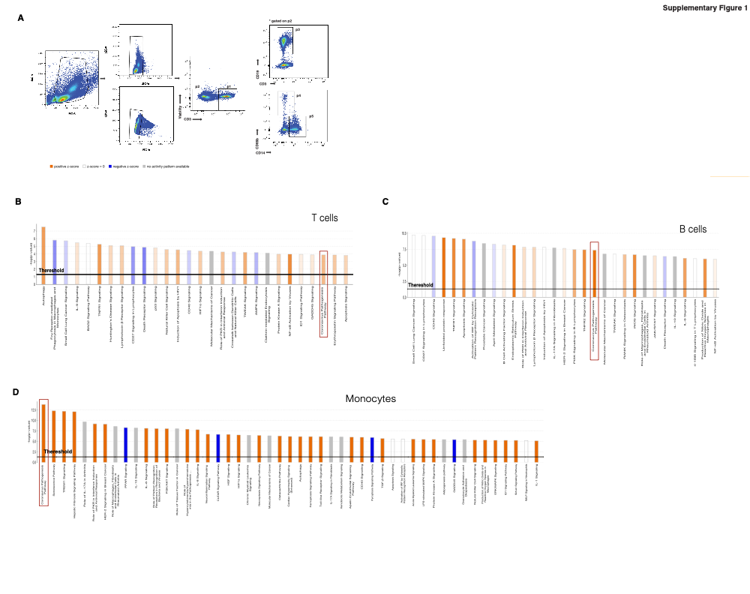
Supplementary Figure 1. Gating strategy for RNA-sequencing and Ingenuity Pathway Analysis. A) Gating strategy for cell sorting: bulk RNA-seq (Smart-Seq2) and 10x single cell RNA-seq. PBMCs were stained with viability dye, CD3, CD19, CD66b and CD14 and FACS-sorted. Cells were gated on singlet+ Live+ cells. P1 (CD3⁺), P3 (CD19⁺) and P5 (CD14⁺) were gated on P2, CD3⁻. B-D) Ingenuity Pathways Analysis on DEG genes (p<0.05) of comparisons between healthy volunteers and COVID-19 subjects in CD3⁺ T cells (B), CD19⁺ B cells (C) and monocytes (D). N=7 healthy volunteers (HV), N=8 untreated controls and N=8 Foralumab treated.

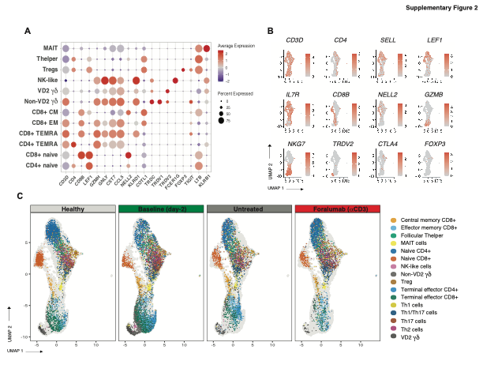
Supplementary Figure 2. T cell subtyping. A) Canonical cell markers for T cell subsets. B) UMAP plots of T cells showing localization of CD3⁺ cell subset markers. C) CD3+ subsets including T helper stratification into Th1, Th2 and Th17 subsets.

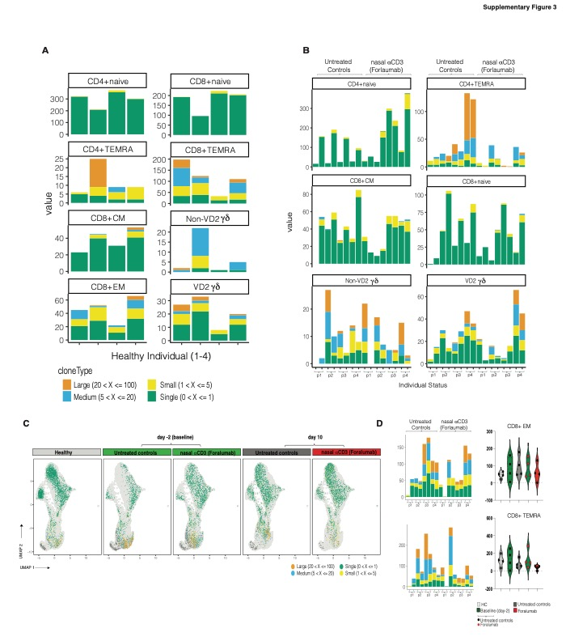
Supplementary Figure 3. TCR sequencing in Foralumab treated subjects. A, B) TCR sharing patterns of specific T cell subsets by comparing usage of V(D)J genes on healthy controls (A), untreated controls vs. Foralumab treated subjects (B). C) Distribution within UMAP plots of T cells subsets. D) Violin plots showing the frequency of clonal T cells in CD8⁺ TEMRA and CD8⁺ CM cells (Median+IQR). Graphs show percentage of each clonal type and individual status. 4 healthy volunteers, 4 untreated controls (before and after) and 4 Foralumab treated subjects (before and after) were studied.

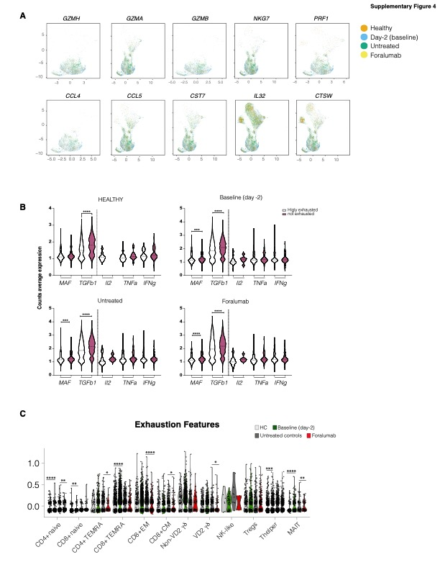Supplementary Figure 4. Effector gene cluster and exhaustion modules in CD3+ T cells. A) UMAP plots of T cells showing localization of effector genes in CD3+ cells across treatment. B) Exhausted score of >0.01 was used to determinate highly exhausted cells and compared to low/not exhausted cells (<0.01). MAF, TGFB1, IL2, TNFa and IFNg gene expression in exhausted and not exhausted cells is compared and shown in Violin-plots (Median+IQR). C) Distribution of exhaustion score within UMAP plots of CD3+ T cells subsets in in healthy controls, untreated COVID19 subjects and Foralumab treated subjects at baseline (day-2) and at day 10. Violin plots (Median+IQR) with individual points is shown. HC= healthy controls. One-way ANOVA, followed by Tukey post hoc analysis was performed and comparison between healthy vs. day-2 and untreated vs Foralumab is shown. * P < 0.05, ** P < 0.01, *** p<0.001, **** P < 0.001.

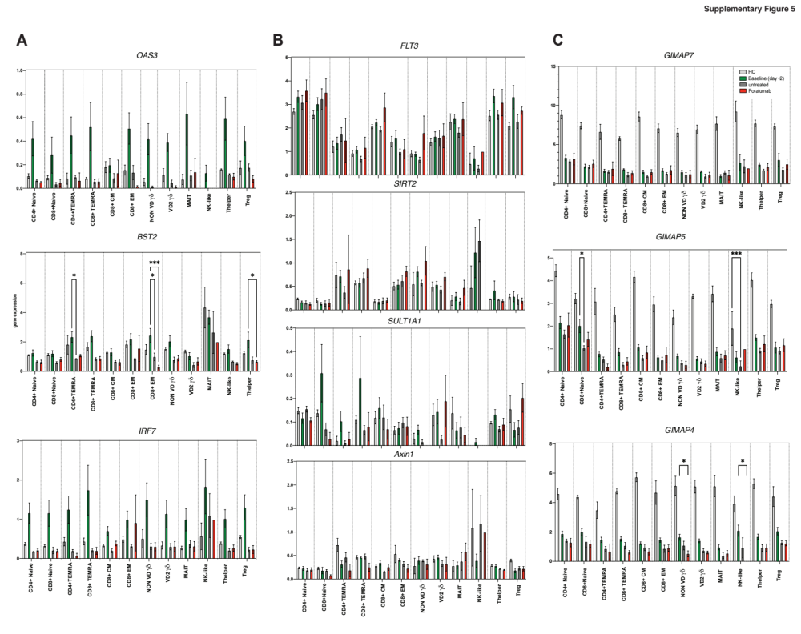

Supplementary Figure 5. Exploratory analysis of sc-RNAseq dataset. A) Expression of selected genes within coronavirus pathogenesis found in bulk RNA-seq analysis in CD3⁺ subsets identified in the sc-RNA-seq in healthy controls, baseline (day-2) and follow up untreated and Foralumab treated subjects. B) Corresponding genes of serum proteins found to be modulated by Foralumab. C) GIMAP7/5/4. Bars (mean+SEM). One-way ANOVA, followed by Tukey post hoc analysis was performed. * P < 0.05, *** P < 0.001. 4 healthy volunteers, 4 untreated controls (before and after) and 4 Foralumab treated subjects (before and after) were studied. HC= healthy controls.

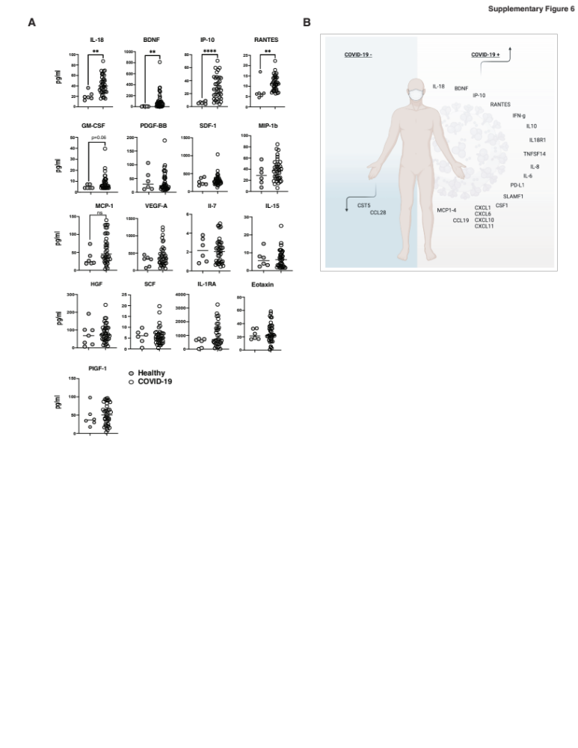Supplementary Figure 6. Serum markers altered by COVID-19 detected by proteomics. A) Comparison between healthy volunteers and COVID-19 subjects. Dots are individual values, bars represent mean+SEM. Student’s t test. Healthy = healthy controls. COVID-19 refers to all COVID-19 subjects at baseline (day-2). **p < 0.01, **** P < 0.001. B) Resume of up and downregulated serum markers obtained by Olink.

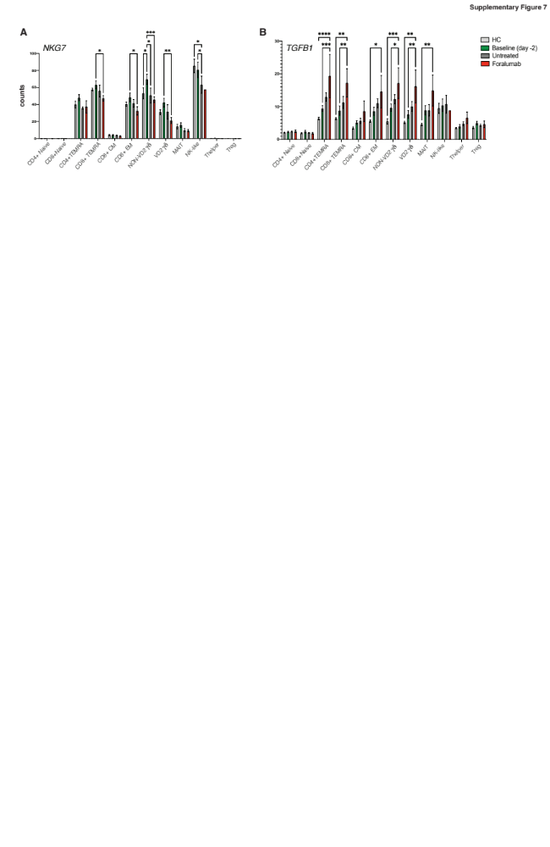
Supplementary Figure 7. NKG7 and TGFB1 counts in CD3+ subsets A, B) NKG7 and TGFB1 counts in CD3+ subsets in healthy controls, untreated and Foralumab treated COVID-19 subjects at baseline (day-2) and at day 10. NKG7 (A) and TGFB1 (B). Bars represent mean+SEM. One-way ANOVA followed by Tukey post hoc analysis ** p<0.01. * P < 0.05, ** P < 0.01, **** P < 0.001.

