Appendix
Four week Task Specific Functional Exercises
First week (Simple movements)
- Improve shoulder flexion and abduction
  - Hands are holding on the abdomen (freely) and ask him to lean forward. The gravity will assist the movement, rocking anterior posterior direction and sideways (sitting)
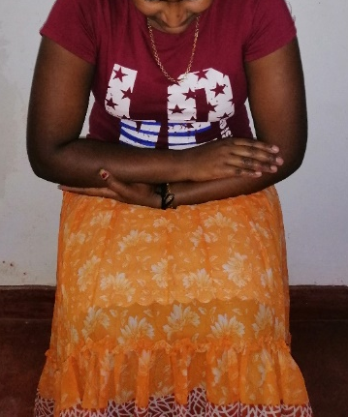  Figure 4a: Gravity assisted shoulder flexion | 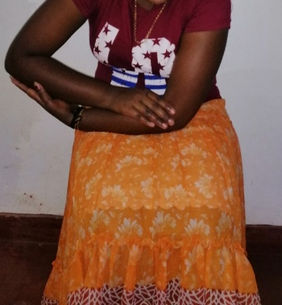  Figure 4b: Gravity assisted right shoulder abduction | 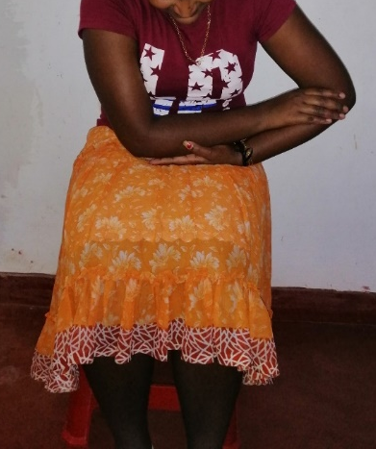  Figure 4c: Gravity assisted right shoulder adduction

  - Bird wings position holding for five seconds at a time (sitting)
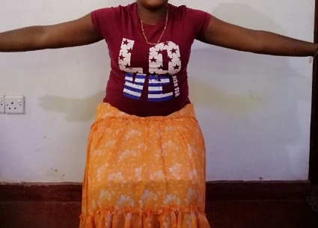
Figure 5: Bird wings position

  - Clasp hands together and shoulder elevation, horizontal abduction and adduction (sitting)
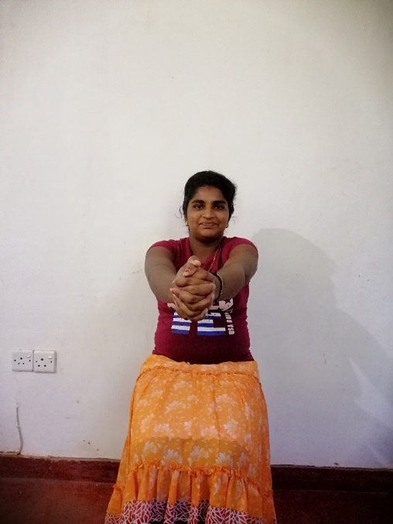  Figure 6a: Clasped hands and shoulder elevation | 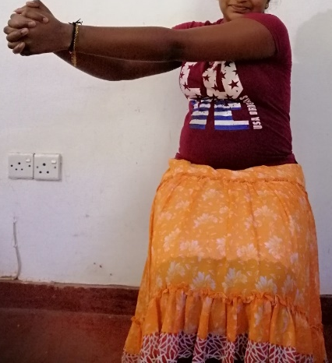  Figure 6b: Clasped hands and shoulder horizontal abduction | 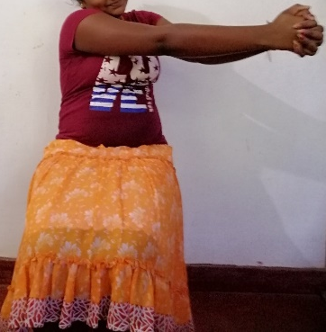  Figure 6c: Clasped hands and shoulder horizontal adduction

  - Self-assisted movements
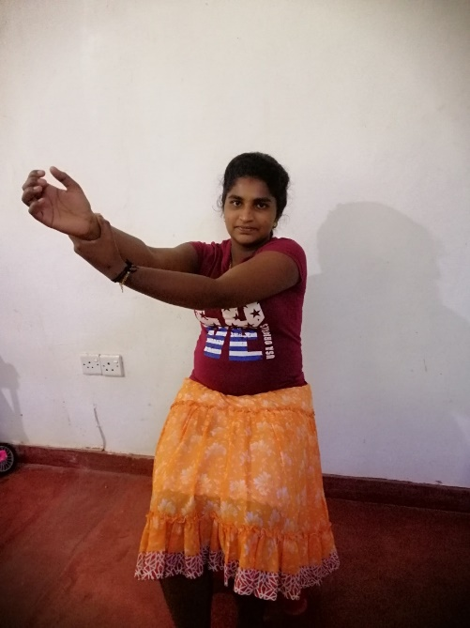 | 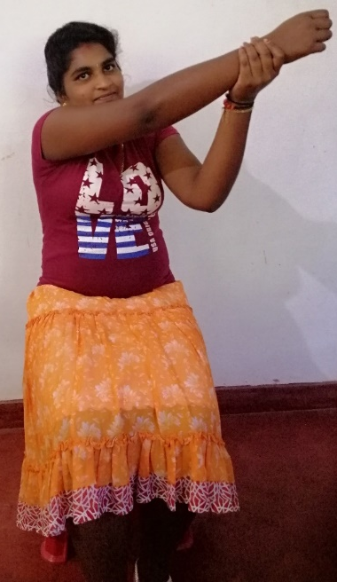
Figure 7: Self-assisted movements

- Improve protraction
  - Ask the patient to clasp his both the hands and push an object kept up. Prevent leaning forward of the trunk (sitting/ lying)
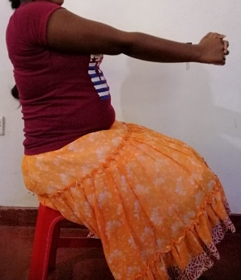  Figure 8a: Protraction, initial position | 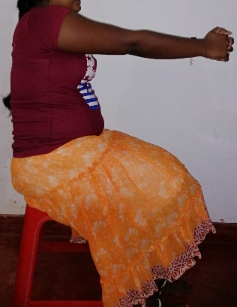  Figure 8b: Protraction, end position

- Weight bearing of upper limb (to improve elbow extension)
  - Shift the weight to the affected side to make the elbow in extension
Double hand then affected hand only
  - Reaching and grasping objects kept front
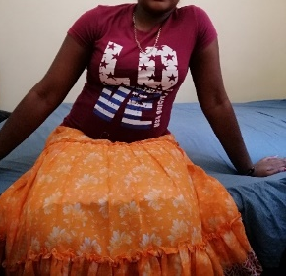  Figure 9a: Shift UL weight to unaffected side | 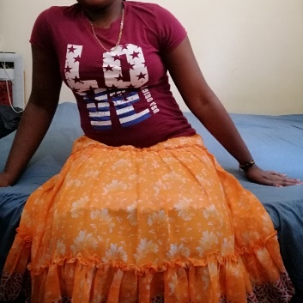  Figure 9b: Shift UL weight to affected side | 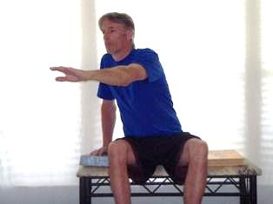  Figure 9c: Weight bearing with affected UL and forward reaching with unaffected UL

- Forearm pronation and supination
  - Ask the patient to hold a pen/ wand by hand and ask him to touch its tip either side
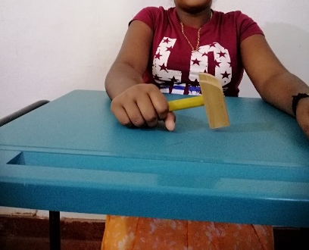  Figure 10a: Pronation, holding a wooden hammer | 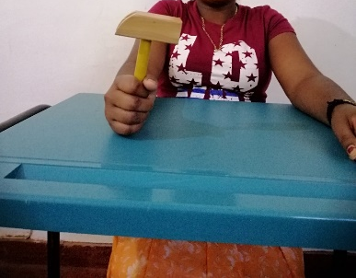  Figure 10b: Mid prone position, holding a wooden hammer | 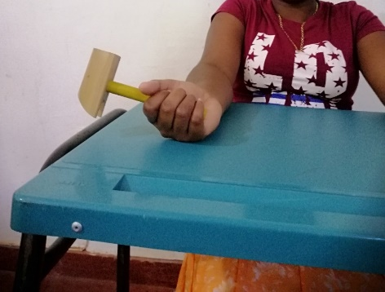  Figure 10c: Supination, holding a wooden hammer

- Wrist flexion and extension
  - Ask the patient to keep his/her hand at the edge of the table and encourage wrist flexion and extension
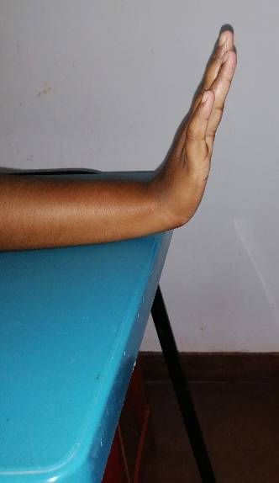  Figure 11a: Wrist flexion | 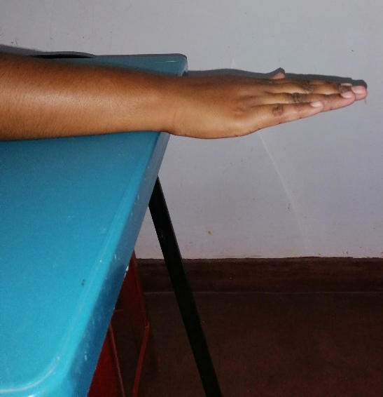  Figure 11b: Wrist neutral position | 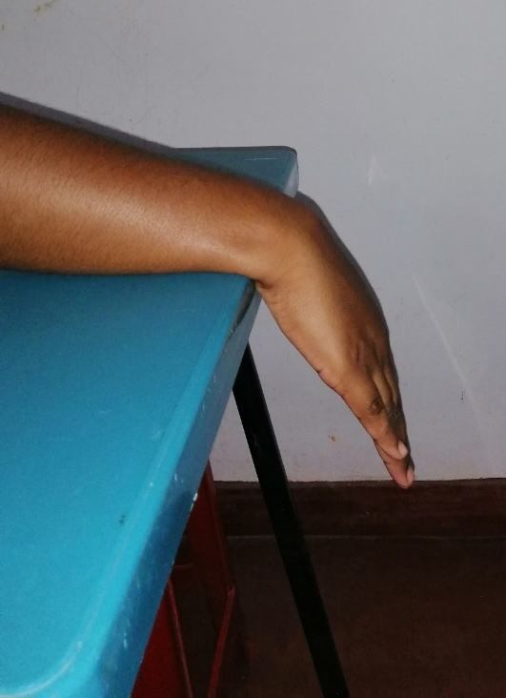  Figure 11c: Wrist extension

- Combined simple movements
  - Holding a flexible “U” curved bar and doing different movements together
  - Elbow extension together with shoulder flexion
  - Elbow extension with wrist extension
  - Shoulder abduction, elbow extension and wrist extension
  - Elbow extension, wrist extension together with forearm supination
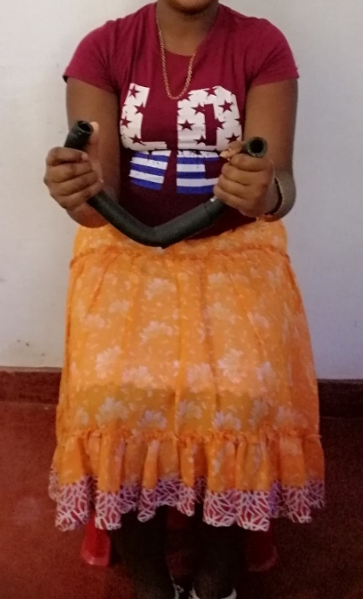 | 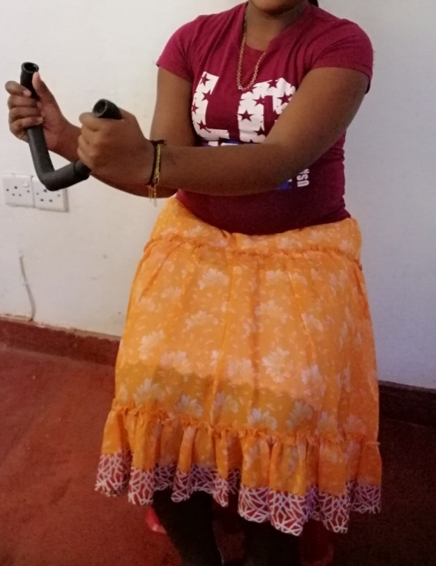 | 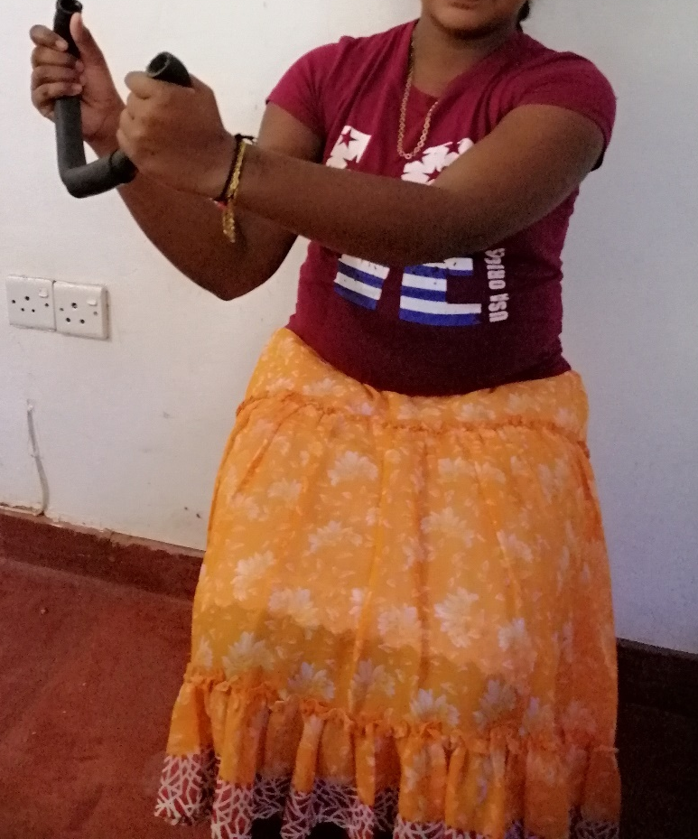 | 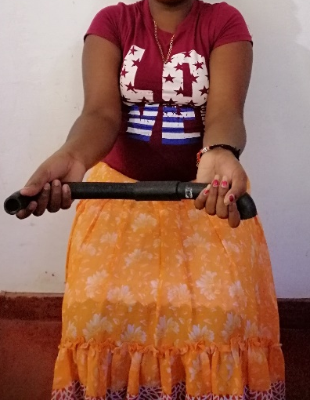
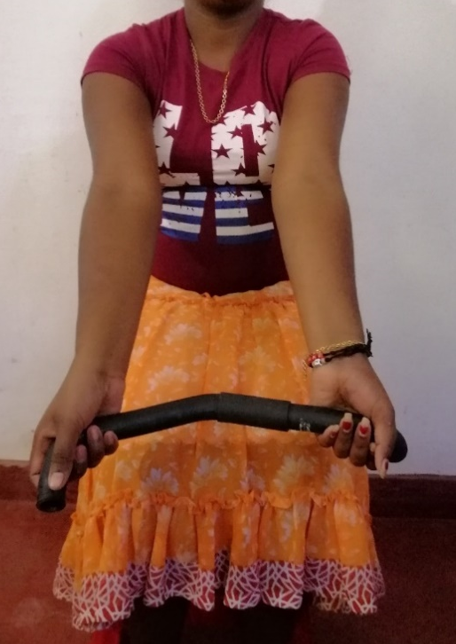 | 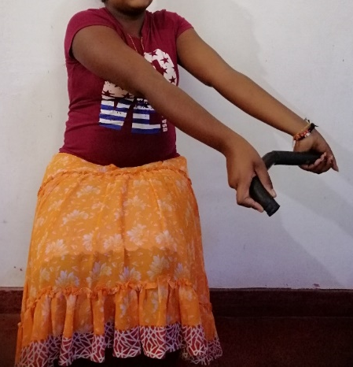 | 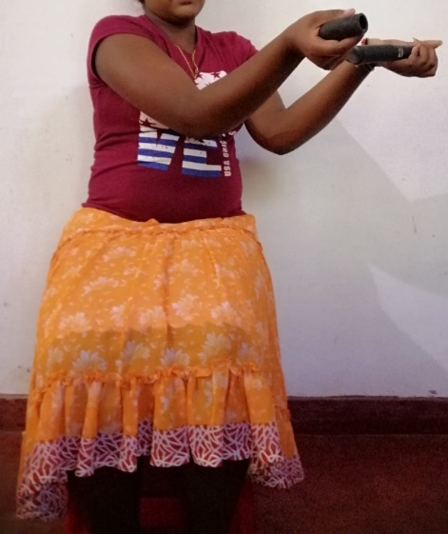 | Figure 12: Simple combined movements with a curved bar

- Reaching/ grasping
  - Missed components in hemiplegics are – Shoulder flexion, elbow extension & supination of forearm
  - Train them separately and combine them to reach for an object kept front
  - Reaching against gravity in frontal and sagittal planes
  - Reaching overhead with active wrist/ hand movements
  - Forward supported reach bilaterally with cane on table top (elbow extension)
  - Forward supported reach with shoulder elevation, elbow/ wrist extension
  - Grasp, hold and release containers with gravity minimized (on table)
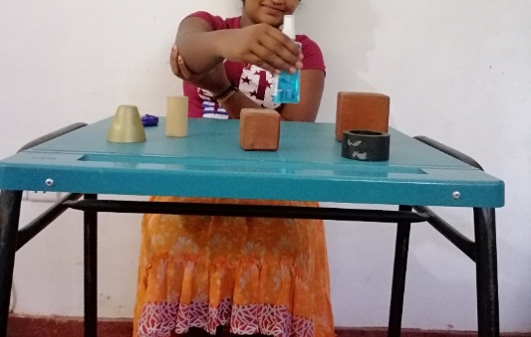 | 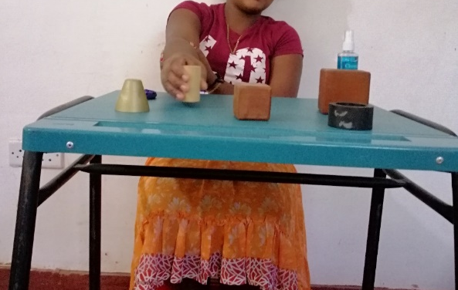 | 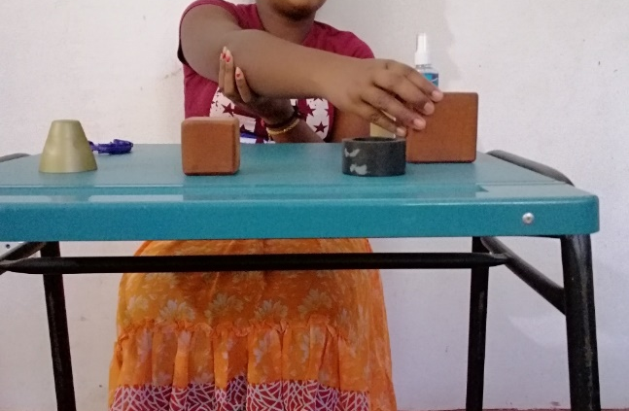
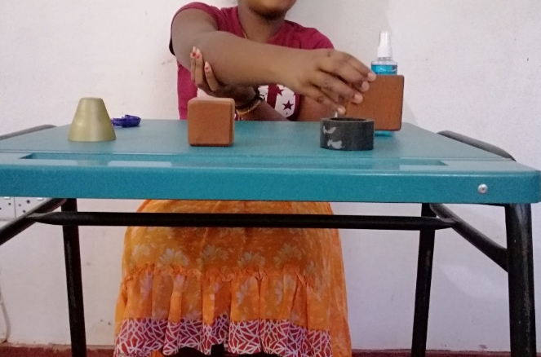 | 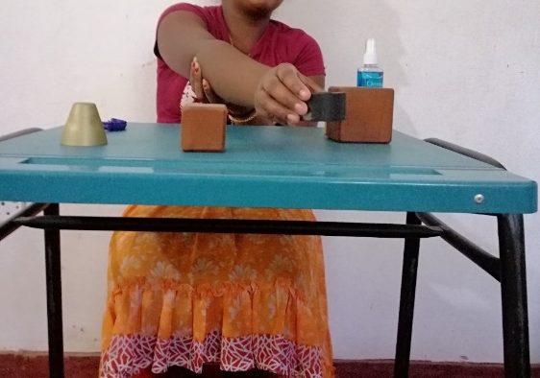 | 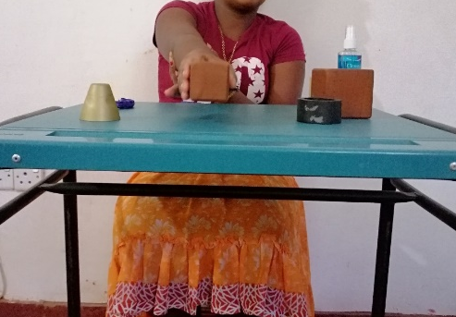
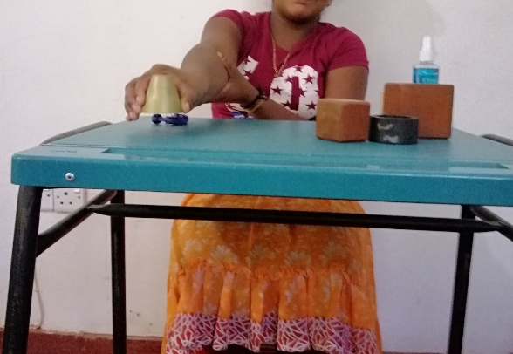 | 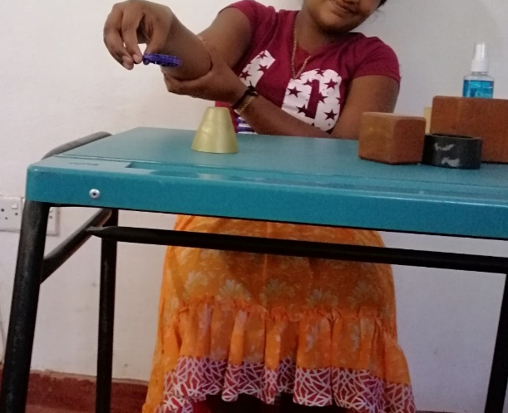 | Figure 13: Reaching and grasping

  - Dynamic reaching to a target
    - Passing a ball in to different directions, catch with both hands, throw it back with both hands or affected hand
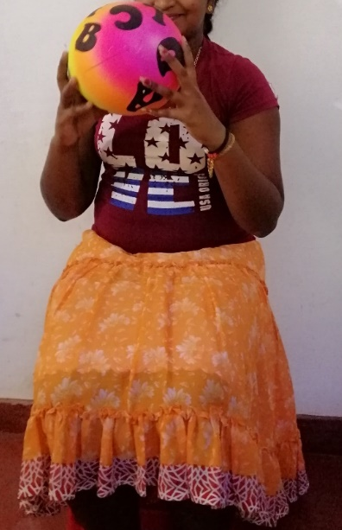  Figure 14a: Catch a ball | 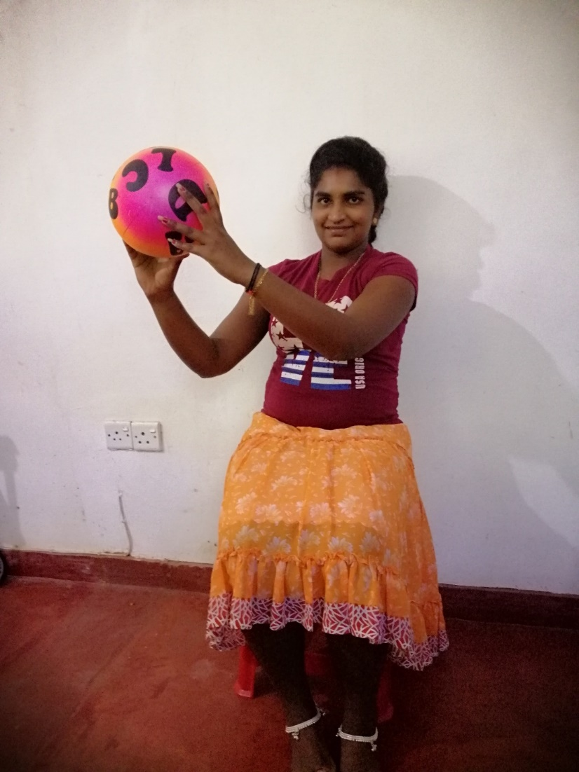  Figure 14b: Throw a ball

Second week (Simple movements)
- Follow all the above first week exercises
- Finger flexion and extension
  - Forearm is in mid prone position. Lock the thumb by your thumb and using other 4 fingers of therapist press the thenar area of the palm then ask him to flex the fingers. Then rotate the arm onto pronation. Then release the pressure over thenar area slowly while asking him to extend the fingers.
(Avoid unwanted tactile pressure on palmar reflexogenous area)
- Forward reach, grasp and release ball in target buckets
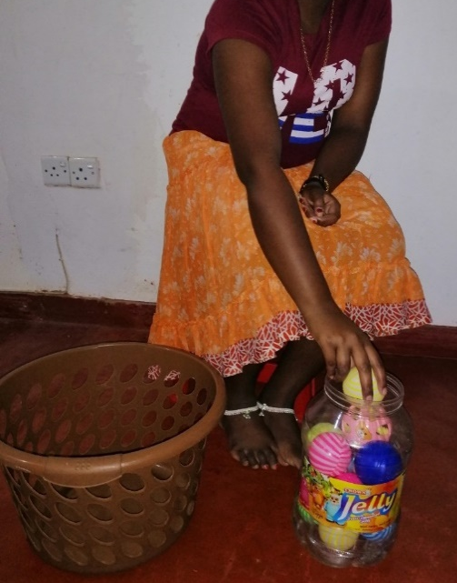  Figure 15a: Forward reach and grasp | 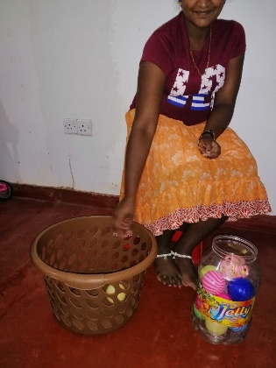  Figure 15b: Forward reach and release

- Grasp, reach forward through loop and release ball in bucket targets
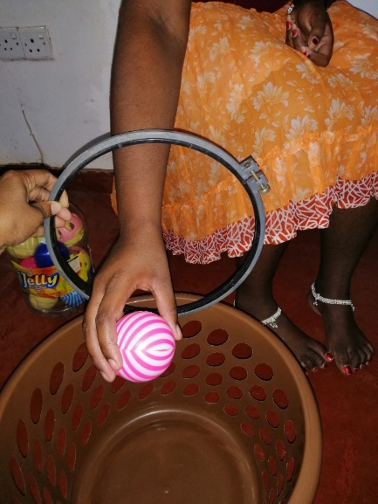  Figure 16a: Forward reach through a loop | 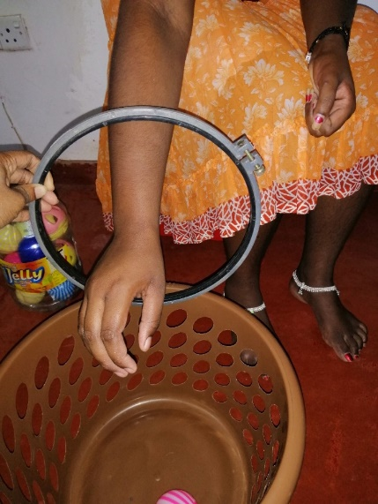  Figure 16b: Forward reach through a loop and release

- Pass the affected hand through a loop
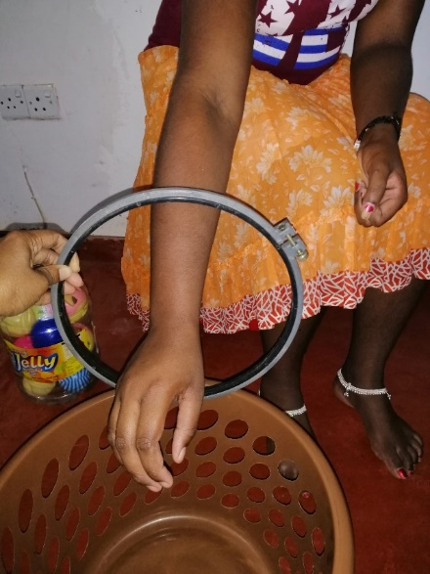
Figure 17: Pass the affected hand through a loop

- Counting fingers

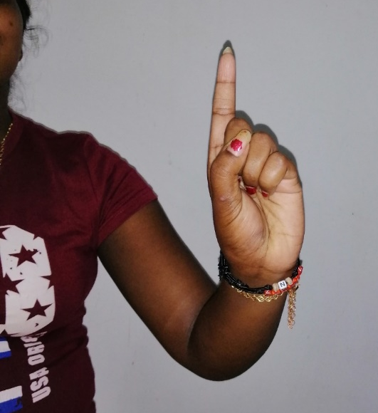 | 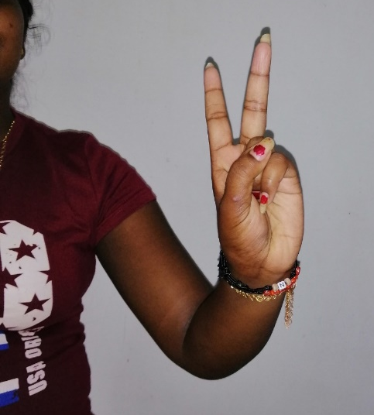 | 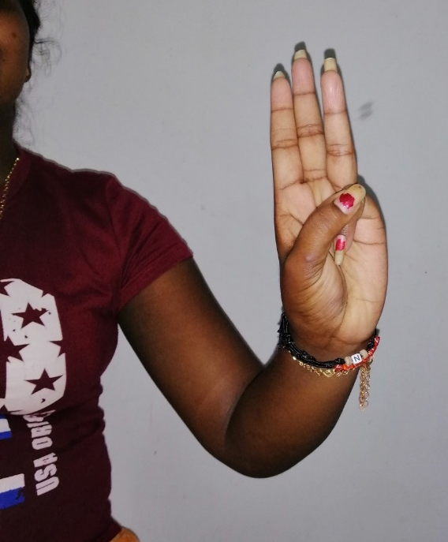
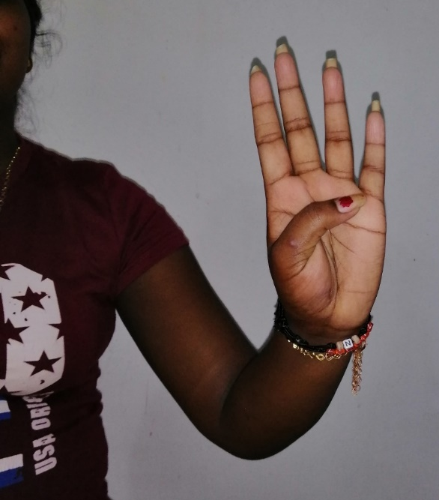 | 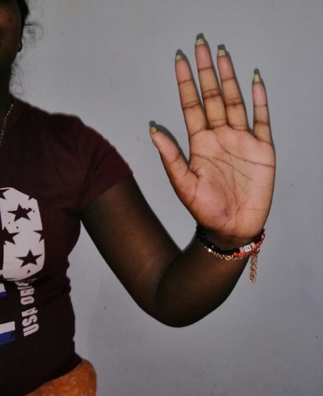 | Figure 18: Counting fingers

- Opposition of fingers
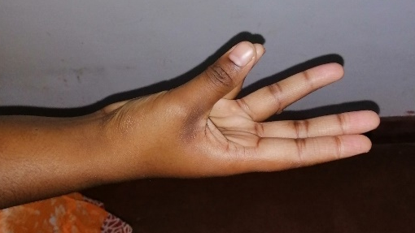 | 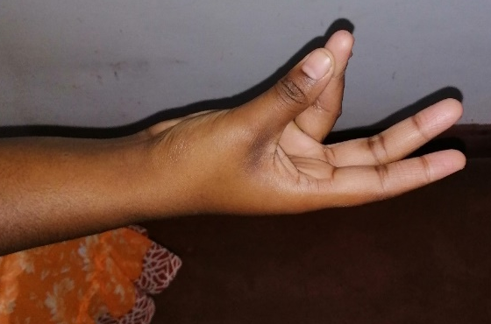
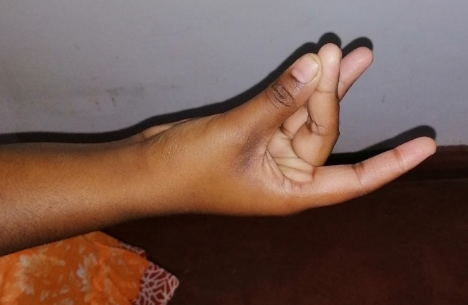 | 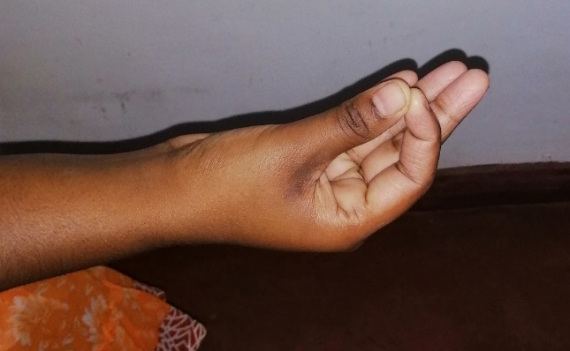
Figure 19: Opposition of fingers

- Tapping by finger tips, playing a keyboard
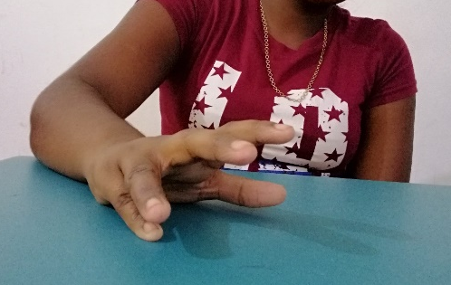 | 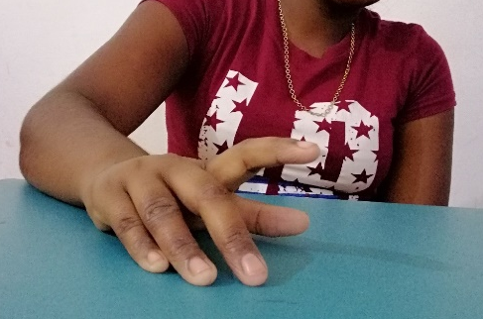
Figure 20: Tapping by finger tips

- Dressing upper garment (shirt/ blouse)
- Finger exercises
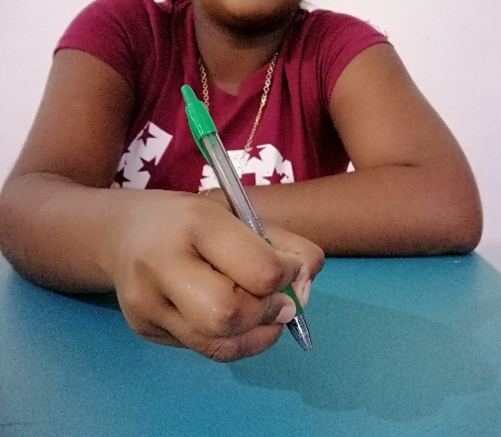 | 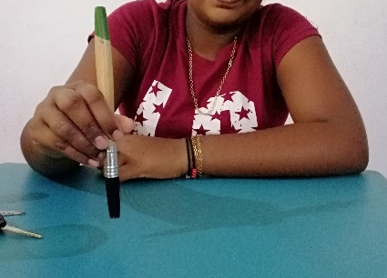 | 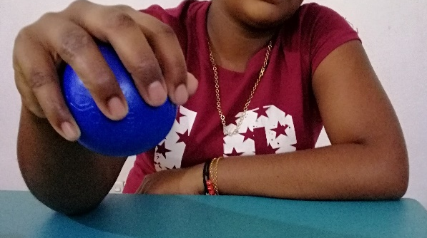
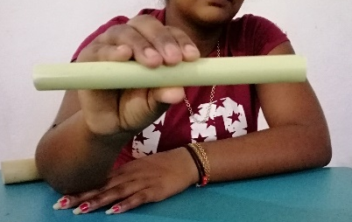 | 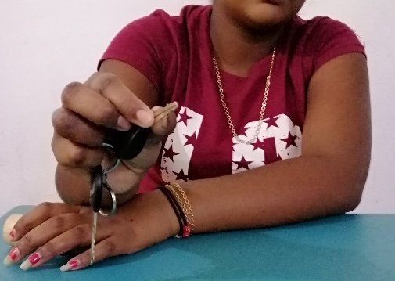 | 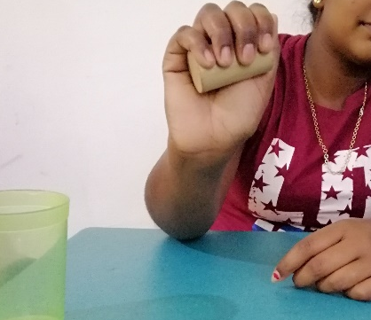
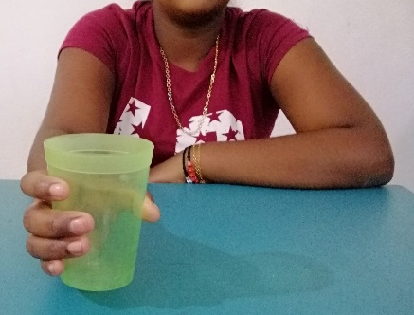 | 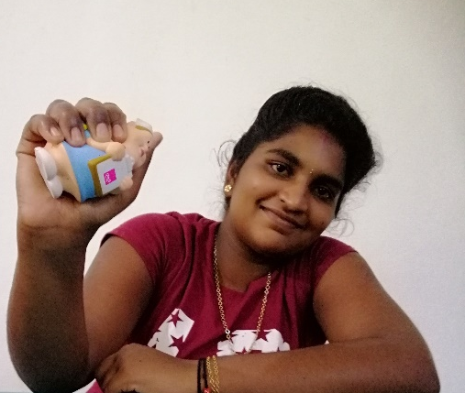 | 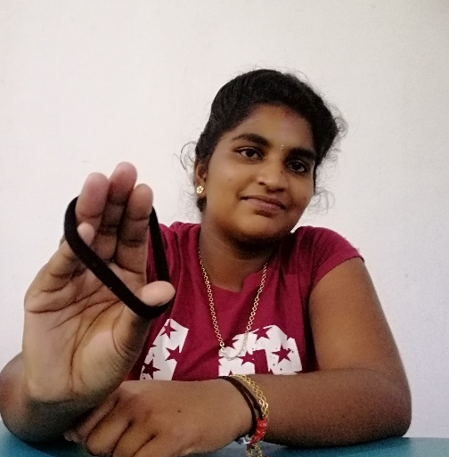
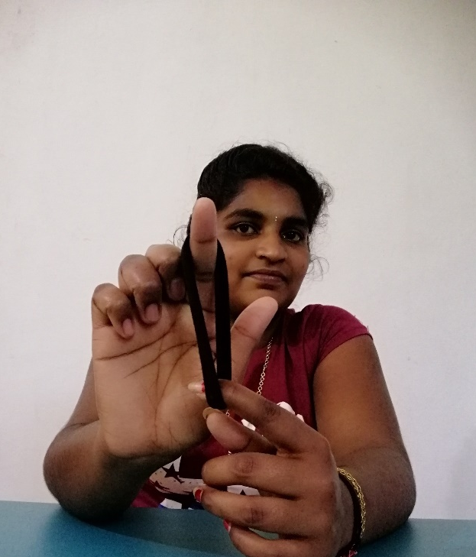 | 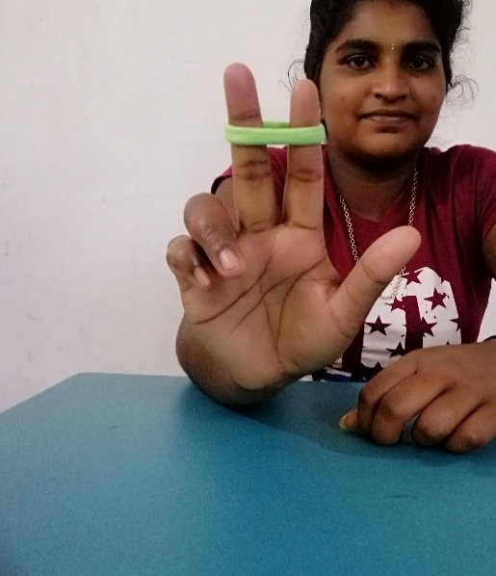 | 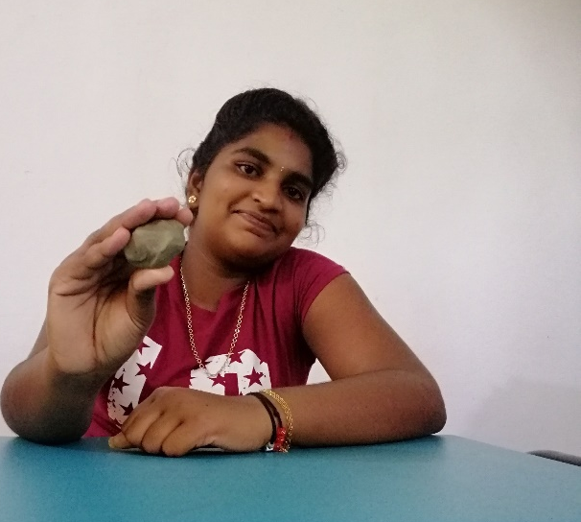
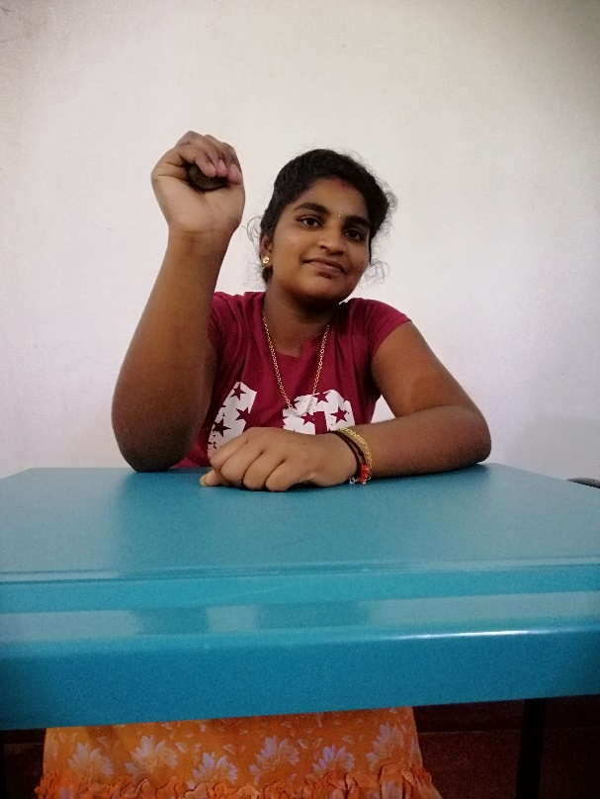 | 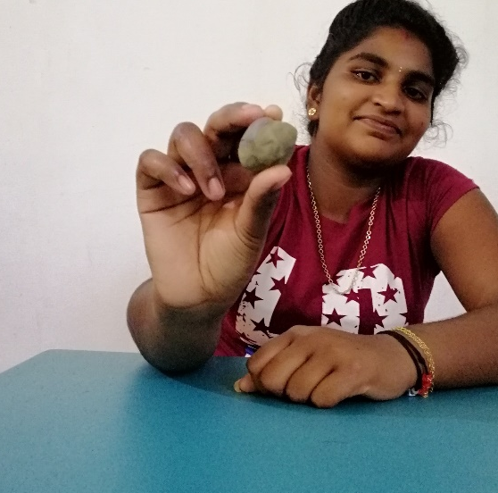 | 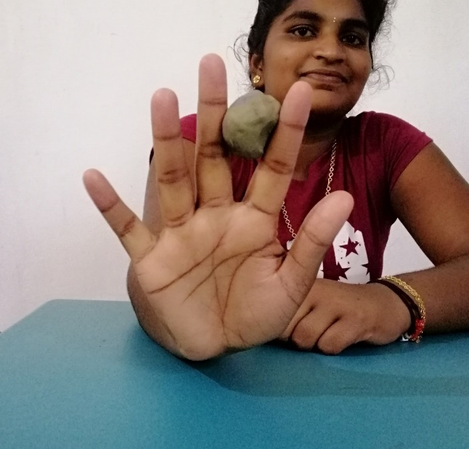
Figure 21: Finger exercises

Third week (Simple task)
- Pick up a coin or bean
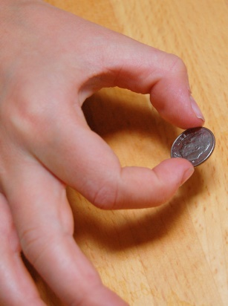 | 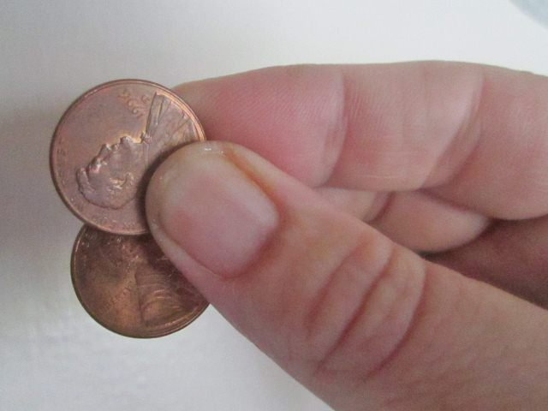
Figure 22: Pick up a coin

- Making straight fist, hook fist, full fist
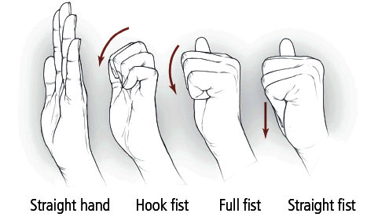
Figure 23: Making fist

- Flip a card
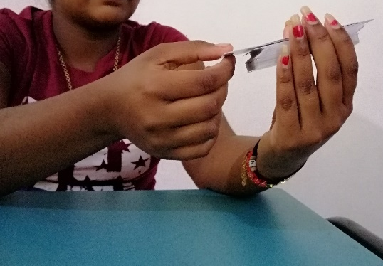 | 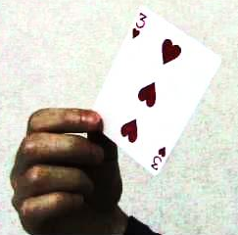
Figure 24: Flip a card

- Put block into a bucket
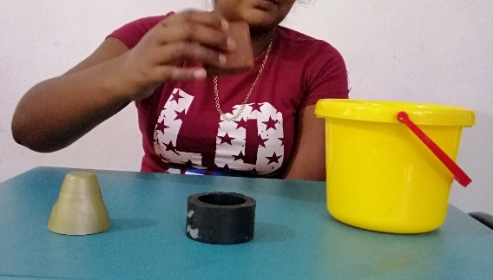 | 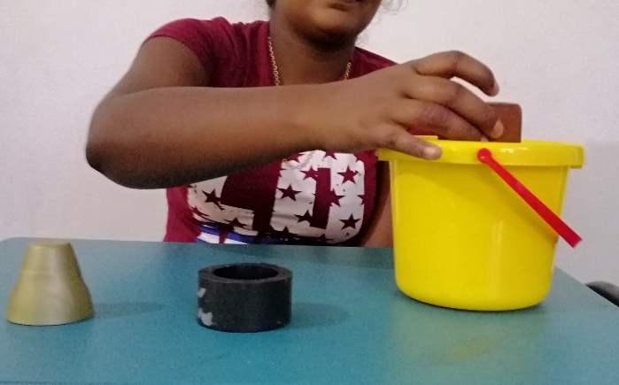
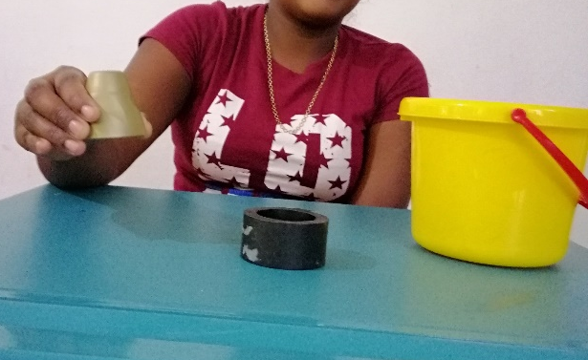 | 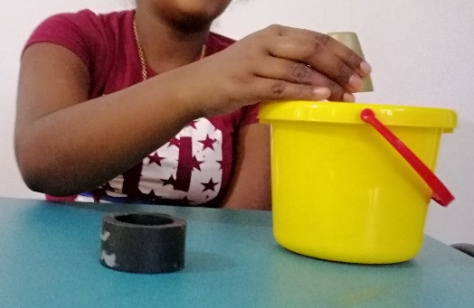
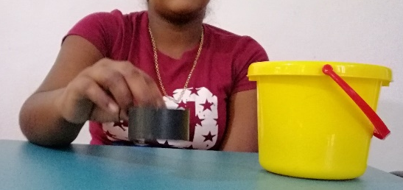 | 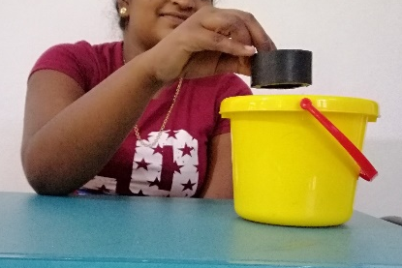
Figure 25: Put blocks in to a bucket

- Drinking/ eating
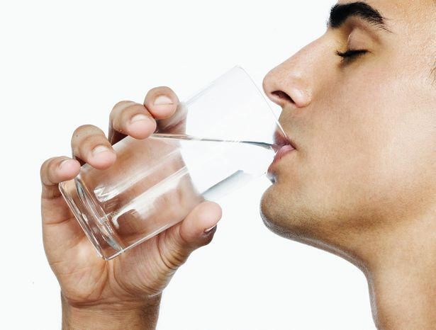  Figure 26a: Drinking | 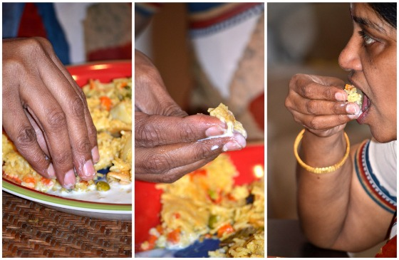  Figure 26b: Eating

- Holding a drinking cup
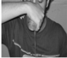
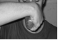
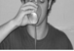
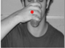
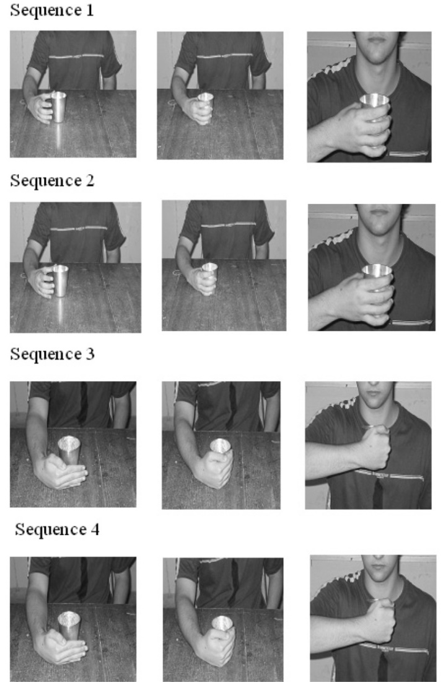
Figure 27: Holding a drinking cup in different sequences

- Pick up and move/ release small object on table
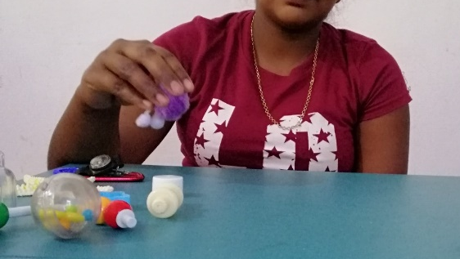 | 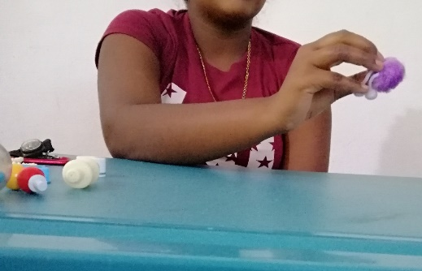
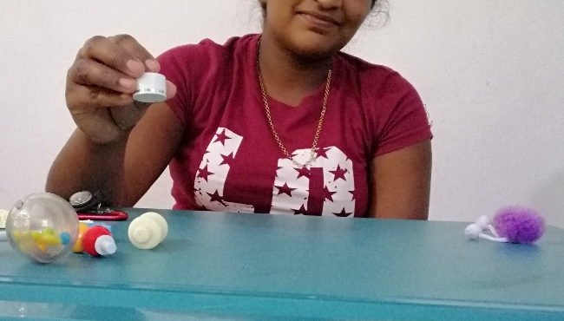 | 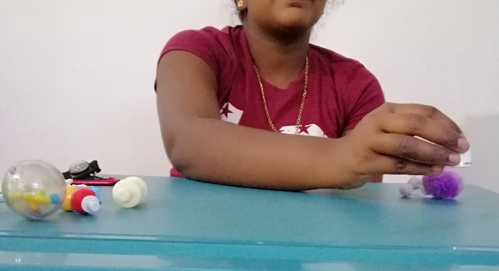
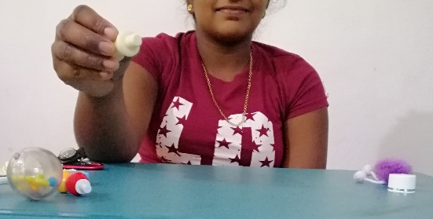 | 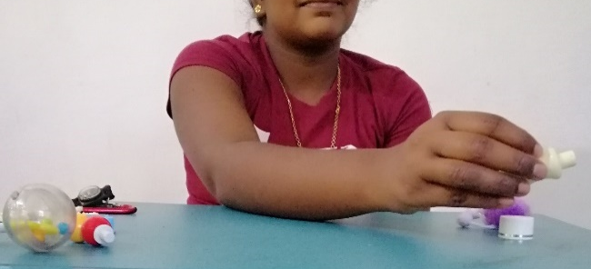
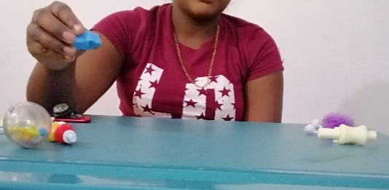 | 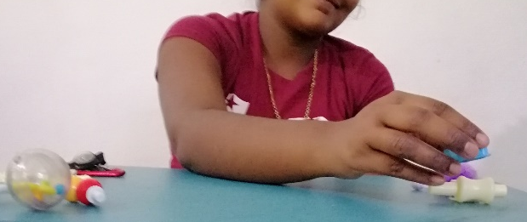
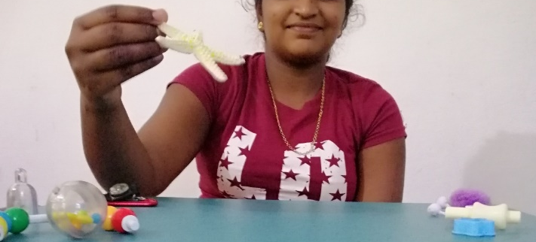 | 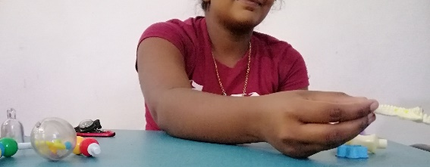
Figure 28: Pick up and move/ release small object on table

- Pick up and move/ release large objects without proximal support
- Incorporate key and pinch grips in hold and release
- Beating the drums
- Large building blocks/ cones
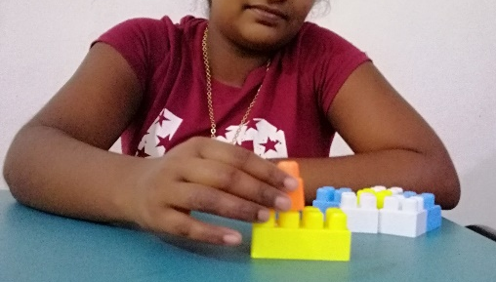 | 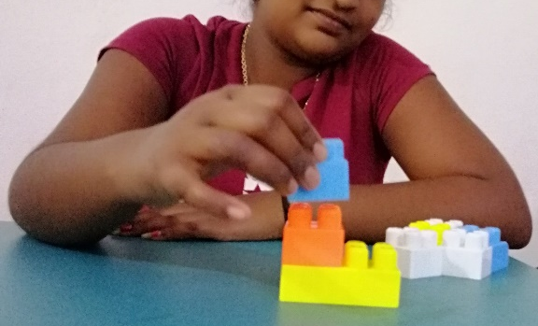
Figure 29: Use of large building blocks

- Grasp with pronated forearm and supinate to place hoop ball on horizontal pole (simulates opening a door-holding object while supinating forearm)
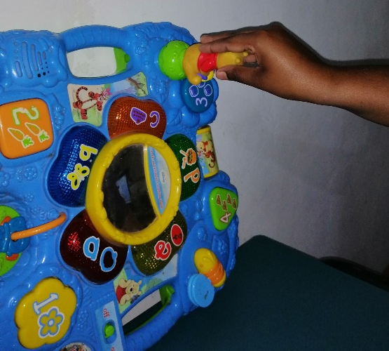  Figure 30a: Grasp with pronated forearm | 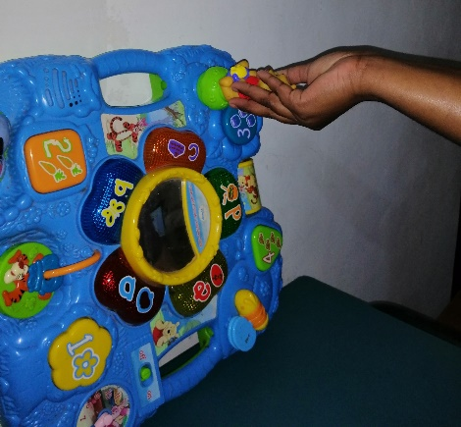  Figure 30b: Grasp with supinated forearm

- Grasp with palmar grasp, flex and abduct arm to place hoop ball on horizontal pole (simulates holding an object and abduction to place at the side)
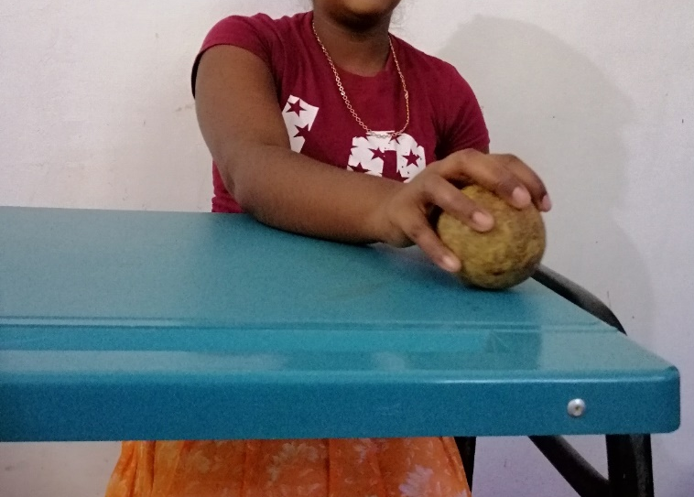 | 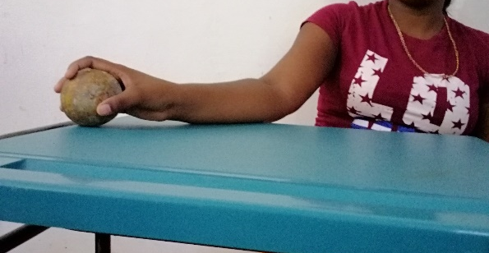
Figure 31: Palmer grasp

- washing clothes, wringing clothes
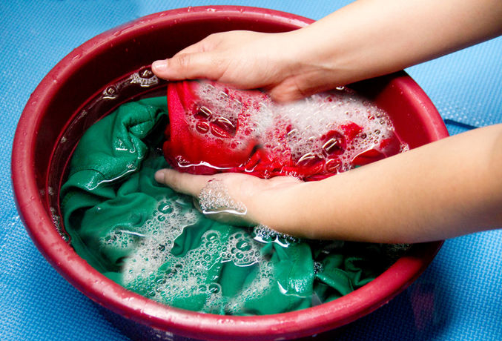  Figure 32: Washing cloths | 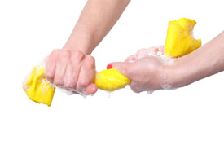  Figure 33: Wringing cloths

- Picking objects in high racks, in the floor and put it back
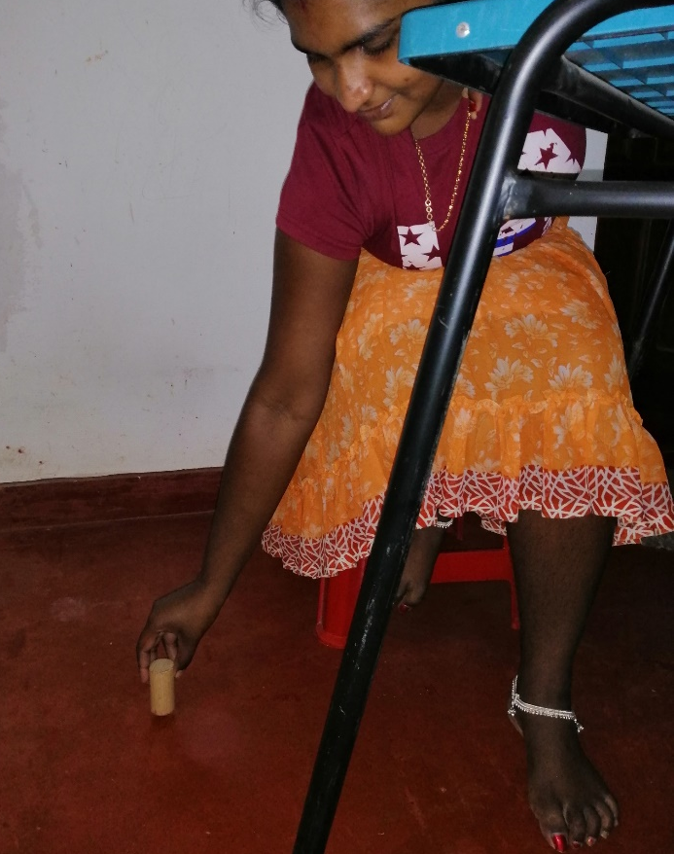 | 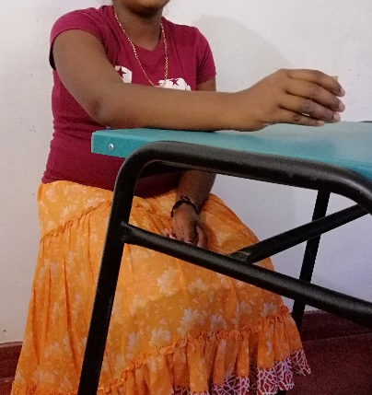
Figure 34: Picking objects from the floor and put it on the table
Fourth week (Complex task)
- Grasp peg ball with supinated wrist, reach forward and place peg in elevated peg board (simulates holding and placing a glass while maintaining upright position)
- Placing a peg on a board
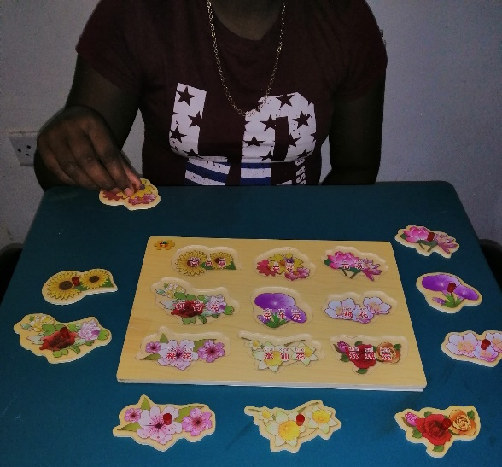 | 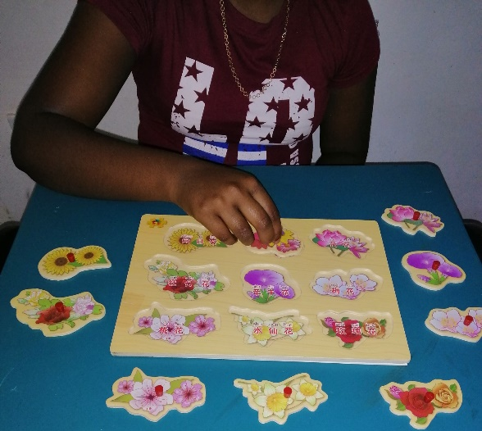
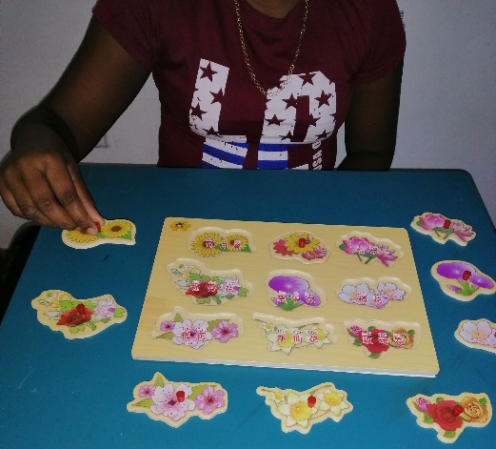 | 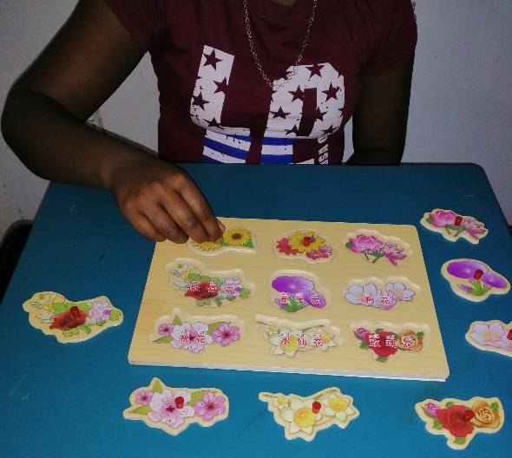
Figure 35: Placing a peg on a board

- Copying shapes on a paper
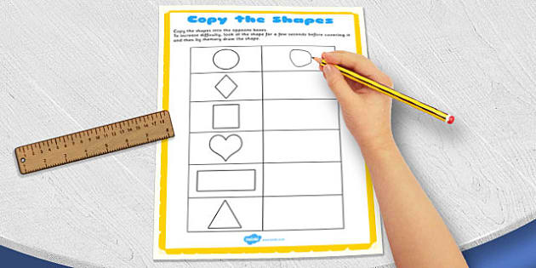
Figure 36: Copying shapes on a paper

- Colour in a drawing with crayons
- Buttoning a shirt or a blouse
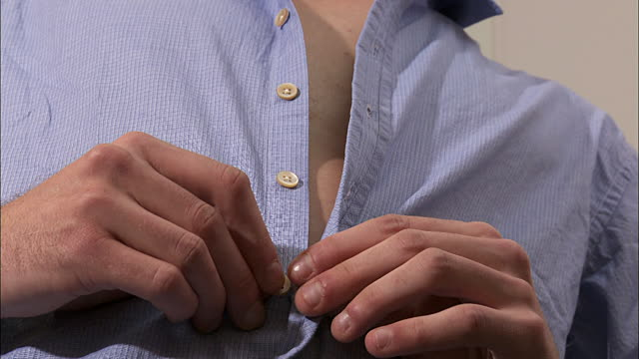
Figure 37: Buttoning a shirt

- Brushing teeth
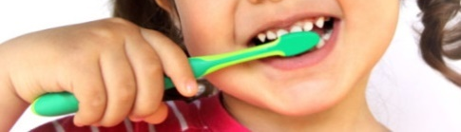
Figure 38: Brushing teeth

- Hold a needle without dropping, threading a needle
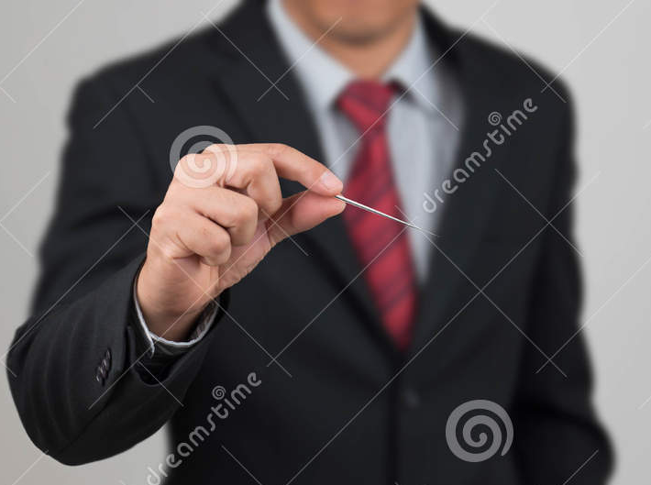  Figure 39a: Hold a needle without dropping | 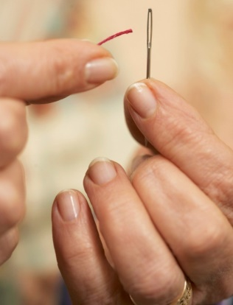  Figure 39b: Treading a needle

- Typing/ Type writing
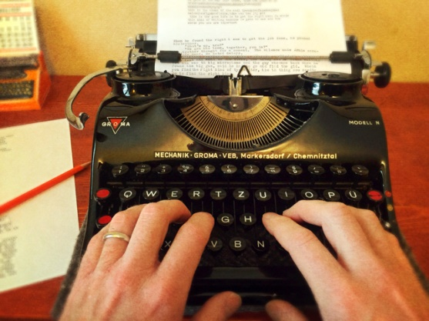 | 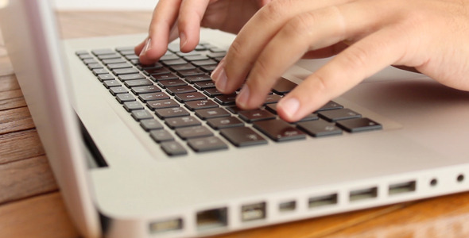
Figure 40: Typing

- Cutting with scissors and pasting
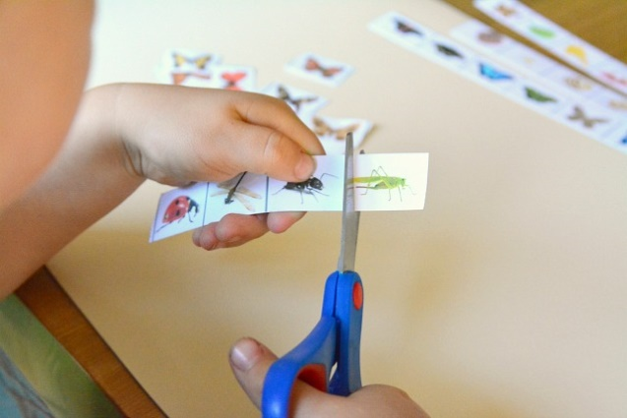  Figure 41a: Cutting with scissors | 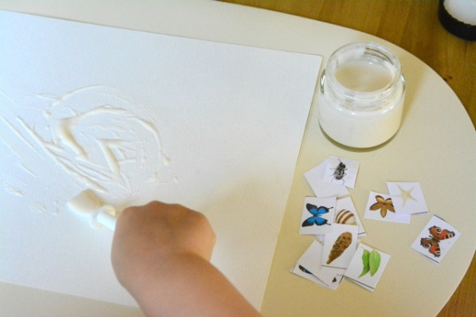  Figure 41b: Applying glue

- Writing, drawing, coloring a paint
- Combing hair, put a hair clip
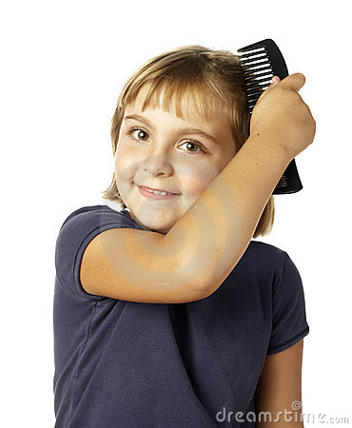
Figure 42a: Combing hair

- Dressing
- Carrying objects with affected UL
- Opening bottles, stabilizing with paretic extremity for reaching
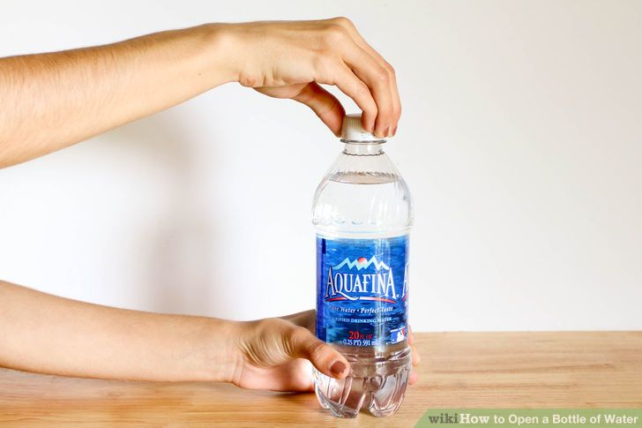 | 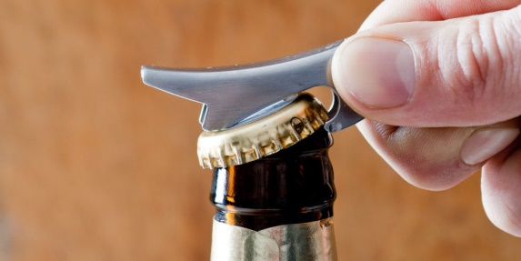
Figure 43: Opening a bottle

- Manipulating small objects
- Folding and hanging towels
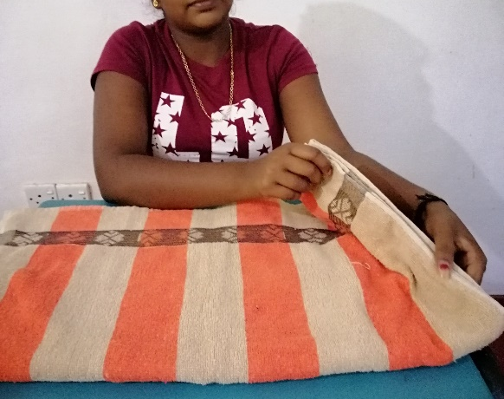 | 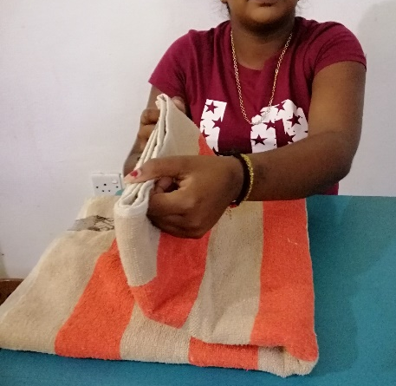 | 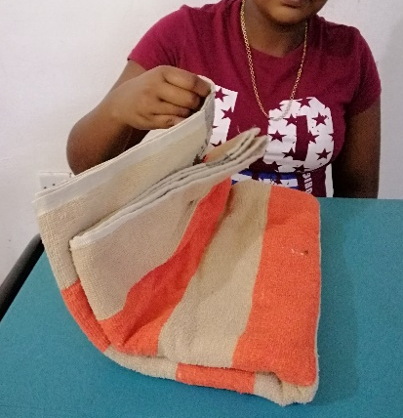
Figure 44: Folding a towel

- Self-feeding

