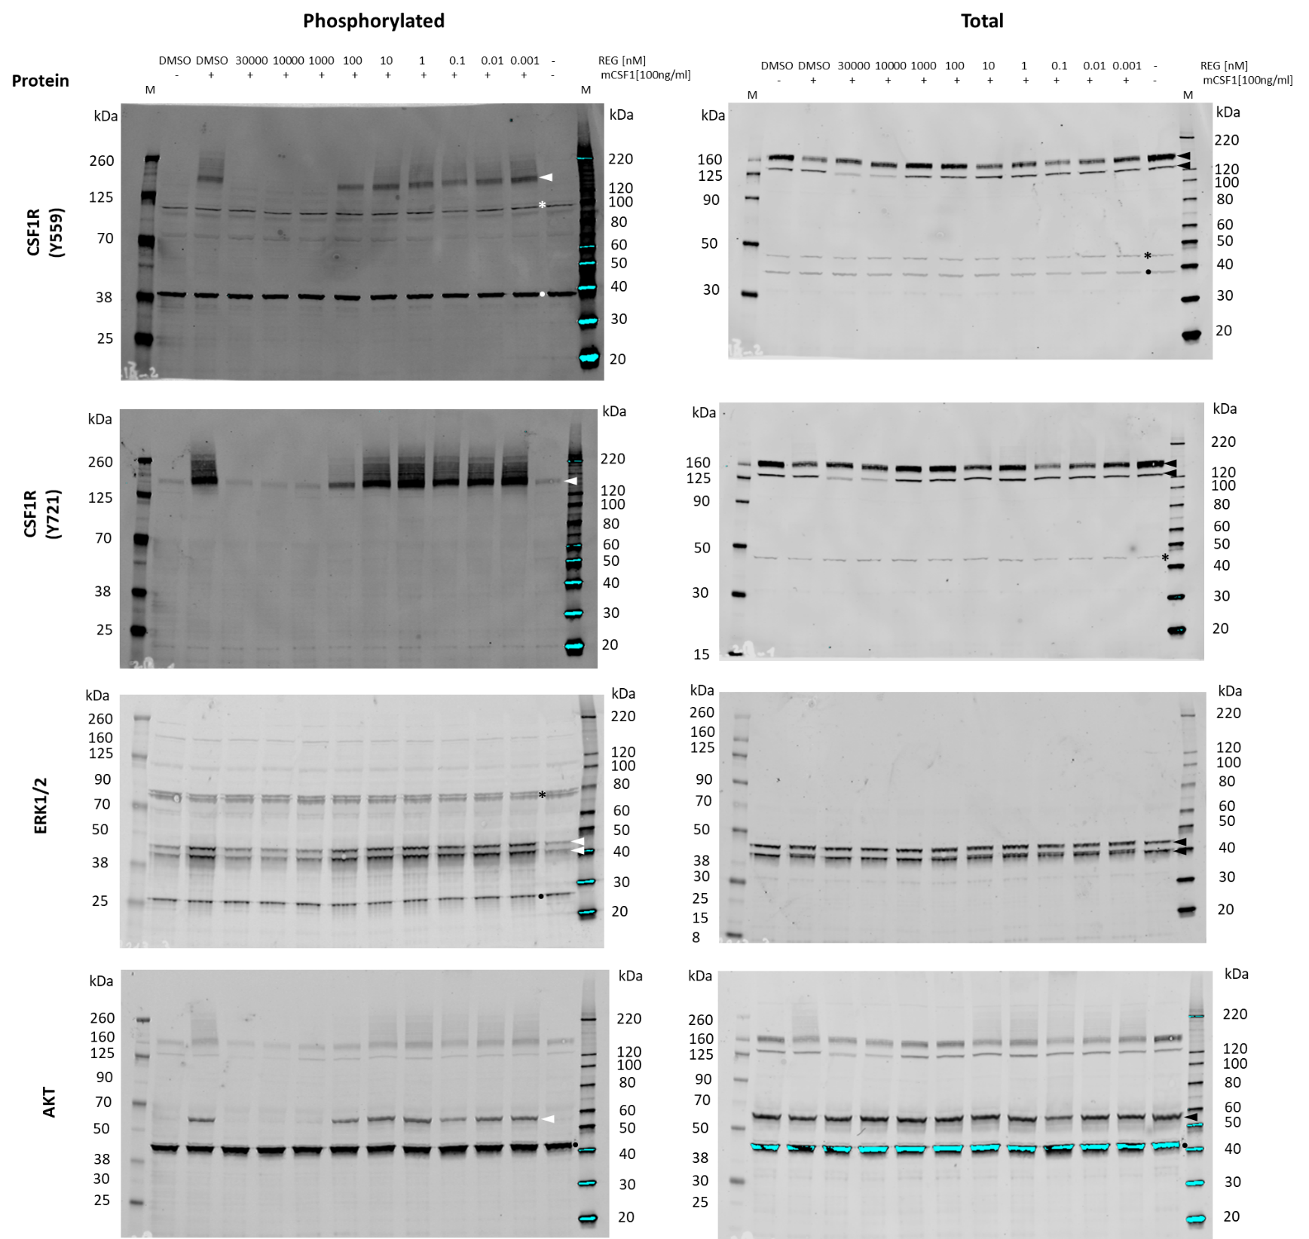
Figure S3. Entire western blots corresponding to the cropped regions depicted in Fig 1B are shown. White and black arrow heads indicate diagnostic target proteins. The black/white dots indicate loading control proteins ß-actin and GRB2 (in ERK1/2 panel). Black asterisk indicate unspecific stains. Bands at the top of the AKT panel are remnants from the CSF1R staining, as the same blot was used for the detection of AKT. M: marker. Phosphorylated and total proteins were detected on the same blots by using secondary detection antibodies with different fluorescent labels (see Materials and Methods).

