Table 1 Active ingredients of TwHF
Mol ID | Structure | Active Ingredients | OB% | DL
MOL000296 | 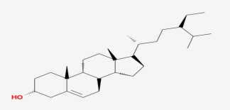 | Progesterone receptor | 36.91 | 0.75
MOL003182 | 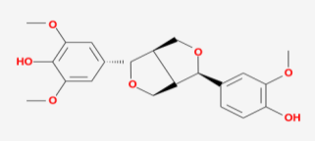 | Coagulation factor Xa | 60.69 | 0.62
MOL003184 | 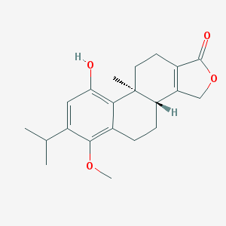 | Delta-type opioid receptor | 45.42 | 0.53
MOL003185 | 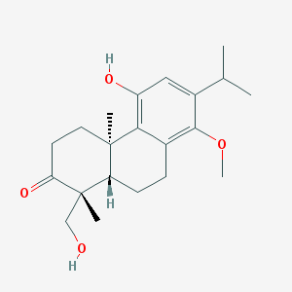 | Interleukin-8 | 48.84 | 0.38
MOL003187 | 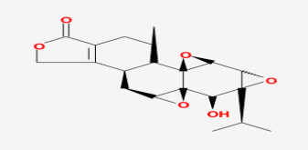 | Monocyte differentiation antigen CD14 | 51.29 | 0.68
MOL003196 | 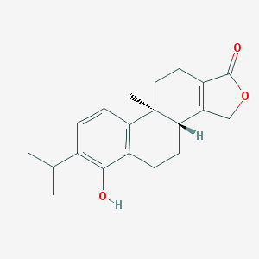 | Interstitial collagenase | 48.5 | 0.44
MOL003199 | 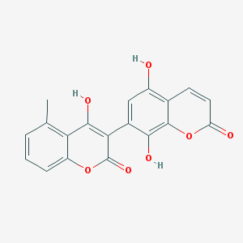 | Peroxidase C1A | 61.85 | 0.54

